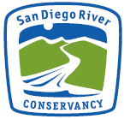
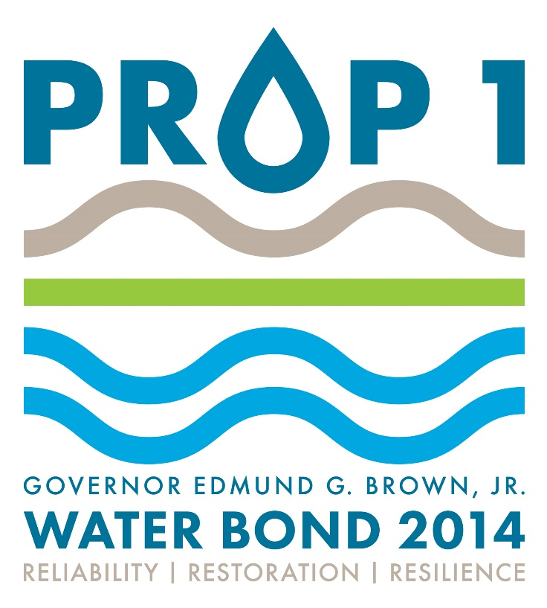

GRANT APPLICATION FORM

PART A: SUMMARY

APPLICANT INFORMATION:

Applicant name (organization):

Address:

Contact name:

Telephone: Fax: Email:

Federal Tax ID#

Position(s) whose incumbents are authorized to negotiate agreements and amendments:

Grant Solicitation Period

Applicants are required to contact Conservancy staff on instructions for pre-proposal materials. The Conservancy will meet with potential applicants, conduct site reviews as necessary and select which proposals meet the minimum criteria to be invited to submit full proposals. This APPLICATION should only be submitted after the applicant has been invited to submit a full proposal. The solicitation period may be extended if the total dollar amount requested in proposals received does not exceed the Conservancy’s appropriation for the year. Proposals received after the initial solicitation period will be accepted 30 days prior to each Conservancy board meeting and scored in the same manner as other proposals.
PROJECT INFORMATION:

Project name (limit 75 characters):

Project location: City: County:
Street: Cross street:

Proposed start date: Click here to enter a date. Estimated completion: Click here to enter a date.

Acreage (if relevant):
APN’s (if an acquisition):
Stream miles (if relevant – miles or linear feet):
Latitude (e.g. 38.337094): Longitude: (e.g. -122.589652):
Note: Latitude/Longitude can be determined using Google Earth, http://itouchmap.com/latlong.html, and other on-line resources

What point is represented by the lat/longs (i.e., parking lot, center of site, etc):

From the information provided above, is the project located within the San Diego River watershed? _________________________________________________________
(For map of the watershed go to http://www.sdrc.ca.gov/explore.htm )

Please describe how the applicant has support from the jurisdiction and/or department in which the project is proposed.
________________________________________________________________________________________________________________________________________________________________________________________________________________________________________________________________________________________

ELIGIBILITY GRANTEE

To be eligible for Prop 1 funding, projects must be consistent with the Conservancy’s enabling legislation, meet the Conservancy’s required project selection criteria (see grant guidelines on Conservancy website http://sdrc.ca.gov/ ) support the Conservancy’s Strategic Plan and advance at least one of the purposes of Chapter 6 of Prop 1.

Applicants eligible for Prop 1 grant funding from the Conservancy are:

- Public agencies, including any city, county, district, joint powers authority, state agency, public college, public university and federal agency.

- Any private, nonprofit organization that qualifies under Section 501(c)(3) of the United States Internal Revenue Code, and whose purposes are consistent with the Conservancy’s enabling legislation (Division 21 of the Public Resources Code).

- Indian Tribes that are either federally recognized or listed on the Native Heritage Commission’s California Tribal Consultation List.

Please describe how the applicant organization is an eligible entity according to the statement above.
________________________________________________________________________________________________________________________________________________________________________________________________________________________________________________________________________________________

PROJECT ADAVANCE PURPOSES in support of Chapter 6
Chapter 6 of Prop 1 sets forth 13 specific purposes of the allocation of funds to the Conservancy (“Chapter 6 purposes”), Water Code Section 79732(a). All Prop 1 grants funded by the Conservancy must achieve at least one of these Chapter 6 purposes listed below. Please describe below how applicant’s project achieves any of these purposes.

- Protect and increase the economic benefits arising from healthy watersheds, fishery resources and instream flow.
- Implement watershed adaptation projects in order to reduce the impacts of climate change on communities and ecosystems.
- Restore river parkways throughout the state, including but not limited to projects pursuant to the California River Parkways Act of 2004 and urban river greenways
- Protect and restore aquatic, wetland and migratory bird ecosystems including fish and wildlife corridors and the acquisition of water rights for instream flow.
- Fulfill the obligations of the state of California in complying with the terms of multiparty settlement agreements related to water resources.
- Remove barriers to fish passage.
- Collaborate with federal agencies in the protection of fish native to California and wetlands in the central valley of California.
- Implement fuel treatment projects to reduce wildfire risks, protect watersheds tributary to water storage facilities and promote watershed health.
- Protect and restore rural and urban watershed health to improve watershed storage capacity, forest health, protection of life and property, stormwater resource management, and greenhouse gas reduction.
- Protect and restore coastal watershed including but not limited to, bays, marine estuaries, and nearshore ecosystems.
- Reduce pollution or contamination of rivers, lakes, streams, or coastal waters, prevent and remediate mercury contamination from legacy mines, and protect or restore natural system functions that contribute to water supply, water quality, or flood management.
- Assist in the recovery of endangered, threatened, or migratory species by improving watershed health, instream flows, fish passage, coastal or inland wetland restoration, or other means, such as natural community conservation plan and habitat conservation plan implementation.
- Assist in water-related agricultural sustainability projects.

________________________________________________________________________________________________________________________________________________________________________________________________________________________________________________________________
____________________________________________________________________________________________________________________________________________

PROJECT DESCRIPTION:

Provide a clear, detailed description of the project proposed for Conservancy funding. Include:

________________________________________________________________________________________________________________________________________________________________________________________________________________________________________________________________
________________________________________________________________________________________________________________________________________________________________________________________________________________________________________________________________________________________
____________________________________________________________________________________________________________________________________________

1) specific need for the project;

________________________________________________________________________________________________________________________________________________________________________________________________________________________________________________________________
______________________________________________________________________

2) the project’s goals and objectives;

________________________________________________________________________________________________________________________________________________________________________________________________________________________________________________________________
______________________________________________________________________
3) the project’s measurable results

________________________________________________________________________________________________________________________________________________________________________________________________________________________________________________________________
______________________________________________________________________

REQUEST:

Funding amount requested from the Conservancy: $

Month and Year Conservancy funding needed: Click here to enter a date.

Other Funding Sources/Matching Funds (do not include in-kind services):
Source of funds | Amount ($) | Estimated commitment date

Total Project Cost (include additional funds):

In-kind Services determination
In-kind services include: volunteer time and materials, bargain sales, and land donations. Please describe and estimate value of in-kind contributions
________________________________________________________________________________________________________________________________________________________________________________________________________________________________________________________________________________________

PART B: Budget, Timeline, and Additional Questions

Preliminary Budget:

In the budget matrix below, list the major tasks of the proposed project, the estimated cost of the task, and the funding sources (applicant, Conservancy, and other) for the task. The listed tasks should correlate with the tasks described in the Project Description and listed on the Schedule.

Task Number | Task | Applicant’s Funds | San Diego River Conservancy | Other Funds | Total Cost
 |  |  |  |  | $ 0
 |  |  |  |  | $ 0
 |  |  |  |  | $ 0
 |  |  |  |  | $ 0
 |  |  |  |  | $ 0
 |  |  |  |  | $ 0
TOTAL |  | $ 0 | $ 0 | $ 0 | $ 0

schedule:

List the project tasks and all significant project milestones related (for example, California Environmental Quality Act compliance, obtaining of permits, appraisal preparation and other land acquisition documents, commencement of construction, and project completion). For each item provide the expected completion date and any factors that could influence the timely implementation of the project.

Task or Milestone | Expected Completion Date
 | Click here to enter a date.
 | Click here to enter a date.
 | Click here to enter a date.
 | Click here to enter a date.
 | Click here to enter a date.
 | Click here to enter a date.
 | Click here to enter a date.

Additional information:
Please address the following additional criteria(limited to 10 pages)

- The project is within the jurisdiction of the San Diego River Conservancy (San Diego watershed) – required. (pass/fail)

- The extent to which the project achieves one or more of the purposes of Chapter 6 of Prop1. (19 points)

- The extent to which the application includes a complete, reasonable and well thought out proposed scope of work, budget and schedule. (16 points)

- The extent to which the project promotes and implements state and/or regional plans and policies. (8 points)

- The extent to which the project employs new or innovative technology or practices. (6 points)

- The extent to which the applicant demonstrates a clear and reasonable method for measuring and reporting the effectiveness of the project. (10 points)

- The extent to which the project provides multiple benefits. (6 points)

- Whether the project reflects best available science. (9 points)

- The extent to which the project has support from the jurisdiction over the location of the project - required. (pass/fail)

- The extent to which the applicant demonstrates experience successfully implementing similar projects or demonstrates appropriate and necessary partnerships to complete the project. (18 points)

- The project that is in a disadvantaged community. "Disadvantaged community" means a community with an annual median household income that is less than 80 percent of the statewide annual median household income. (7 points)

- The Conservancy will award up to 14 points to applicants with significant matching funds. In addition, the Conservancy will provide a summary of the total leverage of Conservancy funds from all its grant programs in an annual financial report to the Conservancy Board.

