APPENDIX A - FULL APPLICATION CHECKLIST (BY INVITATION ONLY)

All items below must be submitted to the Conservancy by July 30, 2019

June_______________________
San Diego River Conservancy Application
Signed Authorizing Resolution or Certification Letter
Eligibility for Nonprofit Applicants – proof of current business with Secretary of State
Environmental Compliance (CEQA) - Project Permit / Approval Status
Adequate Site Control / Land Tenure (I.e. Proof of ownership such as tax rolls, grant deed, etc.)
Project location map
Site Plan
For projects, also submit:
Physical address or GPS coordinates
Concept Plan or and map of project footprint
Native Plant List Applicable for the Site
FIVE (5) Photographs of site/ project location
Flood Project Information
Flood Agency Concurrence
Floodplain Map
Evidence of Disadvantaged or Severely Disadvantaged (if applicable)
Support Letters
Property Data Sheet
Assessor’s Parcel Map(s) of all parcels
Native American consultation
California Conservation Corps consultation
For Acquisition Projects:
Land Acquisition Form
Evidence of Willing Seller
Stewardship Plan (conservation easements)
Appraisal and/or Preliminary Title Report (if available)

APPENDIX B - RESOLUTION TEMPLATE

Resolution No: RESOLUTION (GOVERNING BODY OF GRANTEE)
APPROVING THE APPLICATION FOR GRANT FUNDS FOR THE SAN DIEGO RIVER CONSERVANY PROPOSITION 68 GRANT PROGRAM

WHEREAS, the Legislature and Governor of the State of California have provided funds for the program shown above; and

WHEREAS, the San Diego River Conservancy has been delegated the responsibility for the administration of this grant program, establishing necessary procedures; and

WHEREAS, said procedures established by the San Diego River Conservancy require a resolution certifying the approval of application(s) by the Applicants governing board before submission of said application(s) to the Conservancy; and

WHEREAS, the Applicant, if selected, will enter into an agreement with the Conservancy to carry out the project

NOW, THEREFORE, BE IT RESOLVED that the_ (Governing Body)

1. Approves the filing of an application for the (name of the project);

2. Certifies that Applicant understands the assurances and certification in the application; and,

3. Certifies that Applicant or title holder will have sufficient funds to operate and maintain the project(s) consistent with the land tenure requirements; or will secure the resources to do so; and,

4. Certifies that it will comply with all provisions of Section 1771.5 of the California Labor Code; and,

5. If applicable, certifies that the project will comply with any laws and regulations including, but not limited to, the California Environmental Quality Act (CEQA), legal requirements for building codes, health and safety codes, disabled access laws, and, that prior to commencement of construction, all applicable permits will have been obtained; and,

6. Certifies that applicant will work towards the State Planning Priorities intended to promote equity, strengthen the economy, protect the environment, and promote public health and safety as included in Government Code Section 65041.1, and

7. Appoints the (designate position, not person occupying position) , or designee, as agent to conduct all negotiations, execute and submit all documents including, but not limited to applications, agreements, payment requests and so on, which may be necessary for the completion of the aforementioned project(s).

Approved and adopted the day of 20 . I, the undersigned, hereby certify that the foregoing Resolution Number was duly adopted by the .
(Governing Body)
Following Roll Call Vote: | Ayes:
 | Nos:
 | Absent:
Clerk/Secretary for the Governing Board

APPENDIX C - CERTIFICATION LETTER REQUIREMENTS

If an applicant does not have a governing board, a certification letter from the organization’s director or chief executive officer must be furnished. The letter must:

1. Approve the application for grant funds from the San Diego River Conservancy Prop 68 Grant Program.

2. Approve the filing of an application for the (project).

3. Certify that the applicant understands the assurances and certification in the application.

4. Certify that applicant or title holder has or will have sufficient funds to operate and maintain the project(s).

5. Certify that the project will comply with any laws and regulations that apply to development projects including, but not limited to, the California Environmental Quality Act (CEQA), legal requirements for prevailing wages, building codes, health and safety codes, and disabled access laws.

6. Certify that prior to commencement of construction all applicable permits will have been obtained.

7. Certify that it will comply with all provisions of Section 1771.5 of the California Labor
Code.

8. Certifies that applicant will work towards the State Planning Priorities intended to promote equity, strengthen the economy, protect the environment, and promote public health and safety as included in Government Code Section 65041.1.

9. Appoint the (designate position, not person occupying position), or designee,
as agent to conduct all negotiations, execute and submit all documents including, but not limited to applications, agreements, payment requests and so on, which may be necessary for the completion of the aforementioned project(s).

10. Contain the signature of the Director or Chief Executive Officer.

APPENDIX D – NATIVE AMERICAN CONSULTATION

17
PO Box 485
Alpine, CA 91903

KDLC@gmail.com

APPENDIX E - ELIGIBLE COSTS

Direct project-related costs incurred during the project performance period specified in the grant agreement will be eligible for funding. All eligible project costs must be supported by appropriate documentation. Costs incurred outside of the project performance period, and overhead rates/costs are not eligible for reimbursement (see Appendix P for definition of overhead costs).

All projects must comply with all provisions of Section 1771.5 of the California Labor Code. Include prevailing wages in the cost estimates, as applicable. Refer to the Department of Industrial Relations’ Division of Labor Statistics and Research Web site at http://www.dir.ca.gov/DLSR/PWD/index.htm for general prevailing wage determinations.

A. Development

Project Management – Up to 25 percent (25%) of the grant funds may be spent on non- construction costs (CEQA compliance, environmental impact reports and assessments, planning and design, assessments, utility coordination, architecture and engineering, construction plans, bid preparation, direct project administration and management).

Personnel or employee services – Costs for services of the grantee's employees directly engaged in project execution must be computed according to the grantee's prevailing wage or salary scales, and may include fringe benefit costs such as vacations, sick leave, Social Security contributions, etc., that are customarily charged to the recipient's various projects. Costs charged to the project must be computed on actual time spent on the project and evidenced by time and attendance records describing the work performed on the project as well as payroll records. Overtime costs are allowed under the recipient's established policy provided the regular work time was devoted to the same project.

Salaries and wages claimed for employees working on State grant-funded projects must not exceed the grantee's established rates for similar positions.

Construction - All necessary labor and construction activities, from site preparation (including demolition, excavation, grading, soil/water testing, monitoring during construction, on-site/field supervisor, etc.) to the completion of the project are eligible costs.

Equipment owned by the grantee may be charged to the project for each use. Equipment use charges must be made in accordance with the grantee's normal accounting practices. The equipment rental rates published by the California Department of Transportation or local prevailing rental rates may be used as a guide.

If the grantee's equipment is used, a report or source document must describe the work performed, indicate the date and hours used, relate the use to the project, and be signed by the operator and supervisor.

Equipment may be leased, rented, or purchased, whichever is most economical. If equipment is purchased, its residual market value must be credited to the project costs upon project completion.

Supplies and materials may be purchased for a specific project or may be drawn from a central stock, providing they are claimed at a cost no higher than paid by the grantee. When supplies and/or materials are purchased with the intention of constructing a piece of equipment, a structure or a part of a structure, the costs that are charged as supplies and materials may be capitalized according to the grantee’s normal practice or policy. If capitalized, only that cost reasonably attributable to the project may be claimed under the project.

Other expenditures - In addition to the major categories of expenditures, funding may be provided for miscellaneous costs necessary for execution of the project at the discretion of the Conservancy. Some of these costs may include:

• Premiums on hazard and liability insurance to cover personnel and/or property.
• Work performed by another section or department of the grantee's agency that can be documented as direct costs to the project. (See requirements above under personnel or employee services).
• Transportation costs for moving equipment and/or personnel.
• Community access (up to 5% of grant)

B. Acquisition

Costs of acquiring real property are eligible and include the purchase price of the property at the approved fair market value, appraisals, and surveys for boundary adjustments, preliminary title reports, escrow fees and title insurance fees. Direct staff and consultant costs are limited to $10,000 per grant. Costs of obtaining State approvals of purchase price and transaction reviews from the Department of General Services are also allowable.

Relocation costs are allowable for acquisition projects that result in displacement of any person and/or business. Grantee must comply with the State Relocation Act requirements (Government Code, Chapter 16, Section 7260 et seq.), even if relocation costs are not claimed for funding as part of the grant request.

C. All Projects

Contingency – Up to 10% of the grant may be budgeted for contingency costs. All such costs must be eligible per these guidelines. Contingency funds may not be used to increase the amount of funds used for project management beyond the 25 % maximum nor any other caps set forth in the guidelines.

Signs and interpretive aids – Costs include construction of exhibits, kiosks, display boards or signs located at and communicating information about the project and the costs of required acknowledgement signs

APPENDIX F - LAND ACQUISITION FORM

(Complete one form for each escrow)
Project Title:
Assessor’s Parcel Number(s): |  | Acreage | Fee Title or  Easement | Willing Seller  Name and Address
ACQUISITION COST ESTIMATE
 | Total Costs | RP | Other Sources of Funds  (specify by name)
Estimated Fair Market Value of property
Relocation Costs
Preliminary Title Reports, Appraisal
Escrow Fees, Title Insurance, Closing
Costs
Surveying (limited to boundary line adjustment)
Direct costs (staff and consultants) – limited to
$10,000 per grant
State approval costs of appraisal, transaction review etc.
Contingency (Not to exceed 10% of total grant)
Required signage
Other (Specify)
Grand Total

Acquisition Schedule Timeframe Comments
Complete Appraisal
Submit appraisal and title report for State review
Submit instruments of conveyance, etc.
Close of escrow (submit all final closing documents specified in the grant agreement)
Install Bond Acknowledgement Sign
Close-out

LAND ACQUISITION FORM, Continued - INSTRUCTIONS Complete a separate form for each escrow.
1. Estimated Fair Market Value of Land and Improvements – Provide an estimate for each parcel. On a separate sheet, describe existing improvements and explain the proposed use or disposition.

Note: The State, through the Department of Real Estate Services must approve the fair market value of the acquisition.

2. Required Signage – Provide an estimated cost of required signage.

3. Preliminary Costs – Provide an estimate of the preliminary acquisition costs. Direct staff and consultant costs are limited to $10,000 per grant.

4. Cost of State Approval of Appraisal, Transaction Review, etc. – For cost estimation purposes, use $10,000 per escrow.

5. Contingency – Grantees are allowed to use ten percent (10%) for contingency to cover unexpected eligible costs.

6. Acquisition Timeline – Provide the estimated dates of completion for each acquisition task. (Grantee should submit evidence of progress on the acquisition, e.g. appraisal, title report, purchase documents, correspondence with owner, etc., within 6 months of grant execution.)

7. Other – Include any additional tasks directly related to the proposed acquisition.

APPENDIX G - PROPERTY DATA SHEET

Use the Property Data Sheet to list the owner(s) of all parcels included in the proposed project. Indicate and attach all required documents including any clarifying comments below. Attach additional sheets if necessary.

No | Owner Name | Assessor Parcel  Number(s) | Acreage | If parcel(s) owned by applicant(s), indicate type of ownership |  |  | For all parcels, indicate document used to demonstrate ownership and attach a copy of each document-clearly labeled with the APN-to this document | If parcel(s) not owned by applicant(s) indicate document verifying Permission to Develop and attach |  |  |  |  | Entity to perform O&M | # of years O&M to be performed
 |  |  |  | Fee Simple | Easement | Other  (describe) | Proof of Ownership (tax bill, grant deed, etc.) | O&M Agreement | Lease | JPA | Letter from  Owner | Other  (describe)
1
2
3
4
5
6
7
8
9
10

Comments:

Total Number of Parcels: Total Number of Acres:

22

APPENDIX H - SITE CONTROL/LAND TENURE REQUIREMENTS

The Conservancy recognizes that specific activities may change over time; however all uses on the project property must remain compatible with the Conservancy’s Grant Program in accordance with the following requirements:

Acquisition projects -
The grantee or the grantee’s successor in interest shall hold the real property only for the purpose for which the grant was made and make no other use or sale or other disposition of the property without the written permission of the Conservancy.

Development projects -
The grantee shall maintain and operate the property developed pursuant to this grant for a period of time as defined in the Grant Agreements, Exhibit entitled Maintenance and Operation Agreement:

All projects

• All projects are subject to the recordation of a document against the real property that defines the Conservancy’s interest in the property whether the grantee owns the property or not. Exceptions may be granted as appropriate and at the sole discretion of the Conservancy.

• The grantee shall not use or allow the use of any portion of the real property as security for any debt.

• With the approval of the Conservancy, the grantee or the grantee’s successor in interest in the property may enter into an agreement with another party to maintain and operate the property in accordance with this program. At a minimum, the agreement must do the following:

1. Clearly spell out the roles of each party in detail,
2. Be signed by both parties signifying their acceptance,
3. Not terminate prior to the length of site control/land tenure required by the grant agreement (only agreements that allow early termination for cause or by mutual consent will be acceptable) and,
4. Include language that the grantee would resume responsibility for ongoing operations and maintenance in the event of cancellation.

• Grantee may be excused from its obligations for operation and maintenance of the project site only upon the written approval of the Conservancy for good cause. “Good cause” includes, but is not limited to, natural disasters that destroy the project improvements and render the project obsolete or impracticable to rebuild.

APPENDIX I – WILLING SELLER LETTER (ACQUISITIONS ONLY)
(Letter from Willing Seller acceptable if Purchase Option Agreement is not available.)

All acquisition application packages must include the signed purchase option agreement. If not available, for application purposes only, it is okay to submit willing seller letters from each legal owner. The letter must include the following information and be signed and dated from the legal owner(s) of each parcel to be acquired.

(Sample -- Willing Seller Letter)

Date:

To: San Diego River Conservancy
Proposition 68 Grant Program

From: Name(s) of Legal Owner (Trust, etc.)
Address of Legal Owner(s)

Re: Parcel numbers: County:
Property Address:

To Whom It May Concern:

This letter is provided to confirm that (name of owner, trust, etc.), owner of the above referenced property, is a willing participant in the proposed real property transaction. Should grant funds be awarded to the grant applicant (name of grant applicant), then (name of owner, trust, etc.), as Seller, is willing to enter into negotiations for the sale of the real property for a purchase price not to exceed fair market value.

Acknowledged:

Signature of ALL parties required to sign for a sale Date signed

APPENDIX J - ENVIRONMENTAL COMPLIANCE

To demonstrate compliance with the California Environmental Quality Act Division 13 (commencing with Section 21000; 14 California Code of Regulations section 15000 et seq. [“CEQA”]), applicants must submit one of the following (a draft is acceptable for application purposes).

a. Notice of Exemption stamped by the county clerk if the project is categorically exempt.

b. Negative Declaration and Initial Study including the checklist and Notice of Determination stamped by the county clerk or State Clearinghouse with the State Clearinghouse response, as applicable.

c. Final Environmental Impact Report with Initial Study including the checklist and Notice of
Determination with State Clearinghouse response.

d. For b and c: include documentation that the State of California Department of Fish and
Game CEQA fee was paid or is not applicable. e. Initial Study checklist only
f. A current and complete Initial Study with a description of how the grantee will complete CEQA compliance within one year from the date of grant agreement. Remaining CEQA requirements may be met as part of the grant work plan. However, grant funds for construction or acquisition will be available only after the project is in compliance with CEQA and other environmental laws. Funds for planning and document preparation may be available sooner, if included in the grant work plan.

g. For projects included in a Master Environmental Impact Report (MEIR), CEQA compliance shall include a copy of the subsequent Initial Study for the proposed project together with a copy of the Notice of Determination, stamped by the county clerk or State Clearinghouse, as applicable.

h. Where a lead agency cannot make the findings required in Section 21157.1 Subdivision (c) of the California Public Resources Code for a subsequent Project, CEQA compliance shall include a copy of the Mitigated Negative Declaration or Environmental Impact Report

Pursuant to Section 75102 of the Public Resources Code, before the adoption of a negative declaration or environmental impact report, the lead agency shall notify the proposed action to a California Native American tribe, which is on the contact list maintained by the Native American Heritage Commission, if that tribe has traditional lands located within the area of the proposed project.

APPENDIX K - PROJECT PERMIT/APPROVAL STATUS
List is not all inclusive. It is Grantee’s responsibility to comply with all applicable permits.
Permitting Agency | Type of Requirement | Required? | Applied? | Acquired? | Date  Anticipated
State Agencies:
California Department of  Fish and Game | Streambed Alteration Agreement  Permit (Section 1600)
California Department of  Fish and Game | Incidental Take Permit
CalTrans | Encroachment Permit
Coastal Commission | Coastal Development Permit
Coastal Commission | Letter of Consistency
San Diego Regional Water Quality Control Board | 401 Water Quality Certification or  Waste Discharge Requirement
State Water Resources  Control Board | Water Rights Permit
State Water Resources  Control Board | General Industrial Storm Water  Permit
State Office of Historic  Preservation | Cultural Resources-Submission of findings to State Historic Preservation  Officer
State Lands Commission | Permit required if using State owned property
Other :
_____________________
Federal Agencies
U.S. Fish and Wildlife  Service (USFWS) | Section 7 consultation if federal nexus (see ACOE), or Section 10  Permit
U.S. Army Corps of  Engineers (ACOE) | Clean Water Act, Section 404  Permit, will consult w/USFWS & NMFS Section 7
U.S. Army Corps of  Engineers | Rivers and Harbors Act, Section  10 Permit
U.S. Coast Guard / U.S. Army Corps of Engineers | Rivers and Harbors Act, Section 9  Permit
U.S. National Resources  Conservation Service | Consultation
National Marine Fisheries  Service (NMFS) | Section 7 consultation if federal  nexus see ACOE, or Section 10  Permit
Local and Regional Planning Agencies

City/County | Grading Permit
City/County | Environmental Health Department
Local Resource  Conservation District | Consultation
Flood Control Districts | Floodway & Hydrological Analysis
Others :
Describe any potential delays due to permitting (indicate specific permits):

APPENDIX L - SIGN GUIDELINES Types of Signs
1) Construction - A sign acknowledging the funding source is required during construction.

2) Post Completion - All grantees are required to post a sign at the project site upon completion of the project. The sign must be available for the final inspection of the project and be in place for a minimum of four (4) years from date of project completion. Grantee is responsible to replace sign if it is destroyed or removed prior to four year post project completion. The minimum sign size is 2’ X 3’ the minimum size for the logo is 1’ X 1’ .

If approved by the Conservancy the same sign can be used during construction and completion.

Language for Signs

All signs will contain the following minimum language as seen on the side panel to the right. The name of the director of the local public agency or other governing body may also be added. The sign may also include the names (and/or logos) of other partners, organizations, individuals and elected representatives these logos maximum size shall be 6” x 6”.

Logo
All signs must contain the logo for the San Diego River Conservancy and the Parks and Water Bond Act. The logo is available at http://resources.ca.gov/grants/logo-art/. The logo must be mounted in an area to maximize visibility and durability. Each edge of the logo itself must be a minimum of 12” X 12”. Exceptions may be
Project Title/Description
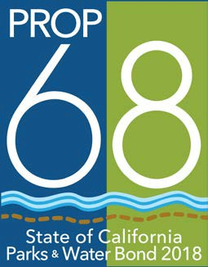

Another project funded through the San Diego River Conservancy

ERT SDRC LOGO

GAVIN NEWSOM, GOVERNOR

Wade Crowfoot, Secretary for
Natural Resources

approved when at the discretion of the Conservancy.

Sign Construction
All materials used shall be durable and resistant to the elements and graffiti. The California Department of Parks and Recreation and California Department of Transportation standards can be used as a guide for gauge of metal, quality of paints used, mounting specifications, etc.

Sign Cost
The cost of the sign(s) is an eligible project cost. Permanent signage is encouraged.

Conservancy Approval
The grantee shall submit proposed locations, size, number of signs and language for Conservancy approval prior to ordering signs. Final funds for development and/or construction projects will not be reimbursed until signage has been approved and installed.

APPENDIX M - SAMPLE MEMORANDUM OF UNRECORDED GRANT
AGREEMENT/DEED RESTRICTIONS
(Do NOT fill out as part of application)

Recording requested by, and ) when recorded, return to: ) State of California ) San Diego River Conservancy ) Attn: Executive Officer )
1350 Front Street, Suite 3024 ) San Diego, CA 92101 )

Space above this line for Recorder’s use

MEMORANDUM OF UNRECORDED GRANT AGREEMENT/DEED RESTRICTIONS
This Memorandum of Unrecorded Grant Agreement (Memorandum), dated as of
, 20 , is recorded to provide notice of an agreement between the State of
California, by and through the San Diego River Conservancy (“Conservancy”) and

(“Grantee”).

RECITALS

• On or about , , Conservancy and Grantee entered into a

certain Grant Agreement, Grant No.
(“Grant”), pursuant to which Agency

granted to Grantee certain funds for the acquisition of certain real property, more particularly described in attached Exhibit A and incorporated by reference (the “Real Property”).

• Under the terms of the Grant, Agency reserved certain rights with respect to the Real
Property.

• Grantee desires to execute this Memorandum to provide constructive notice to all third parties of certain Agency reserved rights under the Grant.

NOTICE

• The Real Property (including any portion of it or any interest in it) may not be sold or transferred without the written approval of the State of California, acting through the Natural Resources Agency, or its successor, provided that such approval shall not be unreasonably withheld as long as the purposes for which the Grant was awarded are maintained.

• The Grantee shall not use or allow the use of any portion of the real property for mitigation without the written permission of the State.

• The Grantee shall not use or allow the use of any portion of the real property as security for any debt.

• For additional terms and conditions of the Grant, reference should be made to the Grant
Agreement, which is on file with the San Diego River Conservancy, 1350 Front Street, Suite 3024, San Diego, CA 92101
GRANTEE:
By:

APPENDIX N – CALIFORNIA CONSERVATION CORPS CONSULTATION (REQUIRED)

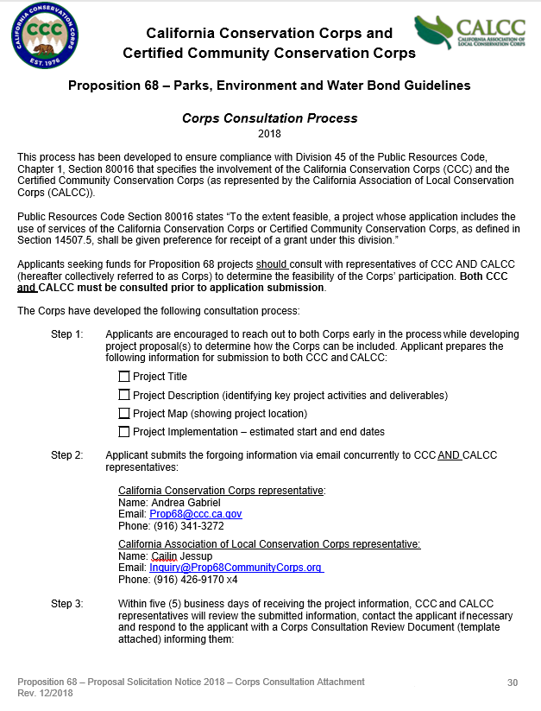

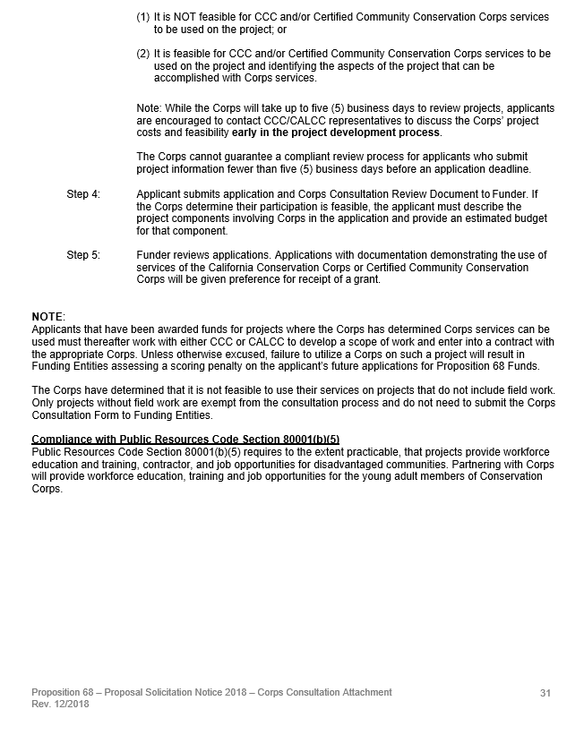

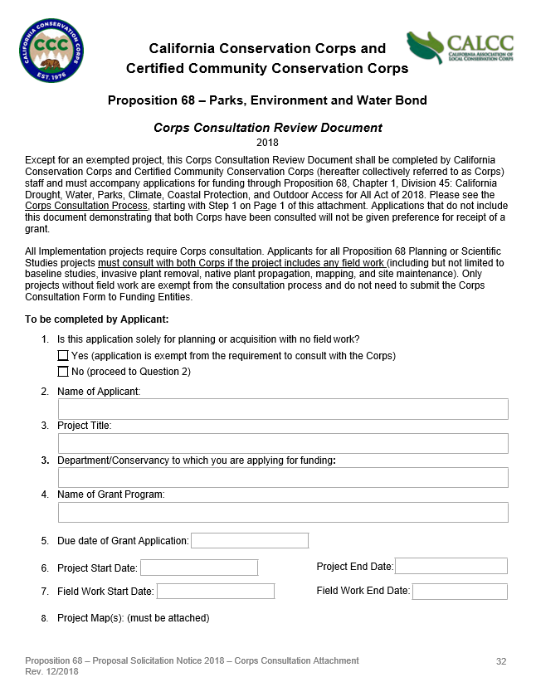

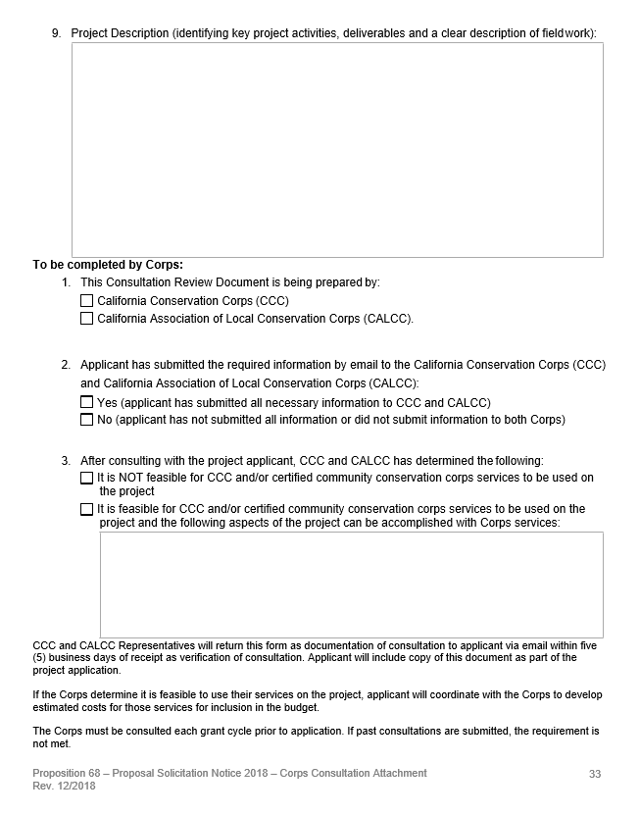

APPENDIX O – SAMPLE OF Eligible Projects

The list below provides examples of project concepts, but is not exhaustive.
Recreation
• Create or expand trails for walking, bicycling and/or equestrian activities that are compatible with other conservation objectives.
• Improve existing river parkways by providing amenities such as picnic and rest areas, shade ramadas, etc.
• Provide river access for non-motorized activities such as fishing, canoeing, etc.
• Acquire property along a river to be used for compatible recreational opportunities such as picnics, nature viewing, etc.
• Relocate or reconstruct existing trails to correct environmental damage.
Habitat
• Convert channelized streams or rivers to a more historical flow pattern that will promote the structure, function and dynamics of riparian and riverine habitat.
• Acquire land that will be managed to increase the size and quality of existing riparian habitat.
• Remove exotic and/or invasive plants along stream corridors that damage habitat.
• Plant appropriate native trees, shrubs, and plants to restore or improve the river parkway’s biological habitat.
• Convert riverfront land from industrial use into public multi-use areas such as floodplains, wetlands, public trails, etc.

Flood Management – as part of a flood management plan or flood management project
• Acquiring lands adjacent to the streams, tributaries and rivers to accommodate periodic flooding.
• Restore land to natural floodplain forms, including wetland areas that will accommodate periodic flooding.
• Acquire streamside parcels that have historically flooded.

Conservation and Interpretive Enhancements
• Construct an overlook area for a restored wetland with interpretive signage, where the public can observe the project benefits.
• Construct a boardwalk adjacent to sensitive habitat to allow public viewing without disturbing flora or fauna.
• Develop open-space areas such as demonstration gardens/basins that illustrate restoration/conservation project benefits.
• Provide informational displays, interpretive kiosks and signage to present information/maps about the River Parkway, its restoration projects, wildlife, etc.
• Construct small scale structures designed to secure kiosks and displays.

34

APPENDIX P – AVAILABLE RESOURCES

California Conservation Corps https://ccc.ca.gov/contact/

California Department of Industrial Relations Prevailing Wage Determination https://www.dir.ca.gov/OPRL/DPreWageDetermination.htm

CAL FIRE’s Tree Planting Standards and Specifications http://www.fire.ca.gov/resource_mgt/downloads/CALFIRE_Nursery_Standards_and_Specs11_12. pdf

California Native Plant Society http://www.cnps.org/cnps/grownative/lists.php/

California Stormwater Quality Association https://www.casqa.org/resources/california-lid-portal

Community FactFinder (SCORP)
http://www.parksforcalifornia.org/communities

Department of Water Resources Disadvantaged Communities Mapping Tool https://gis.water.ca.gov/app/dacs/

Governor’s Office of Planning and Research CEQA Documents http://opr.ca.gov/clearinghouse/ceqa/document-submission.html

i-Tree Planting https://planting.itreetools.org/

i-Tree Streets http://www.itreetools.org/

Local Conservation Corps http://calocalcorps.org/local-conservation-corps/

Save Our Water http://saveourwater.com/

Water Use Classification by Landscape Species (WUCOLS)
http://ucanr.edu/sites/WUCOLS/

END OF GUIDELINES
35

