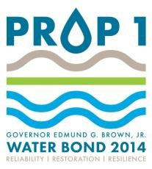
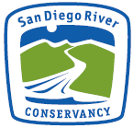
San Diego River Conservancy Proposition 1
Concept Proposal

Please submit Concept Proposal between August 15 and September 30, 2015, to both dharrison@sdrc.ca.gov and jrichards@sdrc.ca.gov. If there are any questions please contact Dustin Harrison by email or at 619.525.4094.
Applicant may use attached additional pages, if needed.

Grant Type | Check which box describes project type:  Acquisition Development/Implementation
Project Title | Provide a brief, descriptive project title:  Rueda Canyon Habitat Restoration & Enhancement Project
Applicant Name | Name of the applicant:  San Diego Canyonlands
Person Authorized to Sign Agreement | Provide name and title of person authorized to legally sign the grant agreement (signatory):  Eric Bowlby, Executive Director
Signatory Information | Provide Signatory’s contact information:  Eric Bowlby 619-284-9399  Eric@sdcanyonlands.org
Applicant’s Project Manager | Provide Project Manager’s contact information:  Jonathan Appelbaum 858-344-6654  Jonathan@sdcanyonlands.org
Eligible Entity | Check box for which organizational type the applicant falls under. If applicant does not fall under a listed category, the applicant is not an eligible entity:  Public agency Nonprofit organization Public utility  Federally recognized Indian tribe  State Indian tribe listed on the Native American Heritage Commission’s California Tribal Consultation List  Water supply company
FEIN | 26-2237918

Non Profit | Check box if applicant is qualified to do business in California and qualified under Section 501(c)(3).  Yes No  If yes, provide 501(c)(3) nonprofit organization number:  501(c)(3) nonprofit organization number: 26-2237918
Mitigation | Is the applicant’s project required mitigation from another project ?  Yes No  If yes, project is ineligible
Proof of Insurance | Applicant must attach a copy of current insurance policy general liability and workers compensation with a minimum of $1 million per occurrence/ and $1 million aggregate.
Project Summary | Write a summary of the proposed project:  San Diego Canyonlands (SDCL) proposes to work in a subset (approximately 20-25 acres) of the 72 acre Rueda Canyon Open Space Preserve to restore and enhance native riparian and transitional habitat via removal of invasive, non-native vegetation species including, but not-limited to, Mexican fan palm (Washingtonia robusta), Pampas grass (Cortaderia selloana), Eucalyptus (Eucalyptus spp.), and sweet fennel (Foeniculum vulgare). Invasive plant removal will be followed by revegetation with native riparian and transitional species (e.g. mule fat [Baccharis salicifolia}, willow [Salix spp.], mugwort [Artemisia douglasiana], etc.) via direct seeding and installation of up to 200 live cuttings. All native plant propagules (i.e. seed & cuttings) will be collected onsite by SDCL staff and volunteers following CNPS-approved protocols.  Small (<10 meter) non-native trees such as Palm and Eucalyptus will either be treated via cut-stump application of systemic herbicide such as triclopyr or via a drill-inject method (pending the recommendation of a licensed Pest Control Advisor [PCA]). Cut biomass will be cut into manageable sized pieces for use as trail barriers or removed from site by SDCL staff and volunteers (potentially including crews from the California Conservation Corps or CDF inmate fire crews). Limbs of trees smaller than 4” diameter will be chipped onsite and used for mulch to improve the surface of authorized trails and reduce soil erosion in high traffic areas such as trailheads. Additional wood chips / mulch may be imported (donated) for this purpose if the available onsite sources are exhausted.  SDCL also proposes to improve water quality by installing features to filter stormwater runoff and dissipate high energy flows from stormwater conveyances discharging into the canyon. Stormwater treatment features may include vegetated check dams, bioswales, and other bioengineering measures. These features will slow the rate of stormwater runoff, reduce sediment displacement and downstream sedimentation, and improve groundwater recharge within the canyon. All stormwater treatment features and devices will be located outside of Federal- and State-jurisdictional waters.  SDCL also proposes to close and decommission unauthorized / social trails within the Rueda Canyon Open Space Preserve by installing brush barriers

constructed from cut eucalyptus limbs and other non-native trees and installing appropriate signage to discourage unauthorized trail use and related negative biological impacts associated with unauthorized trail use.

Finally, SDCL proposed to install (as necessary) minor erosion control best management practices [BMPs] (e.g. fiber rolls, straw wattles, jute netting, etc.) on any work areas or access routes used for work activities displaying an increased risk of soil erosion resulting from the removal of target non-native vegetation associated with the project activities described above.
Proposition 1,  Chapter 6 sets  forth 13 specific purposes for the allocation of funds | Applicant’s proposed project meets the following purposes in support of Chapter 6 of Proposition 1 (California Water Code Section 79732(a)
 | Protect and increase economic benefits arising from healthy watersheds, fishery resources and instream flow.
 | Implement watershed adaptation projects in order to reduce the impacts of climate change on communities and ecosystems.
 | Restore river parkways throughout the state, including but not limited to projects pursuant to the California River Parkways Act of 2004 and urban river greenways.
 | Protect and restore aquatic, wetland and migratory bird ecosystems including fish and wildlife corridors and the acquisition of water rights for instream flow.
 | Fulfill the obligations of the state of California in complying with the terms of multiparty settlement agreements related to water resources.
 | Remove barriers to fish passage.
 | Collaborate with federal agencies in the protection of fish native to California and wetlands in the central valley of California.
 | Implement fuel treatment projects to reduce wildfire risks, protect watersheds tributary to water storage facilities and promote watershed health.
 | Protect and restore rural and urban watershed health to improve watershed storage capacity, forest health, protection of life and property, stormwater resource management, and greenhouse gas reduction.
 | Protect and restore coastal watersheds including but not limited to bays, marine estuaries and nearshore ecosystems.
 | Reduce pollution or contamination of rivers, lakes, streams, or coastal waters, prevent and remediate mercury contamination for legacy mines, and protect or restore natural system functions that contribute to water supply, water quality, or flood management.
 | Assist in the recovery of endangered, threatened, or migratory species by improving watershed health, instream flows, fish passage, coastal or inland wetland restoration, or other means, such as natural community conservation plan and habitat conservation plan implementation.
 | Assist in water-related agricultural sustainability projects.
GPS  Coordinates | Geodetic datum: WGS84  Coordinates: 32°49’27.63”N / 117°5’34.18”W
Information Regarding Project Budget | Planning costs are limited 10 percent (10%) of the total grant amount and shall only be incurred after the date of the Grant Agreement.  Project administration costs are limited to 15 percent (15%) of total grant amount and shall only be incurred after the date of the Grant Agreement.  Applicant must submit methodology and calculations to determine administrative overhead rates, which are subject to approval by the

 | Conservancy prior to the start of each project.
Project Amount Requested | Provide project amount requested from the Conservancy  $42,394(labor+materials+15%administrativecosts)
Matching Funds | Provide estimated amount of matching funds or in-kind contributions:  $29,060($10,260inmaterials/$7,200 involunteerlabor)
Total Project Cost | Provide total project cost, including any cost share and matching funds.  $71,453
Project Readiness | Anticipated start date of project:  Project start and end dates: June 1, 2016 / June 1 2018
Project Area Ownership | Check box if land where project will occur (or will require access to enter) is owned by a private entity, state, federal, or other. If yes on any box, provide name of land owner(s):  Private Yes No If yes, State Yes No If yes, Federal Yes No If yes,  Other Yes No If yes, City of San Diego Dept. of Parks & Open Space (existing license agreement)
APN(s) | 37308009, 45514021, 37308022, 37308101, 45513039, 45506033, 45506017,  45516102, 45516002
Project Acres | 72 Acres
Jurisdiction of Project | Check the box that applies City of San Diego County of San Diego City of Santee  El Cajon Lakeside  Other:

Jurisdiction Approval | Has written approval been provided by the jurisdiction in which the project will be taking place?  No. Must be provided with full application. Yes. Please attach.
Land Tenure/ Site Control | Applicants for projects must submit documentation showing that they have adequate tenure to, and site control of, the properties to be improved or restored or acquired.  Proof of adequate land tenure includes, but is not necessarily limited to:  - Fee title ownership.  - An easement or license agreement.  - Other agreement between the applicant and the fee title owner, or the owner of an easement in the property, sufficient to give the applicant adequate site control for the purposes of the project and long-term management.  - For projects involving multiple landowners, all landowners or an appointed designee must provide written permission to complete the project.  Summarize all steps taken to date to obtain required land tenure documentation:  This concept paper has been recently submitted to Chris Zirkle, the Deputy Director of the Open Space Division of the City Park and Recreation Department for review. We have worked with Mr. Zirkle on several similar projects and obtained Right of Entry (ROE) allowing us to access the project site to fulfill the objectives of our grant and maintain it. The most recent ROE is a three year agreement to restore approximately 12 acres of wetlands and transitional uplands in Shepherd Canyon, San Diego using our volunteer programs in addition to our restoration professionals. Another example is a 20-Year License Agreement that we have in place to restore 14 acres of habitat in four canyons in City Heights, build seven key trail segments, and maintain the project for 20 years.  Mr. Zirkle has agreed that should we be awarded a grant for this application, he will work with us to achieve the necessary ROE to fulfill the grant objectives.
Project Map | Attach both a location and project specific map to this document. The project specific map must include clearly delineated project boundaries and legend. All maps must be labeled with project title, applicant name, and be positioned so that relevant map information such as stream names, towns,  main roads, and water bodies are not obscured.
Site Description | Provide the physical description of terrain and land cover type(s):  The proposed project site is located in the City of San Diego Department of Parks and Open Space’s Rueda Canyon Open Space Preserve in the Tierrasanta neighborhood of north-central San Diego. The proposed project site contains an unnamed ephemeral tributary to the San Diego River. Surrounding land use is primarily residential. Vegetation communities within the work area are a mixture of Southern Willow Scrub, Coastal Sage Scrub, Eucalyptus Woodlands, Ruderal and Disturbed habitats.  Watershed name: San Diego River Tributary: Rueda Canyon  Habitat Type: Southern Willow Scrub, Coastal Sage Scrub, Eucalyptus Woodland, Ruderal / Disturbed Habitat
Project | Objectives are specific, objective, achievable, and measurable. List measurable

Objective(s) | outcomes for the project:  - Host 16 volunteer events engaging at least 80 volunteers over 2 years.  - Collect, prepare, and apply 40 lbs of live native seed to restored areas.  - Install 200 native plants via live cuttings.  - Decommission / prevent access to 2 unauthorized trail segments.
Project Goal(s) | A goal can be viewed as an aim or desired outcome. List desired goals, milestones and outcomes for the project:  Eliminate high-priority invasive species (e.g. Cortaderia selloana, etc). Restore invasion resilient native riparian and transitional plant communities. Improve water quality and stormwater management through installation of vegetated check dams and similar stormwater treatment features. Eliminate adverse biological and water quality impacts associated with unauthorized trail use.
Monitoring and Assessment | Identify specific performance measures designed to assess progress towards achieving the objectives. Include a description of the approach for monitoring, assessing, and reporting the compliance and effectiveness of the project, which is consistent with the project’s objectives. Describe any baseline monitoring that will be conducted in order to support pre- and post- project evaluation following implementation of project.  Quarterly qualitative & quantitative vegetation community monitoring. Establish and monitor 8 permanent photo-monitoring transects. Conduct annual quantitative vegetation sampling (% native cover) using CNPS-approved point-intercept line transect monitoring methods (4 X 50 meter transects). Monitor live-cutting survivorship with a target survivorship rate of 50%.
Data Management | Describe how data and other information generated by the project will be handled, stored, shared (i.e., disseminated to the public, participants, and stakeholders) and provided to the State.  San Diego Canyonlands will prepare annual reports documenting all work performed under this grant as well as the results of detailed quantitative vegetation sampling performed within the work areas. All annual reports will be provided to SDRC as project funder and City of San Diego Department of Parks and Open Space as land owner and will be made publicly available on San Diego Canyonlands website. In addition, San Diego Canyonlands will share these reports and all constituent data with USGS, SANDAG, the San Diego Mitigation and Monitoring Program, and the resource agencies (pursuant to approval from the City of San Diego) upon written request. San Diego Canyonlands will follow professional standards for reporting sensitive species occurrences and other relevant field observations via the California Natural Diversity Database (CNDDB), San Diego Natural History Museum, or equivalent entity.
Deliverables | Deliverables will consist of the following:  Before and after photo documentation of project site Assessment and Monitoring plan  Quarterly invoices to the Conservancy Quarterly progress reports to the Conservancy Final Project Report
Licensed Professional | Is a licensed professional needed? If so check appropriate box, provide license number affiliation and contact information:  Yes No

 | Name: Carl Bell (licensed Pest Control Advisor) License no.: 75713 expiration: 12/31/2016 Contact info: (760) 815-2777
Implement Actions of the California Water Action Plan | Does project implement actions of the California Water Action Plan?  No  Yes, explain  The proposed project would implement the actions of the California Water Action Plan by protecting and restoring important ecosystems. As designed, the proposed project would restore degraded stream ecosystems to assist in natural water management and improved habitat.
Consistency with and Implementation of other Plans | Check box if project has consistency with and implementation of other plans (e.g., existing conservation, restoration, recovery plans, or other relevant local, state, or federal plans or policies):  No Yes. If yes identify the plan(s).  Rueda Canyon is located within the City of San Diego’s Multiple Habitat Planning Area (MHPA) and the proposed project would be consistent with the City of San Diego’s Multiple Species Conservation Plan Subarea Plan and the City’s Natural Communities Conservation Plan(s). It is also consistent with the City of San Diego General Plan Conservation Element, (2008).
Application to Other Grant Programs | Check box if a proposal has been submitted to another grant program for this project (i.e., that would fund the same project components applied for in this application.) If yes, identify program name(s):  No  Yes. If yes identify the other program(s)
References | Applicant must provide 3 references for past work history for projects of a similar nature. Include firm name, project location, project costs and contact information:  - Community Housing Works; Located on Auburn Creek in City Heights, a community in the City of San Diego; $84,500, Sochiata Vutthy, svutthy@chworks.org, 760-432-6878 ext.5459  - Marti Emerald, San Diego City Council Member; Four canyons (Swan, Manzanita, 47th St. and Hollywood) in City Heights, San Diego; restoration budget was $135,000 to restore 14 acres of habitat, 619- 236-6699; martiemerald@sandiego.gov  - Kevin McKernan, Executive Director of San Dieguito River Park. Location: Shepherd Canyon, Tierrasanta, San Diego, restoration and community organizing budget $20,000; (858) 674-2275 x 15; kevin@sdrp.org

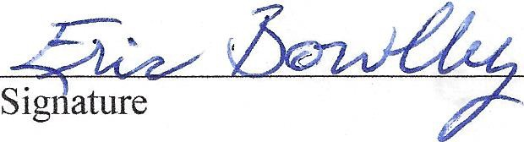

This certification is made under the laws of the State of California. I certify that the foregoing statements are true and complete to the best of my knowledge and belief, and understand that any willfully false statement may cause the agency to reject this concept proposal.
Name and Title "
£ ;c & 1.
& c·u b t.« ./)tce,,ekt.r:
Date: !)t4D4£

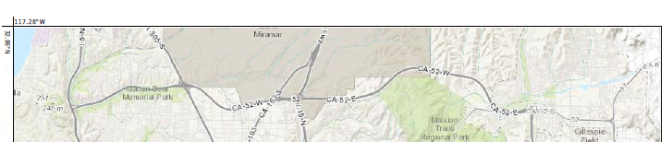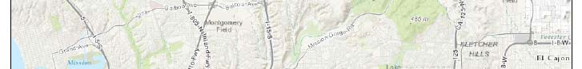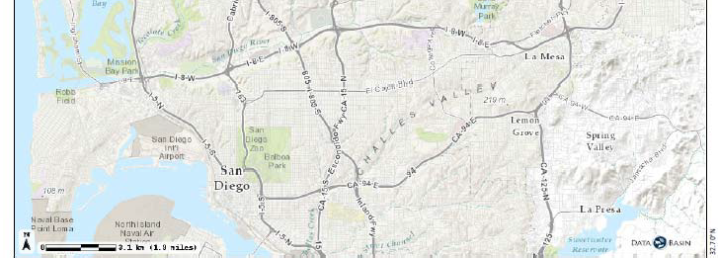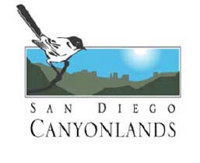Figure 1: Rueda Canyon Site Vicinity Map

Rueda Canyon Open Space Preserve

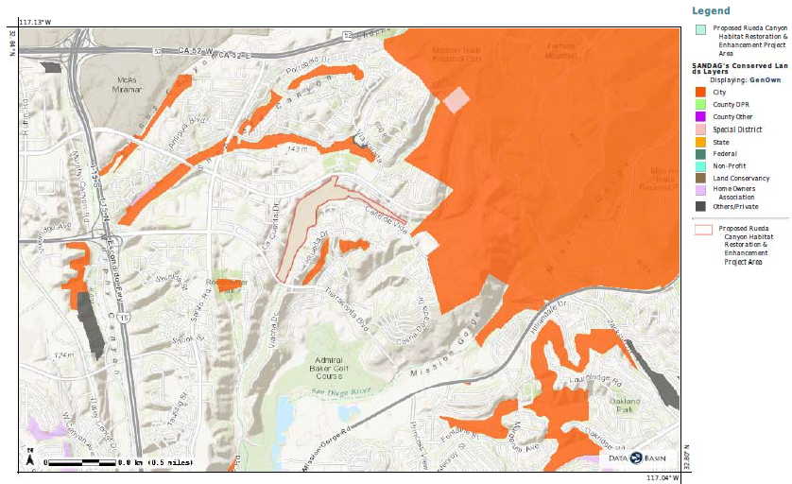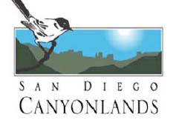Figure 2: Rueda Canyon Open Space Habitat Restoration & Enhancement Project Location Map

Client#· 1287389 305SANDIE14
I
DATE (MM/DD/YYYY)
9/14/2015
THIS CERTIFICATE IS ISSUED AS A MATTER OF INFORMATION ONLY AND CONFERS NO RIGHTS UPON THE CERTIFICATE HOLDER. THIS CERTIFICATE DOES NOT AFFIRMATIVELY OR NEGATIVELY AMEND, EXTEND OR ALTER THE COVERAGE AFFORDED BY THE POLICIES BELOW. THIS CERTIFICATE OF INSURANCE DOES NOT CONSTITUTE A CONTRACT BETWEEN THE ISSUING INSURER(S), AUTHORIZED REPRESENTATIVE OR PRODUCER, AND THE CERTIFICATE HOLDER.
IMPORTANT: If the certificate holder is an ADDITIONAL INSURED, the policy(ies) must be endorsed. If SUBROGATION IS WAIVED, subject to the terms and conditions of the policy, certain policies may require an endorsement. A statement on this certificate does not confer rights to the certificate holder in lieu of such endorsement(s).
PRODUCER  BB&T Insurance Services of Orange County  2400 Katella Avenue Ste 1100  Anaheim, CA 92806 | 2AA cT Terri Amsbury
 | !AJW1f0 Ext): 714 941-2936 I rffc.Nol: 877 297-9259
 | iflJ ss: TAmsbury@bbandt.com
 | INSURER(S) AFFORDING COVERAGE |  | NAIC#
 | INSURER A, Philadelphia Indemnity lnsuranc |  | 18058
INSURED  San Diego Canyonlands Inc.  3552 Bancroft Street San Diego, CA 92104 | INSURER B , Westchester Surplus Lines Insur |  | 10172
 | INSURERC:
 | INSURERD:
 | lNSURERE:
 | INSURERF:

ACORD™ CERTIFICATE OF LIABILITY INSURANCE

COVERAGES CERTIFICATE NUMBER: REVISION NUMBER:
THIS IS TO CERTIFY THAT THE POLICIES OF INSURANCE LISTED BELOW HAVE BEEN ISSUED TO THE INSURED NAMED ABOVE FOR THE POLICY PERIOD INDICATED. NOTWITHSTANDING ANY REQUIREMENT, TERM OR CONDITION OF ANY CONTRACT OR OTHER DOCUMENT WITH RESPECT TO WHICH THIS CERTIFICATE MAY BE ISSUED OR MAY PERTAIN, THE INSURANCE AFFORDED BY THE POLICIES DESCRIBED HEREIN IS SUBJECT TO ALL THE TERMS, EXCLUSIONS AND CONDITIONS OF SUCH POLICIES. LIMITS SHOWN MAY HAVE BEEN REDUCED BY PAID CLAIMS.

INSR TYPE OF INSURANCE ADDL SUBR
LTR lNSR WVD

POLICY NUMBER
,::lM& ,,::lM& LIMITS

A -GENERAL LIABILITY X PHPK1352184 08/01/2015 08/01/2016 EACH OCCURRENCE $1 000 000

r- X COMMERCIAL GENERAL LIABILITY
ff,%J9E 7i W nce1

$100 000

D CLAIMS-MADE OCCUR
r-
MED EXP (Any one person) | $5 000
PERSONAL & ADV INJURY | $1,000,000
GENERAL AGGREGATE | $2,000,000
PRODUCTS - COMP/OP AGG | $2,000,000  $

-
r-
GEN'L AGGREGATE LIMIT APPLIES PER:
rr&
-xi POLICYn nLOC
A AUTOMOBILE LIABILITY X PHPK1352184 08/01/2015 08/01/2016 OMBINED SINGLE LIMIT $1,000,000

-
ANY AUTO ALL OWNED
-
- AUTOS
- SCHEDULED
- AUTOS
Ea accident)
BODILY INJURY (Per person) $
BODILY INJURY (Per accident) $

- X HIRED AUTOS
-X
NON-OWNED iROPERTY DAMAGE
AUTOS Per accident)
$
$

A UMBRELLA LIAB OCCUR X PHUB503558 08/01/2015 08/01/2016 EACH OCCURRENCE $1 000.000
EXCESS LIAB CLAIMS-MADE AGGREGATE $1 000 000
DED I xi RETENTION $10 ooo $
WORKERS COMPENSATION lf2Ri W-rs I l H-
D

AND EMPLOYERS" LIABILITY y / N
ANY PROPRIETOR/PARTNER/EXECUTIVE OFFICER/MEMBER EXCLUDED? N/A

E.L. EACH ACCIDENT $

(Mandatory In NH) E.L. DISEASE - EA EMPLOYEE $
If yes, describe under
DESCRIPTION OF OPERATIONS below E.L. DISEASE - POLICY LIMIT $

B Pollution CL X G27539002001 12/11/2014 12/11/20H $1,000,000 EA Incident
$1,000,000 Aggregate

DESCRIPTION OF OPERATIONS/ LOCATIONS/ VEHICLES (Attach ACORD 101, Additional Remarks Schedule, if more space Is required)
The State of California and San Diego River Conservancy, its officers, agents and employees are to be covered as insureds with respect to liability arising out of work or operations performed by or on behalf of the Grantee including materials, parts or equipment furnished in connection with such work or operations - is additional insured where required by written agreement

CERTIFICATE HOLDER CANCELLATION
Julia Richards San Diego River Conservancy  1350 Front Street Suite 3024  San Diego, CA 92101  I | SHOULD ANY OF THE ABOVE DESCRIBED POLICIES BE CANCELLED BEFORE THE EXPIRATION DATE THEREOF, NOTICE WILL BE DELIVERED IN ACCORDANCE WITH THE POLICY PROVISIONS.
 | AUTHORIZED REPRESENTATIVE

ACORD 25 (2010/05) 1 of 1
#S14798627/M14609342

© 1988-2010 ACORD CORPORATION. All rights reserved.
The ACORD name and logo areregistered marks of ACORD

TLAMS

