The San Diego River Conservancy (Conservancy) continues to work with local, state, federal and tribal governments alongside non-profit partners and volunteers to implement projects in support of the Conservancy’s mission and consistent with the Conservancy’s statute. The Conservancy’s mission is to protect natural, historical, cultural and tribal resources, open space, native habitat, improve water quality, support natural flood conveyance and provide for public access to public lands and an enjoyment of nature and outdoor recreational opportunities. The Conservancy consists of 3 full time staff members and 17 members of its Governing Board.

Highlights from the past year:

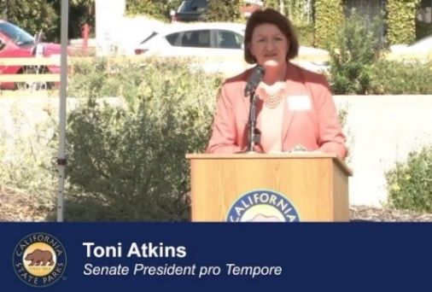
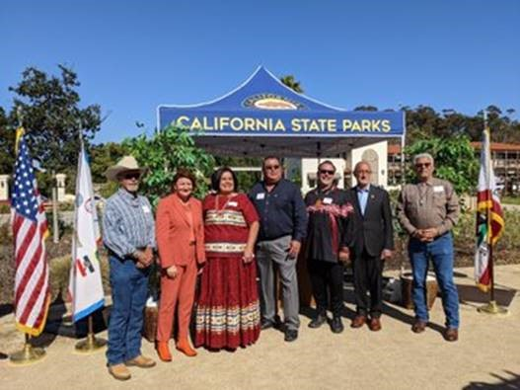
Old Town San Diego State Historic Park
Through a partnership with the California Department of Parks and Recreation and the Kumeyaay Diegueño Land Conservancy, the Iipay ~ Tipay Kumeyaay Mut Niihepok, Land of the First People area within Old Town State Park was designed to commemorate the Kumeyaay Nation, culture and unique relationship with the San Diego River. After 20 years of planning, the site of the original Caltrans state building was transformed into a special new entrance to Old Town State Historic Park recognizing the original Kumeyaay inhabitants of the region.

At the opening ceremony held on October 26, 2021, tribal elder Kenny Meza blessed the area in the Kumeyaay native language, and speakers included Dr. Stan Rodríguez (Iipay Nation of Santa Ysabel), Angela Elliott-Santos (Chairwoman, Manzanita Band of the Kumeyaay Nation), Dave Toler Jr. (San Pasqual Band of Mission Indians) and Dr. Henry Paul Cureo Jr., (Chairman, Campo Band of Kumeyaay Nation), and John Christman (Chairman, Viejas Band of Kumeyaay Indians) performed traditional Kumeyaay bird songs. Representatives from 12 Kumeyaay bands attended the event.

Many were in attendance including Senate President Pro Tempore Toni Atkins, former state Senator Denise Murano Ducheny, former state Assemblymember and U.S. Congressmember Susan Davis, former state Senator Christine Kehoe, State Parks Director Armando Quintero, and San Diego River Conservancy Board Members Ben Clay and John “Eagle Spirit” Elliot. The new entryway features a self-guided tour of the history of the Kumeyaay dating back over 10,000 years in the region.

Senate Bill 85 (2020) – Wildfire Early Action Plan
The Budget Act of 2020 allocated the Conservancy $12 million to fund shovel ready projects including fuels reduction, removal of dead, dying and diseased trees, forest management, road brushing, creating fire and fuel breaks, fire suppression, strengthening protection of communities and public outreach to encourage defensible space for homeowners living in the wildland urban interface.

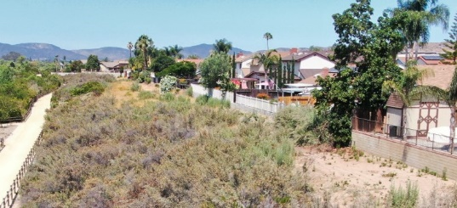
On November 25, 2021, an 18-acre fire occurred at the Walker Preserve. Funded under the Wildfire Early Action Plan, the City of Santee created a fuel break for the residential neighborhood adjacent to the San Diego River Trail.

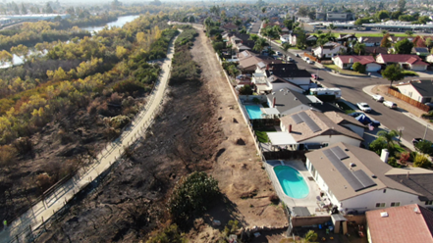
Over 100 firefighters worked to protect life and property. Thankfully the proactive work by the City of Santee created defensible space to buffer between the trail and homes. As a result, these activities prevented over $5,000,000 worth of damages to nearby homes.

Photos of Walker Preserve and the San Diego River Trail before the fire (top right) and after the fire (bottom right)

Native American Conservation Corps
An innovative 2-year pilot project led by the California State Parks’ Colorado Desert District is training tribal members from four nations native to southern California – the Kumeyaay, Luiseño, Cupeño and Cahuilla nations, in forestry and fuels training. The project is a partnership between California State Parks, the San Diego River Conservancy and the Resource Conservation District of Greater San Diego County. Program goals include:
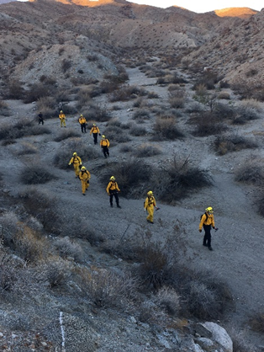
- Provide Forestry and Fuels Training: Basic Wildland Fire &Traditional Ecological Knowledge
- Increase cultural awareness and collaborative relationships among emerging natural resource leaders
- Support career development opportunities beyond program completion

Funding is provided by the Wildfire Early Action Plan in the Budget Act of 2020
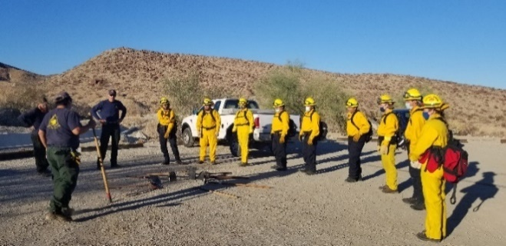

SUMMARY OF PROGRAMS INCLUDED IN THE
SAN DIEGO RIVER CONSERVANCY’S STRATEGIC PLAN

Program 1: Conserve Land within the San Diego River Watershed
The Conservancy works with local governments and non-profit organizations to identify property for conservation purposes and to secure conservation and trail easements, and provide public access to developed parks, open space, as well as recreational opportunities by seeking available funding and willing sellers in the watershed.

Program 2: Support and Encourage Recreation and Education
The Conservancy continues to explore opportunities to partner with organizations to expand recreational and educational opportunities within the watershed and to complete additional segments of the San Diego River Trail.

San Diego State University Mission Valley
San Diego State University’s Mission Valley Park and the planned Mission Valley campus is the center of development that will connect a new commercial center, the expansion west of San Diego State University, a major sports center including a stadium and the San Diego Metropolitan Transit System’s Green Trolley line. When completed, there will be 34 acres of active and passive recreation, 2 miles of a major hike/bike loop in addition to completing a portion of the San Diego River Trail. San Diego State University was awarded funding for the installation of a prefabricated gender-neutral restroom facility. The restroom will be located on the east park adjacent to Murphy Canyon Creek and the San Diego River. It will be open to the public for access to basic needs that improve sanitation practices and will be designed to withstand flooding to coincide with the natural floodplain. The restroom includes sustainable designs to achieve LEED Neighborhood Development Certification.
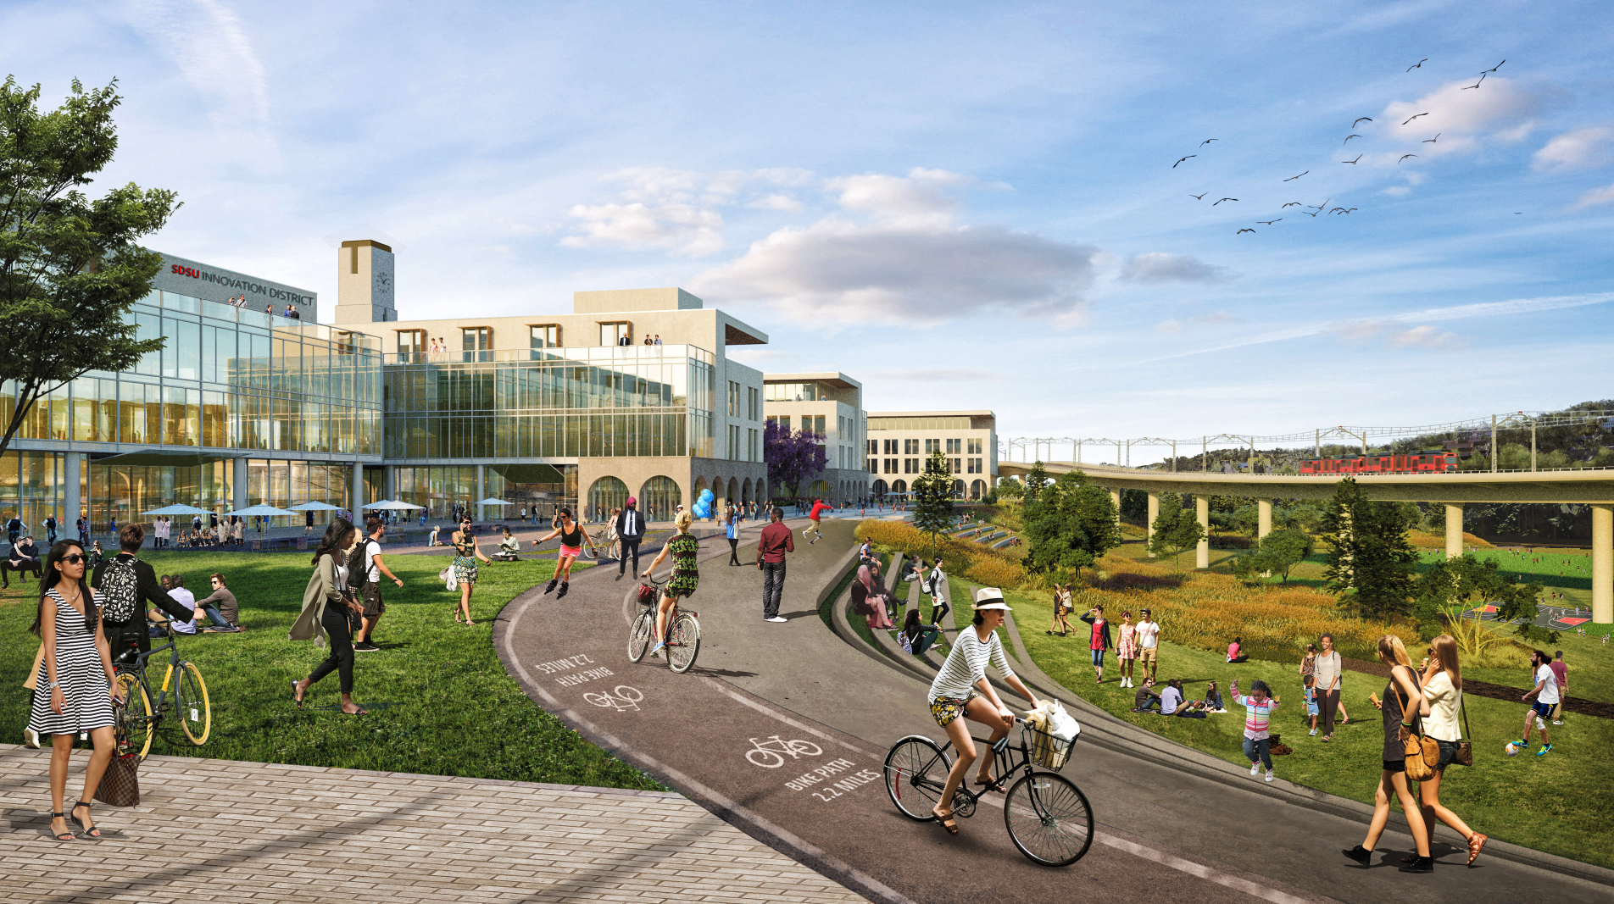
Rendering of the San Diego River Trail segment (left) and the 2-mile Hike and Bike loop (right)

Lakeside River’s Park Conservancy’s - Science Field Station located in the Lakeside community which contains disadvantaged, severely disadvantaged and vulnerable communities, will allow east San Diego County school students access to outdoor facilities for research and educational purposes. It will enable students to conduct hands-on learning within various topics of interest such as environmental science, water quality testing, benthic macroinvertebrate sampling, and habitat restoration. Based on the curriculum developed for school children, the Lakeside Unified School District, Santee School District, and Cajon Valley Union School District will utilize this new facility to expand local citizen science efforts and allow local youth the opportunity to better understand and care for land within their communities.
Program 3: Preserve and Restore Natural Resources, and the Wildfire and Forest Resilience Program
The Conservancy established the Invasive Non-Native Plant Control Program in 2009. This program continues to provide multiple benefits including restoration of native habitat for sensitive/endangered species, and decreasing the risk of floods and fires. The Conservancy works with partner organizations to identify treatment areas to remove biomass, treat re-growth and restore native vegetation to promote biodiversity. The Conservancy also provides no-cost partnership agreements to non-profit organizations. In 2019, the Conservancy obtained a 5-year extension for the suite of permits needed to continue implementation of this program through 2024.

The table below summarizes ongoing efforts to remove and control invasive species planned for 2022 in the San Diego River area at 11 locations totaling nearly 170 acres.

Project title | Grantee | Acres
Arundo completion project Los Coches Creek | Lakeside’s River Park Conservancy | 64
Chaparral Canyon below Lake Murray Reservoir Dam | City of San Diego, Public Utilities Department | 10
Sycamore Canyon/Goodan Ranch Preserve | County of San Diego, Parks and Recreation Department | 32
Ruffin and Sandrock Canyon removal and restoration Phases 1 and 2 | San Diego Canyonlands | 22
Del Cerro reach of lower Alvarado Creek and revegetation | San Diego State University Research Foundation and the Soil Ecology Restoration Group | 13
Lindo Lake Restoration | County of San Diego, Parks and Recreation Department | 12
Navajo Canyon Restoration and Trail Improvements | San Diego Canyonlands | 7
Healthy Headwaters Initiative for the Alpine/ El Capitan Basin | Back Country Land Trust | 1.5
San Diego River Arundo Removal Project | The Nature Collective | 5
Arundo Removal at Alvarado Creek Near MTS Grantville Station | San Diego Metropolitan Transits System | 0.5
San Diego River Healthy Headwaters Restoration Project El Capitan Reservoir Catch Weed Assessment | City of San Diego, Public Utilities Department | 2.5

Cuyamaca Rancho State Park Reforestation Project
The 2003 Cedar fire burned approximately 273,000 acres and decimated approximately 209,118 acres or 75% of the San Diego River watershed. This project continues reforestation activities by State Parks across 442 acres in the San Diego River’s upper watershed including site review, site selection, site preparation, planting seedlings and preserving genetic integrity of one of the last sugar pine stands in San Diego County. Seedling densities will vary, based upon microsite conditions, with an average initial planting density ranging between 275 and 300 seedlings per acre. The seedlings are planted to improve forest health, restore sensitive wildlife habitat and corridors, for carbon sequestration, an increased resiliency to future fires, reduced stormwater run-off, and increased water infiltration.

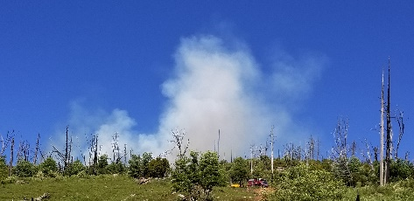
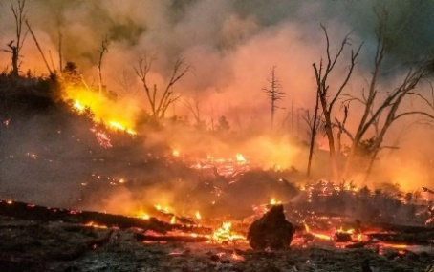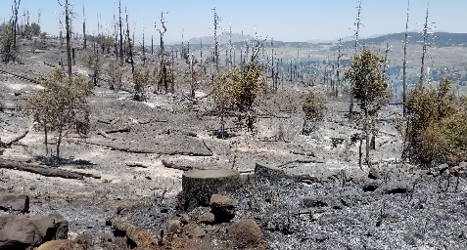
The photos above illustrate a prescribed burn in Cuyamaca Rancho State Park.

Under this project, prescribed burning is used to reduce heavy fuel loads before planting native conifer seedlings. The photos above show a 56-acre burn conducted as a joint Incident Command by State Parks and CAL FIRE. Interagency logistics were coordinated and executed for a week-long interagency prescribed burn on the 54-acre site by CAL FIRE, the Mountain Resource Conservation Association, local Native American Tribes, and other California State Parks Districts that participated in the prescribed burn.

Resource Conservation District (RCD) of Greater San Diego County
RCD of Greater San Diego County has an existing program to reduce the threat of wildfires by providing defensible space and free chipping for homeowners by creating or maintaining 100 feet of defensible space around structures. The RCD also removes dead, dying and diseased trees within 100 feet of structures within a project area.

San Diego Canyonlands
The San Diego Canyonlands project will reduce the risk of fire within land owned by the City of San Diego’s Open Space Division in the San Diego River watershed and tributary canyons. Approximately 1,110 acres will benefit from the fuel reduction including the removal of small dead, dying, and diseased trees; the removal of invasive, non-native vegetation in order to create fuel breaks to reduce fire risk while maintaining habitat values throughout the communities of Serra Mesa and Tierrasanta.

Barona Band of Mission Indians
The Barona Band of Mission Indians, in partnership with the Barona Fire Department, will use funding to purchase a new Brush Rig including the chassis, building of the pump, water tank and compartments, emergency lighting, emergency radios, and onboard wireless technology to provide up to date information via the onboard mobile data computer.

United States Forest Service – Cleveland National Forest
The Cleveland National Forest’s Wildfire Resilience and Forest Health project will reduce fuel loads across approximately 1,855 acres and clear brush from 100 miles of roads within the Cleveland National Forest. To support this added workload, CNF will hire additional employees for two years to ensure the protection of sensitive resources.

The addition of a helicopter landing zone and three 10,000-gallon underground water tanks will provide a local source of water to help reduce wildfire severity, and improve the safety of visitors and first responders. This multi-faceted project is designed to enhance the capability for wildfire suppression, as well as the remote rescue of people within the High Fire Severity Threat Zone.

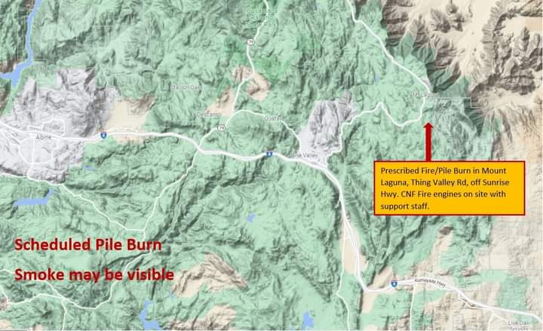 | 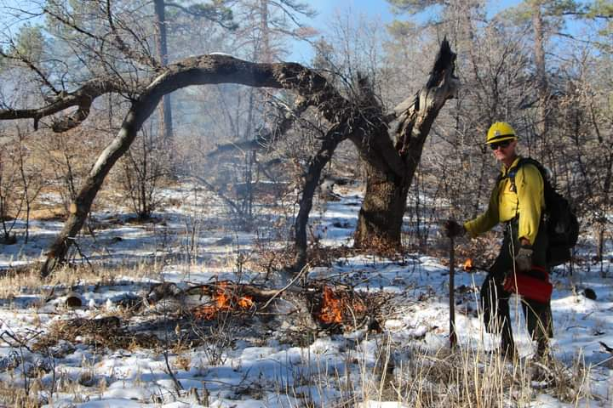 | 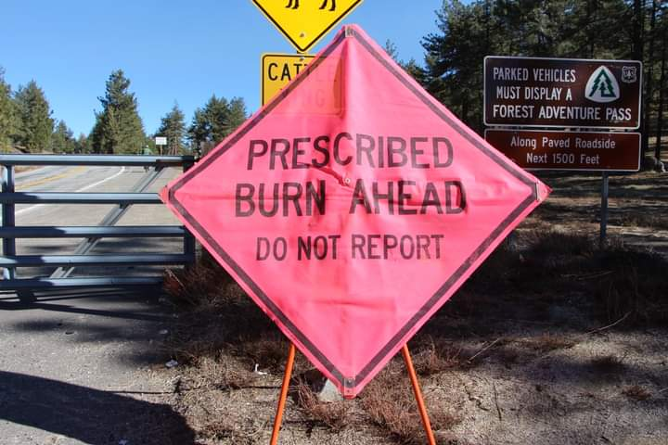
Photos above illustrate a Cleveland National Forest’s prescribed pile burn in Laguna Mountains

Kumeyaay Diegueño Land Conservancy
Through the Kumeyaay Diegueño Land Conservancy, the Campo Band of Mission Indians, the Campo Fire Protection District, the Jamul Indian Village, the Manzanita Band of the Kumeyaay Nation, the Viejas Band of Kumeyaay Indians, and the Sycuan Band of the Kumeyaay Nation, will use wildfire funds to procure fire-related equipment to use for wildland fire events. The project will provide new vehicles and fire-related apparatus to help reduce the risk of fire by implementing fuel reduction, vegetation management, defensible space, and fuel breaks targeting the removal of diseased, dead and dying trees.

Lakeside’s River Park Conservancy
Lakeside’s River Park Conservancy will reduce flammable fuels in El Monte Valley on public and private land in the Wildland Urban Interface area of the unincorporated community of Lakeside. The project will take place on approximately 62 acres across the High Fire Threat Zone (identified by CAL FIRE) in San Diego County to improve fire readiness and reduce the risk of fire.

City of El Cajon
El Cajon will implement wildfire management strategies across 85 acres. Their three-pronged approach includes the development of a vegetation and wildfire management plan, a training and education program, and clearing and reducing flammable fuels. The presence of invasive plant species and dead vegetation add more fuel loads to adjacent residences near Fletcher Hills Open Space and Hillside Park. These fuel reduction efforts will decrease the wildfire risks around the communities, homes, infrastructure, critical habitat zones, and other highly valued resources, including wildlife passages and disadvantaged communities.

County of San Diego, Department of Parks and Recreation
This project will focus on the immediate need to conduct fuel reduction and perform weed abatement throughout 25,000 acres managed by County Parks, including Kumeyaay Valley Park located in El Monte Valley. County Parks will purchase two tractors equipped with mower attachments, two trucks, and two trailers. This equipment will be used to create and maintain fuel breaks, carry out vegetation management and assist in restoration efforts on properties designated as High Fire Hazard Severity Zone.

San Diego State University Research Foundation/Soil Ecology and Restoration Group
San Diego State University is home to more than 33,000 students with nearly 8% living on campus. Nearby is Alvarado Creek, a channelized and urban stream with substantial non-native vegetation that contributes to an increased risk of fire and flooding in this area. Removing highly flammable trees and vegetation and implementing restoration efforts will reduce the risk of fire, which has occurred on numerous occasions. This project will control vegetation across 9 acres in a designated high fire risk area immediately adjacent to the campus and nearby homes.

Program 4: Protect and Preserve Cultural and Historical Resources

The Native American Conservation Corps 2-year pilot project, led by State Parks, was established to train Kumeyaay, Cupeño, Luiseño, and Cahuilla tribal members on fire and forestry skills to increase regional fire resilience capacity. This program provides workforce development and through a partnership with the Kumeyaay Diegueño Land Conservancy training on traditional ecological knowledge and increased cultural awareness.

Program 5: Enhance Water Quality and Natural Flood Conveyance

Broadway Creek Restoration (Phase A)
This project is located in the City of El Cajon, a disadvantaged community with median household income of $46,472 and is within one mile of a severely disadvantaged community with median household income of $41,320. The project will reinforce a heavily eroded section of Broadway Creek through the installation of gabions and the removal of invasive non-native plants to promote nature-based solutions for stormwater management in an urban environment.

Lindo Lake Improvement Project – Phase 1 (East Basin)
In Lakeside, Lindo Lake has historically provided an important habitat for native and migratory birds. This project will install permanent structural Best Management Practices to capture trash, sediment and filter urban runoff, to improve the health of Lindo Lakes. County Parks will install water-efficient irrigation around the East Basin to support the establishment of native trees, drought-tolerant vegetation, and native aquatic habitat to improve the biodiversity of species. In addition, landscape elements will stabilize banks and reduce erosion.

The Conservancy approved additional funding to provide recreational amenities including expanded accessible trails, viewing platforms along the lake perimeter, a fishing pier and installing benches throughout the site. The project is located in a disadvantaged community.
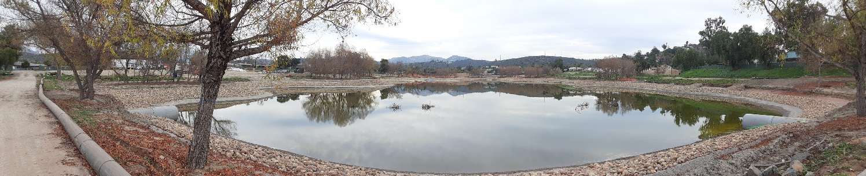
Photo of Lindo Lake County Park – East Basin

Wells Park Improvement Project
The City of El Cajon will install 5 structural Low Impact Development devices including 2 stormwater retention basins to collect stormwater runoff and reduce the risk of flooding at Wells Park. Currently, this park lacks stormwater infrastructure and minor rain events have an adverse effect on park grounds causing floods and park closures. The project is located in a designated severely disadvantaged community.

San Diego River Trash Cleanups
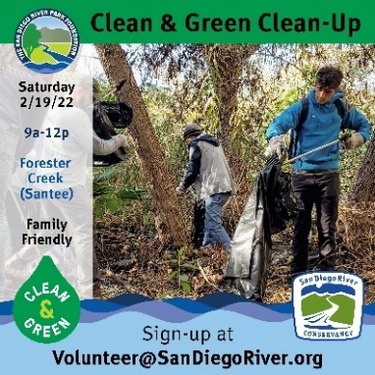
"Clean & Green Clean-Up" events are organized by the San Diego River Park Foundation and engage residents and businesses in nearby communities to help remove trash before it enters the San Diego River. This non-profit organization specializes in community advocacy and outreach and attracts a range of volunteers who are passionate about enjoying the outdoors. Conservancy staff participated in a clean-up event to remove trash along the river corridor with 45 to 50 volunteers in February 2022. San Diego River Conservancy staff member Wendell Taper commented that, “It was an incredibly gratifying experience. Of course, the feeling of pride also comes with a bit of disappointment. The battle with trash along the San Diego River is never ending.”

Program 6: Expand the Organization’s Capacity and Public Outreach

Carbon Assessment for the San Diego River Watershed and 3 Consortium Watersheds
In partnership with San Diego Canyonlands, the environmental consulting firm Dudek will provide a comprehensive carbon storage and sequestration assessment based on a review of literature from local, state and federal data over several decades. This assessment will help identify the highest carbon sequestration potential for restoration areas across natural and working lands within the watersheds of the San Diego River, Sweetwater River, Otay River and Tijuana River based on the accumulation of carbon in above-ground and below-ground biomass, dead organic matter and soils.

Publications by San Diego State University

The proposed San Diego River Research Center concept includes research done by staff at San Diego State University and other partner organizations to gather data and share information related to local river watersheds. Recent publications include:

- Detection, quantification, and simplified wastewater surveillance model of SARS-CoV-2 in the Tijuana River. Rocha, A. et al. (In Review)
https://www.calstate.edu/impact-of-the-csu/research/coast/funding/Pages/SARS-COV-2_in_Natural_Waters.aspx

- Persistence of fecal indicators and microbial source tracking markers in water flushed from riverbank soils. Calderon, J. et al. (2022)
https://link.springer.com/article/10.1007/s11270-022-05542-8

- Evaluation of process limit of detection and quantification variation of SARS-CoV-2 RT-qPCR and RT-dPCR assays for wastewater surveillance. Warish, A. et al. (2022)
https://pubmed.ncbi.nlm.nih.gov/35152136/

- Upland and riparian surface soil processes in an urban creek with native and non-native vegetation after fire. Kinoshita, A. at al. (2022)
https://www.mdpi.com/2571-6255/5/2/32/htm

- Groundwater-surface water interactions and flux of organic matter and nutrients in an urban Mediterranean stream. Mladenov, N. et al. (2021) https://pubmed.ncbi.nlm.nih.gov/34914998/

- A case study of soil moisture and infiltration after an urban fire. Alkin, Q. and Kinoshita, A. (2020)
https://www.mdpi.com/2571-6255/3/2/22

The Executive Officer attends the following meetings:
- Fire Safe Council of San Diego County – Executive Committee
- Resource Conservation District of Greater San Diego County
    - In partnership with the Fire Safe Council of San Diego County
- Tijuana River Valley Recovery Team Steering Committee Meeting –
    - A committee of the San Diego Regional Water Quality Control Board
- Regional Forestry and Fire Capacity Program –
    - A program by the Resource Conservation District of Greater San Diego
- Binational Water Quality Workgroup, Bi-national Core Group, Minute 320

SUMMARY OF BOND FUNDS

Proposition 1 - Water Quality, Supply, and Infrastructure Improvement Act of 2014
- $17,000,000 allocated to the Conservancy for water-related projects.
- Round 1 The Conservancy Governing Board approved $3,000,000 in projects for 2015.
- Round 2 The Conservancy Governing Board approved $2,720,419 in projects for 2016.
- Round 3 The Conservancy Governing Board approved $1,293,222 in projects for 2017.
- Round 4 The Conservancy Governing Board approved $2,500,000 in projects for 2019.
- Round 5 The Conservancy Governing Board approved $1,800,000 in projects for 2020.
Remaining Funds $5,686,359

Proposition 68 - California Drought, Water, Parks, Climate, Coastal Protection, and Outdoor Access for All Act of 2018
- $12,000,000 allocated to the Conservancy for park, trail facilities and water-related projects.
- Round 1 The Conservancy Governing Board approved $1,810,000 in projects for 2019.
- Round 2 The Conservancy Governing Board approved $2,452,841 in projects for 2021.
- Round 3 it is anticipated that to $2,000,000 will be available in 2023 for projects
Remaining Funds $5,737,159

ADMINISTRATION/FISCAL DUTIES

- State Operations Budget $428,000; California Environmental License Plate Fund for FY 2021-22;
- State Operations Budget $390,000; California Environmental License Plate Fund for FY 2022-23;
- Prepare, execute and conduct Governing Board meetings;
- Coordinate and communicate with other state agencies, grantees, partners and the public;
- Review, respond and participate in various planning efforts in the San Diego River watershed, including CEQA review;
- Support state priorities and plans that align with Conservancy purposes and mission;
- Provide Bond accountability updates to state departments and databases, reports, cash projections and other relevant information as requested;
- Leverage funds through grant agreements;
- Prepare budgets, agreements, purchase documents, vendor payments, timesheets,
accounting and various reports to other state agencies;
- Process bills, input purchase orders and pay invoices in Fi$cal system;
- The Conservancy contracts out its accounting, budget and human resources services to the Department of General Services - Office of Fiscal Services, Contracted Fiscal Services and Office of Human Resources.

