Notice of Public Meeting San Diego River Conservancy
A public meeting of the Governing Board of The San Diego River Conservancy
will be held Thursday,

March 2, 2023
2:00 pm – 4:00 pm
Meeting Location
County of San Diego Administration Center (CAC) 1600 Pacific Highway, Room 302
San Diego, California 92101

Teleconference Line 877-411-9748, Code 3906093

For Questions Contact:
Wendell Taper at wendell.taper@sdrc.ca.gov or (619) 390-0568

Meeting Agenda

The Board may take agenda items out of order to accommodate speakers and to maintain a quorum, unless noted as time specific.

- Roll Call
- Approval of Minutes (ACTION)
Consider approval of minutes for the November 10, 2022 meeting.

- Public Comment (INFORMATIONAL)
Any person may address the Governing Board at this time regarding any matter within the Board’s authority. Presentations will be limited to three minutes for individuals and five minutes for representatives of organizations. Submission of information in writing is encouraged. The Board is prohibited by law from taking any action on matters that are discussed that are not on the agenda; no adverse conclusions should be drawn by the Board’s not responding to such matters or public comments.

- Chairperson’s and Governing Board Members’ Report (INFORMATIONAL/ ACTION)

- Deputy Attorney General Report (INFORMATIONAL/ ACTION)

- Health and Safety Report (INFORMATIONAL)
- Election of Officers (ACTION)
The Executive Officer and the Chairman will conduct the biennial election of officers.

Presentation:
Julia Richards, Executive Officer Ben Clay, Chair

- Assemblymember Christopher Ward (INFORMATIONAL)
Assemblymember Ward will provide updated on the current Legislative session and state priorities.

Presentation:
Chris Ward, Assembly Member, 78th District

- San Diego Fire-Rescue Foundation Proposal for New Dry Suits (ACTION)
The proposed project will replace old dry suits used by San Diego Lifeguards who are tasked with entering inland waters during emergencies. New dry suits would reduce Lifeguards’ exposure to contamination from potentially hazardous water and allow them to safely perform their job duties in rivers and flooded areas, such as the San Diego and Tijuana Rivers. San Diego Fire-Rescue Foundation requested funding for $37,068.42 and the Conservancy staff recommends fully funding this project.

Presentation:
Wendy Robinson, San Diego Fire-Rescue Foundation
Maureen Hodges, Marine Safety Captain, City of San Diego Fire-Rescue Department, Lifeguard Division

Recommendation: Approval of Resolution 23-01

- San Diego State University’s Mission Valley and River Park Interpretive Signage Proposal (ACTION)
The proposed project for interpretation and storytelling will be accomplished in several ways. The proposal will provide signage along the hiking and biking trails network, highlighting the cultural, historical and biological resources of the San Diego River area. This includes interpretive signage, boulder etchings, and other mileage signage to enhance the significance of the San Diego River and educate the public about these resources. San Diego State University requested funding for $150,065 and the Conservancy staff recommends fully funding this project.

Presentation:
Paul Jackson, Program Manager, Mission Valley Development, San Diego State University

Recommendation: Approval of Resolution 23-02

- San Diego Regional Water Quality Control Board Project (ACTION)
The Conservancy and other state agencies were requested to assist with the administration of legislative priority allocations contained in the Budget Act of 2022. The Legislature appropriated $175,000 to the San Diego River Conservancy for the San Diego Regional Water Quality Control Board (Water Board) for technical assistance services. The Water Board will use the funding to prepare a binational water quality report with protection measures for transboundary issues in the Tijuana River Basin. The proposed report will include a scoping level feasibility analysis of 10-15 projects in the U.S. and Mexico to address sediment, trash and water quality problems that are not already addressed by ongoing state and federal efforts in both countries. Minute 320 of the 1944 Treaty regarding the utilization of the Tijuana and Colorado Rivers and of the Rio Grande, identifies a binational framework to address sediment, water quality and trash in the Tijuana River Basin. The report will be subject to approval under Minute 320 by the Commissioners of the U.S. and Mexico sections of the Internal Boundary and Water Commission. Approval of Resolution 23-03 authorizes allocation of the funds as set forth by the Legislature to the Water Board and authorizes the Conservancy’s Executive Officer to administer and execute all necessary documents needed for completion of the project.

Presentation:
Dave Gibson, Executive Officer
Recommendation: Approval of Resolution 23-03

- East County Advanced Water Purification Program (ACTION)
As noted above, the Conservancy and other state agencies were requested to assist with the administration of legislative priority allocations contained in the Budget Act of 2022. This is another appropriation under the Act. The Legislature appropriated to the San Diego River Conservancy $2,000,000 to be allocated to the East County Advanced Water Purification Program Joint Powers Authority (JPA) to assist in the construction of facilities needed to implement the East County Advanced Water Purification Program in the County of San Diego. The East County Advanced Water Purification Program is a regional sustainable drinking water supply system collaboration between Padre Dam Municipal Water District, the County of San Diego, the City of El Cajon and Helix Water District. This program will provide East County residents with a secure drinking water supply while enhancing and diversifying the entire San Diego region’s water network. Approval of Resolution 23-04 authorizes allocation of the funds as set forth by the Legislature to the JPA and authorizes the Conservancy’s Executive Officer to administer and execute all necessary documents needed for completion of the project.

Presentation:
Melissa McChesney, Communications Manager, Padre Dam Municipal Water District Recommendation: Approval of Resolution 23-04

- Executive Officer’s Report (INFORMATIONAL/ ACTION)
The following topics may be included in the Executive Officer’s Report. The Board may take action regarding any of them:

  - Legislative Report for 2021-22
  - Annual Report 2023
  - Strategic Plan Update

- Next Meeting
The next regularly scheduled Board meeting will be held May 11, 2023, from 2:00 to 4:00 p.m.

Adjournment
Accessibility
If you require a disability related modification or accommodation to participate in this meeting, including auxiliary aids or services, please call Wendell Taper at 619-390-0568 or by email at Wendell.taper@sdrc.ca.gov

Meeting of March 2, 2023

ITEM: 1
SUBJECT: ROLL CALL AND INTRODUCTIONS

Meeting of March 2, 2023
ITEM: 2
SUBJECT: APPROVAL OF MINUTES (ACTION)
The Board will consider adoption of the November 10, 2022 Board Meeting.

PURPOSE: The minutes of the Board Meeting are attached for
review.

RECOMMENDATION: Approve minutes

SAN DIEGO RIVER CONSERVANCY

Minutes of November 10, 2022 Public Meeting (Draft Minutes for Approval on March 2, 2023)

CONSERVANCY Board Chair, Ben Clay called the November 10, 2022 meeting of the San Diego River Conservancy to order at approximately 2:01 p.m.
Item 1. Roll Call Members Present
Joel Anderson Supervisor, County of San Diego, Second District Jennifer Campbell Mayor, City of San Diego, Designee
Raul Campillo Councilmember, City of San Diego, District 7 Ben Clay, Chair Public at Large
John Donnelly Wildlife Conservation Board
John Elliott Kumeyaay Diegueño Land Conservancy Ruth Hayward Public at Large
Ray Lennox Department of Parks and Recreation Sally Lukenbill Department of Finance
Gina Moran Department of Parks and Recreation Cody Petterson Speaker of the Assembly
Elsa Saxod Public at Large
Andrea Scharffer Natural Resources Agency (arrive 2:20pm)
Gary Strawn San Diego Regional Water Quality Control Board (arrive 2:30pm) Dustin Trotter City of Santee

Absent
Richard Burg Department of Fish and Wildlife

Staff Members Present
Julia Richards Executive Officer
Wendell Taper Administrative Services Manager Dustin Harrison Environmental Scientist
Hayley Peterson Deputy Attorney General Item 2. Approval of Minutes
Raul Campillo moved for approval of the minutes for the September 8, 2022 meeting and Joel Anderson seconded. Roll Call: Ayes: Ben Clay, Ruth Hayward, Gina Moran, Ray Lennox, Joel Anderson, Cody Petterson, Dr. Jennifer Campbell, Raul Campillo, John Elliott, Dustin Trotter, Elsa Saxod (11-0-1) Abstain: Sally Lukenbill

Item 3. Public Comment (INFORMATIONAL)
No report.

Item 4. Chairperson’s and Governing Board Members’ Report (INFORMATIONAL)

Ben Clay recognized all the veterans in observance of Veterans Day tomorrow. He updated provide an update on a meeting with Lakeside Fire Protection District regarding the grant for the radio repeaters on Cowles Mountain in

Mission Trails Regional Park. He would also like to update the memorandum of understanding with San Diego State University, the original one was signed in 2011.

Raul Campillo appreciated the San Diego City colleague’s support on the Enhanced Infrastructure Financing District for San Diego River improvements through the Environment Committee last month. He thanked Supervisor Anderson for his work on that and appreciates everyone who has offered their support including the Conservancy. This initiative will provide an opportunity to create the dedicated revenue stream and implement the River Park Master Plan for the City of San Diego which also is part of the City of San Diego’s updated Climate Action Plan. With that funding he will be able to invest in enhancing and restoring the River Park from west to east and ensuring that the River Park Trail receives the attention it deserves for so long. He thanked the Conservancy and Chairman Clay’s leadership.

Joel Anderson added he would be happy to help installing hardware on Cowles Mountain to increase coverage in the Lakeside area for Firefighters and first responders.

Item 5. Deputy Attorney General Report (INFORMATIONAL/ACTION) No report.
Item 6. Health and Safety Report (INFORMATIONAL/ACTION) No report.
Item 7. San Diego Regional Water Quality Control Board’s Investigative Order No. R9-2019-0014 for the San Diego River (INFORMATIONAL)

Julia Richards On June 12, 2019, the San Diego Regional Water Quality Control Board (Water Board) issued Investigative Order No. R9-2019-0014 in response to water quality data collected from the San Diego River and its tributaries. The responses indicated the presence of human fecal material in the river, which poses a potential health risk to people recreating in local surface waters such as rivers and the ocean.

I would like to introduce James Smith, Senior Environmental Scientist, San Diego Water Board, to provide additional information on this matter.

James Smith introduced himself as Jimmy Smith with the San Diego Regional Water Quality Control Board (Water Board). He provided information on the status update on the investigative order. The Water Board shares a couple goals such as preserve, enhance and restore the River Watershed. Water quality protection is accomplished through chemical or biological objectives with permits and through enforcement. Beneficial uses of water for people industry or the environment come from the Clean Water Act such as safe to swim, safe to eat and safe to drink.

The Water Board follows watershed boundaries. Hydrologic units are based on drainages and extend from the Pacific Ocean to the mountain divide in Julian and Mount Laguna. The laws established within California predate the Clean Water Act by almost 20 years with the Dickey Act of 1949. It wasn’t until 1970 that California adopted the Porter Cologne Water Quality Control Act which added permitting and enforcement authorities to the Water Board.

These California laws were a model for the 1972 Federal Water Pollution Control Act better known as the Clean Water Act. In California, the Water Board is empowered to enforce the Clean Water Act through the California Water Code. In California, the discharge of waste is considered a privilege, not a right. The Water Board adopts and creates water quality standards based on Federal rules. They can develop ones specific to the region through Total Maximum Daily Loads (TMDLs) or the development of biological objectives for benthic stream conditions. The water standards are implemented through permits; including construction sites, municipal stormwater and wastewater.

The Water Board enforcement is through violations, cleanup orders and monetary penalties, but compliance is voluntary. The objective is compliance so they work with non-compliant entities. They only escalate the severity to compel action. The Water Board can issue stop work orders or fines of up to $10,000 per day. If there’s anything that can harm the quality of the surface or groundwaters, the Water Board has authority over it in California.

The San Diego River watershed investigative order pertains to contact and non-contact recreation of the lower watershed, below San Vicente and El Capitan Reservoir. The San Diego River watershed drains to areas heavily used for recreational purposes. San Diego has some of the highest use per beach mile in the entire country which partially leads to high bacterial levels. Many of the environmental justice and marginalized communities frequent these beaches simply because of easy access. The watershed is also home to 200-300 unhoused individuals.
Surveys suggest homeless use the river water for drinking.

In March 2017, the Water Board adopted a key use and key area strategy to help prioritize efforts. Safe to swim was deemed a key use and the oceans and bays were deemed key areas. Each year the Board meets to discuss enforcement priorities with the Executive Officer and the prosecution team for controlling bacteria as one of their highest priorities.

To date, the Water Board has established 7 TMDLs, 2 of which involve fecal indicator bacteria and swimming. In 2014, collaboration with cities, the County of San Diego and the Southern California Coastal Water Research Project (SCCWRP) endeavored in a surfer health study to understand illness rates after contact with the ocean. That study revealed 12 additional gastrointestinal illnesses for every 1,000 exposures. This led to a microbial source tracking study. Some of the concentrations of bacteria at the lowest station were on the same order of magnitude as wastewater entering Point Loma Waste Water Treatment Plant.

After working extensively on a cost-benefit analysis, the most cost-effective approach would be to go after sources of human waste. The requirement is general, consisting of identification of sources and pathways of human fecal waste to the Lower San Diego River. The Water Board is about halfway through their investigation, with a work plan, quality assurance project plan and semi-annual progress reports, hoping to finish by the middle of 2024.

The responsible parties and potential sources include sanitary sewer overflows which are any kind of sewage spill. Similar to that are private sewer laterals, which are connections from private homes or industrial facilities to the main line which may be leaking as well. Exfiltration is a kind of sanitary sewer overflow, and they are seeing if pollution enters surface waters. Onsite wastewater treatment systems also known as septic systems, illegal connections and discharges and finally homeless encampments are the last area of investigation. This becomes a challenge because there are numerous sewer mains near or underneath the San Diego River. The high priority or potential hotspots were generated by measuring distance from stream or storm drain, soil type, pipe diameter and age of pipe.

Sewer spills from 2007 to 2016 were shown. Private lateral discharges, which are reported voluntarily were likely underrepresented. Up to 15,000 gallons with another 2,500 gallons of sewage reach the River each year. Most areas have had enforcement action from the Water Board. There are about 10,000 septic systems in the lower San Diego River watershed. Additionally, the storm drain system collects waste and transports pollution to the San Diego River during wet weather events.

The actual investigation took a multi-perspective approach. For examining sanitary exfiltration, biofilm known to live only in sewer systems may leak allowing the signature of the sewer system to get into the environment. In situ testing blocks off a section of pipe and runs water through it at a known volume for a set amount of time to see how much water is lost. The Water Board’s private sewer lateral program is just getting started and will be imaging pipes throughout the watershed and offering to fix broken pipes.

In June 2024, San Diego Water Board hopes to have results. He asked the Board for questions.

Ben Clay asked about caffeine and sucralose if that is an indication of leaks in the sewer system.

James Smith responded possibly. They added pharmaceutical products as a measurable target and sampled water in the backcountry and found caffeine, particularly near trailheads.

Clayton Tschudy asked about exfiltration as the main problem being that the system is old. What would be the corrective action since discharge of any waste is illegal.

James Smith stated any waste discharge is illegal. The reality is there are hundreds to thousands of miles of collection sewer pipes. If a lot are leaking, there will be an expensive fix. They hope through collaboration, responsible parties will take action.

Natalie Mladenov San Diego State University (SDSU) had a long study funded through the Conservancy and the Water Board is looking at 5 storm events over a 2-year period. They have interesting results about the microbial markers hoping to present their results at a future meeting. A research paper was produced as a result, and SDSU collaborated with SCCWRP.

Gary Strawn reiterated he is on the Waterboard’s Governing Board and is willing to answer questions. He thanked Jimmy for his briefing.

Item 8. Viejas Band of Kumeyaay Indians Request to Fund the Purchase of a Type 3 Fire Engine and Conduct Vegetation Management (ACTION)

Julia Richards The Viejas Band of Kumeyaay Indians’ (Viejas) proposed project requests funding to purchase a new Type 3 Fire Engine, vegetation management to reduce flammable fuel loads and maintain safe evacuation routes.
Type 3 engines are four-wheel drive units adapted for fire suppression in wildland terrain for rapid deployment. The fire engine can carry a minimum of 500 gallons of water. In addition, Viejas will mechanically remove fuel loads to reduce the risk of fire and so native species can re-establish.

During the application process, Conservancy staff met on-site with Viejas Fire Department and toured the fire station, fire vehicles and equipment. The proposed project is Consistent with San Diego River Conservancy enabling legislation, support’s 2 priorities within the Directed Grant Program, is supported by 3 Conservancy program areas, and is aligned with other state plans and priorities.

Julia introduced Bob Pfohl, Viejas Fire Chief and Ray Teran, Resource Management Director, Viejas Tribal Government, who will provide a presentation on the proposed project, and answer any questions you may have.

Ray Teran introduced Bob Pfohl, Fire Chief, for the Viejas Fire Department.

Bob Pfohl stated the Viejas Fire Department (VFD) was established in 2006 when they bought their first type 3 fire engine. They are a full-service fire department and engage and participate in auto mutual aide at the county and state level. VFD has 15 staff members on All-Risk Department and 5 staff dedicated to the Wildland Division. The type 1 structural engine, cross staffed with the existing Type 3 and Type 6 fire engine. The water tender belongs to the County on agreement that VFD will staff and respond anywhere in the county. They operate 7 fire ambulances.

The scope of work, if awarded the grant, includes an apparatus committee who is 95% complete with specifications. VFD fire truck must meet National Fire Protection Association Standard 1901. Due to supply chain delays, it takes the manufacturer 1-2 years to build the engine. The current wildland fire engine is 17 years old and maintenance and repairs are costly. Today’s proposal would update the vehicle and include the newest technology and safety features.

Ray Teran expressed appreciation for consideration of this grant. Viejas is asking for $625,139 to meet the goals and objectives of this project. $593,000 would be for the apparatus, $12,000 is in-kind contribution and the remaining amount would be used for vegetation management.

Joel Anderson added Viejas is a neighbor to his constituents. He served in the Senate during the Witch Creek Fire and supports this proposal.

John Elliott moved to approve Resolution 22-10 and Elsa Saxod seconded. Roll Call: Ayes: Ben Clay, Ruth Hayward, Andrea Scharffer, Sally Lukenbill, Gina Moran, Ray Lennox, Joel Anderson, Cody Petterson, Dr. Jennifer Campbell, Raul Campillo, John Elliott, Dustin Trotter, Elsa Saxod (13-0-0)

Item 9. Lakeside’s River Park Conservancy Request to Fund the San Diego River Science Field Station
(ACTION)

Julia Richards Visiting nature centers or field stations can change one’s perspective of the world by revealing community values and increasing stewardship and protection of natural resources. The San Diego River Conservancy’s first step was approving a grant to Lakeside’s River Park Conservancy (LRPC) to complete the design of the San Diego River Science Field Station and underground the facility’s utilities.

Today the Lakeside’s River Park Conservancy is requesting $1.5 million to complete the construction of the San Diego River Science Field station. The field station will serve as a living lab and is designed to provide classroom and public meeting space for students, teachers, lecturers, citizen scientists, and volunteers. The facility is located in the community of Lakeside and contains disadvantaged, vulnerable, and underserved neighborhoods in east County - San Diego. This facility will educate local community members about the natural environment and resource protection. This will help facilitate stewardship of the San Diego River watershed. The Conservancy staff met with LRPC staff and the Field Station Committee to review the construction plans.

The proposed project is consistent with San Diego River Conservancy enabling legislation, support’s 2 priorities within the Directed Grant Program, is supported by 2 Conservancy program areas and is aligned with other state plans and priorities.

Julia introduced Julie Turko, Assistant Director of LRPC, who will provide a presentation on the proposed project and answer any questions.

Julie Turko thanked the Conservancy Board Members for the opportunity to present this proposed project. LRPC is a non-profit organization whose purpose is twofold. First to preserve the integrity of the San Diego River and to balance that with recreational, educational and cultural opportunities for the community. The River Park sits on 100 acres of restored wetlands and the project they are presenting today is the field station planned to be built on one end of the property. The San Diego River Science Field Station facility will offer both classrooms and community meeting space surrounded by the outdoor living lab of riparian habitat and wild spaces on their property. With Conservancy support, this project is already underway. Phase 1 as Julia mentioned, is utilities and underground work expected to be complete by the end of this year. The proposal today is to secure funding to complete building construction on this project.

As one can imagine constructing the building is just the first step in offering this resource to the community. Their vision for the Field Station is a destination for learning and an appreciation of nature. With an open invitation to students, teachers, school districts, scientists, naturalists, and families in San Diego County. There are many ways to consider the San Diego River as a natural resource, and they want to inspire curiosity and investigation about all of them. The river itself symbolizes different things to different people and they want to understand and incorporate different cultures and viewpoints.

One primary use of the Field Station is a partnership with teachers and local school districts – an idea that has been well received in Lakeside, Santee and El Cajon. With the guidance of local educators, LRPC will supply classrooms with lab equipment and expand their River Keeper’s Curriculum for students of all ages.

Research has shown not all children have equitable access to nature. Each of the local school districts serves children from disadvantaged communities and they hope to offer these children access an experience of science and nature that would not otherwise be available. A map was shown of the proximity of disadvantaged communities to the field station site. These are communities of some combination of economic, health and environmental burdens. They want to offer the cognitive, emotional and physical benefits of time spent in nature. In addition to field trips, the vision is the field station serving as a place to grow many other community connections. It will be a place to reflect on the natural history of the San Diego Watershed and all the people who depend on it.

LPRC’s proposal requests for $1.5 million, is based on an engineer’s estimate from an architecture and design firm HED with vetting by local contractors. Phase 2 is the heart of this project, building a facility that is accessible to the public. In addition to Conservancy funding, they currently have funding to cover phases 3 and 4 and to equip the classrooms appropriately. The location is easily accessed from the 67 and is adjacent to wetland areas, riparian habitat, and the San Diego River Trail. She thanked the Board for their consideration.

Ruth Hayward asked how many square feet the Field Station will be. How many parking spaces will be offered? Ruth asked if there will be supervisors on site and whether teachers will be able to prepare onsite or in another existing building.

Julie Turko responded the two buildings will be 1,800 sq ft each. One building will be composted of 2 classrooms, each holding up to 60 students. The other 1,800 sq ft building will be community meeting and office space. She did not know how many parking spaces will be provided. Teachers will be able to prepare within the constructed field station.

John Elliott moved to approve Resolution 22-11 and Ruth Hayward seconded. Roll Call: Ayes: Ben Clay, Ruth Hayward, Andrea Scharffer, Sally Lukenbill, Gina Moran, Ray Lennox, Joel Anderson, Cody Petterson, Dr. Jennifer Campbell, Raul Campillo, John Elliott, Dustin Trotter, Elsa Saxod (13-0-0)

Item 10. San Diego Canyonlands’ Proposal to Update the San Diego River Conservancy’s Strategic Plan Update for 2024-2029 (ACTION)

Julia Richards Every five (5) years, the San Diego River Conservancy prepares an update to its Strategic Plan. In developing the update, the goals should reflect the enabling legislation and the mission of the Conservancy. Strategic goals should reflect the broad, long-term outcomes and tie into the Conservancy’s current program areas.

San Diego Canyonland’s (SDCL) proposed project will help the San Diego River Conservancy update its Strategic Plan. The process will review the Conservancy’s mission and alignment with State goals, and adopted local and regional conservation plans and priorities. SDCL will interview Conservancy Board Members and reach out to local governments, resource agencies, and jurisdictional land managers. Additional outreach will include meeting with key stakeholders and surveys to gather information on community priorities and solicit creative strategies to reach these goals from a watershed-wide perspective.

The proposed project is consistent with San Diego River Conservancy statute, supports all of the Conservancy program areas and multiple priorities within the Directed Grant Program. The proposed project is also aligned with other state plans and priorities. Conservancy staff recommends approval of Resolution 22-12 to San Diego Canyonlands for $65,000.

I would like to introduce Clayton Tschudy, Executive Director SDCL. He will provide a presentation on the proposed project.

Clayton Tschudy thanked Julia and the Governing Board for the opportunity to present this proposal. SDCL has a broad network of outreach community groups. They develop and work with nature friends’ groups throughout San Diego and also a broad network of different jurisdictional land managers. With the help of Kendra Hickson, they will conduct community outreach while contracting with Schaefer Ecological Solutions for the technical analysis. This process will be oriented around the existing priorities identifying the overarching themes or pillars that are central to how the Conservancy work. At the strategic level, they will look at the mission, former strategic plans, amendments, California state resources that directly influence work. They would look at changes in state polices, funding capacity and opportunities. Finally looking at updating or creating new adaptive strategies reflecting current science, especially climate change. For community access, they would look at local tribal perspectives and make sure the Conservancy is working effectively with different communities.

Resource protection and native habitat enhancement and close focus on local tribal and underserved communities. There will be three research areas they will focus on as part of this process; the first document policy and program review. Looking at all the SDRC workplans, relevant legislation and other state programs and priorities. Examining the 6 SDRC program areas and assessing their success. They would work very closely with SDRC staff and under the guidance of the Tribal Consultation Policy, work with tribal communities that have a history of presence and use of the land in the San Diego River Watershed.

Project timeline proposed start time is December of this year and finish by December of next year. They will need about 6 months to complete the research and stakeholder outreach. Progress reports will be submitted. A draft plan for Conservancy’s staff review in September and final draft to Board by end of next year. Approximate cost is
$75,000. Canyonlands will provide a $10,000 match from a local foundation that supports their outreach. The request from Conservancy is $65,000.

Ben Clay mentioned this is a key document. The Conservancy has contracted out in the past and draft this update would constrain Conservancy staff if done in-house. Clayton’s organization has been a pleasure to work with and their contacts within the community so that’s the recommendation.

Ruth Hayward stated reading local newspapers and articles this last month, she has seen several talks about the County and City of San Diego trying to identify other funding for the River Trail and amenities. She wants to make sure there is thought on collaboration between the government agencies.

Ben Clay the County and City are both proposing their governing board adopt a financing mechanism that will provide an opportunity to fund projects in terms of the updated Strategic Plan. Almost like a redevelopment agency with a tax increment. It’s a great way to provide long term revenue for bond funding and stretching money to do the various different projects. In preparation of that, the Conservancy needs the plan developed so that we can show our needs and funding sources.

Cody Petterson moved to approve Resolution 22-12 and Elsa Saxod seconded. Roll Call: Ayes: Ben Clay, Ruth Hayward, Andrea Scharffer, Sally Lukenbill, Gina Moran, Ray Lennox, Joel Anderson, Cody Petterson, Dr. Jennifer Campbell, Raul Campillo, John Elliott, Dustin Trotter, Elsa Saxod (13-0-0)

Item 11. Presentation on “Carbon Storage and Sequestration Assessment for Four Watersheds in San Diego County, California” (INFORMATIONAL)

Julia Richards San Diego Canyonlands received a grant from the Conservancy to assess the carbon storage and sequestration potential for the natural and working lands of the San Diego River, Sweetwater River, Otay River, and Tijuana River watersheds in San Diego County. San Diego Canyonlands partnered with Dudek, an environmental,

planning, and engineering firm, for the study. Dudek will summarize their baseline carbon storage findings and discuss their methods of estimating projected carbon sequestration over time in the study area. The data obtained from this report will be publicly available on the Conservancy’s website.

Julia introduced Clayton Tschudy, Executive Director, San Diego Canyonlands. He will provide a brief overview of the project and Mike Howard, Biologist from Dudek who will provide a presentation on the report and its findings.

Clayton Tschudy enjoyed this experience because SDCL worked closely with SDRC staff and the professional staff at Dudek including Mike Howard and Sarah Halterman on this study. He thinks it will be an important study for the region because it pulls in local data that has not previously been organized to look at carbon sequestration. This could be a starting point for robust carbon sequestration and climate action planning. Clayton introduced Mike.

Mike Howard thanked Clayton for the introduction. He introduced himself as principal and senior biologist at Dudek. He was the lead investigator on this study. Last year he presented to this Board when they kicked the study off.

There has not been a study to this detail for the San Diego region, carbon sequestration information is usually presented at the national or state level. The goal of this project was to examine the four watersheds, get the best data for mapped vegetation and soils on the ground and match that with local studies. The intended purpose and use was funded by the Conservancy in collaboration with SDCL to identify the amount of carbon storage and sequestration potential in the natural and working lands - working lands being agricultural lands.

Increase knowledge of the amount and geographic distribution of where the carbon is for future conservation and management actions. The result of this study is the carbon storage inventory. Methods include study area of the four watersheds and key data sources. They used San Diego Association of Government’s County level land cover data set with key data sources. Everything in terms of existing research including from SDSU and other local researchers on biomass. These reports measure amount of carbon in each of the vegetation types. A library of measurements were compiled into a geographic information system (GIS) modeling approach. A total of 122 landcover types were assigned to above ground live biomass, below ground live biomass, dead biomass, and soils as baseline inventory.

In terms of baseline, the inventory found 21.6 million metric tons (MMT) of carbon stored total. The percentages were broken out across the four watersheds. For context, SANDAG used state data for the entire County and estimated 65 MMT of landscape carbon. This study was about a third of that number which represents the area mapped.
Statewide, the California Air Resources Board (CARB) has an estimate around 5,300 MMT across the entire state.

Carbon storage and acreage was shown as pie charts for the San Diego River Watershed. The amount of chaparral and sage scrub is about 50:50. This indicates these habitat types are important from a carbon storage perspective and cover a large portion of the study area. Forest, woodland and riparian make up a smaller acreage of the study area, but contain a higher proportion of carbon storage.

Carbon sequestration is accumulation of carbon over time. As the vegetation grows, the baseline carbon condition changes. They estimated the minimum carbon storage, as if all the vegetation is young or new growth. They approximated around 11 MMT. If it was old growth, all the vegetation at its maximum growth stage it would be near
  - MMT. Remember the baseline was 21 MMT.

They evaluated potential for more carbon on the landscape by subtracting maximum from baseline. 5.6 MMT of new carbon can potentially accumulate on the landscape. Carbon accumulation over time is not linear. Different plant communities reach their maximum earlier or later. Forest, woodland and riparian areas tend to store more, but they take longer to reach maximum storage. For example, forests can continue sequestering carbon 100-200 years whereas chaparral and sage scrub reach near their maximum at 20-30 years. The study found chaparral and coastal sage scrub provide the majority (62%) of carbon storage because of the vast acreage and dominant land cover.
Forest and woodlands store a quarter (25%) of the total carbon, but only cover 10% of the study area.

Temperatures, drought, wildfire pest and disease are threats to maximizing carbon storage. Habitat restoration of grasslands to riparian areas would increase carbon storage through active habitat restoration. Fire management by preventing large wildfires ensures carbon is not converted to atmospheric GHG. Avoiding conversion of oak woodlands or coastal sage scrub to disturbed areas or housing. Agricultural practices can include fertilizer management, cover crops and mulches. Also, urban tree planting can contribute to carbon storage and sequestration. Protection and management of natural lands is critical for carbon storage persistence.

There are also complimentary benefits such as biodiversity, wildlife connectivity, and climate change resilience. A link to the study was provided in the staff report and Mike appreciated being involved with this study.

Ben Clay thanked Mike for his work on this. To summarize, plant more trees in the backcountry.

Cody Petterson also mentioned conifers are important to restore. He asked about the lower portion of the watershed where the river is channelized. Is blue carbon also considered important?

Mike Howard there is work being done on blue carbon. This study was largely terrestrial. So, the intertidal areas and coastal salt marshes, weren’t examined but certainly there are opportunities in the estuaries and coastal marshes.

Ben Clay asked if the Coastal Conservancy handled the water issues.

Julia Richards responded yes, along with Natural Resources Agency and the Ocean Protection Council. This study was focused on soils and vegetation above ground.

Clayton Tschudy commented on the usefulness of this document as a planning tool for the Conservancy. Some of the conclusions and discussions could affect policy. The natural lands in San Diego including the San Diego River Watershed are becoming increasingly important for hitting carbon storage targets. Finally, the risk of land cover conversion to ruderal or invasive species is complex surrounding fire. The more it is prevented, the better natural land cover is and less likely carbon storage is lost. He thanked Mike for being part of the study.

Dr. Jennifer Campbell thanked Mike for the presentation. She wanted to know more about marshland compared to forest and sage scrub. She asked if they have conducted studies of seashore-type sequestration or if there is quality data about blue carbon. There are miles of beaches with constituents pushing to replant marshland with plants which are very expensive. She is also interested how carbon is measured because it appears this is an estimate.

Mike Howard responded there wasn’t much acreage for blue carbon. Also, coastal wetlands store carbon in the soils. There are researchers doing soil core examination. That was one of their limitations because of the ongoing research. The study area was focused on terrestrial communities. Blue carbon and coastal salt marsh below the sea level was not investigated. In terms of the above ground biomass, there’s more above ground biomass in riparian trees or oak woodlands compared to coastal salt marsh.

Ruth Hayward asked Mike what his favorite native tree is? Thinking of the landscaping being developed, she would like to see more trees along the River Trail and in existing city parks. She thanked Mike for his advice.

Mike Howard responded, coast live oak and arroyo willow, cottonwoods would be his top pick. In terms of carbon storage, widening the riparian corridor is the best opportunity that provides co-benefits.

Cody Petterson big cone Douglas fir, is the true king of the back country.

Item 12. San Diego River Conservancy’s Legislative Report for 2021-2022 (INFORMATIONAL/ACTION)

Ben Clay every two years the Conservancy is required to submit a report to the legislature on the Conservancy’s work progress. This is for 2021-2022.

Julia Richards thanked Ben. In the Board Packet, the draft Legislative Report was included for the Governing Board Member’s review. This report contains information regarding projects funded and or performed by the San Diego River Conservancy based on programs identified in its strategic plan and actions undertaken to achieve its goals and objectives. The Conservancy will submit the report on January 2, 2023 to the state. Julia gave the Board an opportunity to ask comments, provide suggestions or offer improvements.

Raul Campillo thanked the Board and stated the report mentions projects that have helped his constituents. Mission Trails Regional Park Foundation, more land acquired, SDSU Research Foundation, and the restoration of Alvarado Creek, both HOA phase and Phase 5 at Adobe Falls. The River Park Foundation and their river cleanups, and San Diego Canyonlands and their restoration work, palm removal and trail improvement. Also, Navajo and Ruffin Canyon. On behalf of District 7 he thanked the Conservancy.

Ben Clay this report to the legislature helps demonstrate the Conservancy’s abilities.

Item 13. Executive Officer’s Report (INFORMATIONAL/ACTION)

Julia Richards provided a brief presentation. The Budget Act of 2022 allocated $390,000 for the Conservancy’s operations budget, and $2 million for wildfire resilience projects. Additional funding was provided by Assembly Bill 179 as follows: $12.95 for nature-based solutions and multi-benefit projects, and $2.28 million for legislative priorities including funds for the East County Advanced Water Purification Program and the San Diego Waterboard.

A notice of funding availability was included in the Board materials for today. This money was from the state’s general fund for the Conservancy Directed Grant Program. The Grant Guidelines and concept proposals are posted on the Conservancy’s website. Eligible project types include but is not limited to land acquisition and conservation, resource protection, nature-based solutions, native habitat creation or restoration, recreation, public access, and climate wildfire and forest resilience. There is no minimum award amount but the maximum amount is $2 million. Projects are accepted on an ongoing basis and as a reminder, the program manager is Dustin Harrison, Environmental Scientist.

A summary on state bond funding through Proposition 1 and 68. Proposition 1, the Water Bond, was a $17 million allocation to the Conservancy. It currently funds 23 projects with a balance of $1 million in the account. Proposition 68 is the Parks and Water Bond. $12 million was allocated to the Conservancy which currently funds 12 projects. Proposition 68 has a balance of $7 million.

The last slide shows two maps. The San Diego River Watershed and the Proposition 1 and 68 project locations. The majority of projects are in the middle and lower watershed with a few in the headwaters on Cleveland National Forest’s property and Cuyamaca Rancho State Park.

Item 14. Next Meeting (INFORMATIONAL/ACTION)
The next regularly scheduled Board meeting will be held Thursday, January 12, 2022, from 2:00 to 4:00 p.m.

Item 15. Adjournment

Ben Clay adjourned the meeting at 3:51 pm

Meeting of March 2, 2023

ITEM: 3
SUBJECT: PUBLIC COMMENT

PURPOSE: Any person may address the Governing Board at this time
regarding any matter within the Board’s authority. Presentations will be limited to three minutes for individuals and five minutes for representatives of organizations. Submission of information in writing is encouraged. The Board is prohibited by law from taking any action on matters that are discussed that are not on the agenda; no adverse conclusions should be drawn by the Board’s not responding to such matters or public comments.

Meeting of March 2, 2023

ITEM: 4
SUBJECT: CHAIRPERSON’S AND GOVERNING BOARD
MEMBERS’ REPORTS (INFORMATIONAL/ACTION)
PURPOSE: These items are for Board discussion only and the Board will take no formal action.

Meeting of March 2, 2023

ITEM: 5
SUBJECT: DEPUTY ATTORNEY GENERAL REPORT
(INFORMATIONAL/ACTION)

Meeting of March 2, 2023
ITEM: 6
SUBJECT: HEALTH AND SAFETY (INFORMATIONAL)

Meeting of March 2, 2023
ITEM: 7

SUBJECT: ELECTION OF OFFICERS (ACTION)
The Executive Officer and the Chairman will conduct the biennial election of officers.

Discussion:
Julia Richards, Executive Officer Ben Clay, Chair

Meeting of March 2, 2023

ITEM: 8
SUBJECT: ASSEMBLYMEMBER CHRISTOPHER WARD
(INFORMATIONAL)
Assemblymember Ward will provide updated on the current Legislative session and state priorities.

Presentation:
Chris Ward, Assembly Member, 78th District

Meeting of March 2, 2023

ITEM: 9
SUBJECT: SAN DIEGO FIRE-RESCUE FOUNDATION PROPOSAL FOR NEW DRY SUITS (ACTION)
The proposed project will replace old dry suits used by San Diego Lifeguards who are tasked with entering inland waters during emergencies. New dry suits would reduce Lifeguards’ exposure to contamination from potentially hazardous water and allow them to safely perform their job duties in rivers and flooded areas, such as the San Diego and Tijuana Rivers. San Diego Fire-Rescue Foundation requested funding for $37,068.42 and the Conservancy staff recommends fully funding this project.

Presentation:
Wendy Robinson, San Diego Fire-Rescue Foundation
Maureen Hodges, Marine Safety Captain, City of San Diego Fire- Rescue Department, Lifeguard Division

Recommendation: Approval of Resolution 23-01

Resolution No: 23-01

RESOLUTION OF THE GOVERNING BOARD OF THE SAN DIEGO RIVER CONSERVANCY

AUTHORIZING THE EXECUTIVE OFFICER TO GRANT $37,068.42 FROM THE BUDGET ACT OF 2021 TO SAN DIEGO FIRE-RESCUE FOUNDATION TO PURCHASE NEW DRY SUITS FOR CITY OF SAN DIEGO FIRE-RESCUE DEPARTMENT AND THE SAN DIEGO LIFEGUARD SWIFTWATER AND FLOOD RESCUE TEAM

WHEREAS, the mission of the San Diego River Conservancy is to further the goals of its enabling legislation by conserving and restoring the lands and waters of the San Diego River watershed and the San Diego Rivers Watershed Consortium Program areas; and
WHEREAS, the Legislature of the State of California has provided funds under the Budget Act of 2021 for
$11,100,000 to fund climate resilience, natural and cultural resource protection, wildfire and community access projects; and
WHEREAS, the San Diego River Conservancy has been delegated the responsibility for the administration of this grant program, establishing necessary procedures and guidelines in accordance with statewide priorities and plans; and
WHEREAS, the San Diego Fire-Rescue Foundation applied to the San Diego River Conservancy for $37,068.42 to purchase 30 new dry suits (Project); and
WHEREAS, San Diego River Conservancy staff is recommending $37,068.42 to implement the Project; and
WHEREAS, this Project is consistent with the Conservancy’s Strategic Plan, Program 5 Water Quality and Natural Flood Conveyance, and Program 6 Expand the Organization’s Capacity and Public Outreach.
WHEREAS, the San Diego River Conservancy staff have reviewed the grant application, and recommends the Project for approval.
NOW, THEREFORE, BE IT RESOLVED that the San Diego River Conservancy’s Governing Board, based on the accompanying staff report and attached exhibits:

    - The proposed Project is consistent with the purposes and intent of the Budget Act of 2021.
    - The proposed authorization is consistent with the purposes and objectives of the San Diego River Conservancy Act (Public Resources Code, Sections 32630-32659.9).
    - The San Diego River Conservancy hereby authorizes the disbursement of up to $37,068.42 (Thirty-Seven Thousand Sixty-Eight Dollars and Forty-Two Cents) for the Project.

    - Appoints the Executive Officer, or her designee, as an agent to execute all agreements, grants, sub- contracts, and other documents needed for the completion of the Project.

    - Prior to the disbursement of funds, the grantee shall submit for the review and written approval of the Executive Officer of the Conservancy a scope of work, budget, and schedule.

Approved and adopted on March 2, 2023. I, the undersigned, hereby certify that the foregoing Resolution Number 23-01 was duly adopted by the San Diego River Conservancy’s Governing Board.

Roll Call Vote: Yeas:
Nays: Absent:

Julia L. Richards Executive Officer

San Diego River Conservancy’s Governing Board Members Roll Call Vote
Name | Ayes | Noes | Abstained
CNRA: Andrea Scharffer
DOF: Sally Lukenbill
CADFW: Richard Burg
Dr. Jennifer Campbell, SD Mayor Designee
Joel Anderson, County Supervisor
Raul Campillo
Ben Clay, Chair
Ruth Hayward, Vice Chair
J. Cody Petterson
John Elliott
Elsa Saxod
DPR Designee, Ray Lennox
DPR Designee, Gina Moran
Dustin Trotter
Vacant

Staff Recommendation SDRC Resolution 23-01
March 2, 2023

DIRECTED GRANT PROGRAM

RECOMMENDED ACTION: Authorization to provide up to $37,068.42 to the San Diego Fire-Rescue Foundation to purchase thirty (30) dry suits to protect first responders from contaminants and help facilitate emergency rescues within the San Diego and Tijuana River watersheds in the County of San Diego County.

LOCATION: Equipment will be housed at the City of San Diego’s Lifeguard Service, 2581 Quivira Court in the City of San Diego. River rescues typically occur in areas of San Diego served by the City of San Diego’s Fire-Rescue Department.

RESOLUTION AND FINDINGS: Staff recommends that the San Diego River Conservancy adopt the following resolution pursuant to the San Diego River Conservancy Act (Public Resources Code, § 32630 et seq.):

The San Diego River Conservancy hereby authorizes the disbursement of funding for projects focused on providing public access to open space and trails, enhancing river parkways, public safety, protecting resources, and supporting education and outreach opportunities, specifically as follows:

To San Diego Fire-Rescue Foundation, the sum of $37,068.42 (Thirty-Seven Thousand Sixty-Eight Dollars and Forty-Two Cents) to be used as follows:
      - To purchase 30 (Thirty) dry suits for use by San Diego Lifeguard Swiftwater and Flood Rescue Team Lifeguards who are tasked with entering inland waters for emergency/rescue services, hazard prevention and to protect life, property, and the environment (Project).

Before the disbursement of funds, the grantee shall submit for the review and written approval of the Executive Officer of the Conservancy a scope of work, budget and schedule, and the names and qualifications of any contractors to be employed in carrying out the project.

Staff further recommends that the Conservancy adopt the following findings:

Based on the accompanying staff report and attached exhibits, the San Diego River Conservancy hereby finds that:

- The proposed authorization is consistent with the purposes and objectives of the San Diego River Conservancy Act, including Section 32649.
- The proposed project is consistent with the current Guidelines for the Conservancy’s Directed Grant program.
- The proposed Project is consistent with the Budget Act of 2021.

BACKGROUND:
The City of San Diego’s Fire-Rescue Department’s (Fire-Rescue) mission is to serve the community of San Diego by providing the highest level of emergency/rescue services, hazard prevention and safety education ensuring the protection of life, property and the environment. This encompasses all fire, emergency medical, lifeguard and emergency management services, including 9-1-1 services, fire inspections, permits and community education. Fire-Rescue oversees 343 square miles with a population of approximately 1.5 million residents. The area contains 52 fire stations, 9 permanent lifeguard stations (31 seasonal stations during peak period), 949 uniformed fire personnel, 98 permanent uniformed lifeguard personnel and 246 civilian personnel. For the 2022 calendar year, Fire-Rescue assisted in 103,623 life-threatening emergency responses, 29,782 urgent responses, and 1,488 rescues. https://www.sandiego.gov/fire/about

Fire-Rescue's San Diego Lifeguard Swiftwater and Flood Rescue Team performs water rescues and water safety in the San Diego and Tijuana River valleys. This includes, but is not limited to, ensuring public safety by checking common flood areas, making appropriate closures and providing warnings during major rain events and incidents of flooding, conserving habitat by preventing vehicles from being swept into these areas, and ultimately rescuing victims caught by flooded waters.

PROJECT SUMMARY:
The Swiftwater and Flood Rescue Team’s Lifeguards performs water and flood management through various methods in the San Diego and Tijuana rivers valleys. During rain/flood events, the Team prevents vehicles from becoming submerged in water through road closures, and rescues people who become trapped by water. To continue to provide this level of service, the Team requires updated personal protective equipment. In addition, the Team may use the equipment when it conducts public outreach during river clean ups and reduces flooding by removing debris and trash from the riparian areas.

The goal of this project is to provide Personal Protective Equipment (PPE) for Lifeguard personnel who help to safeguard river watersheds in San Diego. Dry suits are worn by rescuers to provide a barrier to hazards in the water (i.e., contaminated water and exposure to heavy metals during normal and heavy rain events). New dry suits will help to protect personnel from elements in the water and can also be utilized as a
redundant buoyancy device for added safety.

PROJECT NEED:
The Swiftwater and Flood Rescue Team performs its job duties under the City of San Diego’s Fire-Rescue Department. Currently, some Lifeguards are using dry suits that are 20 years old, which is double the life expectancy of a dry suit. Using dry suits past their life expectancy is a safety concern for these Lifeguards.

The San Diego Fire-Rescue Department keeps record of many of the actions performed by the Swiftwater and Flood Rescue Team. These actions include emergency response to various locations in San Diego County during major rain events.

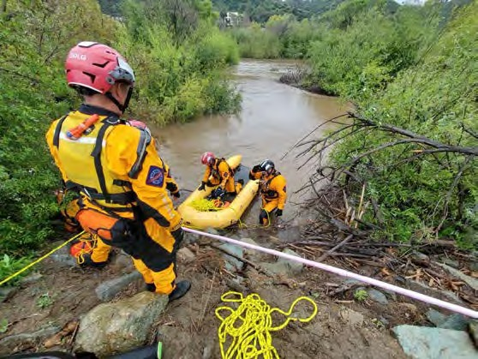
The Swiftwater and Flood Rescue Team assists with water and flood management by participating in and providing safety services to conservation groups that perform river cleanups. These cleanups restore the natural flow of water, mitigate flooding, and improve water quality. Additionally, the
Swiftwater and Flood Rescue Team assists the Metropolitan Transportation System and the San Diego Police Department with homeless encampment cleanups within the river valleys. Cleaning this debris prevents trash and other pollutants from entering the river.
Proper personal protective equipment enables Lifeguards to perform tasks within San Diego’s rivers watershed. The Conservancy supports the health and well-being of first responders and allows them to be readily available for assistance in and around the river.

GOALS:
There are three goals associated with this Project:
- Protecting life and property by placing warnings signs and conducting rescues during rain events to keep people out of hazardous areas.
- Conserving and preserving natural resources and the scenic area by initiating road closures during flooding events which prevents vehicles from entering and polluting the water.
- Conducting public outreach, and disseminating education and interpretation through river and homeless encampment clean ups and reducing flooding by removing debris during river clean ups.

Table 1. Estimated Budget and Anticipated Schedule

Task # | Description | Amount | Schedule
1 | Procure 30 dry suits | $37,068.42 | Throughout the grant term
TOTAL |  | $37,068.42

PROJECT FINANCING: The total Project amount is $37,068.42; the Conservancy staff recommends funding in the amount of $37,068.42 toward the purchase of PPE. The anticipated source of Conservancy funds for this Project is the Budget Act of 2021.

CONSISTENCY WITH CONSERVANCY’S ENABLING LEGISLATION: This Project
would be undertaken consistent with the Conservancy’s enabling legislation (Public Resources Code, §§ 32630-32659.9).

Map 1. Locations of River Hazards within the San Diego River in Mission Valley.
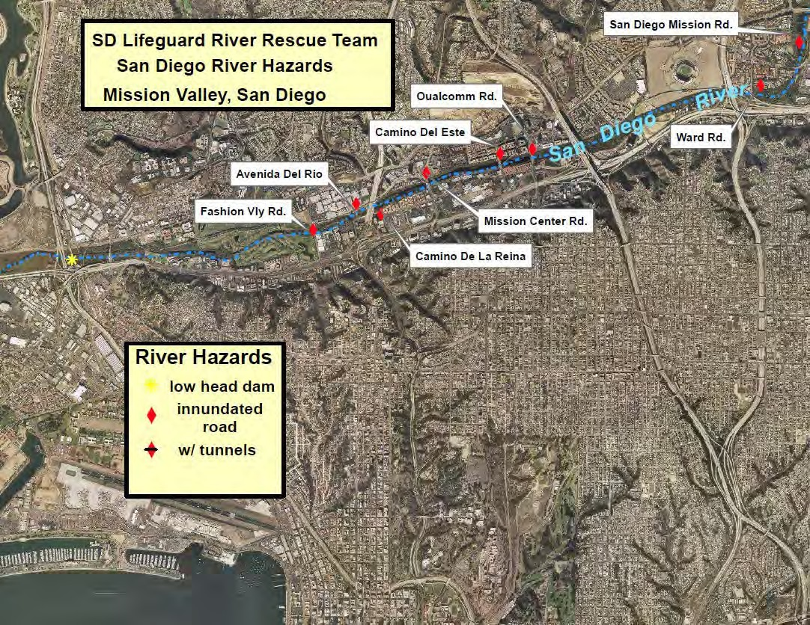

Map 2. Approximate Locations of Fire-Rescue within the Tijuana River Valley
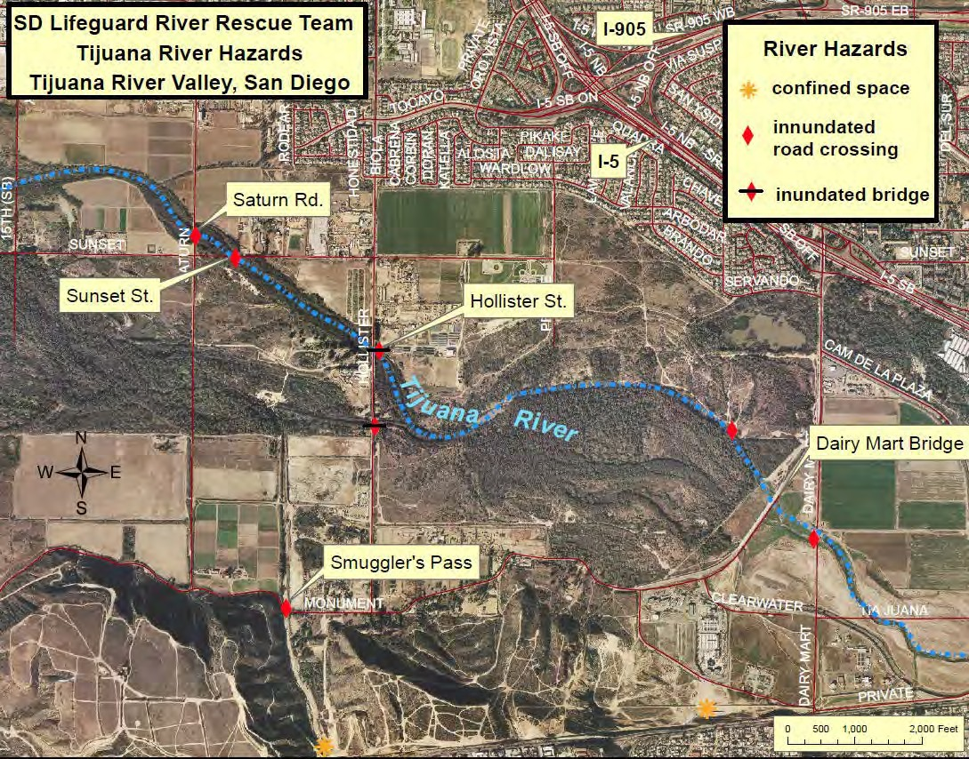

CONSISTENCY WITH CONSERVANCY’S STRATEGIC PLAN GOAL(S) &
OBJECTIVE(S): Consistent with Program 5 Enhance Water Quality and Natural Flood Conveyance, and Program 6, Expand the Organization’s Capacity and Public Outreach by strengthening current partnerships and develop additional partnerships, including other agencies, K-12, universities, and other stakeholders, from the Conservancy’s Strategic Plan Update 2018-2023.

CONSISTENCY WITH THE PURPOSES OF THE FUNDING SOURCE: The Budget Act
2021 is for wildfire and climate resilience, watershed protection, natural and cultural resource protection, and community access projects.

CONSISTENCY WITH THE CONSERVANCY’S DIRECTED GRANT PROGRAM:
This Project achieves one of the priorities of the grant program because it benefits disadvantaged, severely disadvantaged, or underserved communities and public safety.

ALIGNMENT WITH PLANS AND PRIORITIES

California’s Fourth Climate Change Assessment
Supports local adaptation strategy and resilience, and protection of the state’s most vulnerable populations and communities.

San Diego River Conservancy’s Climate Change Policy
    - Adaptive Management and Monitoring of ecosystem and physical processes to support implementation of management actions to achieve project objectives under rapidly changing climatic conditions.

San Diego Region Basin Plan
    - Nonhazardous solid waste means all putrescible and non-putrescible solid, semi-solid, and liquid wastes, including garbage, trash, refuse, paper, rubbish, ashes, industrial wastes, demolition and construction wastes, abandoned vehicles and parts thereof.

San Diego County Fire Chiefs Association
    - Goal 8 Promote Safety and Wellness among all members

California’s Flood Future Recommendations for Managing the State’s Flood Risk
    - 2.3.4 Flood Emergency Management:
      - Flood Preparedness - Flood preparedness includes the development of plans and procedures on how to respond to a flood in advance of a flood emergency, including preparing emergency response plans, training local response personnel, designating evacuation procedures, conducting exercises to assess readiness, and developing emergency response agreements that address issues of liability and responsibility.
      - Emergency Response - Emergency response is the aggregate of all those actions taken by responsible parties at the time of a flood emergency.

Operational Area Emergency Operations Plan – Annex B Fire and Rescue Mutual Aid Operations
    - To minimize loss of life, subsequent disability, and human suffering by ensuring timely and coordinated firefighting and search and rescue efforts.
    - To identify the resources necessary for locating and removing endangered, trapped, injured, or isolated persons and providing adequate care.
    - Ensure fire and rescue services are available to the whole community, including those with disabilities and others with access and functional needs.

San Diego County Fire Strategic Plan 2020-2025
    - Goal 1 Employee health and professional development

      - Objective 4. Empower and engage the workforce to effectively accomplish the Organizations mission.
    - Goal 2 Exceptional Emergency Services
      - Objective 2. Enhance all hazard response capabilities
      - Objective 4. Ensure effective deployment of resources
    - Goal 4 Organizational Excellence and Fiscal Sustainability
      - Objective 4. Increase grant opportunities and funding

California Disaster and Civil Defense Master Mutual Aid Agreement
Provides for systematic mobilization, organization, and operation of necessary fire and rescue resources of the state and its political subdivisions in mitigating the effects of disasters, whether natural or human-caused. In developing emergency plans, provisions should be made for integrating fire and rescue resources into mutual aid organizations for both fire and non-fire related disaster; (i.e., earthquake, flood).

City of San Diego Flood Mitigation Plan
    - Goal 2 - Build and support local capacity to enable the public to prepare for, respond to and recover from flood hazards.
    - Goal 7 – Improve coordination and communication with federal, state, local and tribal governments.
      - 7.A Establish and maintain closer working relationships with state agencies, local and tribal governments. Encourage other organizations to incorporate flood hazard mitigation activities. Improve the State’s capability and efficiency at administering pre- and post-disaster mitigation.

BENEFITS
Public safety, PPE for water rescues, public outreach, trash and debris removal, improved water quality, education, and interpretation, are some of the multi-benefits of this project.

LEVERAGED FUNDING
There are no matching funds for this project.

PROJECT READINESS
If project approved, dry suits can immediately be ordered from the vendor. The project would be complete upon delivery of dry suits to San Diego Fire-Rescue Foundation for prompt distribution and use by San Diego Swiftwater and Flood Rescue Team Lifeguards.

PERMIT COMPLIANCE
Not applicable.

State of California
San Diego River Conservancy

Meeting of March 2, 2023

ITEM: 10

SUBJECT: SAN DIEGO STATE UNIVERSITY’S MISSION VALLEY
AND RIVER PARK INTERPRETIVE SIGNAGE PROPOSAL (ACTION)
The proposed project for interpretation and storytelling will be accomplished in several ways. The proposal will provide signage along the hiking and biking trails network, highlighting the cultural, historical and biological resources of the San Diego River area. This includes interpretive signage, boulder etchings, and other mileage signage to enhance the significance of the San Diego River and educate the public about these resources. San Diego State University requested funding for $150,065 and the Conservancy staff recommends fully funding this project.

Presentation:
Paul Jackson, Program Manager, Mission Valley Development, San Diego State University

Recommendation: Approval of Resolution 23-02

.

Resolution No: 23-02

RESOLUTION OF THE GOVERNING BOARD OF THE SAN DIEGO RIVER CONSERVANCY

AUTHORIZING THE EXECUTIVE OFFICER TO GRANT $150,065 FROM THE BUDGET ACT OF 2021 TO SAN DIEGO STATE UNIVERSITY TO IMPLEMENT SAN DIEGO STATE UNIVERSITY’S MISSION VALLEY AND RIVER PARK INTERPRETIVE SIGNAGE PROJECT

WHEREAS, the mission of the San Diego River Conservancy is to further the goals of its enabling legislation by conserving and restoring the lands and waters of the San Diego River watershed and the San Diego Rivers Watershed Consortium Program areas; and
WHEREAS, the Legislature of the State of California has provided funds under the Budget Act of 2021 for
$11,100,000 to fund climate resilience, natural and cultural resource protection, wildfire and community access projects; and
WHEREAS, the San Diego River Conservancy has been delegated the responsibility for the administration of this grant program, establishing necessary procedures and guidelines in accordance with statewide priorities and plans; and

WHEREAS, San Diego State University applied to the San Diego River Conservancy for $150,065 to install interpretive signage, boulder etchings, mileage medallions, and other interpretive elements throughout the River Park at SDSU Mission Valley (Project); and
WHEREAS, San Diego River Conservancy staff is recommending $150,065 to implement the Project; and
WHEREAS, this Project is consistent with the Conservancy’s Strategic Plan 2018-2023, Program 2: Support and Encourage Recreation and Education, Program 3: Preserve and Restore Natural Resources, and Program 4: Protect and Preserve Cultural and Historical Resources, and Program 6: Expand the Organization’s Capacity and Public Outreach.
WHEREAS, the San Diego River Conservancy staff have reviewed the grant application, and recommends the Project for approval.
NOW, THEREFORE, BE IT RESOLVED that the San Diego River Conservancy’s Governing Board, based on the accompanying staff report and attached exhibits:
- The proposed Project is consistent with the purposes and intent of the Budget Act of 2021.
- The proposed authorization is consistent with the purposes and objectives of the San Diego River Conservancy Act (Public Resources Code, Sections 32630-32659.9).
- The San Diego River Conservancy hereby authorizes the disbursement of up to $150,065 (One Hundred Fifty Thousand Sixty-Five Dollars) for the Project.

- Appoints the Executive Officer, or her designee, as an agent to execute all agreements, grants, sub- contracts, and other documents needed for the completion of the Project.

- Prior to the disbursement of funds, the grantee shall submit for the review and written approval of the Executive Officer of the Conservancy a scope of work, budget, and schedule.
Approved and adopted on March 2, 2023. I, the undersigned, hereby certify that the foregoing Resolution Number 23-02 was duly adopted by the San Diego River Conservancy’s Governing Board.

Roll Call Vote: Yeas:
Nays: Absent:

Julia L. Richards Executive Officer

San Diego River Conservancy’s Governing Board Members Roll Call Vote
Name | Ayes | Noes | Abstained
CNRA: Andrea Scharffer
DOF: Sally Lukenbill
CADFW: Richard Burg
Dr. Jennifer Campbell, SD Mayor Designee
Joel Anderson, County Supervisor
Raul Campillo
Ben Clay, Chair
Ruth Hayward, Vice Chair
J. Cody Petterson
John Elliott
Elsa Saxod
DPR Designee, Ray Lennox
DPR Designee, Gina Moran
Dustin Trotter
Vacant

Staff Recommendation SDRC Resolution 23-02
March 2, 2023

BUDGET ACT 2021

RECOMMENDED ACTION: Authorization to provide up to $150,065.00 to San Diego State University (SDSU), to install interpretive signage, mileage markers and other educational elements to enhance the visitor experience at the River Park in Mission Valley.

LOCATION: The proposed interpretive signage project at the River Park at SDSU Mission Valley is in the City of San Diego.

RESOLUTION AND FINDINGS: Staff recommends that the San Diego River Conservancy adopt the following resolution pursuant to the San Diego River Conservancy Act (Public Resources Code, § 32630 et seq.):

The San Diego River Conservancy hereby authorizes the disbursement of funding to implement projects focused on creating and enhancing park and trail facilities, providing public access, and enhancing river parkways, specifically as follows:

- San Diego State University: One Hundred Fifty Thousand, Sixty-Five Dollars ($150,065.00) to install interpretive signage, boulder etchings, mileage medallions, and other interpretive elements throughout the River Park at SDSU Mission Valley (Project).

Prior to the disbursement of funds, SDSU shall submit for the review and written approval of the Executive Officer of the Conservancy a scope of work, budget and schedule, and the names and qualifications of any contractors to be employed in carrying out the project.

Staff further recommends that the Conservancy adopt the following findings:

Based on the accompanying staff report and attached exhibits, the San Diego River Conservancy hereby finds that:

- The proposed authorization is consistent with the purposes and objectives of the San Diego River Conservancy Act, including Section 32649.

- The proposed project is consistent with the Guidelines for the Conservancy’s Directed Grant program.

- The proposed Project is consistent with the Budget Act of 2021.

PROJECT NEED: The City of San Diego’s Mission Valley area is park deficient. There is growing need to support the Mission Valley community and creating a public park with

historical and cultural areas for educational opportunities.

PROJECT BACKGROUND: The SDSU Mission Valley site development and River Park project is located on the former San Diego County Credit Union stadium site. The development of SDSU’s Mission Valley will provide San Diego with access to approximately 80 acres of community parks and open space with multiple trail and facility improvements, including four miles of pedestrian and bike pathways and an extension of the San Diego River Trail (Segment 19 and 20) from Fenton Parkway to Rancho Mission Road. This trail will be accessible to the public on an ongoing basis once complete.

SDSU created a River Park Advisory Group to provide input throughout the design process. The group includes representatives from Mission Valley and other adjacent communities, as well as park advocates, environmental organizations, SDSU faculty and staff. SDSU also engaged the Kumeyaay Diegueño Land Conservancy to provide substantial input of all Kumeyaay related design and signage. SDSU also hosted public design workshops with the greater community to solicit input and share ideas about the amenities that are important to them. As part of the terms of the purchase and sale agreement, SDSU is constructing, and will maintain and operate 34-acres of park and open space along the San Diego River upon land that will remain in fee ownership by the City of San Diego. The park improvements themselves, including the signage, will be owned and maintained by SDSU.

PROJECT SUMMARY
Importantly this Project create spaces for recreation as well as learning. The proposed Project will provide signage along the pedestrian and biking trails network, highlighting the cultural, historical, and biological resources of the San Diego River. This includes interpretive signage to educate the public about its resources and original inhabitants and includes use of a QR code on the interpretive signs to expound on the historical, cultural, and natural information provided along the River Trail.

The proposed Project will provide interpretive signage to educate the public of the many cultural heritage and resources found in and around the San Diego River.
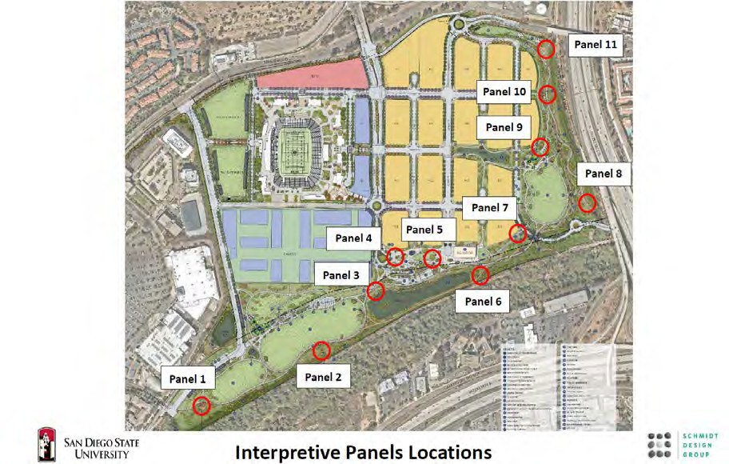
A description of the interpretive panels themes and content are listed below: Panel 1 - Kumeyaay Nation
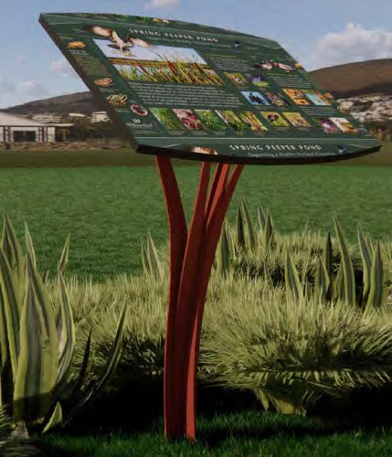
Information on the 16 Tribal Bands in San Diego County and Baja California. Kumeyaay connection to the land, history, resilience, and present day.

Panel 2 - The Watershed of the San Diego River Information on river watershed and hydrology, including historic changes to the river alignment. Includes Kumeyaay’s connection to the river.

Panel 3 -Water Quality in San Diego River Valley Describes the way in which natural habitat in the river provides water quality improvements along with many other benefits. Also, includes the science behind the stormwater system at SDSU Mission Valley.

Panel 4 - The many Colors of Mission Valley
Kumeyaay symbolic colors and other colors of the valley both natural and man-made. Introduces the colors and medallions along the Hike and Bike Loop.

Panel 5 - Farming and Agriculture in Mission Valley
Describes the agricultural history of Mission Valley including narrative about the Kumeyaay use of the land.

Panel 6 - Kumeyaay use of native plantings (Ethnobotany)
This panel will discuss the various Kumeyaay uses of our native plants in the region. Each plant identified on the medallions on the Hike and Bike Loop will be featured on this panel.

Panel 7 - “The Day the San Diego River was Saved”
At one point in San Diego’s history, the City of San Diego and Army Corps of Engineers determined that they would create a concrete channel out of the San Diego River. This panel describes that proposal and the community who successfully rallied to stop it.

Panel 8 - Fauna (Animals) of the San Diego River
This will include a number of animals important to the Kumeyaay which will correspond to the animal images etched in boulders on site.

Panel 9 - Play and Games of the Kumeyaay People
This panel will describe play and games of the Kumeyaay, including both children and adults.

Panel 10 - Pollinator's of the San Diego River
Many native plants in our natural habitats in San Diego are important pollinators that keep our ecosystems healthy and flourishing.

Panel 11 - Water Supply and the Future
This panel will provide a history and overview of water supply and delivery in the San Diego County region.

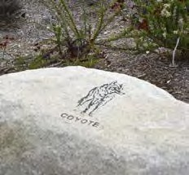
The River Park will have a hike and bike trail loop colors of nature reflecting the natural resources of the San Diego River. In addition, boulder etchings will be placed in the east park area showcasing animals of the San Diego River with image and identification text in English, Spanish and Kumeyaay.

The proposed improvements will be owned and operated by SDSU. Maintenance will be funded by revenue generated from
various on-site uses. SDSU’s obligation to fund the maintenance and operation of the area in perpetuity is a term in the purchase agreement with the City of San Diego.

SITE DESCRIPTION: SDSU Mission Valley includes the development of Snapdragon Stadium, initial site infrastructure, as well as 34 acres of public park adjacent to the San Diego River and another 50 acres of active and passive park space, and open spaces.

The proposed Project is within the San Diego River’s current 100-year flood plain. The River Park is being designed to serve as a buffer to both the San Diego River and Murphy Canyon Creek, which previously flooded into the former stadium and across the parking lot. The development of the site and the River Park include bioretention basins, bioswales, passive and active natural turf fields, and riparian habitat to improve the storm water quality and flood protection.

PROJECT FINANCING: The total project amount for the park’s Interpretive Signage program is $209,354. The applicant is requesting $150,065.00 for Project implementation. SDSU provided in kind matching funds in the amount of $59,289. The anticipated source of Conservancy funds for this project is the Budget Act of 2021. The estimated budget is as follows:

Category | Description | Amount
Interpretive Signage Elements | Trolley Plaza Story Ribbons Etching | $11,380.00
 | Boulder Etching | $25,425.00
 | Mileage Medallions | $18,483.00
 | Interpretive Signage and Bases | $60,777.00
 | River Trail Wayfinding Signage | $34,000.00
 | Total | $150,065.00

Leveraged Funding: The total cost of the River Park at SDSU Mission Valley exceeds
$30,000,000 and is funded by SDSU.

CONSISTENCY WITH CONSERVANCY’S ENABLING LEGISLATION: This project
would be undertaken consistent with the Conservancy’s enabling legislation (Public Resources Code, §§ 32630-32659.9).

CONSISTENCY WITH CONSERVANCY’S STRATEGIC PLAN GOAL(S) & OBJECTIVE(S):
Consistent with Program 2: Support and Encourage Recreation and Education, Program 3: Preserve and Restore Natural Resources, and Program 4: Protect and Preserve Cultural and Historical Resources, and Program 6 Expand the Organization’s Capacity and Public Outreach from the Conservancy’s Strategic Plan Update 2018-2023.

CONSISTENCY WITH PURPOSES OF THE FUNDING SOURCE
Budget Act 2021 is for wildfire and climate resilience, watershed protection, natural and cultural and resource protection, and community access projects. The funding is immediately available for shovel-ready projects.

ALIGNMENT WITH STATE PLANS AND PRIORITIES

San Diego River Recreational Trail Plan
    - This Project will create interpretive signage about Kumeyaay culture along and near the San Diego River Trail, of which SDSU is constructing segments 19 and 20 as part of the River Park project.

San Diego River Conservancy’s Climate Change Policy
    - The Conservancy will collaborate with other agencies and entities to develop, support, and implement climate change adaptation plans, strategies and projects that minimize or offset impacts to natural and cultural resources, public access, and other matters specified in the Conservancy’s enabling legislation.

Tribal Consultation Policy
    - Kumeyaay representatives participated in the development of the park design. Through design inspiration and interpretive signage on site, the Kumeyaay history will be reflected within the park improvements.

SDRC Strategic Plan Update 2018-2023
    - The proposed Project will create new educational content concerning San Diego’s original inhabitants and how they used the resources of the San Diego River.

San Diego River Conservancy Act, Public Resources Code Sections 32630
    - The proposed Project will create new educational and interpretive opportunities adjacent to the San Diego River Trail.

California’s Statewide Historic Preservation Plan 2019-2023 Update
    - Goal 1: Elevate the value of historical resources and the contribution that stewardship of historic and cultural resources has to the broader California community.
      - Objective 1.C: Improve access to information about historical and cultural resources for public agencies and private organizations as well as the general public.
    - Goal 3: Communicate to all Californians the many ways that historic and cultural resources contribute to the livability and sustainability of communities.
    - Goal 4: Cultivate a sense of stewardship for historical and cultural resources in all Californians through the belief that these resources, and the stories they tell can enrich our lives and communities.
      - Objective 4.A: Educate the public about historical and cultural resources, why they matter, and ways to use and protect them.

California Code of Regulations Section 1427
    - Recognizes that California’s archaeological resources are endangered by urban development and population growth and by natural forces.
      - These resources need to be preserved in order to illuminate and increase public knowledge concerning the historic and prehistoric past of California.

  - California Government Code § 65351: Native American Involvement in General Plan Proposals
    - Requires local planning agencies to provide opportunities for involvement of California Native American tribes on the contact list maintained by the Native American Heritage Commission, and others, in the preparation or amendment of the general plan.

San Diego River Park Master Plan
    - Principal four Reveal the River Valley History
      - Develop an interpretive program based on the historical, biological and cultural resources of the river.
      - Create a San Diego River Park Interpretive Center.
      - Use maps, art and signage to integrate the history of the river valley in appropriate locations.

CLIMATE CHANGE CONSIDERATIONS
The River Park is part of a greater redevelopment that is eliminating the heat island effect caused by the former stadium’s parking lot. The asphalt is being replaced with natural and native habitat, green belts, and open space. The redevelopment will use sustainable practices and are designed to achieve LEED Neighborhood Development Certification and expand the San Diego River’s riparian environment.

MULTIPLE BENEFITS
The SDSU Mission Valley Development and the River Park Project will achieve multiple benefits. The educational signage will enhance and highlight the many efforts within to protect and improve wildlife habitats. As part of the San Diego River Trail, the signage features will help the public connect with the San Diego River by learning its cultural heritage and knowledge of San Diego River’s history dating back thousands of years.
Signage will also help keep the public out of sensitive habitats through education and wayfinding.

This project supports the San Diego River Conservancy’s mission to educate the public by including a well-designed series of interpretive panels, and themes. The themes feature the importance of the San Diego River at the regional scale. This includes the Kumeyaay people’s use of the river since time immemorial, development in the 1900s and protection of the river are important to understand and preserve these valuable cultural, historical and natural resources for future generations. This project aligns with the Conservancy’s mission to provide education opportunities to the public about the adjacent

San Diego River and increase public stewardship for the protection and restoration of sensitive habitat.

PROJECT READINESS
The proposed Project is shovel ready. SDSU obtained required permits and grading of the site began in 2021. Expected completion is in 2023. Long-term maintenance will be the responsibility of SDSU in perpetuity for the River Park’s trails and signage.

COMMUNITY SUPPORT, NON-PROFIT AND OR GOVERNMENT SUPPORT AND COLLABORATION
SDSU Mission Valley started with support from the local community after San Diego voters supported Measure G to allow SDSU to purchase and develop the City property. Since then, SDSU created a River Park Advisory Group to provide input throughout the design process. The group includes representatives from Mission Valley and other adjacent communities, as well as park advocates, representatives from the Kumeyaay nation, environmental organizations, SDSU faculty and staff.

DISADVANTAGED OR SEVERELY DISADVANTAGED COMMUNITY
The River Park is located within one-mile of two disadvantaged communities, Serra Mesa and Grantville, and serves the other nearby severely disadvantaged communities of Montezuma Mesa and City/Normal Heights. The public can access SDSU Mission Valley via the San Diego Metropolitan Transportation System (MTS) Green Line Trolley station on site, a new transit plaza that supports the staging of four busses for future bus service, and adjacent roadways with surface street parking.

LEVERAGED FUNDING
SDSU has a total of $59,289 in matching funds for the interpretive signs.

COMPLIANCE WITH CEQA:
SDSU completed CEQA for development of the River Park in January 2020.

State of California
San Diego River Conservancy

Meeting of March 2, 2023

ITEM: 11
SUBJECT: SAN DIEGO REGIONAL WATER QUALTITY CONTROL BOARD PROJECT (ACTION)
The Conservancy and other state agencies were requested to assist with the administration of legislative priority allocations contained in the Budget Act of 2022. The Legislature appropriated $175,000 to the San Diego River Conservancy for the San Diego Regional Water Quality Control Board (Water Board) for technical assistance services. The Water Board will use the funding to prepare a binational water quality report with protection measures for transboundary issues in the Tijuana River Basin. The proposed report will include a scoping level feasibility analysis of 10-15 projects in the U.S. and Mexico to address sediment, trash and water quality problems that are not already addressed by ongoing state and federal efforts in both countries.
Minute 320 of the 1944 Treaty regarding the utilization of the Tijuana and Colorado Rivers and of the Rio Grande, identifies a binational framework to address sediment, water quality and trash in the Tijuana River Basin. The report will be subject to approval under Minute 320 by the Commissioners of the U.S. and Mexico sections of the Internal Boundary and Water Commission. Approval of Resolution 23-03 authorizes allocation of the funds as set forth by the Legislature to the Water Board and authorizes the Conservancy’s Executive Officer to administer and execute all necessary documents needed for completion of the project.

Introduction:
Dave Gibson, Executive Officer Recommendation: Approval of Resolution 23-03

Resolution No: 23-03

RESOLUTION OF THE GOVERNING BOARD OF THE SAN DIEGO RIVER CONSERVANCY

AUTHORIZING THE EXECUTIVE OFFICER TO GRANT $175,000 FROM THE BUDGET ACT OF 2022 TO THE SAN DIEGO REGIONAL WATER QUALITY CONTROL BOARD FOR TECHNICAL ASSISTANCE SERVICES

WHEREAS, the mission of the San Diego River Conservancy is to further the goals of its enabling legislation by conserving and restoring the lands and waters of the San Diego River watershed and the San Diego Rivers Watershed Consortium Program areas; and
WHEREAS, the Legislature of the State of California under the Budget Act of 2022 identified priority funding for the San Diego Regional Water Quality Control Board (Water Board); and,
WHEREAS, the Conservancy and a number of other agencies were requested to assist with the administration of legislative priority allocations contained in the amended Budget Act of 2022; and,
WHEREAS, the Legislature of the State of California appropriated $175,000 to the San Diego River Conservancy for the San Diego Regional Water Quality Control Board (Water Board) for technical assistance services (Project); and,

WHEREAS, the Water Board will use the funding to prepare a binational water quality report with protection measures for transboundary issues in the Tijuana River Basin; and,
WHEREAS, San Diego River Conservancy staff is recommending approval of $175,000 to implement the Water Board’s Project; and
NOW, THEREFORE, BE IT RESOLVED that the San Diego River Conservancy’s Governing Board, based on the legislative questionnaire:

- The proposed Project is consistent with the purposes and intent of the Budget Act of 2022.
- The San Diego River Conservancy hereby authorizes the disbursement of up to $175,000 (One Hundred Seventy-Five Thousand Dollars) for the Project.

- Appoints the Executive Officer, or her designee, as an agent to execute all agreements, grants, sub- contracts, and other documents needed for the completion of the Project.

Approved and adopted on the 2nd day of March 2023. I, the undersigned, hereby certify that the foregoing Resolution Number 23-03 was duly adopted by the San Diego River Conservancy’s Governing Board.
Roll Call Vote: Yeas:
Nays: Absent:

Julia L. Richards Executive Officer

San Diego River Conservancy’s Governing Board Members Roll Call Vote
Name | Ayes | Noes | Abstained
CNRA: Andrea Scharffer
DOF: Sally Lukenbill
CADFW: Richard Burg
Dr. Jennifer Campbell, SD Mayor Designee
Joel Anderson, County Supervisor
Raul Campillo
Ben Clay, Chair
Ruth Hayward, Vice Chair
J. Cody Petterson
John Elliott
Elsa Saxod
DPR Designee, Ray Lennox
DPR Designee, Gina Moran
Dustin Trotter
Vacant

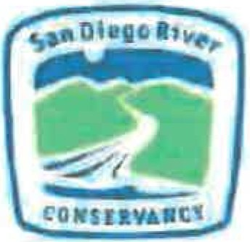
Questionnaire for Legislative Priority

Please answer the following questions as they relate to the Budget Act of 2022 (AB 179 (2021-22]), SECTION 19.56, subsection (e) WATER, DROUGHT, AND
OTHER INFRASTRUCTURE, subsection (6) To be allocated by the San Diego River Conservancy,
$2,000,000 to the East County Advanced Water Purification Joint Powers Authority (JPA) for the East County Advanced Water Purification Program. https://leginfo.legislature.ca.gov/faces/bi11NavCIient.xhtml?bi11 id=202120220AB179

Which Legislative representative did your organization work with when requesting funding? N/A

Organi.zation: California Regional Water Quality Control Board. Region 9, San Diego Basin

Address: 2375 Northside Drive, Suite 100 San Diego. CA 92071 Contact name: David Gibson

Telephone:619-521-3005
Email: david.gibson@waterboards.ca.gov

Federal Tax ID # 94-6001347

Position(s) whose incumbents are authorized to negotiate agreement$ an1 d amendments:
David W. Gib s on

I, David W. Gibson, acknowledge the information is true and correct to the best of my
knowledge and belief.
Da. vId w. G"rbson. . ·lysignedby DavidW.Gibson

Signature
.: 2023.02.27 09:54'.52-0BW Date: -'Jc...a.a'"'""'n-=-u_ar_y 1
7. 2_ 0_2 3_

David W. Gibson. Executive Officer Name and Title
San Diego RWQCB Organization

Page 1

PROJECT INFORMATION:

Project name: Minute 320 Binational Framework Water Quality Improvement Plan Report

Project location: Tijuana River Watershed

Proposed start date: 3/15/2023 Estimated completion: 6/30/2024

SPECIFIC PROJECT-RELATED QUESTIONS

    - General Project description/Scope of work for funding request

The project will support the U.S and Mexico (Comisión Internacional de Límites y Agua- CILA) Commissioners of the International Boundary and Water Commission in the Minute 320 Binational Framework for Binational Cooperation on Transboundary Issues in the Tijuana River Watershed. The project will review existing project inventories, select projects for further study and perform scoping level feasibility assessments on projects to address sources and conveyances of sediment, flooding, trash, and water quality.

The proposed Binational Framework Water Quality Improvement Plan (Plan) will extend the level of detail and analysis of the highly successful Tijuana River Valley Needs and Opportunities Assessment Report prepared by the County of San Diego (pursuant to funding by the California Legislature through SB 507) to include additional projects in Mexico to address sources and conveyances of polluted water, sediment, flooding, and trash through the Minute 320 Binational Work Groups.

The draft Plan will be circulated in English and Spanish for public comment and the final Plan is proposed for adoption by IBWC Commissioners Maria Elena Giner (U.S. IBWC) and Adriana Reséndez Maldonado (CILA) as a product of the Minute 320 Binational Framework to support future funding decisions and compliment the efforts being undertaken by the U.S. and Mexico in the Minute 328 and the U.S. Mexico Statement of Intent pursuant to the United States-Mexico- Canada Agreement. Each Work Group will identify 3-5 keystone projects to address sources or conveyances of polluted flows, sediment, flooding, trash. Projects may also include restoration of impaired areas or development of recycled water sources for climate change resiliency in the Tijuana River Watershed.

    - Specific need for the project;
The Tijuana River Valley Recovery Strategy and Tijuana River Valley Needs and Opportunities Assessment Report identified several projects for additional study and funding. Many of those projects in the U.S are now being implemented by state and local agencies. The federal government (IBWC/CILA) identified the Tijuana River Watershed as a Priority Watershed with the U.S. Army Corps of Engineers and Comision Nacional del Agua (CONAQUA).

Previous efforts through Minute 320 since 2015 identified lists of projects in both countries, but did not meaningfully describe or assess the feasibility of projects in Mexico to control sources or conveyances of sediment, trash, and polluted flows into the U.S. The proposed project is needed to coordinate and memorialize the efforts in the three Work Groups to identify 3-5 key projects, consistently describe them, and conduct an initial feasibility assessment for future project development and funding by the Minute 320 Binational Core Group (steering committee) member agencies in both countries. The projects selected will complement the projects currently under development by both countries through Minute 328, and the U.S.-Mexico Statement of Intent, and the pending Record of Decision on the Mitigation of Contaminated Transboundary Flows Project (USMCA Project).

    - Are permits needed?
Permits are not needed to coordinate the efforts pursuant to the Minute 320 Framework. Lead agencies, permitting and environmental assessment needs, capital and operations and maintenance costs for each project will be identified in the final Plan.

    - What are the benefits to the public and the resources?
Project description and initial feasibility assessment will support meaningful, physical source controls and treatment/removal of wastes in Mexico and the U.S. that would otherwise continue to impact the Tijuana River Valley. Recent experience with funding opportunities established by the California Legislature demonstrated the need for a binational, watershed scale plan similar to the one prepared by the County of San Diego with funding from SB 507 that clearly identifies and details a strategy of project implementation to control sources and conveyances of polluted flows, sediment, and trash equitably throughout the watershed and reduce flooding downstream. The projects identified in the Plan could also support the restoration of impaired areas and the development of reliable sources of recycled wastewater for climate change resiliency consistent with the California Water Supply Strategy.

    - Discuss Project design and budget
The project will be a services contract for a consultant to be selected by the San Diego Water Board and representatives of the Binational Core Group including, but not limited to the U.S. IBWC, CILA, U.S. EPA, and CONAGUA. The project scoping phase will include meeting facilitation and documentation of meetings of the Minute 320 Binational Work Groups in summer and fall of 2023, drafting project descriptions including estimates of capital and operations and maintenance costs, lead agencies and supporting agencies, and subsequent project development steps including more detailed feasibility assessment, environmental documentation and permitting needs. The draft Plan will be circulated in English and Spanish for public review and comment in the winter 2023-24 and a Final Plan will be scheduled for completion and consideration by the Binational Core Group and the U.S. IBWC and CILA Commissioners by April/May 2023.

Estimated Milestone
Milestone | Expected Completion Date
Contractor/Consultant Selection | July 2023
Work Group Project List | October 2023
Draft Plan | December 2023
Final Plan | April/May 2024

Estimated Budget
Description of Activities/Task | Applicant’s Funds | San Diego River Conservancy | Other Funds | Total Project Cost
Consulting services contract |  | 175,000 |  | $ 175,000
 |  |  |  | $ 0
 |  |  |  | $ 0
 |  |  |  | $ 0
TOTAL | $ 0 | $ 0 | $ 0 | $ 175,0000

    - The extent to which the project promotes and implements state plans and priorities
Discuss how Proposed Project promotes and implements State plans and priorities, directives and Executive Orders, including but not limited to: California Water Action Plan, Forest Carbon Plan, Safeguarding California – California’s Climate Adaptation Strategy, the 2017 Climate Change Scoping Plan (Scoping Plan) and the Integrated Climate Adaptation and Resiliency Program, Natural Working Lands Plan, and Wildlife Action Plan,
Water Quality Control Plan for the San Diego Basin as well as other adopted State plans.
The proposed project will identify and complete a binational report with a scoping level feasibility analysis of the projects selected in 2023-2024 by the participants in the Minute 320 Binational Framework workgroups and Binational Core Group. The Report is proposed to the basis for subsequent Treaty Minutes and funding solicitations by member agencies in both countries to address sediment, flooding, water quality, and trash through the watershed.
Publication of the report will assist lawmakers in both countries identify key projects for funding and implementation. Component projects of the USMCA Statement of Intent and Minute 328 have the potential to recycle and return high quality effluent to Tijuana for re- use; the projects that may be considered in the Minute 320 Framework would support and

expand on those projects’ outcomes. Regional water supply reliability in the border regions are critical to the overall success of the California Water Strategy “...enabling better and safer use of wastewater currently discharged to the ocean.” The Tijuana River, Estuary and coastal waters are listed for 54 impairments due to transboundary flows of pollutants. Source control through collaborative, binational projects couple with treatment and offshore discharge is the most promising combination of strategies to achieve the water quality objects and protect beneficial uses established in the Water Quality Control Plan for the San Diego Basin. Without an effective binational strategy document, the San Diego Water Board will need to adopt 10 Total Maximum Daily Loads.

Leveraged Funding
Include other sources of funds, including matching funds, and in-kind funds, donations or from other grant programs
San Diego Water Board currently support the Tijuana River Valley Recovery Team through unsupported staff services. The San Diego Water Board Executive Officer is a member of the Binational Core Group and contributes additional staff in kind services (approximately 25% of his time) to the Minute 320 process and the USMCA efforts of U.S. EPA and U.S. IBWC. The San Diego Water has conducted monitoring and assessment of the Tijuana River and impaired waters including the Southern California Coastal Water Research Project (SCCWRP) Southern California Bight Monitoring Program. The San Diego Water Board, through its regulatory oversight of the NPDES Permits of both the City of San Diego and U.S. IBWC can redirect certain permit compliance activities to support the Minute 320 process and projects.

Matching Funds

Source of funds | Amount ($) | Estimated commitment date
N/A

In-Kind Services determination
In-kind services include unbilled staff labor, volunteer time and materials, bargain sales, and land donations. Please describe and estimate value of in-kind contributions.
- Executive Officer (25%) $73,704
- Water Resource Control Engineers (10% each) $37,656 1 Staff Services Analyst (5%) $4,959

Collaboration and Community, Tribal, Non-Profit and/or Government
Support
The San Diego Water coordinates the Tijuana River Valley Recovery Team, which includes over 30 stakeholder agencies and organizations. The San Diego Water Board routinely participates in regional forums like the South County Environmental Justice Task Force. In addition, the San Diego Water Board is actively engaged with Tribal Governments on Tribal Beneficial Use designations that will include the waters of the state within the Tijuana River watershed, estuary, and coastal waters. The San Diego Water Board is working with both Tribal Governments and non-governmental organizations representing Disadvantaged Communities in fish and shellfish bioaccumulation studies, which will include the Tijuana River, estuary, and coastal waters.

State of California
San Diego River Conservancy

Meeting of March 2, 2023

ITEM: 12

SUBJECT: EAST COUNTY ADVANCED WATER PURIFICATION
PROGRAM (ACTION)
As noted above, the Conservancy and other state agencies were requested to assist with the administration of legislative priority allocations contained in the Budget Act of 2022. This is another appropriation under the Act. The Legislature appropriated to the San Diego River Conservancy $2,000,000 to be allocated to the East County Advanced Water Purification Program Joint Powers Authority (JPA) to assist in the construction of facilities needed to implement the East County Advanced Water Purification Program in the County of San Diego. The East County Advanced Water Purification Program is a regional sustainable drinking water supply system collaboration between Padre Dam Municipal Water District, the County of San Diego, the City of El Cajon and Helix Water District. This program will provide East County residents with a secure drinking water supply while enhancing and diversifying the entire San Diego region’s water network. Approval of Resolution 23-04 authorizes allocation of the funds as set forth by the Legislature to the JPA and authorizes the Conservancy’s Executive Officer to administer and execute all necessary documents needed for completion of the project.

Presentation:
Melissa McChesney, Communications Manager, Padre Dam Municipal Water District

Recommendation: Approval of Resolution 23-04

Resolution No: 23-04

RESOLUTION OF THE GOVERNING BOARD OF THE SAN DIEGO RIVER CONSERVANCY

AUTHORIZING THE EXECUTIVE OFFICER TO GRANT $2,000,000 FROM THE BUDGET ACT OF 2022 TO THE EAST COUNTY ADVANCED WATER PURIFICATION PROGRAM JOINT POWERS AUTHORITY

WHEREAS, the mission of the San Diego River Conservancy is to further the goals of its enabling legislation by conserving and restoring the lands and waters of the San Diego River watershed and the San Diego Rivers Watershed Consortium Program areas; and
WHEREAS, the Legislature of the State of California under the Budget Act of 2022 identified priority funding for the East County Advanced Water Purification Program Joint Powers Authority (JPA); and,
WHEREAS, the Conservancy and other agencies were requested to assist with the administration of legislative priority allocations contained in the amended Budget Act of 2022; and,
WHEREAS, the Legislature of the State of California appropriated $2,000,000 to the San Diego River Conservancy for the JPA to assist in the construction of facilities needed to implement the East County Advanced Water Purification Program in the County of San Diego (Project); and,
WHEREAS, the JPA will use the funding to complete a critical element of the Project, the 11-mile purified water pipeline that will take the purified water from Advanced Water Purification Plant to Lake Jennings in Lakeside; and,
WHEREAS, San Diego River Conservancy staff is recommending approval of $2,000,000 to implement the Project; and
NOW, THEREFORE, BE IT RESOLVED that the San Diego River Conservancy’s Governing Board, based on the legislative questionnaire:
- The proposed Project is consistent with the purposes and intent of the Budget Act of 2022.
- The San Diego River Conservancy hereby authorizes the disbursement of up to $2,000,000 (One Hundred Seventy-Five Thousand Dollars) for the Project.

- Appoints the Executive Officer, or her designee, as an agent to execute all agreements, grants, sub- contracts, and other documents needed for the completion of the Project.

Approved and adopted on the 2nd day of March 2023. I, the undersigned, hereby certify that the foregoing Resolution Number 23-04 was duly adopted by the San Diego River Conservancy’s Governing Board.
Roll Call Vote: Yeas:
Nays: Absent:

Julia L. Richards Executive Officer

San Diego River Conservancy’s Governing Board Members Roll Call Vote
Name | Ayes | Noes | Abstained
CNRA: Andrea Scharffer
DOF: Sally Lukenbill
CADFW: Richard Burg
Dr. Jennifer Campbell, SD Mayor Designee
Joel Anderson, County Supervisor
Raul Campillo
Ben Clay, Chair
Ruth Hayward, Vice Chair
J. Cody Petterson
John Elliott
Elsa Saxod
DPR Designee, Ray Lennox
DPR Designee, Vacant
Dustin Trotter
Vacant

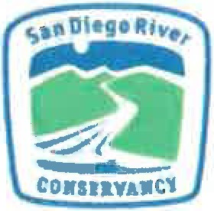
Questionnaire for Legislat ive Priorit y

Please answer the following questions as they relate to the Budget Act of 2022 (AB 179 (2021-22]), SECTION 19.56, subsection (e) WATER, DROUGHT, AND
OTHER INFRASTRUCTURE, subsection (6) To be allocated by the San Diego River Conservancy,
$2,000,000 to the East County Advanced Water Purification Joint Powers Authority (JPA) for the East County Advanced Water Purification Program. https://leginfo.legislature.ca.gov/faces/bi11NavCIient.xhtml?bi11 id=202120220AB179

Which Legislative representative did your organization work with when requesting funding? Dr. Akilah Weber

Organization: East County Advanced Water Purification Joint Powers Authority ( East Count y AWP JP A)

Address: P.O. Box 719002 Santee, CA 92072
Contact name: Melissa McChesney and Karen Jassoy Telephone: 619-572-1490
Email: mmcchesney@padre.org and kjassoy@padre.org Federal Tax ID# 844564185
Position(s) whose incumbents are authorized to negotiate agreements and amendments:
Kyle Swanson, CEO/ General Manager Padre Dam Municipal Water District, Administrator for the East Count y AWP JPA

I, Kyle Swanson, acknowledge the information is true and correct to the best of my knowledge and belief.

Slgnature

Kyle Swanson, CEO/General Manager Name and Title
Date: 12/15/2022

East County AWP JPA Organization

Page 1

- PROJECT INFORMATION:

Project name: East County Advanced Water Purification Program

Project location: East San Diego Count y

Proposed start date: 6/1/2022 Estimated completion: 2/1/2026

- SPECIFIC PROJECT-RELATED QUESTIONS

  - General Project description/Scope of work for funding request
The East County Advanced Water Purification Program (Program) is a regional water and wastewater solution located in East San Diego County. It is a collaborative partnership between Padre Dam Municipal Water District, the County of San Diego, the City of El Cajon and Helix Water District to provide East San Diego County residents with a secure water supply while enhancing and diversifying the region's water supply. The JPA held an official groundbreaking to kickoff construction in June 2022. Construction is well underway with initial grading and fill for the new water treatment facilities, installation of the purified water pipeline near Lake Jennings and underground pipeline drilling for wastewater related pipelines in Santee. This important project aligns will with Governor Newsom's goal for a sustainable water supply for California.

In addition to reducing our regional dependence on imported water, this Program brings significant sustainable benefit to our coastal environment by eliminating the need to send most of the wastewater generated from East County to the City of San Diego's Point Loma Wastewater Treatment Plant (WTP), where the majority of its wastewater is currently treated and then discharged into the Pacific Ocean. Completion of this Program in 2026 will provide over 10 million gallons of purified water each day.

  - Specific need for the project;
Overall, the Program has seen cost increases in response to supply chain challenges, and materials, labor and transportation costs. While the JPA has worked tirelessly to secure funding for this project, these added costs are concerning. State Budget funding helps secure the best cost for the people and communities the Program will serve.

The funding allocated from the State Budget through the San Diego River Conservancy will help with the increase seen in the purified water pipeline to Lake Jennings. This critical element of the project is the 11-mile purified water pipeline that will take the purified water from the treatment facility out to Lake Jennings. With COVID-19, the price for steel pipe has increased significantly since the start of the pricing for construction of the purified water pipeline. The current estimate is an increase of $3.3 million caused by the supply chain shortage in steel driving up costs as well as transportation costs.

C Are perm1"ts needed?
Yes, there are numerous permits needed for this project. The permits specific to the Package 2 purified pipeline which will benefit from this funding are outlined below.
Package 2 Permits
 | Agency | Permit Name | Purpose | Needed for
 | Stat e Water Resource Control Board | IStormwater Pollution  Prevention Plans | To protect stormwater discharge. | Construction
 |  | Discharges of groundwater from  construction Dewatering o Surface Waters Permit | Will be obtained as needed if Package 2 encounters groundwater. | Construction
 | Caltrans | Caltrans Encroachment Permit | Allows construction in Caltrans property or easements. | Construction
 |  | Calt rans Traffic Handling Permit | Permit required for construction that impacts vehicle travel in the CaItrans right of way. | Construction
 | Cal OSHA | CalOSHA Mining and tunneling Permits | Permit required to complete the  jack and bore construction. | Construction
 | County of San Diego | County of San Diego Encroachment Permit | Required for any construction within the County of San Diego right of  way. | Construction
 |  | County of San Diego  Traffic Handling Permit | Required for construction impacts vehicle and pedestrian travel in the County of San Diego's right of way. | Construction
 |  | County of San Diego  Subsurface Exploration Permits | Subsurface exploration permits for performing geotechnical borings located in the County of  San Diego. | Investigation
 |  | County of San Diego Building and Safety Permit | Building and Safety Permit for the Dechlorination facility. | Construction
 |  | County of San Diego Certificate of Occupancy | Certificate of occupancy for the Dechlorination Facility. | Construction
 | City of Santee | City of Santee Encroachment Permits | An encroachment permit for work located within the City of Santee. | Construction
 |  | City of Santee Traffic Handling Permits | Required for construction that impacts vehicle and pedestrian travel in the City of Santee's right of way. | Construction
 | San Diego Gas & Electric | San Diego Gas & Electric approval | San Diego Gas & Electric preapproval is required for crossing SDG&E's easements. | Construction

 |  | San Diego Gas & Electric power pole relocation  !approval | Required to relocate a SDG&E power pole at the dechlorination facility. | Construction

- What are the benefits to the public and the resources?
This Program has multiple benefits to the community and our resources. In addition to reducing our regional dependence on imported water, the AWP Program will significantly benefit our coastal environment by eliminating the need to send most of the wastewater generated from East County to the City of San Diego's WTP, where the majority of its wastewater is currently treated and then discharged into the ocean. Additional benefits include:
- Serves disadvantaged communities and provides equity in access to clean water resources.
- Creates local jobs to aide in post-pandemic economic recovery.
- Establishes new, drought-resistant, clean water source.
- Provides an example of recycled water innovation for other communities.
- Includes renewable energy components reducing demand on regional energy infrastructure.

- Discuss Project design and budget
The Program is broken into 5 packages.

- Package 1 includes the Water Reclamation Facility, the Advanced Water Purification Plant and the Solids Handling Facilities.
- Package 2 includes the 10-mile-long purified water pipeline running from the Advanced Water Purification Plant to Lake Jennings in Lakeside.
- Package 3 includes retrofitting and expanding the capacity of the influent pump station and the East Mission Gorge Pump station both utilized for wastewater conveyance to the Program. It also includes a 3.5-mile force main, a 3-mile-long residuals bypass and a 1.7-million-gallon day residuals lift station.
- Package 4 is a joint effort between the JPA and the City of San Diego to install a regional pipeline that will convey brine and concentrate created during the treatment processes from the East Mission Gorge Pump Station to a connection with the City of San Diego South Mission Valley Trunk Sewer.
- Package 5 includes a combined heat and power energy recovery plant that will capture biogas generated from the digestion of biosolids and sludge, use the biogas to generate electricity and use the heat generated to heat the digesters.
Design Build Contracts have been awarded by the East County Advanced Water Purification Joint Powers of Authority for Packages 1 thru 4. Package 5 proposals are under review.

The State Budget funding from the River Conservancy will benefit Package 2. The increased funding amount for the purified water pipeline to Lake Jennings is anticipated to be $3.3 million more than initially planned for the project. The $2 million in funding from the River Conservancy will help to over more than half of this anticipated increase in costs from supply chain challenges and inflation cost increases.

Estimated Milestone
Milestone | Expected Completion Date
East County AWP JPA Formed | November 2019
Fina. I Project approval for moving to construction | May 2022
Construction begins | June 2022
Title 22 Drinking Water Permitting Public Hearings | February 2023
Project Construction Completion | End of 2025
Water Supply Comes Online for the Community | Early 2026

Estimated Budget
Description of Activities/Task | Applicant's Funds | San Diego River Conservancy | Other Funds | Total Project Cost
Design and Construction | $521 M | $2 M | $123 M | $644M
Financing and Reserves | $72 M |  |  | $72M
Materials & equipment, JPA admin and professional support, startup & commissioning, program contingency | $243 M |  |  | $234M
 |  |  |  | $ 0
TOTAL | $ 836 M | $2M | $123 M | $950M

- The extent to which the project promotes and implements state plans and priorities
Discuss how Proposed Project promotes and implements State plans and priorities, directives and Executive Orders, including but not limited to: California Water Action Plan, Forest Carbon Plan, Safeguarding California - California's Climate Adaptation Strategy, the 2017 Climate Change Scoping Plan (Scoping Plan) and the Integrated Climate Adaptation and Resiliency Program, Natural Working Lands Plan, and Wildlife Action Plan,
Water Quality Control Plan for the San Diego Basin as well as other adopted State plans.

This Program aligns with California climate change goals, California Water Action Plan and the Governor's most recent Water Supply Strategy document. The first goal of California's Water Supply Strategy is to "Develop new water through recycled and desalination to create more drought-proof supplies". The goal of the East County AWP Program is to provide East San Diego County residents with a secure drought-proof water supply while enhancing and diversifying the region's water supply. The Program will create a new, locally sourced, environmentally friendly supply of water in East San Diego County. Not only does the East San Diego County region import the majority of its drinking water supply from the Sacramento Bay Delta and the Colorado River, but rapidly advancing climate change impacts add to the urgent need for this new water supply. Prolonged and more frequent droughts, and the prospect of a mega drought, require increased water conservation.

- Leveraged Funding
Include other sources of funds, including matching funds, and in-kind funds, donations or from other grant programs
This important water supply project has secured over $123 million in grants to date.
- Prop 84: $6 million
- Prop 1: $5 million
- Title XVI: $20 million
- Metropolitan Water District Local Resources Program: Up to $90 million in credits for water produced.
- WIIN: $1.7 million (up to a maximum of $30 million)

  - Matching Funds

Source of funds | Amount ($) | Estimated commitment date
  - In-Kind Services determination
In-kind services include unbilled staff labor, volunteer time and materials, bargain sales, and land donations. Please describe and estimate value of in-kind contributions.
Helix Water District easements needed for the purified water pipeline have been provided at no cost to the JPA. Padre Dam Municipal Water District is providing easements throughout Santee Lakes at no cost to the JPA.
- Collaboration and Community, Tribal, Non-Profit and/or Government
Support

The East County AWP Program has a well-established outreach and communications program. The Program has worked to engage the community and build support for the project for the last eight years. This was been done through public tours of the AWP Demonstration Facility, community group presentations, school and scout group tour and presentations, legislative days, community special events, mailers to customers, e-newsletters, press events, media relations, water industry events, and more. The Program has received significant support from the community. Below is a list of support letters secured over the last few years:

2022 Local Agency & Chamber Support:
- City of El Cajon - Secured (March 23, signed by Mayor Bill Wells)
- City of Santee- Draft with city (to be signed by Mayor John Minto)
- San Diego Regional East County Chamber of Commerce - Secured (March 17, signed by President/CEO Rick Wilson)
- County of San Diego - Draft has been prepared but not shared with Board Chair, Supervisor Nathan Fletcher as a briefing was requested first via Fletcher's Chief of Staff (Paul Worlie)
- Senator Dianne Feinstein - Staff was briefed
- Senator Alex Padilla - Staff was briefed
- Congressmember Sarah Jacobs -Visit the AWP demonstration project site in 2021)
- Congressmember Darrell Issa visited the AWP site pressed for funding for the Padre Dam Municipal Water District. Is currently championing a federal appropriations request for the project.

2020 Environmental Organizations:
  - San Diego Coastkeeper - Signed April 3, 2020
  - Surfrider Foundation - Signed April 21, 2020
  - San Diego Audubon Society- Signed
  - Coastal Environmental Rights Foundation/ Coast Law Group - Marco Gonzales, will sign WRC letter
  - San Diego River Conservancy - Signed

2020 Economic Development:
- San Diego Regional Chamber of Commerce - Dike Anyiwo, Policy Advisor per Paola Avila, Vice President
- East County Chamber of Commerce - Rick Wilson, CEO
- San Diego Regional Economic Development Corporation - Mark Cafferty, CEO
- CONNECT - Mike Krenn, CEO
- Industrial Environmental Association -Jack Monger, CEO
- Alpine Chamber of Commerce -Alex Ward, Executive Director
- Santee Chamber of Commerce - Kristen Dare, CEO
- La Mesa Chamber of Commerce - Mary England, President & CEO
- Lakeside Chamber of Commerce - Kathy Kassel, President & CEO

Water Industry:
- San Diego County Water Authority- Sandy Kerl, General Manager
- WateReuse Association, San Diego Chapter - Lesley Dobalian, President (SDCWA) 12. California Water Environment Association - Jenn Jones, Executive Director

- CWEA San Diego Chapter- Ryan James Morgan, President
- Water Education Foundation - Jennifer Bowles, Executive Director

State of California
San Diego River Conservancy

Meeting of March 2, 2023

ITEM: 13
SUBJECT: EXECUTIVE OFFICER’S REPORT (INFORMATIONAL/ACTION)
The following topics may be included in the Executive Officer’s Report. The Board may take action regarding any of them:

  - Legislative Report for 2021-22
  - Annual Report 2023
  - Strategic Plan Update

SAN DIEGO RIVER CONSERVANCY
Legislative Report 2021-2022

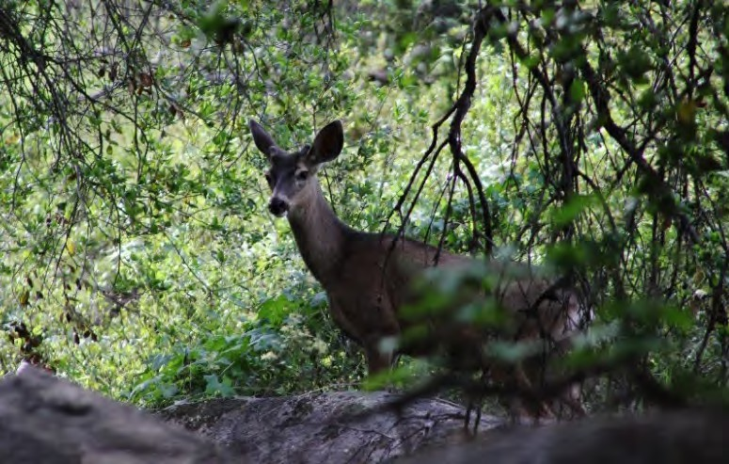
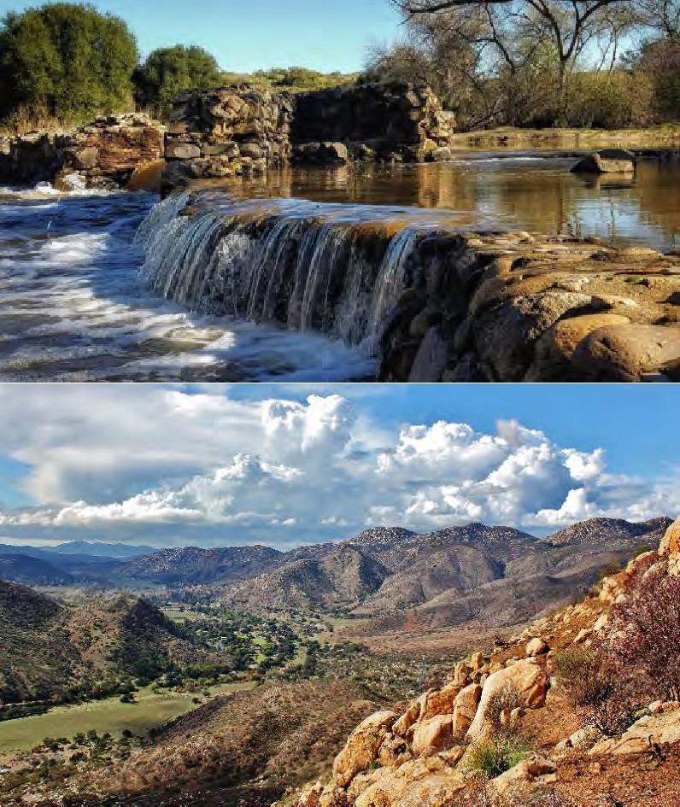

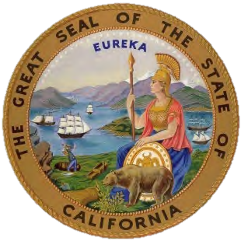
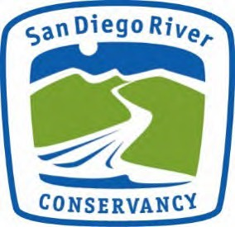
January 20, 2023

San Diego River Conservancy 11769 Waterhill Road, Bldg. 2
Lakeside, CA 92040 https://sdrc.ca.gov/

Julia.richards@sdrc.ca.gov

January 20, 2023

The Honorable Gavin Newsom Governor of the State of California
The Honorable Members of the California State Legislature

Dear Governor Newsom and Members of the California State Senate and Assembly,

On behalf of the 17-member Board of the San Diego River Conservancy, we are pleased to submit our Legislative Report to the Governor and Legislature outlining the Conservancy’s activities over the past two years, consistent with Assembly Bill 392 approved by the Legislature and signed by former Governor Jerry Brown in 2015.

The San Diego River Conservancy protects and preserves the natural, cultural, and historic resources of the San Diego River that extends 52 miles from the headwaters of the river near Julian, California west to the Pacific Ocean. The San Diego River and watershed encompasses 281,600 acres. Stakeholders include the US Forest Service, Kumeyaay Tribal Governments, the Department of State Parks and Recreation, California Department of Fish and Wildlife, the City of San Diego, the City of Santee, the City of El Cajon, the County of San Diego, many non-profit organizations, and members of the public. These allies revere this precious asset in our region and work to protect and improve it.

Progress has been made through the hard work and dedication of those who work, live, and volunteer along the river, including federal, state, and local agencies, elected officials and local Native American tribes. Together we offer public access to public lands, recreational activities for all ages, protection and enhancement of wildlife habitat and species, nature-based restoration, and preservation of cultural and historic assets within the watershed. Our focus also includes anticipating and dealing with the impacts of climate change, carbon sequestration by newly planted native plants and trees and sea level rise, including saltwater intrusion at the mouth of the river.

On behalf of the Board and staff of the San Diego River Conservancy, we are pleased to submit this biennial report covering what we have accomplished and our goals for the future.

Sincerely,
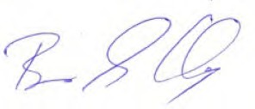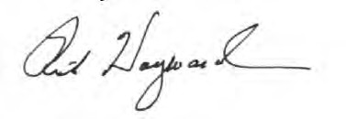
Ben G. Clay, Chair Ruth Hayward, Vice Chair
San Diego River Conservancy San Diego River Conservancy

Julia.richards@sdrc.ca.gov

January 20, 2023

The Honorable Gavin Newsom, Governor of the State of California Honorable Members of the California State Legislature

Dear Governor Newsom and Members of the State Senate and Assembly,

On behalf of the San Diego River Conservancy, thank you for your continued interest and support of work by the Conservancy to protect and enhance the unique history, natural resources, and cultural heritage within the San Diego River watershed. Attached is a Legislative Report on the Conservancy’s progress for 2021 and 2022. The Conservancy was established in 2002, and now 20 years later the Conservancy serves as a catalyst for improvements within the San Diego River watershed by working with local jurisdictions, government agencies, tribal nations, academic institutions, nonprofits, and coalitions that share an appreciation of and vision for the river. The Conservancy leverages local, state, federal, and other funding sources through innovative partnerships to yield projects with multiple benefits.

The native people, the Kumeyaay have lived in the San Diego River watershed since time immemorial. Preserving their cultural and tribal heritage and providing enhancements to their communities is a priority of the Conservancy. We honor their ancestors and respect their traditional ecological knowledge to guides environmental stewardship and sustainability through relationships between humans and environmental systems.

The Conservancy prides itself on being a steward of the environment that fosters relationships with organizations with the commitment and capacity to restore and improve the river and its watershed through resource protection. In addition, the Conservancy works with its partners to support public access to public lands along the San Diego River Trail, which creates unique opportunities to experience nature and outdoor recreation.

There are so many people to thank for the completed and ongoing improvements to public access and trails, water quality and supply, and protection of resources within the San Diego River watershed, beginning with the members of the Conservancy’s Governing Board and our dedicated staff. It is through the combined efforts of elected officials, government agencies, Native American Tribes, and the many stakeholders, including dedicated volunteers, that the health of the river and its watershed continues to improve.

The Conservancy’s Board and staff members greatly appreciate the continued confidence and support the Governor and Legislature have placed in the San Diego River Conservancy Board and staff members.

Sincerely,
Julia L. Richards Executive Officer
San Diego River Conservancy

Executive Summary

The San Diego River Conservancy was established in 2002 to conserve land, protect and preserve natural, cultural, and historic resources, and provide recreational opportunities for the public within the San Diego River watershed. The San Diego River starts at its headwaters in Julian, flowing southwest through the Cleveland National Forest before it enters the El Capitan Reservoir. The San Diego River continues westward from Lakeside through rural and urban areas to its terminus at the mouth of the river in Ocean Beach. The Conservancy's goals include conserving land, promoting outdoor recreation and education, and completing the San Diego River Trail from the Pacific Ocean to the Cuyamaca Mountains.
Over the years, the Conservancy's statute has expanded to include preserving cultural and tribal resources connected to the river. The Conservancy also aims to increase biodiversity through native habitat restoration while balancing the need for public access. In this Legislative Report, the Conservancy provides an overview of its highlights, sets out its operating budget, and summarizes its 2021-2022 accomplishments under each of the six programs within its strategic plan.
As discussed throughout the report, the Conservancy received funding in the Budget Acts of 2020 and 2021 for wildfire and forest resilience projects. In 2021 and 2022, the Conservancy awarded its regional partners $18 million in grants. Grant funds are used to implement projects that reduce flammable fuel loads on public and private lands, reduce the risk and intensity of wildfires in the San Diego region and restore the ecological health of native habitats within the San Diego, Sweetwater, Otay and Tijuana River watersheds. Approved projects included:
- Procuring firefighting apparatus (fire engines and command vehicles) and equipment (fire hoses, fire-resistant protective clothing, helmets, respirators, ladders, power tools, hand tools, and communication equipment) to improve public safety, fire suppression and forest health
- Holding community events and conducting public outreach to support and encourage the establishment of defensible space for homeowners in the Wildland-Urban Interface (WUI) zone

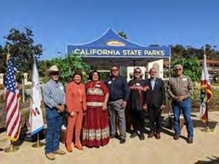
On October 26, 2021, San Diego River Conservancy Board Members and staff were invited to attend a ceremony to commemorate the Kumeyaay people and their connection to the San Diego River was held. The completion of The Iipay ~ Tipay Kumeyaay Mut Niihepok (Land of the First People) area in Old Town San Diego State Historic Park was attended by 12 Kumeyaay Bands. Kumeyaay tribal members performed bird songs in the traditional music of the Kumeyaay and elders blessed the area in their native language. Photo right includes Dave Toler, Jr., Senate President Pro Tempore
Toni Atkins, Angela Elliott-Santos, Chairwoman (Manzanita Band of the Kumeyaay Nation), John Christman, Chairman (Viejas Band of Kumeyaay Indians), Johnny Elliot, Chairman (Kumeyaay Diegueño Land Conservancy), State Parks Director Armando Quintero.

Overview of the Conservancy’s Highlights

In January 2021, the Governor’s Forest Management Task Force issued California’s Wildfire and Forest Resilience Action Plan. This Plan centers on building an extensive network of fuel breaks around vulnerable communities, expanding home hardening, defensible space, and preparedness planning to create wildfire-adapted communities, and sustaining rural forested areas. Through the Conservancy’s Directed Grant Program, the Governing Board awarded $18 million through 12 grants to implement fuel reduction, road brushing, vegetation management activities, and improve forest health within the County of San Diego.

The Conservancy’s Invasive Non-native Plant Removal and Restoration Program focused on removal of vegetation in the San Diego River area. The Conservancy Program’s annual regulatory report for the fiscal year 2021-2022 identified 16 project sites within the San Diego River watershed with a total of 80 acres of invasive plant removal, control, re-treatment, and restoration from a combination of funding sources.

San Diego County continues to experience growth and development with an emerging need to provide outdoor open space recreation for its nearly 3.3 million residents. In the City of San Diego, approximately 1 mile of the San Diego River Trail will be constructed as San Diego State University (SDSU) redevelops an area of Mission Valley to expand its campus. The redevelopment includes a stadium, mixed use space, housing, a hotel, and more than 80 acres of community parks and open space. Due to a need for outdoor recreation, this area will include a 34-acre River Park comprised of active and passive recreation, a two-mile hike, and bike loop around the perimeter. Additionally, of new public spaces will require public facilities. The Conservancy awarded SDSU a grant to install a solid concrete precast gender-neutral restroom in the River Park directly adjacent to the San Diego River.

State Parks’ Colorado Desert District is leading a new two-year pilot program, the Native American Conservation Corps, in partnership with the Resource Conservation District of Greater San Diego County and the Kumeyaay Diegueño Land Conservancy. The Conservancy received a $1 million allocation from the State Budget Act of 2021 to administer funds for State Parks and other partners to implement the pilot program. Various additional entities and individuals are assisting with the pilot program, including local tribal elders and leaders who provide information and share lessons on traditional ecological knowledge, prescribed burns, and forestry management.

The San Diego River Conservancy staff continues outreach to tribal, disadvantaged, low-income and vulnerable communities to offer technical assistance for project development, to identify funding sources and to apply for grants.

Operating Budget

  - $428,000 State Operations Budget; California Environmental License Plate Fund for FY 2021-22.
  - $390,000 State Operations Budget; California Environmental License Plate Fund for FY 2022-23.
  - The Conservancy’s accounting, budget, and human resources services are provided by the Department of General Services – Office of Fiscal Services, Contracted Fiscal Services, and Office of Human Resources.

Current Bond Programs

State bond funds provide funding to the Conservancy through:

  - Proposition 1: $17 million allocated through the Water Quality, Supply, and Infrastructure Improvement Act of 2014/23 projects approved.

  - Proposition 68: $12 million allocated through the California Drought, Water, Parks, Climate, Coastal Protection, and Outdoor Access for All Act of 2018/12 projects approved.

Budget Acts of 2021 and 2022

State General Fund allocations to the Conservancy through:

  - The Budget Act of 2021 allocated $25 million to the Conservancy for climate or wildfire resilience projects, community access, nature-based solutions, and a two-year pilot program for the Native American Conservation Corps.

  - The Budget Act of 2022 allocated $15 million to the Conservancy for programs and activities that advance wildfire protection and multi-benefit and nature-based solutions.

Summary of Conservancy Projects by Program Area

Program 1: Conserve Land within the San Diego River Watershed

The Conservancy approved a $2 million grant to the Mission Trails Regional Park Foundation to help acquire approximately 83 acres of in-holdings within the City of San Diego’s Mission Trails Regional Park. The Mission Trails Regional Park Master Plan adopted in 2019 reflected a vision for the park’s future and outlined priorities for acquiring over 700 acres of private property in the East Elliott Community Planning Area. Acquisition of these parcels furthers the Park’s Master Plan’s priorities and

prevents future development, provides open space, protects water quality, and increases recreational benefits within the San Diego River watershed.

Program 2: Support and Encourage Recreation and Education

The Conservancy’s mission includes providing recreational opportunities for the public. The Conservancy and its partners developed the San Diego River Recreational Trail Plan to achieve its long-term vision. Recreational facilities along the San Diego River Trail include the developed parks and open space, beaches, active sports fields, equestrian and polo fields, mountain biking areas, a bicycle motocross track, a disc golf course, campgrounds, the 8,000-acre Mission Trails Regional Park, the three-acre Santee Lakes Recreation Preserve, the 24,677-acre Cuyamaca Rancho State Park, and the 460,000-acre Cleveland National Forest which also includes wilderness areas with a multitude of critical habitats for animals and plants. In addition, there are five reservoirs within the watershed, some of which offer fishing, boating, and jet skiing opportunities.

Project Highlight: Lindo Lake County Park Improvement Project

The Conservancy awarded a grant to the County of San Diego, Department of Parks and Recreation, to restore the East Basin in Lindo Lake’s County Park (photo below). The project included trail improvements, the construction of a fishing pier and birdwatching stations, planting native trees, and treating stormwater runoff before it enters the lake. The Conservancy provided grant funding for the Lindo Lake project through Proposition 1 and Proposition 68.
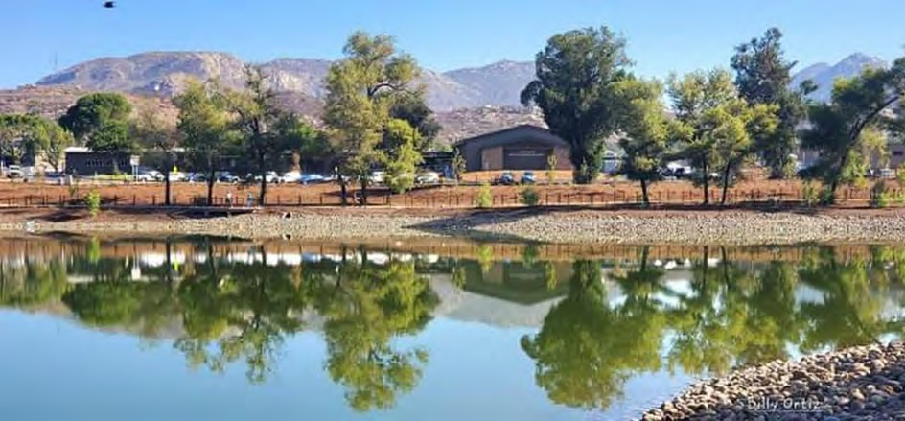
It is important to note that the community of Lakeside is a disadvantaged and vulnerable community within the unincorporated area of San Diego County. In general, disadvantaged communities throughout California suffer the most from economic, health, and environmental burdens. The Lakeside community's median household income of approximately $55,411 is around 70% of California's median household income, and the community contains disadvantaged and severely disadvantaged tracks (State Parks, 2020).

Project Highlight: San Diego River Science Field Station

The Science Field Station will provide an indoor space to promote environmental science and stewardship of the San Diego River. This living laboratory will be open to the public, is in a disadvantaged community, and will benefit students, teachers, and scientists of all ages. In addition, the facility will provide direct access to Lakeside’s River Park Conservancy's riparian habitat to engage people in tactile learning experiences. Existing programs focus on 6th graders and will expand to reach all skill and knowledge levels. Two collaborating school districts serve children from disadvantaged and severely disadvantaged neighborhoods with a large immigrant population. When completed, the Science Field Station will provide a community meeting space with access to the San Diego River Trail. The approved grant amount of $1,200,000 was provided from the Conservancy’s General Fund allocation.

Below is a table of projects supporting recreational opportunities and facilities. Three of the four projects serve disadvantaged communities in the County of San Diego.

Table 1. Recreation and Education Projects, Strategic Plan Program 2
Proposition 68
The California Drought, Water, Parks, Climate, Coastal Protection, and Outdoor Access for All Act of 2018
Grantee: San Diego State University (SDSU) | Title: SDSU Mission Valley Site Development and River Park – A solid concrete precast gender-neutral restroom
Agreement Period:  3/2022 – 1/2024 | Amount: $738,000  Status: In Progress
Grantee: Lakeside’s River Park Conservancy | Title: A Pocket Park on the San Diego River Trail
Agreement Period:  1/2022 – 12/2022 | Amount: $147,150  Status: Complete
Grantee: Lakeside’s River Park Conservancy | Title: Design and Planning for the San Diego River Science Field Station
Agreement Period:  4/2020 – 4/2023 | Amount: $250,000  Status: In Progress
Grantee: County of San Diego, Department of Parks and Recreation | Title: Lindo Lake County Park Improvement Project, East Basin
Agreement Period:  12/2020 – 3/2023 | Amount: $250,000  Status: In Progress

Program 3: Preserve and Restore Natural Resources
Wildfire and Forest Resilience Program
California is facing a growing forest and wildfire crisis. Decades of fire suppression, coupled with the increasing impacts of global warming and climate change, have dramatically increased the size and intensity of wildfires in the state. However, the Governor and the Legislature have been forward-thinking and created the Wildfire Early Action Plan (Plan) to provide funding for state agencies to immediately implement protective measures at a regional level to improve the protection of life and property for all Californians.

From May 2021 through November 2022, the Governing Board of the Conservancy approved approximately $18 million in funding for projects to help reduce the risk and intensity of wildfires in San Diego County. These fuel reduction efforts will decrease the wildfire risks around the communities, homes, infrastructure, critical habitat zones, and other highly valued resources, including wildlife passages and disadvantaged communities. These projects will provide new vehicles and fire-related apparatus to help reduce the risk of fire by implementing fuel reduction, vegetation management, defensible space, and fuel breaks targeting the removal of diseased, dead, and dying trees. Some of the fire equipment to be purchased under this program includes fire engines, brush rigs, command vehicles, skid steers, and masticators. This equipment helps reduce flammable fuel loads, which slows or stops the fire in these areas and strengthens the protection of places in San Diego County’s backcountry. The Conservancy funded projects include:

United States Forest Service – Cleveland National Forest
The Cleveland National Forest’s (CNF) Wildfire Resilience and Forest Health Project will reduce fuel loads across approximately 1,855 acres, 100 miles of road brushing, and hire additional employees for two years to protect sensitive resources. In addition, the project includes the installation of a helicopter landing zone and three 10,000-gallon underground water tanks that will provide a local source of water to help reduce wildfire severity and improve the safety of visitors and first responders in the upper San Diego River watershed. (Grant amount
$3,715,632). Photos below show CNF pile and prescribed burns.
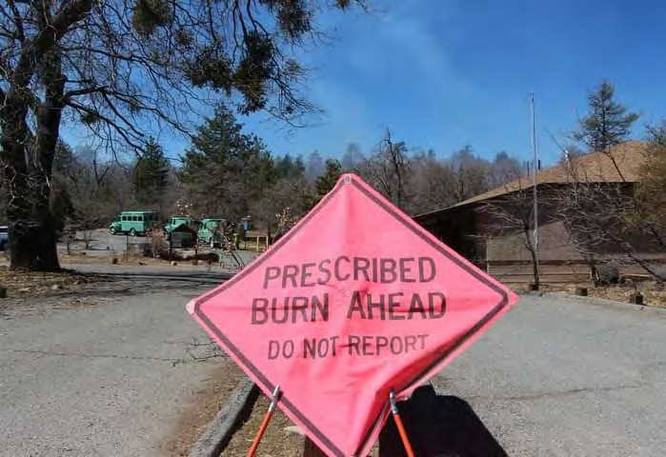
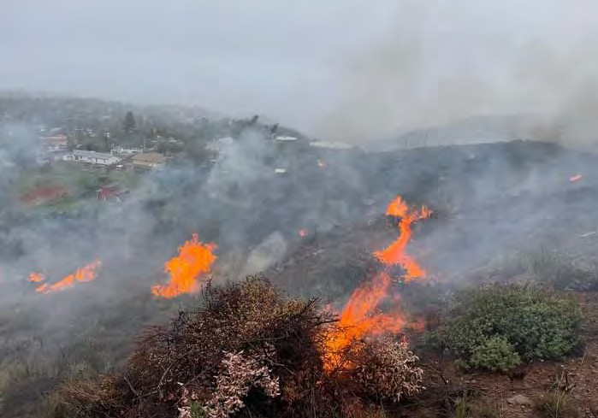

County of San Diego, Department of Parks and Recreation
This project focuses on the immediate need to conduct fuel reduction and perform weed abatement throughout 10,000 acres of developed parks and open space lands owned and managed by County Parks and includes the procurement of equipment necessary for project implementation. Areas served include the following river watersheds: San Diego, Sweetwater, Otay, and Tijuana. (Grant amount $3,450,000)

Viejas Band of Kumeyaay Indians
This project will replace a 17-year-old Brush Rig (Type 3 fire engine) and include vegetation management activities. This type of fire apparatus is built and equipped 4-wheel drive units specially adapted for fire suppression in wildland terrain. In addition, fire hydrants are sparse in many wildland areas, and this engine can carry 500 gallons of water, making them better equipped to protect communities. The Viejas Reservation is located within the Wildland-Urban Interface in rural San Diego County, and surrounded by the Cleveland National Forest and within the very High Fire Threat Zone, as identified by CAL FIRE. (Grant amount $620,000)

Kumeyaay Diegueño Land Conservancy
Through the Kumeyaay Diegueño Land Conservancy, the Campo Band of Mission Indians, the Campo Fire Protection District, the Jamul Indian Village, the Manzanita Band of the Kumeyaay Nation, the Viejas Band of Kumeyaay Indians, and the Sycuan Band of the Kumeyaay Nation will use wildfire funds to procure fire- related equipment, such as a skid steer with masticator (photo right) and vehicles to use during wildland fire events. These tribal reservations are in the High Fire Threat Zone, as identified by CAL FIRE. (Grant amount
$800,000)

Barona Band of Mission Indians
The Barona Band of Mission Indians, in partnership with the Barona Fire Department, will use wildfire funds to purchase a new Brush Rig, including a pump, and water tank. Barona will also use funds to install emergency lighting, emergency radios and onboard wireless technology to provide up to date information during a wildfire or other emergency events via the onboard mobile data computer. The Barona Reservation is in the High Fire Threat Zone, as identified by CAL FIRE. (Grant amount $350,000)

  - Resource Conservation District (RCD) of Greater San Diego County The RCD of Greater San Diego County will reduce the threat of wildfires by providing defensible space and free chipping for private landowners or
homeowners. These fuel reduction activities include removing dead, dying, and diseased trees within 100 feet of defensible space around structures. This project has treated over 1,200 acres of private property and served 400 homes to date.

In addition, the Conservancy helps to improve the safety of local communities through grants to six Fire Safe Councils within the County of San Diego. (Grant amount $3,500,000)

San Diego Canyonlands
The San Diego Canyonlands project will reduce the fire risk within land owned by the City of San Diego’s Open Space Division in the San Diego River watershed and tributary canyons. Approximately 1,110 acres will benefit from the fuel reduction activities to reduce fire risk while maintaining habitat values throughout the Serra Mesa and Tierrasanta communities in the City of San Diego. (Grant amount $1,000,000)

Lakeside’s River Park Conservancy
Lakeside’s River Park Conservancy will reduce flammable fuels in El Monte Valley on public and private land in the Wildland Urban Interface area of the unincorporated community of Lakeside. The project will take place on approximately 62 acres across CAL FIRE’s High Fire Threat Zone in the County of San Diego. Lakeside neighborhoods include disadvantaged and low-income tracts. (Grant amount $500,000)

City of El Cajon
The City of El Cajon will implement wildfire management strategies across 85 acres and purchase a new Type 1 Fire Engine. In addition, El Cajon will implement a three-pronged approach that includes developing a vegetation and wildfire management plan, a training and education program, and activities to clear and reduce flammable fuels near the Fletcher Hills Open Space and Hillside Park. El Cajon serves people from disadvantaged and severely disadvantaged neighborhoods with a large immigrant population. El Cajon is in the High Fire Threat Zone, as identified by CAL FIRE. (Grant amount
$3,125,000)

San Diego State University Research Foundation
The San Diego State University campus is adjacent to Alvarado Creek, a channelized urban stream with substantial non-native vegetation that contributes to an increased risk of fire and flooding in this area. Removing highly flammable invasive non-native trees and vegetation and implementing restoration efforts will reduce the risk of fire, which has occurred numerous times. In addition, this project will control vegetation across 9 acres in CAL FIRE designated high-fire risk area immediately adjacent to the campus and nearby homes. (Grant amount
$656,815)

City of Santee
The City of Santee will implement wildfire management strategies and reduce fuel loads on 11 acres along the San Diego River. Removing flammable brush will provide more defensible space adjacent to existing residences, parks, and trails. In addition, Santee will procure a light Brush Rig for use by the Santee Fire Department. (Grant amount $500,000)

Invasive Non-Native Plant Removal Program
Conservancy partners are currently implementing fuel reduction projects through weed abatement, brush management, and actively supporting healthy ecosystems. The Conservancy began its Invasive Non-native Plant Removal and Restoration Program in 2009. As a result, the Conservancy and its partners have been reducing flammable biomass in the San Diego River watershed for over 11 years. Removing invasive plants along the river decreases the risk of fire and flood and can also act as a fire break along trails and property lines.

Since the program’s inception in 2009, the Conservancy has overseen the restoration of more than 375 acres of riparian and upland habitat in the San Diego River watershed. This multi-benefit program continues to protect the public and decrease the risk of flood and fire. In addition, the program restores native habitats for sensitive and endangered species resulting in increased biodiversity.

Annually, the Conservancy enters into multiple partnership agreements to allow other organizations to use its permits for invasive non-native plant removal within the San Diego River watershed. These agreements are available to public agencies, non- profits, and other stakeholders at no cost through an established partnership agreement to implement projects with specific deliverables that must be met.
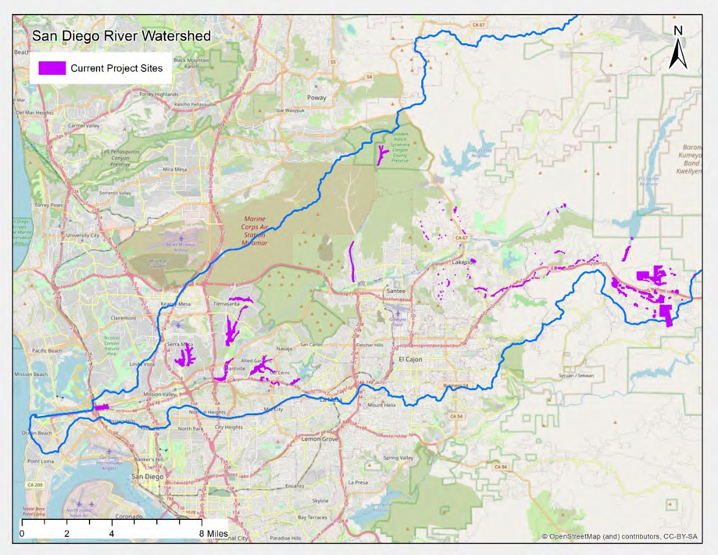
Map 1. Invasive Non-native Plant Removal and Restoration Program & Partnership Agreements 2021-22 (235 acres)

In addition, the Conservancy oversees removal restoration projects, gathers information on locations, and submits annual reports to the Army Corps of Engineers and other regulatory agencies to document past and future work. Below is a list of completed and ongoing invasive removal and control projects from 2021 and 2022 in the San Diego River watershed:

Table 2. Invasive Non-Native Plant Removal & Habitat Restoration Projects, Strategic Plan Program 3
Proposition 1
The Water Quality Supply and Infrastructure Improvement Act of 2014
Grantee: Lakeside’s River Park Conservancy | Title: East County Arundo Removal Project  (*located in a Disadvantaged Community)
Agreement Period:  9/2019 – 10/2022 | Amount: $420,000  Status: Complete
Grantee: City of Santee | Title: Habitat Restoration and Erosion Control at Walker Preserve
Agreement Period:  6/2017 – 6/2021 | Amount: $256,665  Status: Complete
Grantee: City of San Diego, Public Utilities Department | Title: Chaparral Canyon Habitat Restoration and Vegetation Management
Agreement Period:  4/2019 – 5/2022 | Amount: $382,513  Status: Complete
Grantee: San Diego State University Research Foundation | Title: Restoration of the Del Cerro Section of Alvarado Creek
Agreement Period:  2/2019 – 7/2021 | Amount: $910,709  Status: Complete
Grantee: Lakeside’s River Park Conservancy | Title: Lower Sycamore Creek Arundo Control  (*located in a Disadvantaged Community)
Agreement Period:  9/2019 – 7/2021 | Amount: $212,600  Status: Complete
Grantee: San Diego Canyonlands | Title: Ruffin/Sandrock Canyon Habitat Restoration
Agreement Period:  11/2019 – 2/2022 | Amount: $514,400  Status: Complete
Grantee: San Diego County Department of | Title: Sycamore Canyon/Goodan Ranch Preserve Targeted Invasive

Parks and Recreation
Agreement Period:  11/2019 – 6/2022 | Amount: $203,000  Status: Complete
Grantee: San Diego State University Research Foundation | Title: San Diego State University’s Adobe Falls, Phase V
Agreement Period:  2/2022 – 2/2024 | Amount: $600,000  Status: In Progress
Grantee: San Diego Canyonlands | Title: Ruffin/Sandrock Canyon Habitat Restoration, Phase 2
Agreement Period:  3/2021 – 4/2023 | Amount: $600,000  Status: In Progress
State General Fund – Budget Act of 2021
Grantee: San Diego Canyonlands | Title: Navajo Canyon Palm Removal Restoration and Trail Improvement Project
Agreement Period:  9/2022 – 12/2024 | Amount: $600,000  Status: In Progress
Proposition 68
The California Drought, Water, Parks, Climate, Coastal Protection, and Outdoor Access for All Act of 2018
Grantee: San Diego State University Research Foundation | Title: Revegetation Water Quality Hydrology Geomorphology and Bioassessment in Alvarado Creek
Agreement Period:  1/1/2022 – 12/30/2023 | Amount: $467,691  Status: In Progress
Grantee: City of El Cajon | Title: Broadway Creek Restoration Phase A  (*located in a Disadvantaged Community)
Agreement Period:  12/2019 – 1/2023 | Amount: $250,000  Status: Complete
Grantee: City of El Cajon | Title: El Cajon Transit Center Community Connection Improvements (*located in a Disadvantaged Community)
Agreement Period:  4/2020 – 10/2023 | Amount: $250,000  Status: In Progress
Grantee: City of El Cajon | Title: Main Street Greenstreet Gateway Improvements  (*located in a Disadvantaged Community)
Agreement Period:  12/2020 – 9/2023 | Amount: $250,000  Status: In Progress

Cuyamaca Rancho State Park Reforestation Project
The 2003 Cedar Fire burned 273,246 acres, constituting over 13% of San Diego County in total, destroyed 2,820 buildings, killed 15 people, and decimated approximately 75% of the 209,118-acre San Diego River watershed. Conifer mortality in Cuyamaca Rancho State Park was high due to the fire severity and extremely high temperatures, which resulted in very low seed cone survival. In response, State Parks established a reforestation program in 2009. Subsequently, in 2019 and 2021 the Conservancy's Governing Board invested a total of $1 million in State Parks' reforestation efforts in the San Diego River's upper watershed for treatment on approximately 622 acres. This reforestation project provides multi-benefits, including improved forest health, restoration of sensitive wildlife habitats and corridors, carbon sequestration, increased resiliency to future fires, reduced run-off, and increased water infiltration in the upper San Diego River watershed.

Program 4: Protect and Preserve Cultural and Historical Resources

The Conservancy has partnered with Kumeyaay tribes and the Kumeyaay Diegueño Land Conservancy to implement projects under the Wildfire and Forest Resilience program discussed above under Program 3 and the Native American Conservation Corps discussed below under Program 6.

Additionally, to better protect and preserve sensitive cultural resources associated with the Cleveland National Forest’s Wildfire Resilience and Forest Health project, additional funds were awarded for engaging qualified Kumeyaay Cultural Monitors who will have firsthand exposure to project activities so that they may make recommendations to the archaeologist onsite, as well as directly report their observations to their tribal leadership. In the past, Cleveland National Forest did not have funding to pay for cultural monitors, who often volunteered their services and expertise. This $150,000 grant provides compensation for qualified Kumeyaay cultural monitoring activities within the Cleveland National Forest.

Program 5: Enhance Water Quality and Natural Flood Conveyance

The Conservancy has continued to collaborate with its partners on projects and programs that improve water quality and supply within the local watersheds of the San Diego, Sweetwater, Otay, and Tijuana Rivers.

Below is a table of water quality and natural flood conveyance enhancement projects. Three of the four projects serve disadvantaged, severely disadvantages and low- income communities in the San Diego County.

Table 3. Water Quality and Supply, and Flood Conveyance Projects, Strategic Plan Program 5
Proposition 1
Water Quality Supply and Infrastructure Improvement Act of 2014
Grantee: City of El Cajon | Title: Wells Park Sustainability Improvements  (*located in a Disadvantaged Community)
Agreement Period:  12/2019 – 4/2023 | Amount: $400,000 Status: In Progress
Grantee: City of El Cajon | Title: Broadway Creek Restoration Phase A  (*located in a Disadvantaged Community)
Agreement Period:  12/2019 – 1/2023 | Amount: $750,000  Status: In Progress  https://www.facebook.com/CityOfElCajon/videos/1809168449416774/
Grantee: San Diego County Department of Parks and Recreation | Title: Lindo Lake Improvement Project, East Basin  (*located in a Disadvantaged Community)
Agreement Period:  4/2021 – 3/2023 | Amount: $600,000  Status: In Progress
Grantee: The San Diego River Park Foundation | Title: San Diego River Cleanups Events & Outreach
Agreement Period:  12/2021 – 5/2022 | Amount: $9,000  Status: Complete

Program 6: Expand the Organization’s Capacity and Public Outreach

Native American Conservation Corps
State Parks developed a two-year pilot program for local Native American tribes to participate in training for fire and forest resiliency activities in San Diego County. The program’s goal is to increase employment opportunities for local Native Americans with their respective tribes, State Parks, U.S. Forest Service, or other local organizations.
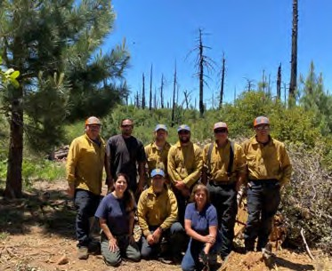
Through this project, State Parks will increase their capacity for reforestation, prescribed burning, restoring wildlife habitat, and reducing hazardous fuels in the upper watershed of the San Diego, Sweetwater, and Tijuana Rivers. The lead for this project is the California Department of Parks and Recreation’s Colorado Desert District.

The program provides on-the-job training at Cuyamaca Rancho State Park in basic wildland fire, chainsaw use in the wilderness, basic first aid and CPR, GPS training,

plant identification, and traditional ecological knowledge. Many partners provide training, including the Resource Conservation District of Greater San Diego County, Tribal Elders, Kumeyaay Diegueño Land Conservancy, Cleveland National Forest, and others. After participants complete training, some individuals will return to their tribal communities to work, and others have received opportunities to work on fuel crews for State Parks and neighboring tribes. The photo shows cohort 1 participants in the spring of 2021 on a worksite in Cuyamaca Ranch State Park.

Below is a table of projects supporting recreation and associated facilities. Three of the four projects serve disadvantaged communities in the County of San Diego.

Table 4. Public Outreach & Capacity Building Projects, Strategic Plan Program 6
 | State General Fund – Budget Act of 2020
Grantee: California Department of Parks and Recreation |  | Title: Native American Conservation Corps  Leveraged/In-Kind funds $354,000
Agreement Period:  11/2021 – 5/2023 |  | Amount: $450,322  Status: In Progress
Grantee: Resource Conservation District of Greater San Diego County |  | Title: Native American Conservation Corps  Matching funds of $287,000
Agreement Period:  11/2021 – 5/2023 |  | Amount: $484,678  Status: In Progress
Grantee: Kumeyaay Diegueño Land Conservancy |  | Title: Native American Conservation Corps
Agreement Period:  11/2021 – 5/2023 |  | Amount: $65,000  Status: In Progress

Carbon Assessment for the San Diego River Watershed and Consortium Areas The Conservancy provided funds to San Diego Canyonlands and Dudek to partner on a study to develop a finer-scale resolution of local habitat and vegetation growth patterns to track potential carbon sequestration and identify focus areas for future restoration projects. In addition, the study included a literature review and analysis to calibrate measurements for carbon stock and sequestration rates for the San Diego River watersheds and Consortium areas. (Grant amount $65,000)

San Diego State University
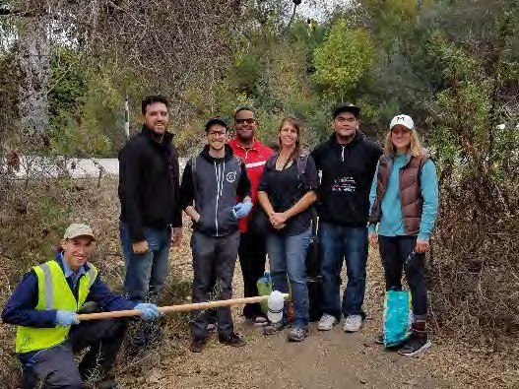
The Conservancy and San Diego State University continue to find partnership opportunities for project advancement to support the missions of both organizations. The San Diego River Research Center concept includes having San Diego State University and other partner organizations gather data and share information related to local river watersheds.
Recent publications include:

  - Chemical and microbial markers for
discriminating sanitary sewer contamination in coastal, urban streams. Pinongcos, F. et al. (2022) https://pubs.acs.org/doi/10.1021/acsestwater.2c00265

  - Surface Water Quality After the Woolsey Fire in Southern California. Barron et al. (2022)
https://link.springer.com/article/10.1007/s11270-022-05844-x

  - Persistence of fecal indicators and microbial source tracking markers in riverbank soils. Calderon, J. et al. (2022)
https://link.springer.com/article/10.1007/s11270-022-05542-8

  - Upland and riparian surface soil processes in an urban creek with native and non-native vegetation after fire. Kinoshita, A. et al. (2022) https://www.mdpi.com/2571-6255/5/2/32/htm

  - An assessment of ambient water quality, sanitation, and hygiene challenges for individuals experiencing homelessness at encampments located along river margins. Verbyla et al. (2021) https://www.liebertpub.com/doi/full/10.1089/ees.2020.0319

  - Groundwater-surface water interactions and flux of organic matter and nutrients in an urban Mediterranean stream. Mladenov, N. et al. (2021) https://pubmed.ncbi.nlm.nih.gov/34914998/

  - Fluorescence-based monitoring of anthropogenic pollutant inputs to an urban stream in Southern California, USA. Mendoza, L. et al. (2020) https://www.sciencedirect.com/science/article/pii/S0048969720307166?via%3Dih ub

  - Detection, quantification, and simplified wastewater surveillance model of SARS- CoV-2 in the Tijuana River. Rocha, A. et al.
https://www.calstate.edu/impact-of-the-csu/research/coast/funding/Pages/SARS- COV-2_in_Natural_Waters.aspx

  - A case study of soil moisture and infiltration after an urban fire. Alkin, Q. and Kinoshita, A. (2020)
https://www.mdpi.com/2571-6255/3/2/22

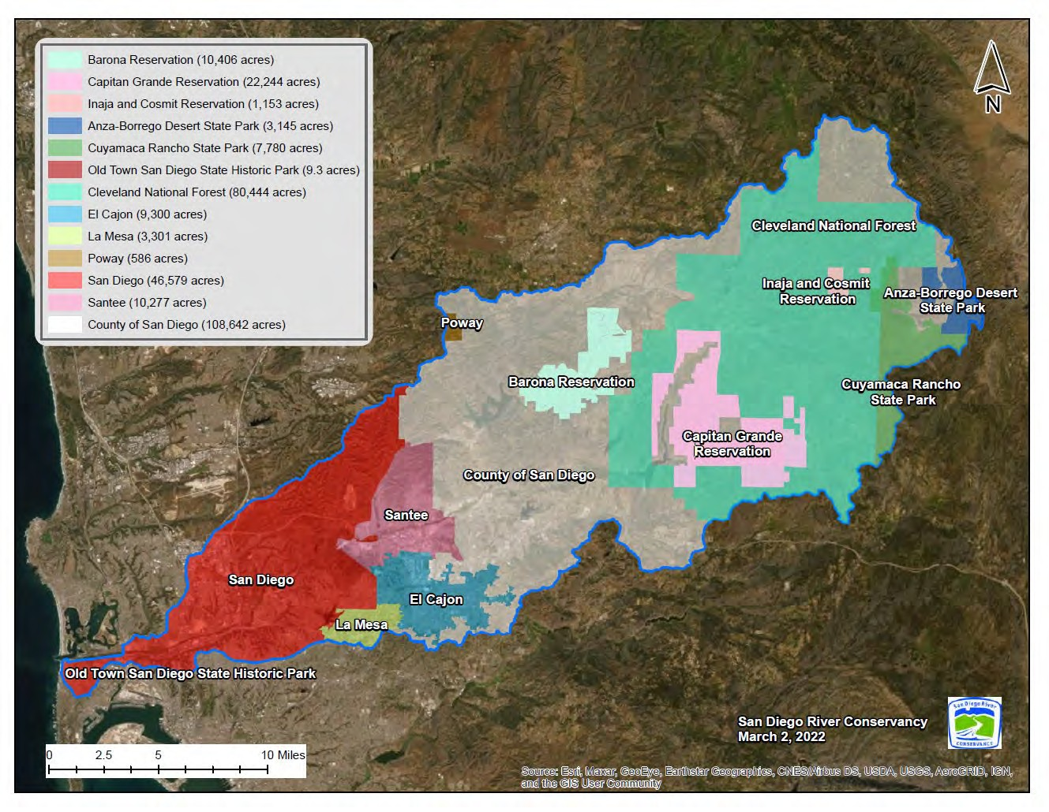

17
San Diego River Conservancy’s Legislative Report
2021-2022

Map 2. The San Diego River Watershed (County, State, Federal, Tribal and Municipal Jurisdictions)

The San Diego River Conservancy (Conservancy) continues to work with and expand partnerships to implement projects in support of the Conservancy’s mission and statute. The Conservancy’s mission is to protect natural, historical, cultural and tribal resources, open space, native habitat, improve water quality, support natural flood conveyance and provide for public access to public lands for the enjoyment of nature and outdoor recreational opportunities. The Conservancy consists of 3 fulltime staff and 18 Governing Board members.

SAN DIEGO RIVER CONSERVANCY’S STRATEGIC PLAN: PROGRAM SUMMARY

Program 1: Conserve Land within the San Diego River Watershed
The Conservancy approved a $2 million grant to the Mission Trails Regional Park Foundation to help acquire approximately 83 acres of in-holdings within the City of San Diego’s Mission Trails Regional Park. The Mission Trails Regional Park Master Plan, adopted in 2019, reflected a vision for the park’s future and outlined priorities for acquiring over 700 acres of private property in the East Elliott Community Planning Area.

Program 2: Support and Encourage Recreation and Education
The Conservancy’s mission includes providing recreational opportunities for the public. The Conservancy and its partners developed the San Diego River Recreational Trail Plan to achieve its long-term vision of a trail spanning from the ocean to the headwaters. Recreational facilities along the San Diego River Trail include parks and open space, beaches, sports fields, equestrian and polo fields, mountain biking areas, a bicycle motocross track, a disc golf course, campgrounds, the 8,000-acre Mission Trails Regional Park, the three-acre Santee Lakes Recreation Preserve, the 24,677-acre Cuyamaca Rancho State Park, and the 460,000-acre Cleveland National Forest. Additionally, some of the five reservoirs within the watershed offer fishing, boating, and jet skiing opportunities.

Lakeside’s River Park Conservancy
The San Diego River Science Field Station will provide an indoor space to promote environmental science and stewardship of the San Diego River. This living laboratory will be open to the public and will benefit students, teachers, and scientists of all ages. In addition, the facility will provide direct access to Lakeside’s River Park Conservancy's riparian habitat to engage people in tactile learning experiences. Existing programs focus on 6th graders, but will expand to reach all skill and knowledge levels. Two collaborating school districts serve children from disadvantaged/severely disadvantaged neighborhoods with a large immigrant population. When completed, the Science Field Station will provide a community meeting space with access to the San Diego River Trail. The grant amount of
$1,200,000 was provided by the Conservancy’s General Fund allocation.

Program 3: Preserve and Restore Natural Resources, and the Wildfire and Forest Resilience Program

Cuyamaca Rancho State Park Reforestation Project
The 2003 Cedar Fire burned 273,246 acres constituting over 13% of San Diego County in total, destroying 2,820 buildings, killing 15 people, and decimating approximately 75% of the 209,118-acre San Diego River watershed. In addition, conifer mortality in Cuyamaca Rancho State Park was high due to the fire severity and extremely high temperatures, which resulted in very low seed cone survival; as a result, State Park established a reforestation program in 2009. Subsequently, the Conservancy's Governing Board invested $1 million in State Parks' reforestation efforts in the San Diego River's upper watershed for treatment on approximately 622 acres. This reforestation project provides multi-benefits, including improved forest health, restoration of sensitive wildlife habitats and corridors, carbon sequestration, increased resiliency to future fires, reduced run-off, and increased water infiltration in the upper San Diego River watershed.

Invasive Non-native Plant Removal and Restoration Program Conservancy partners are currently implementing fuel reduction projects through weed abatement, brush management, and actively supporting healthy ecosystems. One of the co-benefits is that the Conservancy and its partners have been reducing flammable biomass in the San Diego River watershed for over 14 years. Removing invasive plants along the river decreases the risk of fire and flood and can act as a fire break along trails and property lines.

In addition, the Conservancy oversees removal restoration projects, gathers information on locations, and submits annual reports to the Army Corps of Engineers and other regulatory agencies to document past and future work. Annually, the Conservancy issues multiple partnership agreements to allow other organizations to use its permits for invasive non-native plant removal within the San Diego River watershed. These agreements are available to public agencies, non-profits, and other stakeholders at no cost through an established partnership agreement to implement projects with specific deliverables that must be met.

In 2023, the Conservancy continues to work with its grantees and partners to remove invasive plant species and conduct restoration in the San Diego River Watershed.

Grantee | Project | Acres
San Diego Canyonlands | Ruffin and Sandrock Canyon removal and restoration Phase 2 | 11
San Diego State University Research Foundation and the Soil Ecology Restoration Group | San Diego State University’s Adobe Falls, Phase 5 | 13
San Diego Canyonlands | Navajo Canyon palm removal, restoration and trails improvement project, Phase 1 (250+ palms) | 7
Back Country Land Trust | Healthy Headwaters Initiative for the Alpine/ El Capitan Basin | 1.5
The Nature Collective | San Diego River Arundo removal project | 15.3
San Diego Metropolitan Transit System (MTS) | Arundo Removal at Alvarado Creek near MTS Grantville station | 0.5
City of San Diego, Public Utilities Department | San Diego River healthy headwaters restoration project at El Capitan Reservoir | 2.5

Wildfire and Forest Resilience
The Governing Board of the Conservancy approved approximately $19 million for projects to help reduce the risk and intensity of wildfires in San Diego County, in addition to the Conservancy’s Invasive Non-native Plant Removal and Restoration program.
The table below lists wildfire and forest reliance projects approved by the Conservancy Board and will continue to be implemented in 2023.

Grantee | Project Description
County of San Diego, Department of Parks and Recreation | Fuel reduction and weed abatement throughout 10,000 acres of parks and open space owned and managed by County Parks.
United States Forest Service  – Cleveland National Forest | Reduce fuel loads across approximately 1,855 acres, clear brush from 100 miles of roads, and hire additional employees for two years to protect sensitive resources. In addition, installation of a helicopter landing zone and three 10,000-gallon underground water tanks.

Grantee | Project Description
Viejas Band of Kumeyaay Indians | Purchase of Type 3 fire engine with a minimum 500- gallon water tank.
Kumeyaay Diegueño Land Conservancy | Procure fire-related equipment, such as a skid steer with masticator and vehicles to use during wildland fire events.
Barona Band of Mission Indians | Purchase a new brush rig, with chassis, pump, water tank and compartments, emergency lighting, emergency radios and onboard wireless technology.
San Diego Canyonlands | Reduce fire risk across approximately 1,110 acres owned by the City of San Diego’s Open Space Division in the San Diego River watershed.
Lakeside’s River Park Conservancy | Reduce flammable fuels across approximately 62 acres in El Monte Valley on public and private land in the Wildland Urban Interface (WUI) of the unincorporated community of Lakeside.
Resource Conservation District of Greater San Diego County | Provide defensible space and free chipping for private landowners or homeowners over 1,200 acres.
City of El Cajon | Develop a vegetation and wildfire management plan, training and education program, and wildfire management activities to clear and reduce flammable fuels across 85 acres in Fletcher Hills Open Space and Hillside Park.
San Diego State University Research Foundation | Remove highly flammable invasive non-native trees and vegetation across 9 acres of university campus.
City of Santee | Implement wildfire management strategies and reduce fuel loads on 11 acres along the San Diego River.
Lakeside Fire Protection District | To install 3 very high frequency (VHF) radio repeaters in east county San Diego to cover dead zones in Lakeside and the western foothills of the Cuyamaca Mountains (Disadvantaged and low-income community)

Program 4: Protect and Preserve Cultural and Historical Resources

To better protect and preserve sensitive cultural resources associated with the Cleveland National Forest’s Wildfire Resilience and Forest Health project, additional funds were awarded to engage qualified Kumeyaay Cultural Monitors who will have firsthand exposure to project activities so that they may make recommendations to the archaeologist onsite, as well as directly report their observations to their tribal leadership. In the past, Cleveland National Forest did not have funding to pay for cultural monitors, who often volunteered their services and expertise. This $150,000 grant provides compensation for qualified Kumeyaay cultural monitoring activities in the Conservancy’s services areas.

Program 5: Enhance Water Quality and Natural Flood Conveyance

The Conservancy will continue collaborating with its partners on projects and programs that improve water quality and supply within the local watersheds of the San Diego, Sweetwater, Otay, and Tijuana Rivers. Three of the 4 projects serve disadvantaged communities in the County of San Diego.

Broadway Creek Restoration (Phase A)
This project will reinforce a heavily eroded section of Broadway Creek through the installation of gabions and the removal of invasive non-native plants to promote nature-based solutions for stormwater management in an urban environment.

Wells Park Improvement Project
The City of El Cajon will install 5 structural Low Impact Development devices including 2 stormwater retention basins to collect stormwater runoff and reduce the risk of flooding at Wells Park. Currently, this park lacks stormwater infrastructure and minor rain events have an adverse effect on park grounds causing floods and park closures. The project is located in a designated severely disadvantaged community.

Program 6: Expand the Organizations Capacity and Public Outreach

San Diego Canyonlands was awarded a grant to assist Conservancy staff in developing a 5- year strategic plan based on state plans and priorities. This yearlong process includes interviews with Governing Board Members, land managers, stakeholders and the general public.

Native American Conservation Corps
The lead for the project is the Colorado Desert District of the California Department of Parks and Recreation. State Parks developed a two-year pilot program for local Native American tribes to participate in training for fire and forest resiliency activities in San Diego County. The goal is to increase employment opportunities for local Native Americans with their respective tribes, State Parks, U.S. Forest Service, or other local organizations.

DIRECTED GRANT PROGRAM
The following applicants were invited to submit a full application. Conservancy staff is currently reviewing these proposals as follows:

Applicant | Project Description
San Diego Fire- Rescue Foundation | Request for thirty (30) new dry suits for the City of San Diego’s Swiftwater and Flood Rescue Team
San Diego State University | Install interpretive signs program at the River Park at SDSU Mission Valley
San Diego State University Research Foundation | Invasive plant removal in partnership with the Soil and Ecology Restoration Group on Alvarado Creek, Phases 7-9
Center for Natural Lands Management | Enhancing critical wildlife refugia in the San Diego River Watershed through ecological restoration
Lakeside’s River Park Conservancy | Invasive removal and restoration in east county San Diego
County Parks and Recreation | Improvements for the Flume Trail segment of the San Diego River Trail
County Parks and Recreation | Cactus County Park restroom replacement and site improvements
County Parks and Recreation | Cactus County Park refurbishments: Dugout, playgrounds, interpretive signs and snack bar
County Parks and Recreation | Lindo Lake County Park improvement project, Phase 2 (West Basin): Water quality and walking path improvements and facility maintenance
Lakeside Fire Protection District | Type 3 Wildland Engine
San Diego Audubon Society | Silverwood Wildlife Sanctuary conservation project
City of El Cajon | Broadway Creek restoration, Phase B
City of El Cajon | Broadway Creek’s trash capture project
City of El Cajon | San Diego River trash capture and reduction project in the City of El Cajon
Cleveland National Forest | Wildfire and forest resilience project, Phase 2
Mission Trails Regional Park Foundation | Interpretive program implementation

SUMMARY OF BOND FUNDS

Proposition 1 – Water Quality, Supply, and Infrastructure Improvement Act of 2014
- $17,000,000 allocated to the Conservancy.
- $11,313,641 approved for 23 projects.
- $5,686,359 remains for program delivery and project implementation.

Proposition 68 – California Drought, Water, Parks, and Climate, Coastal Protection, and Outdoor Access for All Act of 2018
- $12,000,000 allocated to the Conservancy.
- $4,262,841 approved for 12 projects.
- $5,737,159 remains for program delivery and project implementation.

The Governor’s proposed Budget for 2023-24, released in January 2023, allocated approximately $25,250,000 to the Conservancy for programs and activities that advance multi-benefit wildfire and forest resilience, land conservation (state 30x30 initiative), and nature-based projects. The May Revision will likely reduce allocations due to the projected shortfall in the state budget.

ADMINISTRATION/FISCAL DUTIES

- State Operations Budget $428,000; California Environmental License Plate Fund for FY 2022-23;
- State Operations Budget $390,000; California Environmental License Plate Fund for FY 2023-24;
- Prepare, execute and conduct Governing Board meetings;
- Coordinate and communicate with other state agencies, grantees, partners and the public;
- Review, respond and participate in various planning efforts in the San Diego River watershed, including CEQA review;
- Support state priorities and plans that align with Conservancy purposes and mission;
- Provide Bond accountability updates to state departments and databases, reports, cash projections and other relevant information as requested;
- Leverage funds through grant agreements;
- Prepare budgets, agreements, purchase documents, vendor payments, timesheets, accounting and various reports to other state agencies;
- Process bills, input purchase orders and pay invoices in Fi$Cal system;
- The Conservancy contracts out its accounting, budget and human resources services to the Department of General Services - Office of Fiscal Services, Contracted Fiscal Services and Office of Human Resources.

Meeting of March 2, 2023

ITEM: 14
SUBJECT: NEXT MEETING
The next regularly scheduled Board meeting will be held May 11, 2023, from 2:00 to 4:00 p.m.

Meeting of March 2, 2023
ITEM: 15
SUBJECT: ADJOURNMENT

