Notice of Public Meeting San Diego River Conservancy
A public meeting of the Governing Board of The San Diego River Conservancy
will be held Thursday,

July 13, 2023
2:00 pm – 4:00 pm
Meeting Location

County of San Diego Administration Center 1600 Pacific Highway, Room 302
San Diego, California 92101

Tele-Conference Locations

Natural Resources Agency Manzanita Reservation
715 P Street 6 Old Mine Road
20th Floor Mojave Room (20-104) Boulevard, CA 91905 Sacramento, CA 95814
Teleconference Line 877-411-9748, Code 3906093

For Questions Contact:
Wendell Taper at wendell.taper@sdrc.ca.gov or (619) 390-0568

Meeting Agenda

The Board may take agenda items out of order to accommodate speakers and to maintain a quorum, unless noted as time specific.

- Roll Call
- Approval of Minutes (ACTION)
Consider approval of minutes for the May 11, 2023, meeting.

- Public Comment (INFORMATIONAL)
Any person may address the Governing Board at this time regarding any matter within the Board’s authority. Presentations will be limited to three minutes for individuals and five minutes for representatives of organizations. Submission of information in writing is encouraged. The Board is

prohibited by law from taking any action on matters that are discussed that are not on the agenda; no adverse conclusions should be drawn by the Board’s not responding to such matters or public comments.

- Chairperson’s and Governing Board Members’ Report (INFORMATIONAL/ ACTION)

- Deputy Attorney General Report (INFORMATIONAL/ ACTION)

- Health and Safety Report (INFORMATIONAL)

Viejas Fire Department Proposal for Wildland Protection Equipment - Wildfire and Forest Resilience (ACTION)
The Viejas Band of Kumeyaay Indians resides in a remote area of San Diego’s east county, which contains wetlands, riparian, meadow, upland, wildland urban interface and oak woodland habitats. The Viejas Fire Department is requesting funding for one vehicle, portable radios, tools, and equipment for wildfire responders and treatment of hazardous fuels in the San Diego River and Sweetwater River watersheds. Conservancy staff recommends funding in the amount of $358,772 from the Budget Act of 2021.

Presentation:
Bob Pfohl, Fire Chief, Viejas Fire Protection District
Ray Teran, Resources Management Director, Viejas Tribal Government Recommendation: Approve Resolution 23-08

- San Diego River Conservancy’s Invasive Removal Program (ACTION)
The Conservancy’s invasive removal program was established in 2009 and the Conservancy and its partners implement the program to remove and control hundreds of acres in the watershed.
The proposed Project plans to renew the Conservancy’s Streambed Alteration Agreement permit for its Invasive Non-Native Plant Removal Program (program) for the San Diego River watershed, re-vegetate 15 acres and control invasive perennial non-natives in the lower and middle watershed. Conservancy staff recommends funding in the amount of $81,266 from the Budget Act of 2021.

Presentation:
Doug Gibson, Executive Director, Nature Collective Jason Giessow, DENDRA Inc.
Recommendation: Approve Resolution 23-09

- Alpine Fire Protection District’s Proposal for Fire Truck and Fuel Reduction Activities - Wildfire and Forest Resilience (ACTION)
Alpine Fire Protection District’s proposed project requests funding to procure a Type 6 Fire Engine and conduct hazardous fuels removal on 16 acres in Alpine Creek, a tributary to El Capitan Reservoir which separates the upper San Diego River. Alpine Fire Protection District is in the Wildland-Urban Interface area in San Diego’s east county, and abuts the Cleveland National Forest. CalFIRE’s Fire Hazard Severity Zones maps identified the community of Alpine as a High to Very High risk in the WUI.

Conservancy staff recommends $800,000 for the project, and if approved funding would be provided by Budget Act of 2021.

Presentation:
Brian Boggeln, Fire Chief, Alpine Fire Protection District Jason McBroom, Fire Marshal, Alpine Fire Protection District Recommendation: Approve Resolution 23-10

- Ranger Update on the San Diego River Valley in the City of San Diego
(INFORMATION)
The City of San Diego’s Park Rangers assist the public in use of open space park facilities, develop and conduct interpretive programs, patrol open space parks to enforce park rules and regulations, and to perform related work.

Presentation:
Tiffany Swiderski, Senior Ranger, City of San Diego

- Executive Officer’s Report (INFORMATIONAL/ ACTION)
The following topics may be included in the Executive Officer’s Report. The Board may take action regarding any of them:
Wildfire Project List
Proposed 2024 Conservancy Board Meeting Schedule: January 11
March 14
May 9
July 11
September 12
November 14

Next Meeting
The next regularly scheduled Board meeting is anticipated to be held in person on Thursday, September 14, 2023, from 2:00 to 4:00 p.m.

Adjournment
Accessibility
If you require a disability related modification or accommodation to participate in this meeting, including auxiliary aids or services, please call Wendell Taper at 619-390- 0568 or Wendell.Taper@sdrc.ca.gov

Meeting of July 13, 2023

ITEM: 1
SUBJECT: ROLL CALL AND INTRODUCTIONS
Meeting of July 13, 2023
ITEM: 2

SUBJECT: APPROVAL OF MINUTES (ACTION)
The Board will consider adoption of the May 11, 2023
Board Meeting.

PURPOSE: The minutes of the Board Meeting are attached for
review.

RECOMMENDATION: Approve minutes

SAN DIEGO RIVER CONSERVANCY

Minutes of May 11, 2023 Public Meeting (Draft Minutes for Approval on July 13, 2023)

CONSERVANCY Board Chair, Ben Clay called the May 11, 2023 meeting of the San Diego River Conservancy to order at approximately 2:03 p.m.
Item 1. Roll Call Members Present
Jennifer Campbell Mayor, City of San Diego, Designee
Raul Campillo Councilmember, City of San Diego, District 7 Ben Clay, Chair Public at Large
John Elliott Kumeyaay Diegueño Land Conservancy (arrived 2:05pm) Ruth Hayward Public at Large
Ray Lennox Department of Parks and Recreation Sally Lukenbill Department of Finance
Phil Ortiz City of El Cajon
Cody Petterson Speaker of the Assembly Elsa Saxod Public at Large
Gary Strawn San Diego Regional Water Quality Control Board Katherine Toy Natural Resources Agency
Dustin Trotter City of Santee

Absent
Joel Anderson Supervisor, County of San Diego, Second District Richard Burg Department of Fish and Wildlife
Rebecca Fris Wildlife Conservation Board

Staff Members Present
Julia Richards Executive Officer
Wendell Taper Associate Governmental Program Analyst Dustin Harrison Environmental Scientist
Hayley Peterson Deputy Attorney General Item 2. Approval of Minutes
John Elliott moved for approval of the minutes for the March 2, 2023 meeting and Elsa Saxod seconded. Roll Call: Ayes: Ben Clay, Ruth Hayward, Katherine Toy, Ray Lennox, Cody Petterson, Dr. Jennifer Campbell, Raul Campillo, John Elliott, Phil Ortiz, Dustin Trotter, Elsa Saxod (11-0-0).

Item 3. Public Comment (INFORMATIONAL)

No report.

Item 4. Chairperson’s and Governing Board Members’ Report (INFORMATIONAL)

Ben Clay welcomed the two new San Diego River Conservancy board members, Councilmember Phil Ortiz of El Cajon, and Katherine Toy of the California Natural Resources Agency. Ben also congratulated Ruth Hayward and Julia Richards for their accomplishments as the 2023 Women of the 39th District Honorees presented by

Senate President pro Tempore Toni Atkins. Also, several awards were received by the Conservancy to its support in of projects in furtherance of California’s Wildfire and Forest Resilience Action Plan from Senator Brian Jones, the Fire Safe Council of San Diego County, Assemblyman Randy Voepel, Assemblyman Chris Ward, Assemblymember Marie Waldron, Assemblyman Brian Maienschein, Assemblymember Tasha Boemer Horvath, San Diego County Supervisor Joel Anderson, San Diego County Supervisor Nora Vargas, San Diego County Supervisor Terra Lawson-Remer, San Diego County Supervisor Jim Desmond, and City Councilmember Joe LaCava.

Item 5. Deputy Attorney General Report (INFORMATIONAL/ACTION) No report.
Item 6. Health and Safety Report (INFORMATIONAL/ACTION) No report.
Item 7. Invasive Non-native Plant Removal, Retreatment and Revegetation Alvarado Creek – Phase 7
(ACTION)

Julia Richards mentioned a few things before the two action items. There are two projects both requesting approximately $2 million; however, these are two logistically different projects in separate parts of the City and County. One proposed project is from San Diego State University (SDSU) Research Foundation which is in the City of San Diego, and the other is for Lakeside’s River Park Conservancy in the County of San Diego.

SDSU began its invasive control and restoration in the upper reach of Alvarado Creek in 2015 on the SDSU campus. Since then, they have expanded to 6 phases. Additionally, 120+ identified palm trees are located near Interstate 8 on steep terrain, making access and maneuverability difficult. Helicopter removal is not an option here. In addition, SDSU professors and graduate students conduct research with numerous publications and will assist with revegetation in this area.

For Lakeside’s River Park Conservancy (LRPC), they are one of the few non-profits in east San Diego County serving private residences. The Conservancy has partnered with LRPC for nearly 12 years and they have demonstrated the ability to manage hundreds of acres of invasive vegetation removal and control. While these projects are not on steep terrain, they will require renewal of over 270 right of entry (ROE) permits to remove invasives plants from private landowners. It does no good to remove invasive plants and trees from public land, if the nearby private lands are a source of additional invasive plants. LRPC has identified over 300 large trees for removal, including palms which will be removed by subcontractors.

Ben Clay thanked Julia for the clarification regarding these two projects.

Julia Richards the proposed project plans to remove and control invasive trees and plants on approximately 14 acres along two sections of Alvarado Creek, a tributary to the San Diego River. The project site is on public land owned by San Diego State University and California’s Dept of Transportation- also known as CalTrans. This creek provides nesting and foraging areas for endangered plants, birds and wildlife, and restoration will improve water quality and revegetate sections of the creek. This project also includes continuation of a study on the impacts of creek restoration, post-fire monitoring and the health of the riparian ecosystem.

The Conservancy staff met with San Diego State University Research Foundation and Soil Ecology and Restoration Group to review the proposal. The proposed project is Consistent with San Diego River Conservancy enabling legislation, Identifies priorities from the Directed Grant Program. The proposed project is

supported by 3 Conservancy program areas and is aligned with the California Wildfire and Forest Resilience Action Plan and other state and local plans.

Additional information is located in the staff report, and if approved, funding would be provided through the Wildfire Package in the Budget Act 2021. Conservancy staff recommends approval of Resolution 23-05 to San Diego State University Research Foundation in the amount of $1,978,182.

Julia introduced Julie Lambert, Program Director, Soil Ecology and Restoration Group and San Diego State University Research Foundation who will provide a presentation on the proposed project and answer any questions the Board may have.

Julie Lambert introduced herself as Program Director for the Soil Ecology and Restoration Group (SERG). Their project Alvarado Creek Restoration Phase 7 team is composed of Dr. Natalie Mladenov, as water quality expert Dr. Alicia Kinoshita, as hydro-geomorphology expert and herself as project manager and restoration expert.
These efforts are a continuation of the restoration of Alvarado Creek funded by the San Diego River Conservancy over the past 8 years. To date, SERG in partnership with SDSU and the Conservancy has restored 9 acres by removing palm trees and other non-native vegetation. SERG planted native riparian species on the north and south side of Interstate 8.

This proposed project includes another 5 acres on the north side of Interstate 8, with 1.2 acres on SDSU property and 3.7 acres on CalTrans Property encompassing Adobe Falls. This area is congested with palm trees, giant reed and other non-native plants. The goals for this project are to restore disturbed riparian habitat to enhance wildlife habitat, reduce the risk of fire and increase streamflow. To assess the success of the restoration project, Drs Mladenov and Kinoshita will look at how water quality and hydro-geomorphology respond to the removal of vegetation.

The restoration work will enhance ecosystem health and biodiversity and also address climate change issues. Workforce development will be accomplished by hiring the services of San Diego Urban Corps as well as forming future engineers through the water studies at SDSU. Drs. Mladenov and Kinoshita have used the restoration of Alvarado Creek as their living laboratory for their undergraduate and graduate students. Several papers, presentations and posters have resulted from their work so far. The project will also promote the Conservancy’s goal to preserve and restore natural resources, enhance natural flood conveyance, and expand the Conservancy’s capacity and public outreach.

Other state goals will be promoted by reducing flood and fire risk, reducing water pollution, improving the scenic beauty of the San Diego River Watershed, as well as improve climate change resilience. With climate change, rain storm events are expected to be more intense, so now is the time to take action.

To achieve the following goals of the project, SERG will implement the following tasks: initial tree removal, restoration, water quality, hydro-geomorphology and historical resources compliance report mandated by CalTrans because rock milling structure has been found in the area. They want to preserve these resources as well. Initial tree removal will be sub-contracted to ACS Habitat Management and will occur in 2 stages. Tree removal in the SDSU section of Phase 7 will happen in the Fall of 2023, while tree removal in the CalTrans section will happen Fall 2024 to give them time to produce the Historical Resources Compliance Report which will be subcontracted to Rincon Consultants. Tree removal will be done in the same way as the previous restored phases except by cutting the trees into small sections chipped on site then taken to green waste facility.

Because of the steep terrain in the CalTrans section, ACS Habitat Management will not be able to remove the trees from the area so they will drill the trees and inject them with herbicide. Dead trees will be left in place to naturally degrade. There are only three access points to the Adobe Falls area. The culvert under Interstate 8 from SDSU to Adobe Falls. This route is unsafe. The other access is from Adobe Falls place. This goes past

private property and down an extremely steep slope which is also unsafe. The easiest access is from Adobe Falls cul-de-sac.

From there, the crew needs to cross the creek then travel along the utility road to access the creek. Access to the site and bringing the trees section down to the chipper will take a fair amount of time every day. Restoration will consist of maintenance weed control with manual, mechanical and chemical methods by SERG employees certified by the California Department of Pesticide Regulation.

They are budgeting for a 5-person crew to spend 4 days a week doing weed control throughout the 14 acres of restored land. They will revegetate a 5-acre area of the SDSU area of Phase 7. They have budgeted 1,000 person hours for this task.

One of the notable results that Dr. Mladenov have found is that indicator fecal bacteria either surpassed the state target during rain events and the E. coli levels are above target during rain events. She also stated and showed graphs that enterococci are above the state target during both the wet and dry season. This past winter, Dr.
Mladenov and her team installed a series of sensors along Alvarado Creek on SDSU campus that takes continuous water quality measurements which are automatically uploaded to serve as an early warning system for the community.

Hydro-geomorphology is the study of stream flow and channel morphology. The two graphs showed cross- sections of the creek in the exact same location two years apart. Pre-restoration in 2016 is on the top graph and two years after restoration on the bottom graph in 2018. The creek morphology circled in red has changed in the past two years after removal of palm trees.

Dr. Kinoshita will continue to monitor how creek morphology changes after restoration. This is important because non-native species like giant reed led to bank undercutting and associated aridification of the riparian area. Dr. Kinoshita will also look at other parameters such as the size of sediment and pebbles in the creek which are an indicator of habitat quality. In 2016, on the bar that’s in the front of the graph the majority are small pebbles. After removal of palm trees, the majority are large cobbles. Palm trees accumulate sediment.

If the project gets funded, they will conduct pre restoration monitoring to measure the baseline conditions soon after the funding is awarded. Initial tree removal will be in the fall of 2023-24. Revegetation will start in the winter/spring of 2024. Annual vegetation monitoring will occur in the spring of 24-25, while water quality and hydrogeomorphology sampling will occur on a monthly basis throughout the project, in addition to the continuous sensors and storm samplings.

Total budget for this project $1,978,182 with $1,492,455 going to task 1 and 2 tree removal and restoration
$214,700 go towards water quality and hydrogeomorphology study. And $13,003 s going towards the historical resources’ compliance report. $258,023 are allocated for the administration of the project by SDSU Research Foundation. As Julia explained their indirect rate is usually 50% for projects on SDSU property, but they agreed to reduce to 15% which results in facilities and administrative (F&A) costs of about $600,000.

A quick update of the status of the project shows progress over 4 years. Before palm tree removal in 2019 and current conditions were shown. Wildlife such as bobcat, coyote, birds and rattle snake have been seen on site. Julie thanked the Board for this opportunity to present.

Raul Campillo thanked everyone involved with this project. His constituents value the opportunity of this project. He asked about the project access and how the community will be notified.

Julie Lambert mentioned the gate near the SDSU and City of San Diego property has a lock on it. Dr. Alicia Kinoshita has a key to access the site.

Cody Petterson asked in terms of the restoration portion. What does that look like in with species and where will genetic stock be acquired from.

Julie Lambert seeds will be collected from SDSU property onsite locally. SERG has its own nursery where they grow plants from the area. The plant palette resembles areas with native composition.

John Elliott thanked Julie to see the progress so far. He added that water quality is important because plants drink the water and as Kumeyaay people and other harvest plants, its important the water is clean because it transfers to the plants. Kumeyaay Diegueño Land Conservancy (KDLC) is happy to help or give advice. He asked about the planting palette and listed species and would like to see more grasses such as juncus, deer grass, and others. They are good for retaining soil and water.

Julie Lambert for revegetation, we will use similar species such as cotton wood, willow and sycamore. They are also using Yerba Mansa, a low grown creeping plant that grows near the water, and has lead removal properties. She is happy to discuss the plant pallet.

Raul Campillo offered to help with outreach to the community. They will reach out and help with what they can.

Julie Lambert responded that she has spoken before city councils, and neighborhood groups where they share photos and the benefits of this work. They also present before community colleges, high schools and maybe elementary schools next year.

Raul Campillo moved for approval of Resolution 23-05 and Dustin Trotter seconded. Roll Call: Ayes: Ben Clay, Ruth Hayward, Katherine Toy, Ray Lennox, Cody Petterson, Dr. Jennifer Campbell, Raul Campillo, John Elliott, Phil Ortiz, Dustin Trotter, Elsa Saxod (11-0-0).

Item 8. Invasive Non-native Plant Removal and Control in Los Coches Creek and other Tributaries to the San Diego River (ACTION)

Julia Richards stated the proposed Project will remove 36 acres of invasive non-native trees and biomass and retreats 140 acres in Los Coches Creek, and other streams in Lakeside that flow into the San Diego River. The proposed project will take place in and near several disadvantaged community tracts. As part of the project, Lakeside’s River Park Conservancy (LRPC) will obtain or renew the right-of-entry permits with private landowners.

The proposed Project also supports other prior state investments from the San Diego River Conservancy, the Natural Resources Agency and the State Coastal Conservancy to control invasive non-native vegetation in the middle river area between El Capitan Reservoir and the City of Santee. The Conservancy met with LRPC’s Executive Director and staff to review the proposal.

The proposed project is consistent with San Diego River Conservancy enabling legislation. It identifies priorities in the Conservancy’s Directed Program. The proposed Project is supported by two Conservancy program areas and is aligned with the California Wildfire and Forest Resilience Action Plan, in addition other state and local plans.

Additional information is located in the staff report, and if approved, funding would be provided through the Wildfire Package in the Budget Act 2021. Conservancy staff recommends approval of Resolution 23-06 to LRPC in the amount of $1,917,980.

I would like to introduce Julie Turko, Executive Director of LRPC, who will provide a presentation on the proposed project and answer any questions.

Julie Turko thanked the Board for the opportunity to present. LRPC was founded in 2001 to restore 100 acres of a sand mine back into viable riparian habitat. LRPC’s mission is to preserve the biological integrity of the San Diego River while offering recreation education and cultural opportunities for the community.

In addition to maintaining their own river park property, their field crew does work in the community managing vegetation. As Julia mentioned they have been working with the Conservancy for over a decade on the removal of invasive species and in particular focused on Arundo donax. This proposal will allow them to revisit 140 acres of previously treated properties and target an additional 36 acres of new invasive removal and treatment. They will expand their list of targeted species and widening the geographic area they are addressing with this proposal.

The map showed targeted areas to be treated along Los Coches Creek and San Diego River. The creek joins the river where it terminates on LRPC property and they work on private property and hope to reach new agreements. Working with private property owners has many benefits including no cost to the property owner and surrounding community. This vegetation management improves the river’s ecosystem, reduces the risk of fire and flood and allows native species to return to treated areas.

Securing right of entry (ROE) permits from local property owners is a big challenge. They have over 300 ROEs from the past and look to renew those by mailing and knocking on doors. Teams of two will visit homes and seek 5-year entry agreements and talk with owners about invasives removal and what property owners can do to maintain the vegetation. They will use this opportunity for community outreach and education. They have had good luck in the past sending one man and one woman to knock on doors and approaching each relationship with an offer of what they can do rather than a request from the owner of what they would like from them.

Once permission is granted, their crew will tailor a removal plan for each site and target each set of species on that site. Biomass from an untreated site was shown in a photo. Arundo can grow 10-20 feet tall in wet areas. Their crew will use temporary labor as needed in addition to the core team of four. Large palm removal will be subcontracted out.

Clearing invasive allows natives to natural recruit. Some sites might be appropriate for revegetation. The dry areas might have a different approach than a wet area. Willow staking on the banks allows trees to establish. Another big part of this project is improving data collection process. A searchable database of each parcel, its target species and treatment methods will be recorded. This will help with future efforts in vegetation management.

An allocation of the Project budget showed Conservancy staff recommends $1,917,980 to be used over the next two years. Past work has shown removal of Arundo and fan palms including tamarisk removal of before and after. She mentioned plants are not dug out, they are cut above soil surface and soil is left intact. She thanked the Board for this opportunity.

Ruth Hayward stated she used to drive along highway 80 to Lakeside along Los Coches Road. That was before houses were built and Arundo wasn’t around back then. So many parcels need an ROE. Is LRPC staff going to knock on doors? Of the removal areas, how much do you expect volunteers will do?

Julie Turko confirmed LRPC staff will knock on doors. She also mentioned while LRPC has regular teams of volunteers, in some area’s removal is more technical than they would like volunteers to take on. They have a flexible approach but aren’t counting on volunteers; rather temporary labor to ensure people show up on time, who have the proper skill set and equipment. LRPC’s experienced crew will now manage their own crew if they

need to expand the size of their team to tackle certain areas. Current LRPC field crew include superintendent who has been doing this work for a dozen years, and three crew members working under him. Each of those crew members are qualified to guide their own team.

Greg Kazmer thanked the Board and added Supervisor Anderson could not be in attendance today but wanted to express their gratitude to LRPC and the Conservancy. He offered help from their office.

Cody Petterson asked Julie about the El Monte project. Is LRPC collaborating with the County on invasive removal?

Julie Turko mentioned LRPC is collaborating with the Conservancy on a wildfire grant to reduce fuel loads in El Monte Valley.

John Elliott thanked Julie for her work. He stated Kumeyaay people have been taught and know that in order for native vegetation to thrive they need to actively maintain native plants. He encouraged Julie to take a more active role in revegetation for each place on a case-by-case basis. For example, in the mountains were fires occurred, natives aren’t doing well.

Elsa Saxod moved for approval of Resolution 23-06 and John Elliott seconded. Roll Call: Ayes: Ben Clay, Ruth Hayward, Katherine Toy, Ray Lennox, Cody Petterson, Dr. Jennifer Campbell, Raul Campillo, John Elliott, Phil Ortiz, Dustin Trotter, Elsa Saxod (11-0-0).

Item 9. San Diego River Watershed Water Quality Improvement Project in El Cajon (ACTION)

Julia Richards the proposed project will design and install full trash capture storm drain filters at 70 concrete curb inlets in the City of El Cajon (El Cajon). These physical devices are designed to capture stormwater at its source to remove all trash and debris before it enters Forester Creek, a tributary to the San Diego River.

Removing pollutants and bacteria loads before they enter the storm drain will improve the water quality and health of the riparian ecosystem. El Cajon contains low-income, disadvantaged and severely disadvantaged communities.

The proposed project is consistent with San Diego River Conservancy enabling legislation, is supported 2 Conservancy program areas and identifies multiple priorities within the Directed Grant Program. The proposed Project is aligned with other agency plans and water management priorities.

El Cajon’s proposal also provides matching in kind funding valued at approximately $100,000 in the form of in- kind services from the El Cajon’s Wastewater Department. Additional information on the proposal is located in the staff report, and if approved, funding would be provided through the Budget Act 2022. Conservancy staff recommends approval of Resolution 23-07 to El Cajon for $1,000,000.

Julia introduced Mario Sanchez, City Engineer and Deputy Director of Public Works. He will provide a presentation on the proposed Project followed by questions and answers.

Mario Sanchez introduced himself as Deputy Director of Public Works/City Engineer for the City of El Cajon. He introduced Yazmin Arellano, and John Phillips, Associate Engineer and Stormwater. If approved, this project will be advertised for bids from perspective contractors. El Cajon recently opened bids for a pilot project trash capture devices at 36 different curb inlet locations in the El Cajon. That project will commence in the summer.
The proposed trash capture device project will help fulfill the goals of the Conservancy by protecting its natural resources of the San Diego River and its tributaries, including Forester Creek. The trash capture device project

complies with the State Water Resources Control Board Trash Reduction Implementation Program which requires full compliance by 2030. El Cajon is required to install 350 trash capture devices by 2030.

On April 11, 2023 El Cajon City Council approved staff to submit this grant application to the San Diego River Conservancy. This slide shows all 1,200 storm drain inlets in El Cajon. There are approximately 106,000 residents located entirely within the San Diego River Watershed. More than 80% or 13 square miles is in the Forester Creek sub-watershed which means all rain and surface eventually flows into Forester Creek. Within the City’s 5.4 miles of Forester Creek, which runs parallel to Interstate 8 then north towards the San Diego River.
208 storm drain inlets are located in disadvantaged communities where the household income in less than 80% of the statewide annual median income.

As part of this grant request, El Cajon requests to install 70 trash capture devices within the disadvantaged community of the city. These storm drain inlets connect to Forester Creek which flows into the San Diego River and are located in priority land use areas: commercial, industrial high density residential and mixed urban. These locations will provide the greatest water quality benefits based on upstream observations that drain into these structures. El Cajon conducted a study in 2019 to determine these locations. Mario also noted, 27% of El Cajon is disadvantaged while 17% is severely disadvantaged.

The Annual Creek to Bay Cleanup includes Forester Creek where El Cajon participates. It is sponsored by “I love a Clean San Diego”. Volunteers participated in the April 2023 event which removed over 500 pounds of trash and 90 pounds of recycled plastics. A picture of a hanging basket curb inlet filter showed a bypass weir which diverts trash into a basket and lets clean water flow to the storm drain pipe. A schematic of trash capture device is made of stainless steel and custom designed for storm drain inlets. Before and after photos of what these devices can capture including debris, cigarette butts, and aluminum cans were shown. Vacuum trucks clean the storm drain inlets.

Project budget and schedule was displayed. El Cajon will provide matching funds in the amount of $100,000. El Cajon will complete design and provide construction management services in house. The devices will be installed by a licensed contractor selected by a competitive process following El Cajon’s purchasing policy and the California public contract code. After installation, El Cajon plans to create a maintenance and monitoring plan in alignment with both regional and state standards. They intend to advertise the project in the next fiscal year hopefully completed by June 2024. Mario thanked the Board.

Gary Strawn is the representative form the Regional Water Quality Control Board. He informed the Board that in a major rain event, Forester Creek provides about 70% of the input that goes to Mission Valley through Mission Trials Regional Park. Forester Creek drains a large area from Crest and east county but also doesn’t have a dam like the mainstem. It has the highest levels of nitrates – maybe 10 times what we see in other parts of the San Diego River. Trash being the main source of pollution there with bacteria levels going up along with the amount of trash. This is an important project for everyone downstream. He fully supports this project.

Phil Ortiz thanked the Board and was grateful for this consideration. Phil stated it will help El Cajon come into Waterboard compliance.

Phil Ortiz moved for approval of Resolution 23-07 and Dustin Trotter seconded. Roll Call: Ayes: Ben Clay, Ruth Hayward, Katherine Toy, Ray Lennox, Cody Petterson, Dr. Jennifer Campbell, Raul Campillo, John Elliott, Phil Ortiz, Dustin Trotter, Elsa Saxod (11-0-0)

Item 10. Executive Officer’s Report (ACTION/INFORMATION)

Julia Richards thanked the Board for attending the San Diego River Conservancy’s Board Meeting and it was great to see everyone. Julia shared a few things before wrapping this meeting up. The Conservancy received

numerous awards for the wildfire and resiliency grant programs. Also, the Conservancy is waiting on the
Department of Finance’s (DOF) May Revision (FY 2023-24) which will be posted on DOF’s website soon.

Item 11. Next Meeting (INFORMATIONAL/ACTION)
The next regularly scheduled Board meeting will be held Thursday, July 13, 2023, from 2:00 to 4:00 p.m.

Item 12. Adjournment

Ben Clay adjourned the meeting at 4:15 pm

Meeting of July 13, 2023
ITEM: 3
SUBJECT: PUBLIC COMMENT

PURPOSE: Any person may address the Governing Board at this time
regarding any matter within the Board’s authority. Presentations will be limited to three minutes for individuals and five minutes for representatives of organizations. Submission of information in writing is encouraged. The Board is prohibited by law from taking any action on matters that are discussed that are not on the agenda; no adverse conclusions should be drawn by the Board’s not responding to such matters or public comments.

Meeting of July 13, 2023
ITEM: 4
SUBJECT: CHAIRPERSON’S AND GOVERNING BOARD
MEMBERS’ REPORTS (INFORMATIONAL/ACTION)
PURPOSE: These items are for Board discussion only and the Board will take no formal action.

Meeting of July 13, 2023

ITEM: | 5
SUBJECT: | DEPUTY ATTORNEY GENERAL REPORT
 | (INFORMATIONAL/ACTION)

Meeting of July 13, 2023
ITEM: 6
SUBJECT: HEALTH AND SAFETY (INFORMATIONAL)

Meeting of July 13, 2023
ITEM: 7

SUBJECT: VIEJAS FIRE DEPARTMENT PROPOSAL FOR

WILDLAND PROTECTION EQUIPMENT – WILDFIRE AND FOREST RESILIENCE (ACTION)
The Viejas Band of Kumeyaay Indians resides in a remote area of San Diego’s east county, which contains wetlands, riparian, meadow, upland, wildland urban interface and oak woodland habitats. The Viejas Fire Department is requesting funding for one vehicle, portable radios, tools, and equipment for wildfire responders and treatment of hazardous fuels in the San Diego River and Sweetwater River watersheds. Conservancy staff recommends funding in the amount of $358,772 from the Budget Act of 2021.

Presentation:
Bob Pfohl, Fire Chief, Viejas Fire Protection District
Ray Teran, Resources Manager, Viejas Band of Kumeyaay Indians
Recommendation: Approve Resolution 23-08

Resolution No: 23-08

RESOLUTION OF THE GOVERNING BOARD OF THE SAN DIEGO RIVER CONSERVANCY

AUTHORIZING THE EXECUTIVE OFFICER TO GRANT $358,772 FROM
THE BUDGET ACT OF 2021 TO THE VIEJAS BAND OF KUMEYAAY INDIANS TO PURCHASEWILDFIRE EQUIPMENT, TOOLS, VHF RADIO COMMUNICATIONS AND ONE EMERERGENCY RESPONSE VEHICLE

WHEREAS, the mission of the San Diego River Conservancy is to further the goals of its enabling legislation by conserving and restoring the lands and waters of the San Diego River watershed and Consortium areas; and

WHEREAS, the Legislature of the State of California has provided funds under the Budget Act of 2021 to fund climate resilience, natural and cultural resource protection, wildfire, and community access projects; and
WHEREAS, the San Diego River Conservancy has been delegated the responsibility for the administration of this grant program, establishing necessary procedures and guidelines in accordance with statewide priorities and plans; and

WHEREAS, Viejas Band of Kumeyaay Indians applied to the San Diego River Conservancy for a grant to purchase wildland protection equipment, tools and supplies including 26 very high frequency (VHF) portable radios, personal protective equipment, one chipper, and one emergency response Utility Task Vehicle (Project); and
WHEREAS, San Diego River Conservancy staff recommends funding in the amount of $358,772 to implement the Project; and
WHEREAS, this Project is consistent with the Conservancy’s Strategic Plan, Program 3 Preserve and Restore Natural Resources, and Program 6, Expand the Organization’s Capacity and Public Outreach.
WHEREAS, the San Diego River Conservancy staff have reviewed the grant application, conducted a site visit and recommends the Project for approval.
NOW, THEREFORE, BE IT RESOLVED that the San Diego River Conservancy’s Governing Board, based on the accompanying staff report and attached exhibits:

- The proposed Project is consistent with the purposes and intent of the Budget Act of 2021.
- The proposed authorization is consistent with the purposes and objectives of the San Diego River Conservancy Act (Public Resources Code, Sections 32630-32659.9).
- The San Diego River Conservancy hereby authorizes the disbursement of up to $356,347 (Three Hundred Fifty-Six Thousand Three Hundred Forty-Seven Dollars) for the Project.

- Appoints the Executive Officer, or her designee, as an agent to execute all agreements, grants, sub- contracts, and other documents needed for the completion of the Project.

- Prior to the disbursement of funds, the grantee shall submit for the review and written approval of the Executive Officer of the Conservancy a scope of work, budget, and schedule.
Approved and adopted on July 13, 2023. I, the undersigned, hereby certify that the foregoing Resolution Number 23- 08 was duly adopted by the San Diego River Conservancy’s Governing Board.

Roll Call Vote: Yeas:
Nays: Absent:

Julia L. Richards Executive Officer

San Diego River Conservancy’s Governing Board Members Roll Call Vote

Name | Ayes | Noes | Abstained
CNRA: Andrea Schaffer
DOF: Sally Lukenbill
CADFW: Richard Burg
Dr. Jennifer Campbell, SD Mayor Designee
Joel Anderson, County Supervisor
Raul Campillo
Ben Clay, Chair
Ruth Hayward, Vice Chair
J. Cody Petterson
John Elliott
Elsa Saxod
DPR Designee, Ray Lennox
DPR Designee, Gina Moran
Dustin Trotter
Phil Ortiz

Staff Recommendation SDRC Resolution 23-08
July 13, 2023

DIRECTED GRANT PROGRAM

RECOMMENDED ACTION: Authorization to provide up to $358,772 to Viejas Band of Kumeyaay Indians (Viejas) to purchase wildland and personal protective equipment to respond to emergencies, wildfires and protect life and property in the San Diego River and Sweetwater River watersheds.

LOCATION: The Viejas Indian Reservation and Capitan Grande Reservation comprise 17,750+ acres and contains wetlands, riparian, meadow, upland, urban rural interface and oak woodland habitats. Tribal reservations are within the San Diego River and Sweetwater River watershed.

RESOLUTION AND FINDINGS: Staff recommends that the San Diego River Conservancy adopt the following resolution pursuant to the San Diego River Conservancy Act (Public Resources Code, § 32630 et seq.):

The San Diego River Conservancy hereby authorizes the disbursement of funding for projects focused on providing public access, enhancing river parkways, protecting resources, restoration and wildfire resilience projects, specifically as follows:

To Viejas Band of Kumeyaay Indians, the sum of $358,772.00 (Three Hundred Fifty-Eight Thousand, Seven Hundred Seventy-Two Dollars) to use as follows:
  - To purchase wildfire personal protection equipment, tools and supplies, 26 VHF portable radios for communication (P25 compliant) with other agencies, one chipper, and Polaris Ranger Crew XP 1000 NorthStar Edition emergency response UTV (Utility Task Vehicle). (Project).

Before the disbursement of funds, the grantee shall submit for the review and written approval of the Executive Officer of the Conservancy a scope of work, budget and schedule, and the names and qualifications of any contractors to be employed in carrying out the project.

Staff further recommends that the Conservancy adopt the following findings:

Based on the accompanying staff report and attached exhibits, the San Diego River Conservancy hereby finds that:

- The proposed authorization is consistent with the purposes and objectives of the San Diego River Conservancy Act, including Section 32649.
- The proposed project is consistent with the Guidelines for the Conservancy’s Directed Grant program.

- The proposed Project is consistent with the Budget Act of 2021.

BACKGROUND:
The Viejas Band of Kumeyaay Indians reservation is about 1,600-acre in the Viejas Valley, east of the community of Alpine in San Diego County, California. The Viejas Band (Viejas) is recognized as a sovereign government by the United States. Viejas continues to share a joint-trust patent with the Barona Band for the Capitan Grande Reservation.

The Viejas Fire Department was established to protect life, property, and culturally sensitive sites and artifacts located throughout the reservation. The Viejas Fire Department consists of 20 professionally trained firefighters using one fire engine, one truck company, two ambulances and other emergency equipment. The department provides emergency services to residents, visitors and structures located on the Viejas Reservation, including the Viejas Casino & Outlet Mall. To meet National Fire Protection Association 1710 requirements (2016 edition), Viejas Fire Department receives and reciprocates numerous Mutual and Auto Aid agreements on a regional and statewide level including, but not limited to Cleveland National Forest, the Central Zone of the San Diego Operational Area, San Diego County, CalFire and the U.S. Forest Service. This all- hazard protection includes the response and mitigation of high-risk wildland fires not only on the Viejas Reservation but also for the many rural communities that surround these reservations.

Map 1. Capitan Grande and Viejas Reservation – CalFIRE Fire Hazard Severity
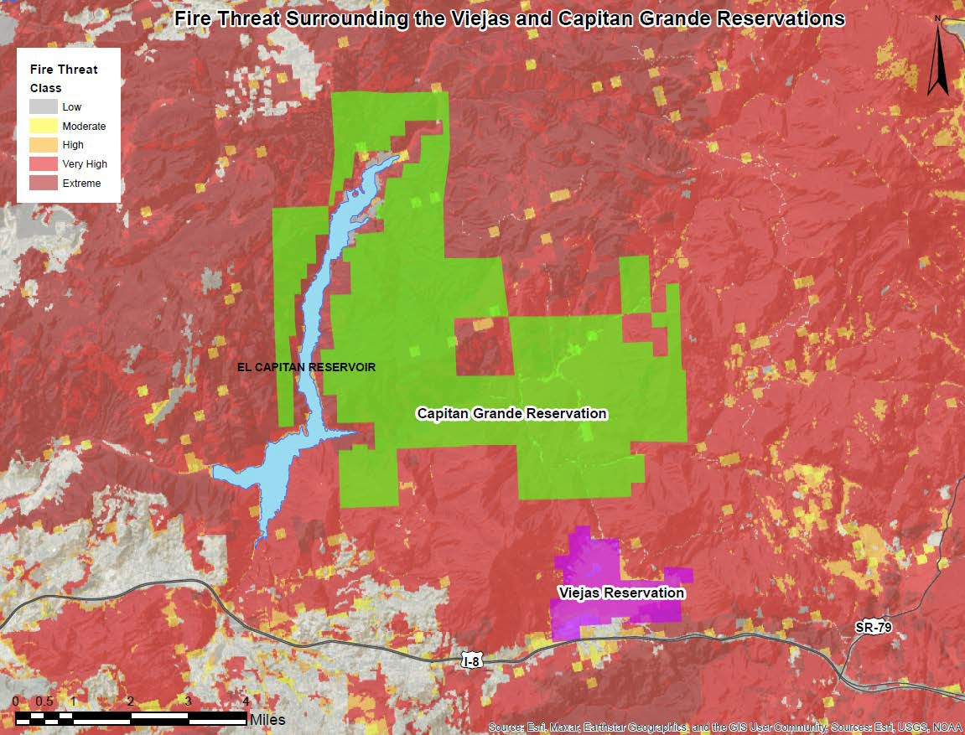

PROJECT NEED:
Viejas and Capitan Grande Reservation and areas immediately surrounding the Reservation have wildland- urban interface challenges and fall within the high and very high fire risk categories of the Fire Hazard Severity Zones developed by CalFire (Map 1). The 2001 Viejas Fire and 2003 Cedar Fire are just two examples of major wildfires that have impacted these two reservations.

Both reservations are located in a rural setting approximately 30 miles east of the city of San Diego, located along the interstate 8 corridor. They are adjacent to vast amount of open space and the Cleveland National Forest. The Viejas Valley lines up with mountain passes that funnel some of the County's strongest Santa Ana winds. Temperatures in the summer and autumn frequently exceed 90 degrees with low humidity levels.

The life hazard at Viejas is significant. For example, the Fire Department protects a resort casino visited by over 3,000,000 guests annually, there are just under 400 hotel rooms on the property, 1,400,000 shoppers per year enjoy the outlet center, and there are two RV parks within the Viejas jurisdiction visited by over 3,500 tourists during the months of May through September. Furthermore, Viejas has 500 permanent residents, approximately 220 Tribal Government employees, and 1,900 Casino and outlet mall employees.

The high risk to life and infrastructure from wildland fire is why funding is needed. This request will improve their ability to keep wildland fires small and as minimal as possible while also supporting their existing Defensible Space Plan (Plan). The Viejas Tribal Council approved the Plan for the purpose of protecting people and property, as well as the invaluable natural and cultural resources of the Viejas Reservation and surrounding land area.

PROJECT SUMMARY:
The proposed Project’s main goals is to acquire equipment, tools and supplies to support the Fire Department’s efforts to reduce flammable fuel loads and provide defensible space. Additionally, if the Project is approved it will provide safe and operational effectiveness by equipping Viejas Wildland firefighters with communication equipment and PPE that meets all industry standards.

Proposed equipment includes one off-road firefighter rescue vehicle and a Project 25 compliant VHF portable radio required under the California Radio Interoperable System by January 2024 for every Viejas Wildland Firefighter. Providing safe reliable wildland PPE for all Viejas Wildland Firefighters enables them to conduct activities that will support the objectives in the Plan which was adopted by the Viejas Tribal Council and addresses the reduction of vegetative fuels around homes, government buildings, driveways and roadways.

These items and other wildland fuel management and fire suppression items support land conservation and environmental programs managed by Viejas Tribal Government, Resource Management Department. The department consists of a small dedicated team determined to improve the environmental and natural health of the reservation, and to

provide the best quality service to the Viejas reservation and surrounding communities

MEASURABLE RESULTS
Reducing risk and intensity of wildfire in Wildland Urban Interface zone and improving fuel breaks that provide an anchor to hold fire spread provide greater opportunity for suppression forces to be successful. The Project will improve Viejas’ ability to transport firefighters with a pump and water to remote off-road areas for both rescue and fire suppression operations. It will also reduce vegetive fuels that shoulder driveways and roads to provide fire department access and serve as emergency evacuation routes.

DELIVERABLES:
- Quarterly invoices, request for disbursements and progress reports
- Final Project Report

Table 1. Estimated Budget and Anticipated Schedule
Task # | Description | Amount | Schedule
1. Implementation | Purchase emergency response UTV (Polaris Ranger Crew XP 1000 NorthStar Edition), equipment, tools, and supplies needed for reduction of hazardous fuels. Purchase 26 P25 compliant VHF portable radios and place in service by January 2024. | $358,772.00 | Throughout the grant term
 | TOTAL | $358,772.00

PROJECT FINANCING: The total Project amount is $363,847.00; the Conservancy staff recommends funding in the amount of $358,772.00 for the implementation of the project. The anticipated source of Conservancy funds for this Project is the Budget Act of 2021.

LEVERAGED FUNDING: $7,500 Viejas Fire Department staff time to administer grant agreement, is matching funds.

CONSISTENCY WITH CONSERVANCY’S ENABLING LEGISLATION: This Project
would be undertaken consistent with the Conservancy’s enabling legislation (Public Resources Code, §§ 32630-32659.9).

CONSISTENCY WITH CONSERVANCY’S STRATEGIC PLAN GOAL(S) & OBJECTIVE(S):
Consistent with Program 3 Preserve and Restore Natural Resources and Program 6, Expand the Organization’s Capacity and Public Outreach from the Conservancy’s Strategic Plan Update 2018-2023.

CONSISTENCY WITH THE PURPOSES OF THE FUNDING SOURCE: Budget Act of
2021 is for wildfire and climate resilience, watershed protection, natural and cultural resource protection, and community access projects. The funding is immediately available

for shovel-ready projects.

CONSISTENCY WITH THE CONSERVANCY’S DIRECTED GRANT PROGRAM:
This Project achieves one or more of the purposes:
- Located in the San Diego River watershed
- Reducing flood and fire risk
- Benefits disadvantaged, severely disadvantaged, or underserved communities
- Protecting the natural and scenic beauty of the San Diego River watershed

ALIGNMENT WITH PLANS AND PRIORITIES
  - California’s Fourth Climate Change Assessment
Supports local adaptation strategy and resilience, fuels reduction to mitigate risk of fire and improve forest health, and protection of the state’s most vulnerable populations and communities.

State Wildlife Action Plan
Encourages projects that seek to create a healthier and more resilient forest ecosystem.

California 2030 Natural and Working Lands Climate Change Implementation Plan
Multi-benefit riparian restoration projects can reduce flood risk and increase water supply while providing critical ecosystem services.

California Wildfire and Forest Resilience Action Plan
Supports activities such as fuels reduction, forest thinning, vegetation management, prescribed fire, shaded fuel breaks, defensible space, and enhancement of fire- prone habitats to reduce fire risk

Safeguarding California – California’s Climate Adaption Strategy
Promotes management activities to reduce the risk of fire.

San Diego River Conservancy’s Climate Change Policy
    - Management of invasive species, especially projects which prevent introduction or spread of invasive species, in order to reduce the impacts of this major stressor on biodiversity;

The San Diego Unit 2022 Strategic Fire Plan

  - 2018 Strategic Fire Plan for California
Support and participate in the collaborative development and implementation of local, county and regional plans that address fire protection and landowner objectives.

Alpine/Viejas Community Wildfire Protection Plan
    - Fuels Treatment

San Diego Integrated Regional Water Management (IRWM) Plan
Supports healthy ecosystems and improve or restore the condition of landscapes and biological communities. Such practices may include brush/forest management for wildfire risk reduction.

BENEFITS
Restoration or enhancement of tribal historical and cultural resources provides benefits for the Kumeyaay Indian Nation. Implementing nature-based solutions allows tribal communities to re-connect to the land which they depend on and continue their traditional practices.

PROJECT READINESS
PPE would be purchased as soon as the grant agreement is signed. The offroad wildland vehicle would be purchased as soon as possible as it is likely supply chain issues may cause delays in product delivery. Invasive non-native plant biomass would occur outside of bird breeding season to avoid impacts to sensitive species and all other mitigation measures with the Conservancy’s suite of permits will be followed.

PERMIT COMPLIANCE
Not applicable.

State of California
San Diego River Conservancy

Meeting of July 13, 2023
ITEM: 8

SUBJECT: SAN DIEGO RIVER CONSERVANCY’S INVASIVE
REMOVAL PROGRAM (ACTION)
The Conservancy’s invasive removal program was established in 2009 and the Conservancy and its partners implement the program to remove and control hundreds of acres in the watershed. The proposed Project plans to renew the Conservancy’s Streambed Alteration Agreement permit for its Invasive Non-Native Plant Removal Program (program) for the San Diego River watershed, re-vegetate 15 acres and control invasive perennial non-natives in the lower and middle watershed. Conservancy staff recommends funding in the amount of
$81,266 from the Budget Act of 2021.

Presentation:
Doug Gibson, Executive Director, Nature Collective Jason Giessow, DENDRA Inc.
Recommendation: Approve Resolution 23-09

Resolution No: 23-09

RESOLUTION OF THE GOVERNING BOARD OF THE SAN DIEGO RIVER CONSERVANCY

AUTHORIZING THE EXECUTIVE OFFICER TO GRANT $81,266 FROM
THE BUDGET ACT OF 2021 TO THE NATURE COLLECTIVE TO OBTAIN A NEW LAKE AND STREAMBED ALTERATION AGREEMENT AND PERMIT FOR CONTROL OF INVASIVE NON-NATIVE PLANT AND RESTROATION IN THE SAN DIEGO RIVER WATERSHED IN ADDITION TO CONTROLING INVASIVE PLANTS AND REVEGATION OF 15 ACRES

WHEREAS, the mission of the San Diego River Conservancy is to further the goals of its enabling legislation by conserving and restoring the lands and waters of the San Diego River watershed and Consortium areas; and
WHEREAS, the Legislature of the State of California has provided funds under the Budget Act of 2021 to fund climate resilience, natural and cultural resource protection, wildfire, and community access projects; and
WHEREAS, the San Diego River Conservancy has been delegated the responsibility for the administration of this grant program, establishing necessary procedures and guidelines in accordance with statewide priorities and plans; and
WHEREAS, the Nature Collective applied to the San Diego River Conservancy for funding to assist the Conservancy in obtaining permit approval through a California Department of Fish and Wildlife Lake and Streambed Alteration Agreement for the Conservancy’s Invasive Non-Native Plant Removal and Control Program and, control 500 acres disturbed habitat and revegetate 15 acres in the San Diego River watershed (Project); and
WHEREAS, San Diego River Conservancy staff recommends funding in the amount of $81,266 to implement the Project; and
WHEREAS, this Project is consistent with the Conservancy’s Strategic Plan, Program 3 Preserve and Restore Natural Resources, and Program 6, Expand the Organization’s Capacity and Public Outreach.
WHEREAS, the San Diego River Conservancy staff have reviewed the grant application, met with applicant and subcontractor and recommends the Project for approval.
NOW, THEREFORE, BE IT RESOLVED that the San Diego River Conservancy’s Governing Board, based on the accompanying staff report and attached exhibits:

- The proposed Project is consistent with the purposes and intent of the Budget Act of 2021.
- The proposed authorization is consistent with the purposes and objectives of the San Diego River Conservancy Act (Public Resources Code, Sections 32630-32659.9).
- The San Diego River Conservancy hereby authorizes the disbursement of up to $81,266 (Eighty-One Thousand Two Hundred Sixty-Six Dollars) for the Project.

- Appoints the Executive Officer, or her designee, as an agent to execute all agreements, grants, sub- contracts, and other documents needed for the completion of the Project.

- Prior to the disbursement of funds, the grantee shall submit for the review and written approval of the Executive Officer of the Conservancy a scope of work, budget, and schedule.
Approved and adopted on July 13, 2023. I, the undersigned, hereby certify that the foregoing Resolution Number 23- 09 was duly adopted by the San Diego River Conservancy’s Governing Board.

Roll Call Vote: Yeas:
Nays: Absent:

Julia L. Richards Executive Officer

San Diego River Conservancy’s Governing Board Members Roll Call Vote

Name | Ayes | Noes | Abstained
CNRA: Andrea Schaffer
DOF: Sally Lukenbill
CADFW: Richard Burg
Dr. Jennifer Campbell, SD Mayor Designee
Joel Anderson, County Supervisor
Raul Campillo
Ben Clay, Chair
Ruth Hayward, Vice Chair
J. Cody Petterson
John Elliott
Elsa Saxod
DPR Designee, Ray Lennox
DPR Designee, Gina Moran
Dustin Trotter
Phil Ortiz

Staff Recommendation SDRC Resolution 23-09
July 13, 2023

DIRECTED GRANT PROGRAM

RECOMMENDED ACTION: Authorization to provide up to $81,266.00 to the Nature Collective to obtain a new permit from the California Department of Fish and Wildlife (CDFW) for a Lake and Streambed Alteration Agreement on behalf of the San Diego River Conservancy, control invasive non-native plant species in 500 acres of riparian habitat and implement native habitat restoration through revegetation across 15 acres in the San Diego River watershed.

LOCATION: The proposed activities would occur within the San Diego River’s riparian habitat including riparian forest, scrub, floodplains, and located within the boundaries of the City of San Diego and the City of Santee.

RESOLUTION AND FINDINGS: Staff recommends that the San Diego River Conservancy adopt the following resolution pursuant to the San Diego River Conservancy Act (Public Resources Code, § 32630 et seq.):

The San Diego River Conservancy hereby authorizes the disbursement of funding for projects focused on enhancing river parkways, protecting resources, removing of invasive species, restoring native habitat and improving water quality, specifically as follows:

To Nature Collective, the sum of $81,266.00 (Eighty-One Thousand, Two Hundred Sixty-Six Dollars) to use as follows:
  - To obtain permit approval through a CDFW’s Lake and Streambed Alteration Agreement for the Conservancy’s Invasive Non-Native Plant Removal and Control Program;
  - Control target perennial invasives within 500 acres of riparian habitat; and
  - Re-vegetate 15 acres with cuttings in the San Diego River watershed (together the “Project”).

Before the disbursement of funds, the grantee shall submit for the review and written approval of the Executive Officer of the Conservancy a scope of work, budget and schedule, and the names and qualifications of any contractors to be employed in carrying out the project.

Staff further recommends that the Conservancy adopt the following findings:

Based on the accompanying staff report and attached exhibits, the San Diego River Conservancy hereby finds that:

- The proposed authorization is consistent with the purposes and objectives of the

San Diego River Conservancy Act, including Section 32649.

- The proposed project is consistent with the Guidelines for the Conservancy’s Directed Grant program.

- The proposed Project is consistent with the Budget Act of 2021.

BACKGROUND:
The San Diego River Conservancy has been operating its Invasive Non-Native Plant Removal and Control Program since 2009, and the Conservancy’s current agreement expires in Spring 2024. The Conservancy would like to continue to implement this program under this authority and the Nature Collective will assist in obtaining permits using the existing CEQA mitigated negative declaration (MND) to renew permits from other authorizing regulatory agencies. Nature Collective has extensive experience completing permitting and managing consultants doing the work. The consultant that will work on the permit wrote the initial permit as well as 12 other similar permits throughout the state.

To carry out plant removal and restoration within the San Diego River watershed, Fish and Game Code (FGC) Section 1602 requires any person, state or local governmental agency, or public utility to notify CDFW prior to beginning any activity that may use material from any river, stream, or lake. A Lake and Streambed Alteration (LSA) Agreement is a type of permit that includes measures to protect existing fish and wildlife resources. Common activities that are permitted by LSA Agreements include installation, repair, or maintenance of water diversions, culverts, stream crossings, or any other modification of a lake or stream's bed, bank, or channel including extraction (removal or control) of vegetative material.

PROJECT NEED:
The Conservancy has funded multiple restoration projects between the mouth of the river to the headwaters. Invasive non-native plants destroy the ability of the San Diego River and watershed to function properly. Many invasive non-native plants contribute to flood damage, fire risk, and degrade native habitats. Also referred to as exotic, alien, noxious, or non-indigenous weeds, invasive plants alter communities by displacing native vegetation and disrupting habitats as they become established and spread over time creating infestations in and along the river.

Conservancy invasive removal and restoration projects assist in controlling invasive non-native perennial plants including palms trees, Brazilian pepper trees, eucalyptus trees, pampas grass, tamarisk, fig, bladder vine, tree tobacco, castor bean, and bottle brush trees and subsequently revegetation with local native plants. These activities will improve the foraging and nesting habitat for native flora and fauna.

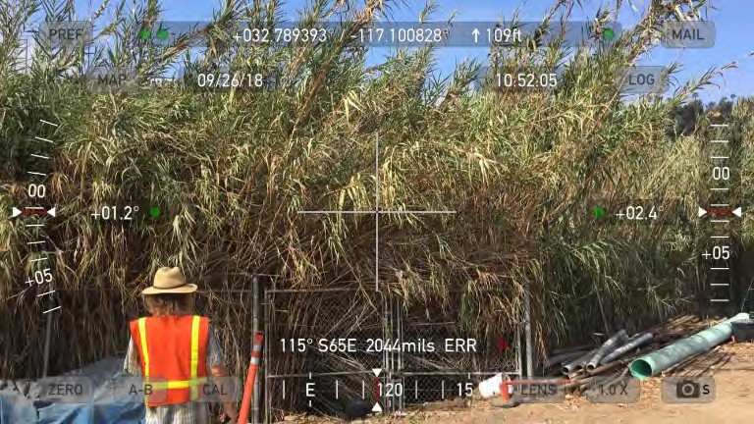
For example, the invasive non-native grass Arundo donax (photo right), also known as giant reed, threatens the ecological integrity of the rivers and streams throughout the San Diego region by altering ecosystem processes and negatively affecting native species. Arundo develop into dense mono-typic stands which displace native vegetation, diminish wildlife habitat, and increase flooding and siltation in natural areas.

In particular, they cause extensive damage to private property and natural resources. Arundo spreads aggressively, potentially onto neighboring properties and is found primarily in stream areas where their vigorous growth and ability to propagate makes them difficult to control. Large stands of Arundo also reduce water availability from underground aquifers due to high evapotranspiration rates with water loss estimated at three times that of native riparian vegetation. Arundo is adapted to a periodic fire regime where canes are readily flammable throughout much of the year increasing the susceptibility of riparian corridors to fire. Unfortunately, much of the San Diego River, especially within the City of San Diego and up to the El Capitan Reservoir has been infested with invasive non-native plants.

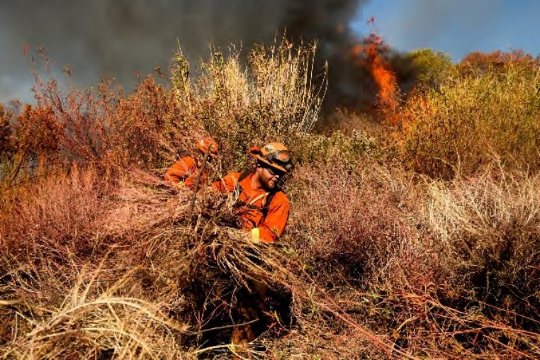
Removing Arundo from local watersheds in California decreases fire hazards and the damage caused by fires. The presence of Arundo increases fire hazards due to its high fuel load, ignitability and the presence of ignition sources. This increased fuel load paired with Arundo’s optimal, well-ventilated structure allow fires to thrive (photo right). In addition, the reed’s vertical structure assists fires in burning the crown of taller shrubs and trees, which increases the frequency and extent of
fires. Once ignited, fires burn hotter in habitats with Arundo. In addition, Arundo-infested riparian habitat can facilitate movement across the landscape – fires can more easily spread and burn a larger area. Further, Arundo regrows three to four times more quickly than native vegetation, allowing it to colonize more space and act as positive feedback mechanism for these events.

The San Diego River Conservancy, working with its private, non-profit and governmental partners along the river, has implemented a watershed-wide program to remove invasive non-native plants in the river and restore the land for the past 14 years. It is critically

important that land owners with affected parcels participate in this program as invasive plants spread aggressively from one property to the next. In addition to invasive non- native plant control, the project restores native vegetation in these areas as an essential step in re-establishing the hydrologic and ecological functions of the river’s riparian and coastal wetland habitats.

PROJECT SUMMARY:
The proposed Project’s main goal is to obtain a new permit for the watershed-wide Invasive Non-Native Plant Removal and Control Program administered by the San Diego River Conservancy. This program’s benefits include reducing flammable invasive biomass from riparian areas and activities to restore the land in the river. This will result in benefits including increasing nesting and foraging habitat for endangered birds and other wildlife species, increasing biodiversity (flora and fauna), reducing risk of flooding and fire as well as protect the natural and cultural resources of the river.

Multiple parcels in the project area will be targeted to restore native habitat through re- vegetation with cuttings. Native woody plant cuttings will be installed across 15 acres of habitat (a minimum of 2,000 cuttings), and invasive perennial plant targets (minimum of 1,000 plants) will be controlled with approved herbicide treatments across 500 acres of riparian habitat. Passive re-vegetation and control of perennial invasive non-native plants accelerates native riparian habitat recovery following historic disturbances and degradation from non-native plant invasion. Annual work plans and reports on completed work activities will be submitted to regulatory agencies by the Conservancy. After the Streambed Alteration Agreement (permit) is approved by CDFW, there is a process and additional fees for adding new projects. Any Conservancy partner working under the Conservancy’s permit must follow all work conditions including, but not limited to: removal/control methods, seasonal timing of work, and additional resource avoidance and minimization measures.

The proposed Project includes the following activities:

- Nature Collective will assist the Conservancy obtain a new CDFW LSA Agreement
/1600 permit. The agreement covers invasive non-native plant control and revegetation/ restoration within the San Diego watershed.

- The Conservancy’s program has targeted over 350 acres of riparian habitat since 2009. A preliminary meeting with Conservancy staff, CDFW, and consultant reviewed permit type, timelines, and process. It should be possible to complete a new agreement prior to the expiration of the current agreement.

- Nature Collective will initiate passive re-vegetation with native woody plant cuttings and selected control of perennial invasive non-native plants. Work areas will be between the mouth of the San Diego River and the city of Santee. The Conservancy has initiated its program to ensure that Arundo and other invasive plants in the riparian habitat do not fill in with other aggressive perennial non-native vegetation. Target plants include identified species on the CAL-IPC list.

Map 1. Proposed Project Areas
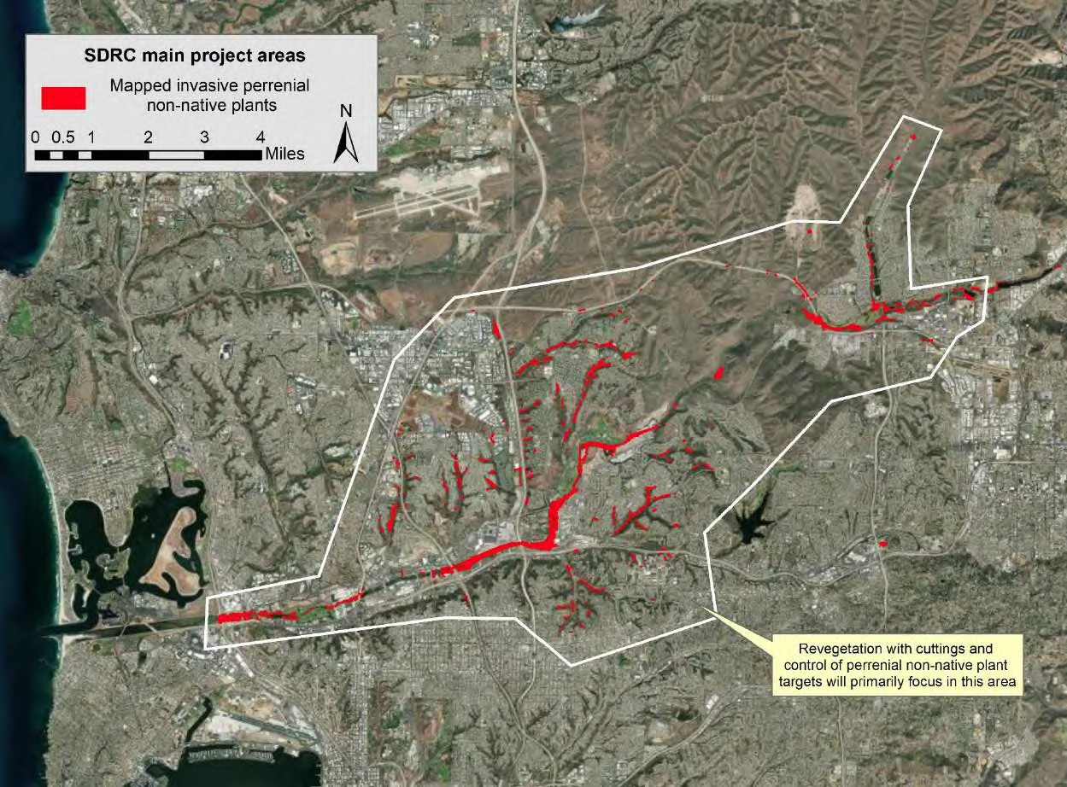

All invasive plant control and revegetation will occur between September 15th and February 14th. This timeframe avoids disruption of wildlife during bird breeding season. Project work will be matched with SANDAG funded Arundo re-treatment work.

DELIVERABLES:
  - Obtain California Department of Fish and Wildlife Lake and Streambed Alteration Agreement & Permit
  - Submit quarterly invoices and progress reports with photo documentation
  - Control over 1,000 target perennial non-native plants
  - Plant over 2,000 cuttings of willows, cottonwood, and mulefat

Table 1. Estimated Budget and Anticipated Schedule

Task # | Description | Amount | Schedule
1 | Permit Renewal | $12,721.75 | Application submitted and reviewed by CDFW within 3 months of grant award
2 | Implementation | $68,544.25 | September 15th 2023 through June 15th, 2025
 | TOTAL | $81,266.00

PROJECT FINANCING: The total Project amount is $96,266.00; the Conservancy staff recommends funding in the amount of $81,266.10 for the implementation of the project. The anticipated source of Conservancy funds for this Project is the Budget Act of 2021.

LEVERAGED FUNDING: Nature Collective is providing $15,000.00 in-matching funds.

CONSISTENCY WITH CONSERVANCY’S ENABLING LEGISLATION: This Project
would be undertaken consistent with the Conservancy’s enabling legislation (Public Resources Code, §§ 32630-32659.9).

CONSISTENCY WITH CONSERVANCY’S STRATEGIC PLAN GOAL(S) & OBJECTIVE(S):
Consistent with Program 3 Preserve and Restore Natural Resources, Program 5 Enhance Water Quality and Natural Flood Conveyance, and Program 6, Expand the Organization’s Capacity and Public Outreach from the Conservancy’s Strategic Plan Update 2018-2023.

CONSISTENCY WITH THE PURPOSES OF THE FUNDING SOURCE: Budget Act 2021
is for wildfire and climate resilience, watershed protection, natural and cultural resource protection, and community access projects. The funding is immediately available for shovel-ready projects.

CONSISTENCY WITH THE CONSERVANCY’S DIRECTED GRANT PROGRAM:
This Project achieves one or more of the purposes:
- Located in the San Diego River watershed
- Reducing flood and fire risk
- Improving water quality
- Protecting and enhancing wildlife habitats
- Benefits disadvantaged, severely disadvantaged, or underserved communities
- Removing invasive plant species from the watershed
- Increasing native habitat and promoting the re-establishment of native species

ALIGNMENT WITH PLANS AND PRIORITIES
- California Wildfire and Forest Resilience Action Plan

Supports activities such as fuels reduction, forest thinning, vegetation management, prescribed fire, shaded fuel breaks, defensible space, and enhancement of fire- prone habitats to reduce fire risk

California’s Fourth Climate Change Assessment
Supports local adaptation strategy and resilience, and protection of the state’s most vulnerable populations and communities.

State Wildlife Action Plan
Goal 3 - Enhance Ecosystem Functions and Processes: Maintain and improve ecosystem functions and processes vital for sustaining ecosystems in California.

California Water Action Plan
Provide safe water for all communities and Increase flood protection

California 2030 Natural and Working Lands Climate Change Implementation Plan
Multi-benefit riparian restoration projects can reduce flood risk and increase water supply while providing critical ecosystem services.

Water Quality Control Plan for the San Diego Basin
Beneficial uses for the San Diego River include wildlife habitat and rare and endangered species.

San Diego River Conservancy’s Climate Change Policy
  - Conservation, restoration and enhancement of habitats that sequester carbon, including forests, tidal wetlands, and estuarine scrub/shrub habitats;
  - Management of invasive species, especially projects which prevent introduction or spread of invasive species, in order to reduce the impacts of this major stressor on biodiversity;
  - Riparian protection, enhancement, and restoration projects that allow for wider riparian corridors to accommodate increased flooding, or provide other benefits such as increased shading to moderate water temperature increases.

Strategic Fire Plan for California
Goal 5: Integrate fire and fuels management practices with landowner/land manager priorities across all ownerships and jurisdictions.

BENEFITS
This project contributes multiple benefits to healthy ecosystems, restoration and enhancement of native habitats, increases native biodiversity, and addresses climate change. This project is expected to significantly improve the conditions, functions and values of the riparian/wetland habitats by reducing the detrimental processes and increasing the ability of these habitats to promote better water quality. This translates to fewer pollutants in the river and the ocean.

Another expected outcome is reduction of backwater flooding – the potential for debris jams on bridges and trestles, and the substantial accumulated of fire fuel load in the river. Plant biomass buildup is typical of Arundo and pampas grass infestations which are known to cause backwater flooding, river diversion, and accumulation of fire fuel load.

Removal of Arundo stands also discourages the use of these areas by humans as shelter. These areas are not safe for inhabitation as they flood and are prone to fire, putting everyone at risk – including rescue and fire crews. Most fires that start in riparian areas are started by humans within stands of Arundo.

PROJECT READINESS
A meeting with CDFW has already occurred who recommended a stream maintenance Agreement which will allow maintenance of existing project areas as well as new work through partnership agreements. However, this work can only be conducted outside of the bird breeding season from September 15th through February 14th.

PERMIT COMPLIANCE
The proposed project will obtain a LSA permit for the San Diego River Conservancy’s environmental program issued by CDFW.

State of California
San Diego River Conservancy

Meeting of July 13, 2023
ITEM: 9

SUBJECT: ALPINE FIRE PROTECTION DISTRICT’S PROPOSAL
FOR FIRE TRUCK AND FUEL REDUCTION ACTIVITIES – WILDFIRE AND FOREST RESILIENCE (ACTION)
Alpine Fire Protection District’s proposed project requests funding to procure a Type 6 Fire Engine and conduct hazardous fuels removal on 16 acres in Alpine Creek, a tributary to El Capitan Reservoir which separates the upper San Diego River. Alpine Fire Protection District is in the Wildland-Urban Interface area in San Diego’s east county, and abuts the Cleveland National Forest. CalFIRE’s Fire Hazard Severity Zones maps identified the community of Alpine as a High to Very High risk in the WUI. Conservancy staff recommends $800,000 for the project, and if approved funding would be provided by Budget Act of 2021.

Presentation:
Brian Boggeln, Fire Chief, Alpine Fire Protection District Jason McBroom, Fire Marshal, Alpine Fire Protection District Recommendation: Approve Resolution 23-10

Resolution No: 23-10

RESOLUTION OF THE GOVERNING BOARD OF THE SAN DIEGO RIVER CONSERVANCY

AUTHORIZING THE EXECUTIVE OFFICER TO GRANT $800,000 FROM THE BUDGET ACT OF 2021 TO ALPINE FIRE PROTECTION DISTIRCT FOR PURCHASE OF A TYPE 6 WILDLAND FIRE ENGINE AND CONDUCT HAZARDOUS FUELS REMOVAL WITHIN ALPINE CREEK

WHEREAS, the mission of the San Diego River Conservancy is to further the goals of its enabling legislation by conserving and restoring the lands and waters of the San Diego River watershed and Consortium areas; and

WHEREAS, the Legislature of the State of California has provided funds under the Budget Act of 2021 to fund climate resilience, natural and cultural resource protection, wildfire, and community access projects; and
WHEREAS, the San Diego River Conservancy has been delegated the responsibility for the administration of this grant program, establishing necessary procedures and guidelines in accordance with statewide priorities and plans; and

WHEREAS, Alpine Fire Protection District applied to the San Diego River Conservancy for a grant to purchase a new Type 6 Wildland Fire Engine and conduct hazardous fuels removal on 16 acres within Alpine Creek (Project); and
WHEREAS, San Diego River Conservancy staff recommends funding in the amount of $800,000 to implement the Project; and
WHEREAS, this Project is consistent with the Conservancy’s Strategic Plan, Program 3 Preserve and Restore Natural Resources, Program 5 Enhance Water Quality and Natural Flood Conveyance and Program 6, Expand the Organization’s Capacity and Public Outreach.
WHEREAS, the San Diego River Conservancy staff have reviewed the grant application, met with applicant and recommends the Project for approval.
NOW, THEREFORE, BE IT RESOLVED that the San Diego River Conservancy’s Governing Board, based on the accompanying staff report and attached exhibits:

- The proposed Project is consistent with the purposes and intent of the Budget Act of 2021.
- The proposed authorization is consistent with the purposes and objectives of the San Diego River Conservancy Act (Public Resources Code, Sections 32630-32659.9).
- The San Diego River Conservancy hereby authorizes the disbursement of up to $800,000 (Eight Hundred Thousand Dollars) to implement the Project.

- Appoints the Executive Officer, or her designee, as an agent to execute all agreements, grants, sub- contracts, and other documents needed for the completion of the Project.

- Prior to the disbursement of funds, the grantee shall submit for the review and written approval of the Executive Officer of the Conservancy a scope of work, budget, and schedule.
Approved and adopted on July 13, 2023. I, the undersigned, hereby certify that the foregoing Resolution Number 23- 10 was duly adopted by the San Diego River Conservancy’s Governing Board.

Roll Call Vote: Yeas:
Nays: Absent:

Julia L. Richards Executive Officer

San Diego River Conservancy’s Governing Board Members Roll Call Vote

Name | Ayes | Noes | Abstained
CNRA: Andrea Schaffer
DOF: Sally Lukenbill
CADFW: Richard Burg
Dr. Jennifer Campbell, SD Mayor Designee
Joel Anderson, County Supervisor
Raul Campillo
Ben Clay, Chair
Ruth Hayward, Vice Chair
J. Cody Petterson
John Elliott
Elsa Saxod
DPR Designee, Ray Lennox
DPR Designee, Gina Moran
Dustin Trotter
Phil Ortiz

Staff Recommendation SDRC Resolution 23-10
July 13, 2023

DIRECTED GRANT PROGRAM

RECOMMENDED ACTION: Authorization to provide up to $800,000.00 to Alpine Fire Protection District to purchase a new Type 6 Wildland Fire Engine and to remove up to 16 acres of Arundo donax from Alpine Creek in order to "protect life, property, and the environment" within the San Diego River and Sweetwater River watersheds (Project).

LOCATION: Alpine is a small semi-rural unincorporated community in San Diego County made up of approximately 37 square miles. It is located 28 miles inland from the Pacific coast on Interstate 8, a major east/west thoroughfare, which bisects the Alpine Fire Protection District. Alpine Creek runs parallel to Interstate 8 before draining north to El Capitan Reservoir.

RESOLUTION AND FINDINGS: Staff recommends that the San Diego River Conservancy adopt the following resolution pursuant to the San Diego River Conservancy Act (Public Resources Code, § 32630 et seq.):

The San Diego River Conservancy hereby authorizes the disbursement of funding for projects focused on providing public access to open space and trails, enhancing river parkways, protecting resources, restoring native vegetation and supporting education and outreach opportunities, specifically as follows:

To Alpine Fire Protection District, the sum of $800,000.00 (Eight Hundred Thousand Dollars) to use as follows:
  - To purchase a new Type 6 Wildland Fire Engine for the Alpine Fire Protection District and
  - To conduct Alpine Creek hazardous fuels removal on 16 acres (together the “Project”).

Before the disbursement of funds, the grantee shall submit for the review and written approval of the Executive Officer of the Conservancy a scope of work, budget and schedule, and the names and qualifications of any contractors to be employed in carrying out the project.

Staff further recommends that the Conservancy adopt the following findings:

Based on the accompanying staff report and attached exhibits, the San Diego River Conservancy hereby finds that:

- The proposed authorization is consistent with the purposes and objectives of the San Diego River Conservancy Act, including Section 32649.

- The proposed project is consistent with the Guidelines for the Conservancy’s Directed Grant program.

- The proposed Project is consistent with the Budget Act of 2021.

BACKGROUND:
The Alpine Fire Protection District (FPD) is an independent special district/public agency formed in 1957. It provides fire protection for an estimated population of 17,747. The Alpine FPD currently has 16 paid employees operating out of one fire station, and is an "all-risk" emergency response agency which responds to wildland fires and other emergencies in the San Diego River Conservancy’s watershed areas.

Two-thirds of the Alpine FPD is in the State’s Responsibility Area except for the eastern third which is in the Cleveland National Forest. They participate in auto-aid agreements with all surrounding fire agencies including: Viejas, Lakeside, San Miguel, Heartland Fire and Rescue, Santee, San Diego Rural FPD, CALFIRE and US Forest Service. Through these agreements and with technology provided through Heartland Fire Dispatch, each engine is equipped with an 800 megahertz (MHz) mobile radio and a very high frequency mobile radio and a portable computer or Mobile Data
Terminal. For safety purposes, each firefighter position has a portable radio assigned to it.

The Alpine FPD uses a closest unit dispatch. This means that if one of the auto-aid partners' engines is closer to the 911 call than the Alpine FPD engine, then they will respond. The dispatcher takes the information and determines what units should respond.

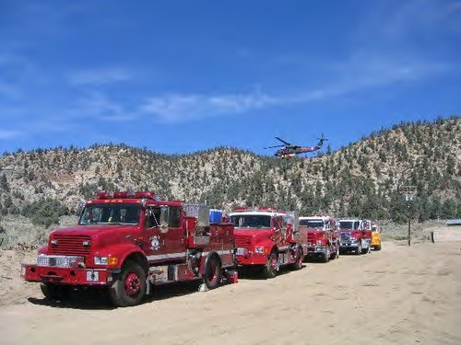
Alpine FPD has 3-4 personnel per engine. That includes one captain, one engineer and one to two firefighter paramedics. Firefighters are also emergency medical technicians. Often the fire truck will arrive before the ambulance and will start treatment. Also, firefighters are able to provide additional personnel and assistance if needed to ensure the residents and businesses of Alpine receive the quickest most appropriate response to their emergencies.

PROJECT NEED:
East County and the community of Alpine are within a very high fire hazard severity zone. The Alpine FPD is applying for funds to purchase a Type 6 Wildland Fire Engine to augment emergency responses and also to remove hazardous fuels in Alpine Creek to take preventative action to reduce fuel loads.

This proposed Type 6 Wildland Fire Engine purchase includes a 150-gallon water tank and a pump rated at 50 gallons per minute (GPM) @ 100 pounds per square inch (PSI). The intent is the new engine will replace the 22-year-old Type 3 Brush Engine and allow firefighters to access narrow roads and steep terrain because they are smaller than Type 3 Brush Engines. Type-3 engines, by definition, include 500 gallons of water and a pump rated at 150 GPM @ 250 PSI of pressure.

The engine will be highly visible in the community and at events supporting fire prevention projects and emergency responses in the service area. The Alpine FPD covers a region susceptible to wildfires and provides mutual aid to other communities.

Furthermore, the growth of Arundo within the watershed adds a high wildfire risk. These fuels are overgrown in Alpine Creek, making many single-family dwellings and multi- family apartments susceptible to wildfire. The last wildfire in the area was recorded in 1929, as per Cal Fire mapping. Therefore, cutting and removing dead stands and applying herbicide to prevent regrowth will lower the risk and intensity of fires and restore natural water flow within Alpine Creek.

PROJECT SUMMARY:
The proposed Project includes purchase of a new fire engine equipped for wildfire responses. The proposed budget includes communication radios, wildland firefighting tools, and a separate line item for vegetation management. Work will be conducted on 28 privately owned parcels throughout Alpine that present a high-fire risk due to flammable fuel buildup contained within the waterway located on each property.

Within the Alpine waterways, fast-growing plants have become established, contributing to the rapid increase in biomass within these areas. This additional accumulation of flammable vegetation can quickly spread a fire to nearby homes. In the Alpine area following the wildfires of 2007, the stands of Arundo have increased from an estimated four acres to 12 acres within three years. During heavy rains and flash-flood events, the Arundo biomass concentrates into debris dams, causing localized flooding and infrastructure damage.

The principal work includes limbing trees up from the ground 6' -10' in height to remove ladder fuels and remove dead, dying, and diseased trees from the project area. Complete defensible space to within 100' of structures in the work area. Alpine PFD will develop a maintenance and monitoring plan to establish a schedule for the continued maintenance and removal of debris and vegetation in partnership with Back Country Land Trust.

Part of the mission of the Alpine FPD is to protect life, property, and the environment. The acquisition of this fire engine aligns with the goals of the Directed Grant Program and allows for quicker responses, and provides better access to remote areas. The end product will be a fire engine in service 24 hours a day, protecting the community and the San Diego River Conservancy area.

Map 1. Map of Alpine Fire Protection District Boundary & CalFIRE
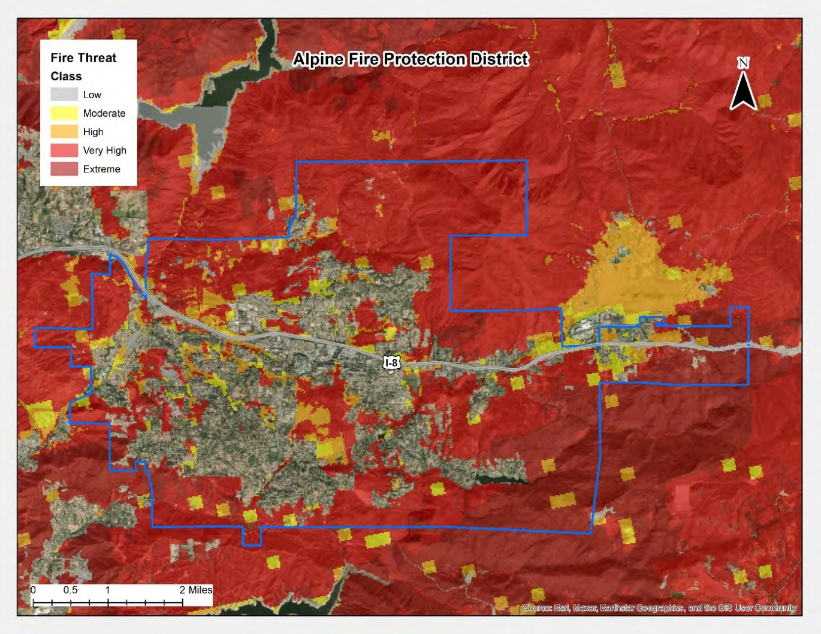

DELIVERABLES:
- Quarterly request for disbursements and progress reports
- Photo documentation of delivered Type 6 Wildland Fire Engine
- Inventory of trees, plants and native brush
- Measurements of fuels chipped and Arundo removed
- Back Country Land Trust will conduct site monitoring and herbicide spraying

Table 1. Estimated Budget and Anticipated Schedule
Task # | Description | Amount | Schedule
1 | Purchase Type 6 Fire Engine | $400,000.00 | Throughout the grant term
2 | Fuels Management along Alpine Creek | $400,000.00
 | TOTAL | $800,000.00

PROJECT FINANCING: The total Project amount is $1,005,000.00; the Conservancy staff recommends funding in the amount of $800,000.00 for the implementation of the project. The anticipated source of Conservancy funds for this Project is the Budget Act of 2021.

LEVERAGED FUNDING: The Alpine FPD will contribute $205,000 towards purchase of the Type 6 Wildland Fire Engine, its equipment and vegetation management.

CONSISTENCY WITH CONSERVANCY’S ENABLING LEGISLATION: This Project
would be undertaken consistent with the Conservancy’s enabling legislation (Public Resources Code, §§ 32630-32659.9).

CONSISTENCY WITH CONSERVANCY’S STRATEGIC PLAN GOAL(S) &
OBJECTIVE(S): Consistent with Program 3 Preserve and Restore Natural Resources, Program 5 Enhance Water Quality and Natural Flood Conveyance, and Program 6, Expand the Organization’s Capacity and Public Outreach from the Conservancy’s Strategic Plan Update 2018-2023.

CONSISTENCY WITH THE PURPOSES OF THE FUNDING SOURCE: Budget Act of
2021 is for wildfire and climate resilience, watershed protection, natural and cultural resource protection, and community access projects. The funding is immediately available for shovel-ready projects.

CONSISTENCY WITH THE CONSERVANCY’S DIRECTED GRANT PROGRAM:
This Project achieves one or more of the purposes:
- Located in the San Diego River watershed
- Reducing flood and fire risk
- Improving water quality
- Benefits disadvantaged, severely disadvantaged, or underserved communities
- Protecting the natural and scenic beauty of the San Diego River watershed

ALIGNMENT WITH PLANS AND PRIORITIES
  - 2018 Strategic Fire Plan for California
Goal 1: Identify and evaluate wildland fire hazards and recognize life, property and natural resource assets at risk, including watershed, habitat, social and other values of functioning ecosystems.

California’s Fourth Climate Change Assessment
Supports local adaptation strategy and resilience, fuels reduction to mitigate risk of fire and improve forest health, and protection of the state’s most vulnerable populations and communities.

California Wildfire and Forest Resilience Action Plan
Supports activities such as fuels reduction, forest thinning, vegetation management, prescribed fire, shaded fuel breaks, defensible space, and enhancement of fire- prone habitats to reduce fire risk

Safeguarding California – California’s Climate Adaption Strategy
Promotes management activities to reduce the risk of fire.

California’s 2030 Natural and Working Lands Climate Change Implementation Plan
Supports Forest fuels reduction, understory clearing, restoration and activities to improve forest health.

San Diego River Conservancy’s Climate Change Policy
    - Riparian protection, enhancement, and restoration projects that allow for wider riparian corridors to accommodate increased flooding, or provide other benefits such as increased shading to moderate water temperature increases.

  - California Wildlife Action Plan, the Forests and Rangelands Companion Plan Encourages projects that seek to create a healthier and more resilient forest ecosystem.

Governor’s Executive Orders

  - San Diego Integrated Regional Water Management Plan
Supports healthy ecosystems and improve or restore the condition of landscapes and biological communities. Such practices may include brush/forest management for wildfire risk reduction.

San Diego County Fire Strategic Plan 2020 – 2025

  - Multiple Species Conservation Program, County of San Diego Subarea Plan
Discusses wildfire and invasive species as a potential risk to protected species.

Alpine Fire Protection District Strategic Plan
Goal 1. Reduce the possibility of damage and losses to existing assets, particularly people, critical facilities/infrastructure due to structural fire/wildfire

Senate Bill 190 - Defensible Space Inspection Bill

  - Alpine/Viejas Community Wildfire Protection Plan
    - Fuels Treatment

BENEFITS
Alpine Boulevard is a primary evacuation route to provide safe egress of community members. Reducing highly combustible fuels in the creek area will reduce the potential for evacuation corridors being obstructed.

The purchase of a fire engine will assist both Alpine FPD to protect sensitive habitat areas and maintain water quality within the San Diego and Sweetwater River areas. Additionally, the Type 6 Wildland Fire Engine will be a resource to other County, state and federal agencies in east county including tribal areas and reservations by assisting them during emergencies.

The primary focus of this project is to save lives, protect property and preserve the environment by reducing the risk and intensity of wildfires. These goals are completed through public education, establishing defensible space for private land owners and wildfire risk reduction by removing ladder fuels. Additional positive benefits of the work include visible sight, resulting in less homeless encampments being built along Alpine Creek. Local sheriff will conduct routine inspections to prevent encampments along the creek.

PROJECT READINESS
The Alpine Fire Protection District is spearheading this project and acting as community lead. The Project will be started immediately upon grant award and Alpine FPD will work with a vendor to deliver the engine in a timely fashion. The Alpine/Viejas Fire Safe Council will conduct all chipping of biomass cut and piled.

Compliance for defensible space for parcels which have had work completed will be conducted annually. All businesses post work completion will continue to maintain the area through defensible space contractors. Back Country Land Trust will assist with maintenance and monitoring for the Project.

PERMIT COMPLIANCE
All necessary permits or clearances have been applied for and issued through the FEMA Cal OES grant application process. CEQA Exemption has been filed with County Recorders office under the Multiple Species Conservation Plan. A biologist has completed an assessment of the entire Alpine Creek and found no significant impacts.

All property owners have provided signed access agreements (Right-of-Entry forms, ROEs) to allow project access on their private streamside properties, whether residential or commercial. Renewed Notice of Trespass will be updated with all businesses and each parcel has an express site plan to address proper methods for fuel removal.

An MOU agreement is in place with CalTrans for shoulder mowing and agreements are in place for shoulder right of way clearing with the County Public Works Department along Alpine Boulevard.

Meeting of July 13, 2023
ITEM: 10
SUBJECT: RANGER UPDATE ON THE SAN DIEGO RIVER VALLEY IN THE CITY OF SAN DIEGO (INFORMATIONAL)
The City of San Diego’s Park Rangers assist the public in use of open space park facilities, develop and conduct interpretive programs, patrol open space parks to enforce park rules and regulations, and to perform related work.

Presentation:
Tiffany Swiderski, Senior Ranger, City of San Diego

Meeting of July 13, 2023
ITEM: 11
SUBJECT: EXECUTIVE OFFICER’S REPORT (INFORMATIONAL/ACTION)
The following topics may be included in the Executive Officer’s Report. The Board may take action regarding any of them:

Wildfire Project List
Proposed 2024 Conservancy Board Meeting Schedule: January 11
March 14
May 9
July 11
September 12
November 14

SAN DIEGO RIVER CONSERVANCY
Wildfire and Forest Resilience Project Awards July 13, 2023
15 Total Projects Awarded 20% of Projects awarded to Tribal Governments 67% of Projects awarded to communities with disadvanatged and low income tracts

Grantee | Title | Tribal Government? | Disadvantaged or low income community | Total Amount
Resource Conservation District of Greater San Diego County | Keeping San Diego Fire Safe | No | Yes | $3,508,826.00
San Diego Canyonlands | San Diego River Watershed Canyons' Fire Resiliency Program | No | Yes | $1,070,563.00
City of Santee | San Diego River Bottom Fire Fuels Reduction Project and Purchase of one Light Brush Rig | No | Yes | $500,000.00
Barona Band of Mission Indians | Brush Fire Engine | Yes | No | $350,000.00
Lakeside's River Park Conservancy | Vegetation Management in and along the San Diego River | No | Yes | $500,000.00
Cleveland National Forest | Forest Wildfire Resilience and Qualified Kumeyaay Cultural Monitors | No | Yes | $3,865,632.00
Kumeyaay Dieguiño Land Conservancy | San Diego River Conservancy’s Wildfire Early Action Program Administered Through the Kumeyaay Diegueño Land Conservancy | Yes | No | $800,000.00
City of El Cajon | El Cajon Vegetation Management Program, training for fuel reduction and mitigation, fire line construction, and to reduce flammable fuels in parks and open space areas | No | Yes | $3,125,000.00
County of San Diego Department of Parks and Recreation | Fire Fuel Reduction in San Diego County's Department of Parks and Recreation | No | Yes | $3,450,000.00
San Diego State University Research Foundation, Soil Ecology and Restoration Group | Alvarado Creek Bed Fire Fuel Reduction | No | Yes | $656,815.00
Lakeside Fire Protection District | Installation of 3 VHF Radio Repeaters | No | No | $600,000.00
San Diego Canyonlands | Navajo Canyon Invasives Removal | No | No | $600,000.00
Viejas Band of Kumeyaay Indians | Viejas Wildland Protection Engine and Vegetation Mangament | Yes | No | $625,139.00
Lakeside's River Park Conservancy | Invasives Removal, Restoration and Maintenance along the San Diego River in Lakeside | No | Yes | $1,917,980.00
San Diego State University Research Foundation | Alvarado Creek Restoration ‐ Phase 7 (in partnership with the Soil Ecology and Restoration Group) | No | Yes | $1,978,182.00
Total Amount Awarded to date $23,548,137.00

Meeting of July 13, 2023
ITEM: 12
SUBJECT: NEXT MEETING
The next regularly scheduled Board meeting is anticipated to be held in person on Thursday, September 14, 2023, from 2:00 to 4:00 p.m.

Meeting of July 13, 2023
ITEM: 13
SUBJECT: ADJOURNMENT

