Notice of Public Meeting San Diego River Conservancy

A public meeting of the Governing Board of The San Diego River Conservancy
will be held Thursday,

November 9, 2023
2:00 pm – 4:00 pm

Meeting Location

County of San Diego Administration Center (CAC) 1600 Pacific Highway, Room 302
San Diego, California 92101

Teleconference Line
877-411-9748, Code 3906093

For Questions Contact:
Wendell Taper at wendell.taper@sdrc.ca.gov or (619) 390-0568

Meeting Agenda

The Board may take agenda items out of order to accommodate speakers and to maintain a quorum, unless noted as time specific.

Roll Call

- Approval of Minutes (ACTION)
Consider approval of minutes for the July 13, 2023 meeting.

Public Comment (INFORMATIONAL)
Any person may address the Governing Board at this time regarding any matter within the Board’s authority. Presentations will be limited to three minutes for individuals and five minutes for representatives of organizations. Submission of information in writing is encouraged. The Board is prohibited by law from taking any action on matters that are discussed that are not on the agenda; no adverse conclusions should be drawn by the Board’s not responding to such matters or public comments.

- Chairperson’s and Governing Board Members’ Report (INFORMATIONAL/ACTION)

- Deputy Attorney General Report (INFORMATIONAL/ACTION)

- Health and Safety Report (INFORMATIONAL)

San Diego River Conservancy’s Strategic Plan Update (ACTION)
The Conservancy engaged the services of San Diego Canyonlands, a community-based organization, to conduct outreach and to help prepare the Conservancy’s next 5-year strategic plan. San Diego Canyonlands conducted an equity-oriented engagement process to learn about local priorities and concerns. The Board may discuss, comment, and/or adopt the plan.

Overview:
Julia Richards, Executive Officer, San Diego River Conservancy Clayton Tschudy, Executive Director, San Diego Canyonlands
Recommendation: Approve Plan

- Campo Band of Mission Indians Proposal for Wildfire Preparedness 2023 (ACTION) The Campo Band of Mission Indians seeks funding to procure multi-agency interoperability hand-held radio equipment, personal protective equipment, and partial funding to replace a fire engine. The Campo Tribal government in partnership with the Campo Reservation Fire Protection District provides wildfire protection and emergency services to the Campo Reservation and neighboring communities, including the La Posta Band of Diegueño Mission Indians, the Manzanita Band of the Kumeyaay Nation and the Ewiiaapaayp Band of Kumeyaay Indians, which are geographically and ancestrally connected. The Conservancy staff recommends funding $560,619 for the proposed Project.

Presentation:
Scott Timbs, Fire Chief, Campo Fire Protection District Recommendation: Approval of Resolution 23-11
- San Diego Regional Fire Foundation Fire Resiliency Proposal (ACTION)
The San Diego Regional Fire Foundation seeks funding to assist thirteen Fire Safe Councils in the Conservancy’s service areas with implementing fire prevention activities, improving fire resilience and procuring one chipper for Alpine Fire Protection District. The Fire Safe Councils will use the funds to help build organizational capacity at the local and regional level to reduce hazardous fuels, maintain fuel breaks, clear defensible space, and provide education on wildfire preparedness and prevention for residents located within CalFire’s “Very High” Fire Hazard Severity Zones. The Conservancy staff recommends funding $318,958.00 for the proposed Project.

Presentation:
Joan Jones, Executive Director, San Diego Regional Fire and Rescue Foundation Recommendation: Approval of Resolution 23-12
- San Diego Fire-Rescue Foundation Proposal for Fuel Reduction in the City of San Diego, Lower San Diego River (ACTION)
The San Diego Fire-Rescue Foundation seeks funding to implement brush management and weed abatement activities to reduce fuel loads and maintain and create firebreaks to help safeguard and protect vulnerable, at-risk, and underserved communities in the San Diego River watershed. The Foundation will use funding to procure an F-350 vehicle, a 4- wheel drive ATV, eco-friendly fuel treatments, and battery-powered equipment to replace gas-powered equipment. The San Diego Fire-Rescue Foundation and the San Diego Fire- Rescue Department will partner with other stakeholders to implement activities in targeted locations within the San Diego River watershed. The Conservancy staff recommends funding $366,949.00 for the proposed project.

Presentation:
Wendy Robinson, Executive Director, San Diego Fire-Rescue Foundation Anthony Tosca, Deputy Chief/Fire Marshall, San Diego Fire-Rescue Department

Recommendation: Approval of Resolution 23-13

- The County of San Diego’s Enhanced Infrastructure Finance District
(INFORMATIONAL)
The County of San Diego undertook a funding feasibility analysis in 2022 to evaluate long- term funding for the San Diego River Park and Trail. The County’s Department of Parks and Recreation is leading efforts with stakeholders to pursue an Enhanced Infrastructure Financing District to develop an alternate funding source for trail, infrastructure and other improvements along the river corridor to help complete the San Diego River Trail and the San Diego River Park vision and will provide a presentation to the Conservancy regarding the above.

Presentation:
Lizzy Bendrick, County of San Diego, Department of Parks and Recreation, Trails Program Manager
James Inglis, County of San Diego, Department of Parks and Recreation, Department Budget Manager

- Executive Officer’s Report (INFORMATIONAL/ACTION)
The following topics may be included in the Executive Officer’s Report. The Board may take action regarding any of them.
The Conservancy’s staff attended or plan to attend the following events:
  - Wildfire Preparedness Fair hosted by San Diego Fire-Rescue Foundation
  - All State Conservancy meeting

  - California State Leadership Forum
  - California Wildfire & Forest Resilience Task Force meeting
  - All State Directors’ meeting for Resource Agencies
  - San Diego County’s Regional Forest and Fire Capacity Program meeting
  - Tijuana River Valley Steering Committee meeting
  - San Diego Trans County Trail meeting

Next Meeting
The next regularly scheduled Board meeting will be held on January 4, 2024 from 2:00 to 4:00 p.m.

Adjournment

Accessibility
If you require a disability related modification or accommodation to participate in this meeting, including auxiliary aids or services, please call Wendell Taper at 619-390-0568 or by email at Wendell.taper@sdrc.ca.gov

Meeting of November 9, 2023

ITEM: 1
SUBJECT: ROLL CALL AND INTRODUCTIONS

Meeting of November 9, 2023
ITEM: 2

SUBJECT: APPROVAL OF MINUTES (ACTION)
The Board will consider adoption of the July 13, 2023
Board Meeting.

PURPOSE: The minutes of the Board Meeting are attached for
review.

RECOMMENDATION: Approve minutes

Minutes of July 13, 2023 Public Meeting (Draft Minutes for Approval on November 9, 2023)

CONSERVANCY Board Member, Raul Campillo called the July 13, 2023 meeting of the San Diego River Conservancy to order at approximately 2:00 p.m.
Item 1. Roll Call Members Present
Richard Burg Department of Fish and Wildlife
Jennifer Campbell Mayor, City of San Diego, Designee
Raul Campillo Councilmember, City of San Diego, District 7 John Elliott Kumeyaay Diegueño Land Conservancy Rebecca Fris Wildlife Conservation Board
Ray Lennox Department of Parks and Recreation Sally Lukenbill Department of Finance
Phil Ortiz City of El Cajon
Elsa Saxod Public at Large
Andrea Scharffer Natural Resources Agency
Gary Strawn San Diego Regional Water Quality Control Board Dustin Trotter City of Santee

Absent
Joel Anderson Supervisor, County of San Diego, Second District Ben Clay, Chair Public at Large
Ruth Hayward Public at Large
Cody Petterson Speaker of the Assembly

Staff Members Present
Julia Richards Executive Officer
Wendell Taper Associate Governmental Program Analyst Dustin Harrison Environmental Scientist
Hayley Peterson Deputy Attorney General Item 2. Approval of Minutes
Dr. Jennifer Campbell moved for approval of the minutes for the July 13, 2023 meeting and Elsa Saxod seconded. Roll Call: Ayes: Andrea Scharffer, Sally Lukenbill, Ray Lennox, Dr. Jennifer Campbell, Raul Campillo, John Elliott, Phil Ortiz, Dustin Trotter, Elsa Saxod (9-0-0). Abstain: Richard Burg

Item 3. Public Comment (INFORMATIONAL)

No report.

Item 4. Chairperson’s and Governing Board Members’ Report (INFORMATIONAL)

Raul Campillo welcomed everyone and stated he is filling in for Ben since Ben is out of town.

No report.

Item 6. Health and Safety Report (INFORMATIONAL/ACTION) No report.

Item 11. Executive Officer’s Report (ACTION/INFORMATION)

Raul Campillo announced before moving onto the action items, he would like the Executive Officer’s report.

Julia Richards thanked the Raul Campillo. First is the Wildfire Project List put together for transparency and to share the projects approved by the Governing Board from 2020-2023. The spreadsheet lists 15 projects awarded to governmental and non-governmental organizations, for a total of $23.5 Million. Of these projects, 20% were awarded to tribal governments and 67% to communities that contain disadvantaged and low-income tracts.

The Second item for today is the proposed Conservancy Board Meeting Schedule for 2024. The Conservancy typically schedules its public meetings on the 2nd Thursday of every other month starting in January. The meeting dates were included in the agenda.

2024 Board Meeting Dates: January 11, March 14, May 9, July 11, September 12, November 14, 2024. Are there any questions or discussion?
Phil Ortiz moved for approval of the 2024 Board Meeting dates and Dr. Jennifer Campbell seconded. Roll Call: Ayes: Andrea Scharffer, Sally Lukenbill, Ray Lennox, Richard Burg, Dr. Jennifer Campbell, Raul Campillo, John Elliott, Phil Ortiz, Dustin Trotter, Elsa Saxod (10-0-0).

Item 7. Viejas Fire Department Proposal for Wildland Protection Equipment – Wildfire and Forest Resilience (ACTION)

Julia Richards thanked Raul Campillo. The proposed project will provide funding to purchase wildfire prevention tools, equipment and supplies for the Viejas Band of Kumeyaay Indian’s who manage of over 17,000 acres within the Viejas and Capitan Grande Reservations.

The Viejas Fire Department is requesting funding specifically for one utility task vehicle (UTV), several portable radios, and other supplies for wildfire responders and to decrease hazardous fuels in the San Diego River and Sweetwater River watersheds.

The Conservancy staff met with Viejas Fire Department to review the proposal. The proposed project is Consistent with the San Diego River Conservancy’s enabling legislation, identifies priorities from the Directed Grant Program, is supported by 2 Conservancy program areas, is aligned with the California Wildfire and Forest Resilience Action Plan, and other state and local plans.

This proposal also provides matching funds of $7,500 for Viejas’ grant management and oversight.

Additional information is located in the staff report, and if approved, funding would be provided through the Budget Act 2021. Conservancy staff recommends approval of Resolution 23-08 to Viejas Band of Kumeyaay

Indians in the amount of $358,772.

Julia introduced Bob Pfohl, Fire Chief, for the Viejas Fire Protection District and Ray Teran, Resources Management Director from the Viejas Tribal Government. They will provide a presentation on the proposed project and answer any questions the Board may have.

Bob Pfohl thanked the Board for the opportunity to present. He stated Viejas Fire Department was established in 2006 to provide dedicated fire, emergency medical services (EMS), and public safety service to the residents, employees and guests of the Viejas Reservation. They receive and reciprocate automatic and mutual aid at the local, regionally and statewide levels.
Their department has 21 full time response personnel and 6 reserve firefighters. They have a Type 1 Structural Engine, a Type 3 Brush Engine, a Type 6 Brush Engine, water tender, and a paramedic fire ambulance.

The Viejas Tribal Council recognizes the wildfire threat and importance of defensible space and fuel management and has adopted a Defensible Space Plan. The Fire Department Wildland Crew follows the Plan to carry out fuel management projects supported by current fire management standards.

A list of significant wildfires that affected the reservation include: the 1970 Laguna Fire which burned 175,425 acres, the 2001 Viejas Fire burning 11,000 acres, the 2003 Cedar Fire decimating 273,246 acres and finally the 2018West Fire which only affected 504 acres, but destroyed some of the houses on the reservation.

The Scope of work for this project includes specifications, bid, purchase and placed with service portable radios, personal protective equipment (PPE), fire hose, packs and tester, an all-terrain emergency response vehicle and other vegetation management tools and equipment.

They would like to update the associated standard of procedure (SOPs) and conduct applicable wildfire training. Support would allow them to integrate all assets into their fuel management/defensible space fire preparedness and fire suppression programs.

Ray Teran discussed the Project goals and anticipated results. This project supports their land conservation program and ability to protect human life, property, cultural assets, and natural resources. it will put them in compliance with the mandated Project 25 (P25) interoperability very high frequency (VHF) portable radio standards.

The total projected cost is $366,272 and included radios for $101,000, PPE ($65,861) equipment such as fire hose, packs and hose tester for $10,000 and vegetation management tools and equipment for $107,053. The emergency response utility terrain vehicle (UTV) costs $74,858. Viejas is contributing in-kind administration match of $7,500

Ray went into the details for the budget items which development of specifications and bid packages are currently underway. The purchase and programming of VHF radios would be completed by December 2023. Specification, order, and place an emergency response all-terrain vehicle in service by May 2024. The purchase and incorporation of remaining assets would be completed by March 2025 as needed, thus concluding the project. He thanked the Board for the opportunity to present.

Dustin Trotter moved for approval of Resolution 23-08 and John Elliott seconded. Roll Call: Ayes: Andrea Scharffer, Sally Lukenbill, Ray Lennox, Richard Burg, Dr. Jennifer Campbell, Raul Campillo, John Elliott, Phil Ortiz, Dustin Trotter, Elsa Saxod (10-0-0).

Item 8. San Diego River Conservancy’s Invasive Non-native Plant Removal Program (ACTION)

Julia Richards stated back in 2009, Jason Giessow helped establish the Conservancy’s Invasive Non-Native Plant Removal Program in the San Diego River watershed. The proposed Project plans to renew the Conservancy’s Streambed Alteration Agreement and permit which expires in the spring of 2024.

This permit will allow projects to continue removing invasive plants within the watershed while avoiding impacts to native flora and fauna. In addition to this permit renewal, Nature Collective’s proposal includes re-vegetating 15 acres and controlling invasives plant within the cities of San Diego and Santee. The Project supports previous state investments in this program. Project benefits include increasing biodiversity, improving the ecosystem’s health, and mitigating climate change.

The Conservancy reviewed the proposal with Nature Collective’s Doug Gibson and Jason Giessow.

The proposed Project is Consistent with San Diego River Conservancy enabling legislation, identifies priorities in the Conservancy’s Directed Program, supported by 3 Conservancy program areas, Aligned with other state and local plans.

Nature Collective will provide $15,000 in matching funds. And Additional information is located in the staff report, and if approved, funding would be provided through the Budget Act 2021. Conservancy staff recommends approval of Resolution 23-09 to Nature Collective for $81,266.

Julia welcomed Nature Collective’s Executive Director, Doug Gibson, and Jason Giessow from DENDRA, Inc. to provide a presentation on the proposed Project and answer any questions.

Doug Gibson introduced himself as Executive Director and Principal Scientist for Nature Collective. Nature Collective has inspired conservation action across San Diego County and beyond for the last 35 years. Founded in 1987 as a grassroots non-profit led by a small group of passionate volunteers, initially concerned about the San Elijo Lagoon. By reconnecting people to nature and providing experiences in nature, Nature Collective has restored habitats to provide healthier waters, and greater wildlife biodiversity. They have vast experience managing projects with over 20 California Coastal Conservancy grants, 6 Wildlife Conservation Board (WCB) grants, 7 SANDAG Environmental Mitigation Program (EMP) grants, and $120 million restoration of the San Elijo Lagoon. He has worked for Nature Collective (formerly San Elijo Lagoon Conservancy) for 28 years.

One of the greatest threats to native habitats is non-native invasive perennial plant species. They cause significant impacts such as fire, flooding and habitat degradation. Big invasive non-native plants provide the fuel. Encampments and roads are the ignition sources and result of destructive wildfires. Riparian areas lose the ability to slow wildfires and become transmission corridors for the fire to spread.

Arundo donax (giant reed) burns so hot it kills all flora and fauna but not itself. Even aerial suppression has little effect. The root balls stay alive below the ground. This leads to a complete type conversion of riparian areas to full Arundo stands. In 2017, a fire started on Interstate 15 as a result from a car that burned 5 miles of that watershed.

Excessive biomass during the non-fire season lends itself to flooding which causes critical infrastructure damage such as bridges and roadways. This leads to an expansion of species downstream as they are moved from upstream, they regrow. Biomass ends up on beaches which create unsafe conditions and requires additional resources to remove so that recreational activities can continue.

Jason Giessow works for Dendra, Inc. and has been working with the San Diego River Conservancy since early 2000 permitting and implementing projects. Additional projects on the river that support restoration through the

California Department of Fish and Wildlife (CDFW) permit. Riparian areas are regulated by the State so a permit is required in order to implement these projects.

Additionally, in order to get money for project this regulatory foundation of the CDFW permit. Both the Conservancy, WCB, cities and other public entities including SANDAG fund work on the San Diego River.

The first task requires the renewal of a permit that was issued over a decade ago. When permits expire they can’t be renewed indefinitely, CDFW requires re-application. In April of 2024, the Conservancy’s permit expires. A meeting with CDFW has be conducted and they are onboard. All that’s needed is money to do the paperwork.

It will follow the same approved methods including timing, impacts to flora and fauna. Most work is done in the fall and winter. There has been a lot of enhancement that has occurred over the last 15 years covering over 400 acres and 5 miles of rivers and streams. Arundo control, fuel management along riparian areas, and the stumps that were cut were all projects funded by the San Diego River Conservancy. Without the permit, all work would be postponed, including work already authorized with projects in progress. There would be an interruption that slows down new applications if a permit is not in place.

The second task is an opportunity to expand the work Nature Collective has already conducted Arundo re- treatments in these riparian areas with SANDAG funding. Going after other perennial non-native species like Brazilian pepper trees, fan palms, and others. Re-vegetation with native cuttings have established and will be expanded to other areas in need of restoration.

The budget for task 1 is not going to cost much, as they will be using the existing permit to work off of. They will work with CDFW and Conservancy staff to complete the permit application, and CDFW fees. The permit is structured so each permit will have a small fee, three are included to cover their proposed projects along the San Diego River in the cities of San Diego and Santee. $70,000 is cost effective for treating 1,000 perennial non- native plants and 2,000 cuttings at minimum plus the $15,000 match from SANDAG.

Raul Campillo thanked Doug and Jason for their presentation. He asked for comments or questions from the public as well as from the Board.

Richard Burg stated he supports this project and this grant in particular. He will be abstaining even though he works for CDFW this is not the program he works on and won’t be issuing the permit. Staff will work on this. He has known Doug and Nature Collective for many years working on the lagoon.

Dr. Jennifer Campbell mentioned this is a good project because it is removing the flammable fuels.

Raul Campillo asked about the indirect line item.

Jason Giessow responded that is what Nature Collective gets for managing the project. It’s a standard line item, same as SANDAG project. For administering the project, bookkeepers, cutting checks, overall reporting, etc.

Richard Burg moved for approval of Resolution 23-09 and Dr. Jennifer Campbell seconded. Roll Call: Ayes: Andrea Scharffer, Sally Lukenbill, Ray Lennox, Dr. Jennifer Campbell, Raul Campillo, John Elliott, Phil Ortiz, Dustin Trotter, Elsa Saxod (10-0-0). Abstain: Richard Burg

Item 9. Alpine Fire Protection District’s Proposal for Fire Truck and Fuel Reduction Activities – Wildfire and Forest Resilience (ACTION)

Julia Richards thanked Councilmember Campillo. The proposed project requests funding to procure a Type 6 Fire Engine and conduct hazardous fuels removal in Alpine Creek, a tributary to El Capitan Reservoir. Alpine

Fire Protection District’s (FPD) service areas are within the watersheds of the San Diego River and Sweetwater River.

Alpine FPD is in the Wildland-Urban Interface area in San Diego’s east county, and abuts the Cleveland National Forest. CalFIRE’s Fire Hazard Severity Zones maps identified the community as a High to Very High risk of fire, in the State Responsibility Area.

The proposed project is consistent with San Diego River Conservancy’s enabling legislation, is supported by 3 Conservancy program areas and the California Wildfire and Forest Resilience Action Plan, identifies multiple priorities within the Directed Grant Program and is Aligned with state and local agency Plans.

The proposal also provides matching funds of $205,000 towards this project. Additional information on the proposal is located in the staff report, and if approved, funding would be provided through the Budget Act 2021. Conservancy staff recommends approval of Resolution 23-10 to the Alpine FPD in the amount of $800,000

Julia introduced Brian Boggeln, Fire Chief, Alpine FPD and Jason McBroom, Fire Marshal, Alpine FPD. They will provide a presentation on the proposed project and answer any questions the Board may have.

Brian Boggeln thanked the Board and introduced himself as Fire Chief of the Alpine FPD. They are and independent special district established in 1957. Before then they were a volunteer fire department. They serve a population of over 17,000 across 36 square miles. They have a 5-member elected Board of Directors and a rather small agency with 15 firefighters and 4 administrative staff. The district is located in east county and share boarders with Viejas tribal area.

A map of the fire history was shown. Any fire that starts to the east or in town burns to the district because of the easterly winds from Santa Ana’s. As Chief Pfohl mentioned, 3 houses in Alpine were lost to the West Fire. Aerial imagery from an airplane showed Alpine Creek. Although deceiving, those trees are about 50-100 feet tall.

Jason McBroom repeated the problem is ever present. Underneath an extensive coastal oak canopy is fire wick, filled with Arundo donax (giant reed), highly invasive species such as tamarisk, Mexican fan palm, castor bean. The watershed there is a tributary stream that feed into El Capitan Reservoir. It also borders and runs immediately along Alpine Boulevard, which is an evacuation route corridor. It is heavy occupied by homeless encampments located inside.

The goal is to identify species of invasives, gain access – some of the obstacles include heavily invested with poison oak, and remove the ladder fuels. They will lift the trees up 100 feet on either side of the catchment basin. By doing that they will expose everything within the water area so no more homeless encampments will be located in there. Some of the encampments are full sized palettes, two story locations, illegal power, trash and refuse located in a water course that feed directly to El Capitan Reservoir.

Brian Boggeln their proposal is two projects, first is a type 6 Fire Engine and the second is vegetation management within the boundaries of the Conservancy. The Type Fire Engine is a smaller platform than the traditional type engine. Two firefighters are staffed 24 hours a day. The engine will be used for fire prevention, wildfire response, public education, EMS, rescue response and mutual aid. They respond throughout east county including Santee, Lakeside, Viejas.

Jason McBroom explained the map for hazardous fuels reduction located in the middle of Alpine Boulevard and where Arnold Way starts. The project runs 3 miles, covering 16 acres of hazardous fuels identified. It has close proximity to large apartment complexes and commercial buildings and densely populated areas with single family dwellings. The overall project is to remove ladder fuels, reduce density and increase stream success rate

by hydrology. They will do extensive monitoring after the work is done to minimize potential for invasives species to re-establish.

Brian Boggeln explained the budget is for $800,000 between the two projects. They are ready to begin the vegetation management project. Jason has approval from pretty much everyone that has property on the creek bed. They are also ready to begin the fire engine project upon approval. He thanked the Board and asked for questions.

Richard Burg wanted to confirm they will be working in the creek since the previous project discussed potential for the CDFW permit. He suggested to check with CDFW is the permit is needed.

Raul Campillo asked about the folks that are immune to poison oak. Are there 41 parcels Alpine FPD will be working on?

Jason McBroom stated there are 4 individuals that are immune and they have a bid proposal for them to conduct work. The grant requested from the Conservancy is a bridge grant. They have a Federal Emergency Management Agency (FEMA)/California Office of Environmental Services (Cal OES) that will help direct costs to remove poison oak. All other bidders rejected the proposal.

41 parcels have been identified as part of the cost benefit analysis per FEMA. They need to identify within 2 miles of the centerline of work. The actual parcels worked on is 28.

Dustin Trotter asked about the supply chain issues.

Brian Boggeln responded about 2 to 2 ½ years.

Elsa Saxod moved for approval of Resolution 23-10 and Raul Campillo seconded. Roll Call: Ayes: Andrea Scharffer, Sally Lukenbill, Ray Lennox, Richard Burg, Dr. Jennifer Campbell, Raul Campillo, John Elliott, Phil Ortiz, Dustin Trotter, Elsa Saxod (10-0-0).

Item 10. Ranger Update on the San Diego River Valley in the City of San Diego (INFORMATION)

Julia Richards the City of San Diego’s Park Rangers assist the public in use of open space park facilities, develop and conduct interpretive programs, patrol open space and parks to enforce park rules and regulations, and to perform related work.

It is my pleasure to introduce Tiffany Swiderski, Senior Ranger, City of San Diego for an update.

Tiffany Swiderski thanked the Board. She has been in the role for 2 ½ years. Prior to this position she work at the San Diego River Park Foundation as the Clean River Manager and oversaw the Clean River Program.

The San Diego River flows through 5 different City of San Diego Ranger districts. The area around old mission dam is managed by Mission Trails Rangers. The area around First San Diego River Improvement Project (FSDRIP) in Mission Valley, just south of Snapdragon Stadium, a parcel by the Admiral Baker Gold Course, and City owned land in Santee and Lakeside is managed by her at the San Diego River Park. The Mission Valley Preserve is managed by the Tri-Canyon Rangers. The River Estuary is managed by Mission Bay Rangers and the area around the San Diego River mouth is managed by the Shoreline Rangers.

The San Diego River Ranger Park position was created nearly 5 years ago as a partnership between the City of San Diego’s Parks and Recreation Department and Public Utilities Department (PUD). Prior to this position, the Parks and Rec parcels were managed by rangers from other parks, whereas the PUD parcels did not have a

ranger presence at all. As you can see the San Diego River Park is comprised on parcels along the San Diego River and tributaries that have drainage flowing into the San Diego River. The overall management areas have over 652 acres, but only a handful of locations have publicly accessible trails. Those locations include FSDRIP, the San Diego River Garden, Ruffin Canyon, Navajo Canyon and Baltimore Canyon which is a small finger canyon across the street from Lake Murray.

Since the inception of the San Diego River Park, it has been overseen by a single ranger and has operated without a budget. Fortunately, this past April a new management intern was hired to help with daily park operations as well as PUD contributing funding for tools, materials and contracted work. Depending on the municipality, agency, park or season, the ranger’s job can differ. Within the City of San Diego their focus is interpretation, resource management and public safety. Though they are authorized to issue citations, they are not sworn peace officers and rely heavily on San Diego Police Department for further enforcement support.

A typical week at the San Diego River Park may include volunteer trash pickup, removing graffiti, overseeing contracted crews and invasive removal, developing educational materials used in kiosks or quarterly newsletter, responding to community work requests through the City’s “Get It Done” app or addressing challenges related to homeless encampments.

Managing over 650 acres as a single ranger would be much more challenging if it weren’t for partnerships. The San Diego River Park Foundation, San Diego Canyonlands, People Assisting the Homeless, San Diego Metropolitan Transportation System (MTS), Rangers from other parks, San Diego Police Department, City’s Environmental Services Department and even libraries have come together to help remove more invasive species, remove more trash, and connect the community with resources and parks. Partners have helped with collecting and sharing data, tools, equipment, and disseminate information.

Tiffany recommended Ruffin or Navajo Canyons for hikes, which both have trails 2 ½ miles long. For views, she recommended the FSDRIP. The San Diego River Garden has native flora. The San Diego River Park has projects including Navajo Canyon restoration site. This started as the San Diego River Park Foundation’s River Days where volunteers donated over 140 hrs. 276 plants on ½-acre reduced fire fuels and increase health of the canyon. San Diego Canyonlands has worked hard to remove invasive in Ruffin Canyon, more than 250 palms via helicopter. They have since installed native plants now in maintenance phase. The Ruffin Canyon south trail project will extend form the Shaw Avenue south to the Escala Housing development expected to be completed in Fall or Winter.

They removed over 30,000 pounds of trash, hosted 23 volunteer events logging over 778 hours of service. They partnered on 19 events and planted 276 plants. They removed 25 acres of invasive vegetation and lead 3 interpretive hikes and resolved 36 get it done reports. There are two events she is hosting including the Watershed Enhancement team which is a weekly volunteer event for 18 or older. The locations and projects changed each week. The Navajo Canyon project needs watering and weeding open to all ages.

Dustin Trotter asked about interpretive hikes.

Raul Campillo stated he appreciated Tiffany’s work. He is familiar with these events. He asked Tiffany to reach out if he can help with anything.

Item 11. Next Meeting (INFORMATIONAL/ACTION)
The next regularly scheduled Board meeting will be held Thursday, September 14, 2023, from 2:00 to 4:00 p.m.

Item 12. Adjournment

Raul Campillo adjourned the meeting at 3:56 pm

Meeting of November 9, 2023

ITEM: 3
SUBJECT: PUBLIC COMMENT

PURPOSE: Any person may address the Governing Board at this time
regarding any matter within the Board’s authority. Presentations will be limited to three minutes for individuals and five minutes for representatives of organizations. Submission of information in writing is encouraged. The Board is prohibited by law from taking any action on matters that are discussed that are not on the agenda; no adverse conclusions should be drawn by the Board’s not responding to such matters or public comments.

Meeting of November 9, 2023

ITEM: 4
SUBJECT: CHAIRPERSON’S AND GOVERNING BOARD
MEMBERS’ REPORTS (INFORMATIONAL/ACTION)
PURPOSE: These items are for Board discussion only and the Board will take no formal action.

Meeting of November 9, 2023

ITEM: 5
SUBJECT: DEPUTY ATTORNEY GENERAL REPORT
(INFORMATIONAL/ACTION)

Meeting of November 9, 2023
ITEM: 6
SUBJECT: HEALTH AND SAFETY (INFORMATIONAL)

Meeting of November 9, 2023
ITEM: 7

SUBJECT: SAN DIEGO RIVER CONSERVANCY STRATEGIC PLAN
(ACTION)
The Conservancy engaged the services of San Diego Canyonlands, a community-based organization, to conduct outreach and to help prepare the Conservancy’s next 5-year strategic plan. San Diego Canyonlands conducted an equity-oriented engagement process to learn about local priorities and concerns. The Board may discuss, comment, and/or adopt the plan.

Overview:
Julia Richards, Executive Officer, San Diego River Conservancy Clayton Tschudy, Executive Director, San Diego Canyonlands

Recommendation: Approve Plan

SAN DIEGO RIVER CONSERVANCY’S STRATEGIC PLAN UPDATE (2024-2028)

FOR THE GOVERNING BOARD MEMBERS APPROVAL ON
NOVEMBER 9, 2023

Strategic Plan Overview

The purpose of this Five-Year Strategic Plan (Strategic Plan) is to provide a high-level vision to direct the work of the San Diego River Conservancy (Conservancy) consistent with the goals of the San Diego River Conservancy Act for the period 2024-2028. The Strategic Plan defines priorities for the Conservancy to implement its enabling legislation and support other state initiatives.

This Update builds upon the six program areas identified in the Conservancy’s previous Strategic Plan Update (2018-2023): (1) Conserve Land Within the San Diego River Watershed; (2) Support and Encourage Recreation and Education; (3) Preserve and Restore Natural Resources; (4) Protect and Preserve Cultural and Historical Resources;
- Enhance Water Quality and Natural Flood Conveyance; and (6) Expand the Conservancy’s Capacity and Public Outreach. This Strategic Plan provides a framework for selecting, funding and developing conservation projects within the Conservancy’s six program areas. The Conservancy seeks to avoid duplicating programs established by other agencies and to focus on the Conservancy’s distinctive role within the State.

Planning Process

To assist with this Strategic Plan, the Conservancy engaged San Diego Canyonlands to assist with public outreach. Canyonlands surveyed over 200 community members, including key stakeholders, agency leaders, land managers, environmental and land use professionals, community benefit organization leaders, community activists, and others for their perspective on the role and efficacy of the Conservancy as they relate to the Conservancy’s six program areas.

Community members voiced support for projects that are multi-benefit (i.e., projects that support multiple Strategic Plan program areas), that contribute to regional climate and fire resilience, and that support outdoor recreation and equitable access to nature.
Additionally, opportunities were identified to utilize the Conservancy’s existing network of relationships to amplify its public outreach and deliver messaging to a wider audience.

Conservancy staff and Canyonlands also considered new data on climate change impacts, mitigation opportunities, water quality challenges, and community needs as well as evolving conservation priorities from the State of California consistent with the statutory obligations of the Conservancy in drafting this Update.

Implement Approved Plans

The Conservancy is in a unique position as a state agency operating at the local level supporting regional conservation planning. Through this Strategic Plan, the Conservancy continues to prioritize and identify projects that align with larger statewide objectives. The Conservancy also leverages regionally approved plans to ensure its efforts are both impactful and sustainable.

The Strategic Plan implements broader conservation and climate change adaptation strategies contained in several state plans; see references under Documents reviewed on page 6. The Plan is consistent with and supports the California Natural Resources Agency’s key initiatives, including (1) Pathways to 30x30, (2) Outdoors for All, (3) Protecting Biodiversity, (4) Climate Resilience, and (5) Nature-Based Solutions by investing in California’s public lands and natural, cultural, tribal and historical resources. The language used to describe the Conservancy’s goals and objectives mirrors language from these plans to ensure that the Conservancy stays true to its course.

Overall, the Strategic Plan is a testament to the Conservancy’s commitment to its mission, enabling the Conservancy to contribute to healthy ecosystems in San Diego. This vision sets a clear direction for the future, and through its implementation, the Conservancy will continue to make meaningful and lasting impacts on the environment and the communities it serves.

Conservancy Programs Areas

Program 1: Conserve Land Within the San Diego River Watershed
  - This objective directly implements the initiatives of the Natural Resources Agency’s Pathways to 30x30, Outdoors for All, Protecting Biodiversity, Climate Resilience

Identify Key Watershed Properties for Acquisition
- Explore land acquisition opportunities with public agencies and other partners
    - Identify opportunities with current and potential partners
    - Identify available local, state and federal grant funding

- Conserve additional acres
    - Prioritize opportunities that support multiple Conservancy objectives
    - Identify conservation easements to protect and provide access to public lands
    - Identify land acquisitions that would increase habitat connectivity, wildlife corridors, and improve floodplain management

    - Identify type(s) of habitat to target, especially those that provide multiple benefits to ecosystem services and further conservation opportunities

Program 2: Support and Encourage Recreation and Education
  - This objective directly implements the initiatives of the Natural Resources Agency’s Pathways to 30x30, and Outdoors for All.

Identify Opportunities
  - Prioritize multi-benefit opportunities that combine local community nature access with passive and nature-oriented recreation, habitat restoration and protection, and nature education and interpretation
  - Support projects that reduce the barrier to public access for people with disabilities
  - Identify opportunities of low-cost/no-cost nature access
  - Support other regional trails that connect communities and expand access
  - Support trails and recreational access in the least sensitive areas to minimize impacts to sensitive species and native habitats.

Complete the San Diego River Trail
  - Collaborate with partners to make the trail real, safe, visible and educational
  - Incorporate trail facilities and amenities
  - Continue development of connections to the San Diego River Trail including state, regional and local parks and open space, linkages to adjacent communities, access to public transportation, ball fields, golf courses, and other recreational amenities
  - Accommodate multiple user types (pedestrian, bicyclist and equestrian)

Program 3: Preserve and Restore Natural Resources
  - This objective directly implements the initiatives of the Natural Resources Agency’s Pathways to 30x30, Protecting Biodiversity, Climate Resilience and Nature-based Solutions

Land Restoration and Vegetation Management
  - Continue to restore natural lands within the watershed
    - Increase habitat connectivity and wildlife corridors
    - Increase wildlife habitat for nesting and foraging opportunities
    - Support studies to monitor endangered, threatened and sensitive wildlife species
  - Continue invasive non-native plant removal program to enhance native species
    - Enter into partnership agreements for work under Conservancy permits

    - Maintain a watershed-wide suite of permits for use by other organizations
    - Continue annual monitoring and reporting to regulatory agencies
  - Coordinate with existing and adopted plans
  - Support San Diego City’s and County’s Multiple Species Conservation Program
    - Protect biodiversity of native species
    - Preserve threatened and endangered species
  - Collaborate with United States Department of Agriculture - Forest Service, Cleveland National Forest, state and local agencies, and colleges and universities to support forest resilience
  - Support Wildfire and Forest resilience projects
    - Improve fire resiliency through invasive plant species removal and vegetation management
    - Support projects to reduce the risk of wildfires in the wildland urban interface and rural areas
    - Support Fire Safe Councils
    - Develop relationships with rural fire stations
    - Support reforestation and enhance oak woodlands
  - Nature-Based Solutions
    - Use sustainable land management practices to protect and restore natural and degraded ecosystems
    - Address social and economic challenges by integrating traditional ecological knowledge and science
    - Collaborate with stakeholders to restore healthy ecosystems and build resilience

Multi-Benefit and Climate Resiliency Restoration Projects
California is already experiencing the impacts of increasing temperature, including rising sea level, loss of native habitats, excessive heat, extreme storm events, flooding, and intense wildfires. The impacts of climate change pose an unparalleled threat to local resources, which calls for immediate action. In the next 5 years, the Conservancy will work with stakeholders to support projects that address a changing climate.
  - Identify and pursue projects that mitigate climate change and its impacts in the watershed
  - Improve climate resilience of communities (reducing risks from increased temperatures, flooding, wildfire, salt water intrusion, and other climate change impacts)
  - Help restore the historic footprint of riparian systems
    - Recover habitat areas lost to erosion
    - Expand the area covered by climate-resilient, carbon-sequestering native trees including oaks, sycamores, cottonwoods, and willows
    - Improve water quality through upstream sediment capture and stormwater filtration

    - Improve local ecosystem services including heat island reduction, improved air quality, and access to nature for all
  - Support green infrastructure projects that positively impact adjacent lands including, but not limited to, the following:
    - De-channelization projects
    - Natural infiltration and bioretention basins
    - Trash booms preventing deposition of debris into natural areas
    - Streambed bioengineering with low-impact and biological grade controls
  - Restore river floodplains, tributaries, and historical flumes
    - Improve flood management by supporting land acquisition and restoration of historical floodplains
Program 4: Protect and Preserve Cultural and Historical Resources Expand partnerships to preserve and provide access to cultural and historical resources, and build on educational efforts
  - Collaborate with Tribes whose ancestral lands are within the Conservancy’s
service areas
  - Collaborate with the Kumeyaay Diegueño Land Conservancy
  - Update Tribal Consultation Policy
  - Attend Tribal Council meetings or other Tribal leadership meetings
  - Connect with the Southern California Tribal Chairman’s Association
  - Support State-level designation of Cultural Districts and federal National Heritage Areas to protect cultural, tribal and historical resources
  - Support the Federal Native American Graves Protection and Repatriation Act (1990) and California’s Native American Graves Protection and Repatriation Act 2010
  - Seek opportunities to restore ownership and management local tribes indigenous to the San Diego area.

Program 5: Enhance Water Quality and Natural Flood Conveyance
  - This objective directly implements of the Natural Resources Agency’s Building Climate Resilience initiative

Continue collaboration with the San Diego Regional Water Quality Control Board, as well as other partners and co-permittees on projects or programs consistent with the strategic plans of both agencies, and other water quality plans and goals, particularly:
  - Municipal Storm Water Permit
  - Support San Diego River’s Watershed Monitoring and Assessment Program
  - San Diego River Watershed Management Plan
  - Support community cleanups and trash collection projects with community-based organizations and non-governmental organizations

  - Support San Diego States University’s OneWater Center and StreamSense project
  - Southern California Wetlands Recovery Project
  - International Boundary and Water Commission United States Section

Program 6: Expand the Organization’s Capacity and Public Outreach
Increase capacity
  - Strengthen current partnerships and develop additional partnerships between the Conservancy and other agencies, K-12 schools, universities, community benefit organizations, and other community stakeholders
  - Implement the Memorandum of Understating with San Diego State University and San Diego State University Research Foundation
  - Target under-served communities
    - Identify and pursue projects that address environmental justice, people of color, underserved populations; and Tribal communities
    - Proactive outreach to local community groups to encourage them to apply for grant funding
    - Provide online/in-person workshops to educate community groups on the grant application process and potential project opportunities in their areas
  - Coordinate with appropriate jurisdictions on redevelopment projects
  - Coordinate with approved master plans and updates, as well as other jurisdictions’ planning documents
  - Collaborate with partners regarding regulatory and resource issues, and develop a comprehensive approach to obtain additional permits

Expand public outreach
  - Provide presentations to communities, professional groups, and under-resourced communities targeted for outreach
  - Continue to emphasize grant-funded project signage that indicates the Conservancy’s support
    - Require permanent, stand-alone signage at project sites
    - Create and include a required Quick Response (QR) code on posted signs that links back to the Conservancy webpage
  - Better utilize website to improve external communications about the Conservancy’s work and accomplishments
  - Create a social media strategy that leverages partner resources
    - Utilizes the capacity of agency partners and grant-funded partners to promote the Conservancy’s programs through social media
    - Require grant-funded partners to make social media posts and send out email or newsletters to feature Conservancy funded projects

    - Require grant-funded partners to link the Conservancy webpage to grant- funded partner websites

Documents reviewed:
  - San Diego River Conservancy Act (Pub. Resources Code, §§ 32630-32661)
  - The Conservancy’s Five-Year Strategic and Infrastructure Plan 2006-2011
  - Addendum to the Conservancy’s Five-Year Strategic and Infrastructure Plan (2011)
  - San Diego River Conservancy’s Strategic Plan Update 2012-2017
  - San Diego River Conservancy’s Strategic Plan Update 2018-2023
  - San Diego River Recreational Trail Plan
  - San Diego River Conservancy’s Climate Change Policy
  - Carbon Storage and Sequestration Assessment Report for Four watersheds of San Diego County, California
  - San Diego River Conservancy’s Tribal Consultation Policy
  - San Diego River Watershed Management Area Water Quality Improvement Plan
  - California’s Water Action Plan
  - Safeguarding California - California’s Climate Adaption Strategy
  - State’s Wildlife Action Plan (Department of Fish and Wildlife)
  - California’s Fourth Climate Change Assessment
  - California Wildfire and Forest Resilience Action Plan
  - San Diego County’s Multiple Species Conservation Program
  - San Diego River Park Master Plan – City of San Diego
  - Water Quality Control Plan for the San Diego Basin
  - Mission Trails Regional Master Plan Update 2019
  - San Diego County Fire Protection District’s Strategic Plan 2020-2025
  - City of San Diego Flood Mitigation Plan

State of California
San Diego River Conservancy

Meeting of November 9, 2023

ITEM: 8
SUBJECT: CAMPO BAND OF MISSION INDIANS’ PROPOSAL FOR WILDFIRE PREPAREDNESS 2023 (ACTION)
The Campo Band of Mission Indians in partnership with the Campo Fire Protection District seeks partial funding to replace a fire engine, multi-agency interoperability hand-held radio equipment, and personal protective equipment. The Campo Fire Protection District provides wildfire protection and emergency services to the Campo Reservation and neighboring communities, including the La Posta Band of Diegueño Mission Indians, the Manzanita Band of the Kumeyaay Nation and the Ewiiaapaayp Band of Kumeyaay Indians, which are geographically and ancestrally connected. The Conservancy staff recommends funding $560,619 for the proposed Project.

Presentation:
Scott Timbs, Fire Chief, Campo Fire Protection District Recommendation: Approval of Resolution 23-11

Resolution No: 23-11

RESOLUTION OF THE GOVERNING BOARD OF THE SAN DIEGO RIVER CONSERVANCY

AUTHORIZING THE EXECUTIVE OFFICER TO GRANT $560,619 FROM THE BUDGET ACT OF 2023 TO THE CAMPO BAND OF MISSION INDIANS
FOR PURCHASE OF A TYPE 1 FIRE ENGINE AND ASSOCIATED EQUIPMENT, TEN COMMUNICATIONS DEVICES (P25 COMPLIANT), WILDFIRE PERSONAL PROTECTION EQUIPEMNT, TOOLS AND SUPPLIES

WHEREAS, the mission of the San Diego River Conservancy is to further the goals of its enabling legislation by conserving and restoring the lands and waters of the San Diego River watershed and Consortium areas; and
WHEREAS, the Legislature of the State of California has provided funds under the Budget Act of 2023 to fund climate resilience, natural and cultural resource protection, wildfire resilience, and community access projects; and
WHEREAS, the San Diego River Conservancy has been delegated the responsibility for the administration of this grant program, establishing necessary procedures and guidelines in accordance with statewide priorities and plans; and
WHEREAS, Campo Band of Mission Indians applied to the San Diego River Conservancy for a grant to purchase a Type 1 Fire Engine and associated equipment, ten communications devices (P25 compliant for interoperable land mobile radio systems), wildfire personal protection equipment, tools and supplies (Project); and

WHEREAS, San Diego River Conservancy staff recommends funding in the amount of $560,619 to implement the Project; and
WHEREAS, this Project is consistent with the Conservancy’s Strategic Plan, Program 3 Preserve and Restore Natural Resources, and Program 6, Expand the Organization’s Capacity and Public Outreach.
WHEREAS, the San Diego River Conservancy staff have reviewed the grant application, met with applicant and recommends the Project for approval.

NOW, THEREFORE, BE IT RESOLVED that the San Diego River Conservancy’s Governing Board, based on the accompanying staff report and attached exhibits:
- The proposed Project is consistent with the purposes and intent of the Budget Act of 2023.
- The proposed authorization is consistent with the purposes and objectives of the San Diego River Conservancy Act (Public Resources Code, Sections 32630-32659.9).

- The San Diego River Conservancy hereby authorizes the disbursement of up to $560,619 (Five Hundred Sixty Thousand Six Hundred and Nineteen Dollars) for the Project.

- Appoints the Executive Officer, or her designee, as an agent to execute all agreements, grants, sub- contracts, and other documents needed for the completion of the Project.

- Prior to the disbursement of funds, the grantee shall submit for the review and written approval of the Executive Officer of the Conservancy a scope of work, budget, and schedule.
Approved and adopted on November 9, 2023. I, the undersigned, hereby certify that the foregoing Resolution Number 23-11 was duly adopted by the San Diego River Conservancy’s Governing Board.

Roll Call Vote: Yeas:
Nays: Absent:

Julia L. Richards Executive Officer

San Diego River Conservancy’s Governing Board Members Roll Call Vote

Name | Ayes | Noes | Abstained
CNRA: Katherine Toy
DOF: Stephen Benson
CADFW: Richard Burg
Dr. Jennifer Campbell, SD Mayor Designee
Joel Anderson, County Supervisor
Raul Campillo
Ben Clay, Chair
Ruth Hayward, Vice Chair
J. Cody Petterson
John Elliott
Elsa Saxod
DPR Designee, Ray Lennox
DPR Designee, Nicole Van Doren
Dustin Trotter
Phil Ortiz

Staff Recommendation SDRC Resolution 23-11
November 9, 2023

DIRECTED GRANT PROGRAM

RECOMMENDED ACTION: Authorization to provide up to $560,619 to Campo Band of Mission Indians (Campo) in partnership with the Campo Reservation Fire Protection District to purchase one Type 1 Fire Engine, new communications equipment and wildland personal protective equipment to respond to wildfires and other emergencies in San Diego’s rural east county.

LOCATION: The Campo Reservation is located in southeastern San Diego County on the eastern escarpment of the Laguna Mountain Range, north of the international border in the Tijuana River watershed.

RESOLUTION AND FINDINGS: Staff recommends that the San Diego River Conservancy adopt the following resolution pursuant to the San Diego River Conservancy Act (Public Resources Code, § 32630 et seq.):

The San Diego River Conservancy hereby authorizes the disbursement of funding for projects focused on providing public access, enhancing river parkways, protecting resources, restoration and wildfire resilience projects, specifically as follows:

To the Campo Band of Mission Indians, the sum of $560,619 (Five Hundred Sixty Thousand Six Hundred Nineteen Dollars) to use as follows:

  - To purchase one Type 1 Fire Engine and associated equipment, ten communications devices (P25 compliant for interoperable land mobile radio systems), wildfire personal protection equipment, tools and supplies (Project).

Before the disbursement of funds, the grantee shall submit for the review and written approval of the Executive Officer of the Conservancy a scope of work, budget and schedule, and the names and qualifications of any contractors to be employed in carrying out the project.

Staff further recommends that the Conservancy adopt the following findings:

- The proposed authorization is consistent with the purposes and objectives of the San Diego River Conservancy Act, including Section 32649.
- The proposed project is consistent with the Guidelines for the Conservancy’s Directed Grant program.
- The proposed Project is consistent with the Budget Act of 2023.

BACKGROUND:
The Campo Reservation was established in 1893. It contains approximately 16,540 acres and is organized under a non-Indian Reorganization Act Constitution with governmental branches and an elected Executive Committee.

The Campo Reservation Fire Protection District (Fire Protection District) was established in 1987 because these areas experience higher than average fire return intervals, making them prone to high wildfire risk. The Fire Protection District’s mission is to provide for the protection of Campo Tribal members and resources from fire and other emergencies, including residences, infrastructure, cultural resources, sites and the natural environment. The Fire Protection District is also dedicated to serving and protecting neighboring communities including the Ewiiaapaayp Band of Kumeyaay Indians (formerly known as Cuyapaipe), the Manzanita Band of Mission Indians, and the La Posta Band of Mission Indians, who are all geographically as well as ancestrally connected.

The Fire Protection District personnel operate from a single station located south of Interstate 8 and Crestwood Road and seek to offer the best available service by providing State Fire Marshal level education opportunities, extensive training and “all- hazard” experience within an efficient, cost-effective environment. Additionally, the District is a signatory to multiple aid agreements with the County of San Diego, the State of California, and the Federal Government.

Map 1. Campo Reservation Fire Protection District and Cal FIRE’s Fire Hazard Severity Map
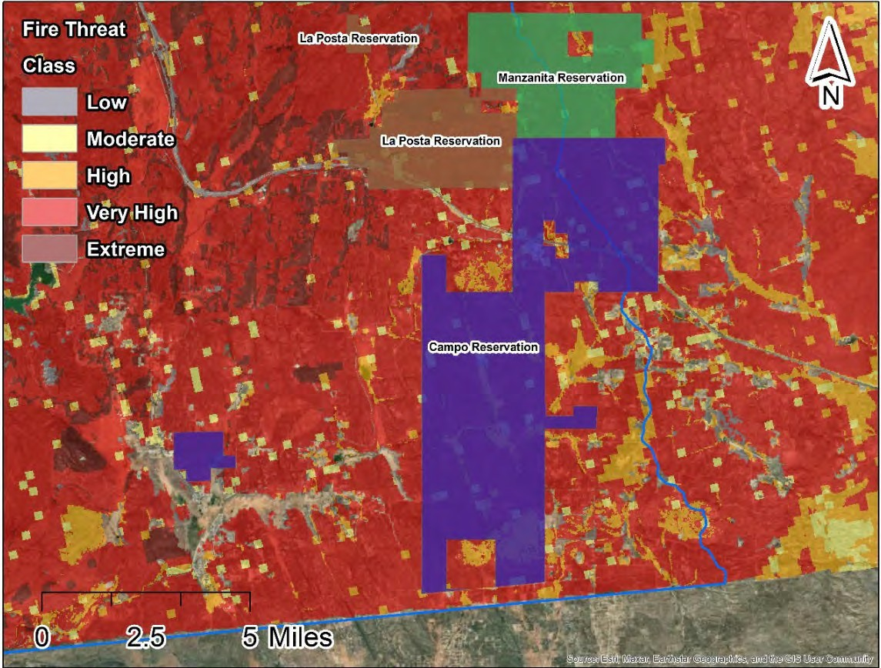

To meet the National Fire Protection Association 1710 requirements (2016 edition), the Fire Protection District receives and reciprocates numerous Mutual and Auto Aid agreements on a regional and statewide level including, but not limited to, the U.S. Forest Service, the Central Zone of the San Diego Operational Area, San Diego County Fire Protection District, Cal FIRE and the Bureau of Indian Affairs (U.S. Department of Interior). This all-hazard protection includes the response and mitigation of high-risk wildland fires not only on the Campo Reservation, but also for the many rural communities that surround these reservations.

PROJECT NEED:
The area’s fire history dates as far back as the 1940s. San Diego County has experienced some of the largest wildfires in California, most notably the Cedar Fire in 2003 and the Witch Creek Fire in 2007. Other recent fires in this area include the 2017 Eclipse and Church Fire, the 2016 Border Fire, the 2015 Corners Fire, and the 2011 Lake Morena Fire. Annual fires near or on the U.S./Mexico border are also common.

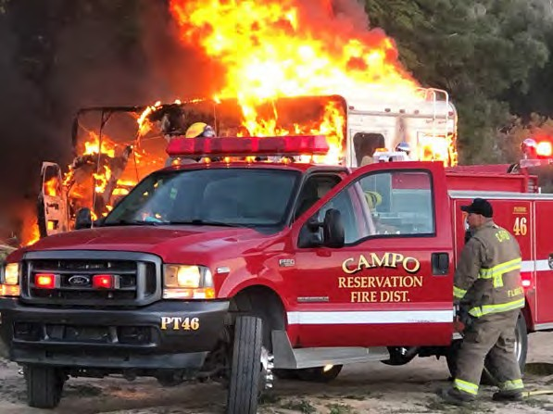
An unfortunate incident involving the frontline firefighting apparatus earlier this year resulted in the Fire Protection District being severely compromised in terms of emergency response. Patrol 46 is a Type 6 fire engine (small fire engine), and it currently serves as the primary rescue apparatus for vehicle accidents, fires and rescues. Patrol 46 was historically used for fires and as a secondary apparatus for freeway incidents and training purposes. (Photo Right)

The Campo Reservation has limited fiscal resources. This proposal would augment Tribal funds, received from the sale of another fire engine unit, to secure a modern Type I Engine that is more appropriate in terms of emergency response within the Fire Protection District as well as emergency requests from neighboring communities.

The Personal Protective Equipment (PPE) request and industry standards dictate the need for modern, serviceable PPE when engaged in wildland firefighting. Fire resistive pants and jackets, shrouds to protect the face and airway and lug sole 10-inch-high leather boots are the primary components of the wildland firefighting safety gear.
Providing safe reliable wildland PPE for all wildland firefighters will enable them to conduct activities that will support their response to wildfires, reduction of vegetative fuels, and other emergencies in the Fire Protection District’s service areas.

Additionally, the Fire Protection District utilizes both the Very High Frequency (VHF) and Ultra High Frequency (UHF) band radio systems on a daily basis. Proposed equipment includes ten Project 25 compliant VHF/UHF portable radios (for interoperable land mobile radio systems) as required under the California Radio Interoperable System by January 2024.

PROJECT SUMMARY:
The Campo Band of Mission Indians in conjunction with the Fire Protection District seeks funding from the Conservancy to augment Tribal monies in order to purchase a modern, robust Type I Fire Engine to replace an aging Fire Engine. Additionally, they are requesting funding for P25 (multi-agency interoperability) compliant hand-held radio equipment and PPE to be utilized in the event of wildland fires, and day-to-day operations.

It is the intent of the Fire Protection District to maintain the Type I Fire Engine in accordance with all manufacturers' recommendations and requirements to ensure warranty viability and extended reliability. The Fire Protection District has long-term relationships with regional, licensed mechanics and vendors knowledgeable in maintenance and repair of emergency devices.

Communications equipment will be routinely maintained by a licensed vendor as well as by the County of San Diego Sheriff's Department which is the proprietary contact regarding the 800-megahertz (MHz) system. PPE will be inspected and maintained on a daily basis. All maintenance and repairs to items under this proposal will be addressed via the appropriate "budget line-item" within the Fire Protection District’s annual operating budget.

Table 1. Estimated Budget and Anticipated Schedule
Task # | Description | Amount | Schedule
Grant Request to the Conservancy
1. Implementation | Purchase one Type 1 Fire Engine and associated equipment, ten P25 compliant communication devices, wildland PPE, and other fire supplies | $560,619.00 | Throughout the grant term
 | Total Amount Requested | $560,619.00
Leveraged Funding
Matching Funds | Campo Band of Mission Indians  funding for fire engine | $406,500.00
In -Kind Services | Campo Reservation Fire Protection District | $6,253.00
 | Total Leverage Funding | $412,753.00
 | TOTAL PROJECT COST | $973,372.00

DELIVERABLES:
- Quarterly invoices, request for disbursements (RFDs) and progress reports with photo documentation
- Priority areas identified for hazardous fuel reduction and recommended types and methods of treatment consistent with the Community Wildfire Protection Plan (CWPP)
- Recommended measures to reduce ignitability of structures throughout the area addressed by the CWPP
- Final Project Report
PROJECT FINANCING: The total Project amount is $973,372.00; the Conservancy staff recommends funding in the amount of $560,619.00 for the implementation of the project. The anticipated source of Conservancy funds for this Project is the Budget Act of 2023.

LEVERAGED FUNDING: Applicant will provide 42% in matching funds or $406,500 toward the replacement of an aging Fire Engine as well as updated communications units and PPE. The Department estimates a total of 150 hours to address these and other issues. The estimated fiscal commitment is $5,360.00 (including Department fringe package). An estimated total of 25 hours ($893.00) is anticipated to finalize this portion of the proposal. The total "in-kind services" is approximately $6,253.00.

CONSISTENCY WITH CONSERVANCY’S ENABLING LEGISLATION: This Project
would be undertaken consistent with the Conservancy’s enabling legislation (Public Resources Code, §§ 32630-32659.9).

CONSISTENCY WITH CONSERVANCY’S STRATEGIC PLAN GOAL(S) &
OBJECTIVE(S): Consistent with Program 3 Preserve and Restore Natural Resources and Program 6, Expand the Organization’s Capacity and Public Outreach from the Conservancy’s Strategic Plan Update 2018-2023.

CONSISTENCY WITH THE PURPOSES OF THE FUNDING SOURCE: Budget Act of
2023 is for wildfire and climate resilience, watershed protection, natural and cultural resource protection, and community access projects. The funding is immediately available for shovel-ready projects.

CONSISTENCY WITH THE CONSERVANCY’S DIRECTED GRANT PROGRAM:
This Project achieves one or more of the purposes:
- Climate, Wildfire and Forest Resilience
- Protecting resources
- Reducing flood and fire risk
- Removing invasive plant species from the watershed
- Increasing native habitat and promoting the re-establishment of native species
- Benefits disadvantaged, severely disadvantaged, or underserved communities

ALIGNMENT WITH PLANS AND PRIORITIES
  - California’s Fourth Climate Change Assessment
Supports local adaptation strategy and resilience, fuels reduction to mitigate risk of fire and improve forest health, and protection of the state’s most vulnerable populations and communities.

State Wildlife Action Plan
Encourages projects that seek to create a healthier and more resilient forest ecosystem.

California Wildfire and Forest Resilience Action Plan
Supports restoration of natural fire regime and forest composition through a multitude of approaches including thinning, prescribed burns, invasive vegetation management, and shaded fuel breaks.

Safeguarding California – California’s Climate Adaption Strategy
Promotes management activities to reduce the risk of fire.

San Diego River Conservancy’s Climate Change Policy
Management of invasive species, especially projects which prevent introduction or spread of invasive species, in order to reduce the impacts of this major stressor on biodiversity.

The San Diego Unit 2022 Strategic Fire Plan
Foster fire prevention and safety through community education and training and establish strategic fuel breaks and reduced fuel zones to improve community defense.

2018 Strategic Fire Plan for California
Support and participate in the collaborative development and implementation of local, county and regional plans that address fire protection and landowner objectives.

Campo and Lake Morena Community Wildfire and Protection Plan
Identify and prioritize areas for hazardous fuel reduction treatment. Recommend the types and methods of treatment that will protect the community. Recommend measures to reduce the ignitability of structures throughout the area addressed by the plan

  - California Natural Resources Agency’s Initiatives. This project advances one or more initiatives:
    - Protecting Biodiversity
    - Access for All
    - Nature Based Solutions
    - 30x30 Plan for land conservation

  - Governor’s Executive Orders B-52-18, N-05-19

BENEFITS
The Campo Band of Mission Indians reside in a low-income and underserved community. The Fire Protection District staff will utilize the proposed equipment to protect resources within the Tijuana River Watershed, including residents, property, culturally significant artifacts and sites, wildlife, and native habitats. Fire department staff will perform fire suppression tactics and strategies to mitigate the impacts and intensity of wildfires, and contribute to improving wildfire resilience.

Campo Reservation as well as the La Posta, Manzanita and Ewiiaapaayp Reservations and surrounding areas, such as Cleveland National Forest, frequently experience critical weather conditions and have some of the most flammable vegetation in the state. The Fire Protection District relies on the proposed specialty fire equipment to protect life, infrastructure and the environment from the effects of devastating wildfires. They also recognize that wildland fires contribute to atmospheric carbon dioxide. By implementing fire safety mitigation projects, they can leverage partnerships and resources within local communities.

PROJECT READINESS
The proposed Project is ready for implementation. The Campo Band of Mission Indians, as well as the Fire Protection District are committed to completing the project within a 2- year timeframe. The fire engine will require a significant time commitment due to the establishment and review of unit specifications, meetings with the selected vendor (pre- construction and final inspections) and training. A significant number of hours have already been spent in research and discussion amongst the Tribal Executive Committees and Tribal Communities.

The communications devices and wildland fire equipment is in line with neighboring Fire Agencies. The proposed communications equipment has been specified by Cal FIRE as well as the San Diego County Fire Protection District and will serve the Fire Protection District well into the future.

PERMIT COMPLIANCE
The applicant anticipates no CEQA/NEPA review process is needed because the proposed Project will only purchase of equipment and supplies.

State of California
San Diego River Conservancy

Meeting of November 9, 2023

ITEM: 9

SUBJECT: San Diego Regional Fire Foundation Fire Resiliency
Proposal (ACTION)
The San Diego Regional Fire Foundation seeks funding to assist thirteen Fire Safe Councils in the Conservancy’s service area with implementing fire prevention activities, improving fire resilience and procuring one chipper for Alpine Fire Protection District. The Fire Safe Councils will use the funds to help build organizational capacity at the local and regional level to implement hazardous fuels reduction, maintain fuel breaks, clear defensible space, chipping, and provide wildfire preparedness and prevention safety education for residents as well as within CalFire’s “Very High” Fire Hazard Severity Zones. The Conservancy staff recommends funding $318,958.00 for the proposed Project.

Presentation:
Joan Jones, Executive Director, San Diego Regional Fire and Rescue Foundation

Recommendation: Approval of Resolution 23-12

Resolution No: 23-12

RESOLUTION OF THE GOVERNING BOARD OF THE SAN DIEGO RIVER CONSERVANCY

AUTHORIZING THE EXECUTIVE OFFICER TO GRANT $318,958.00 FROM THE BUDGET ACT OF 2023 TO SAN DIEGO REGIONAL FIRE FOUNDATION
TO IMPLEMENT HAZARDOUS FUELS REDUCTION, MAINTAIN FUEL BREAKS, CLEAR DEFENSIBLE SPACE, CHIPPING, AND CONDUCTING WILDFIRE PREPAREDNESS AND PREVENTION SAFETY EDUCATION AT 13 FIRE SAFE COUNCILS AND PROCURE A CHIPPER FOR THE APLINE FIRE PROTECTION DISTRICT

WHEREAS, the mission of the San Diego River Conservancy is to further the goals of its enabling legislation by conserving and restoring the lands and waters of the San Diego River watershed; and
WHEREAS, the Legislature of the State of California has provided funds under the Budget Act of 2023 to fund climate resilience, natural and cultural resource protection, wildfire resilience, and community access projects; and
WHEREAS, the San Diego River Conservancy has been delegated the responsibility for the administration of this grant program, establishing necessary procedures and guidelines in accordance with statewide priorities and plans; and
WHEREAS, San Diego Regional Fire Foundation applied to the San Diego River Conservancy for a grant to implement hazardous fuels reduction, maintain fuel breaks, clear defensible space, chipping, and conducting wildfire preparedness and prevention safety education at 13 Fire Safe Councils and procure a chipper for the Alpine Fire Protection District within the San Diego River Conservancy’s service area (Project); and
WHEREAS, San Diego River Conservancy staff recommends funding in the amount of $318,958.00 to implement the Project; and
WHEREAS, this Project is consistent with the Conservancy’s Strategic Plan, Program 3 Preserve and Restore Natural Resources, Program 5 Enhance Water Quality and Natural Flood Conveyance and Program 6, Expand the Organization’s Capacity and Public Outreach.
WHEREAS, the San Diego River Conservancy staff have reviewed the grant application, met with applicant and recommends the Project for approval.
NOW, THEREFORE, BE IT RESOLVED that the San Diego River Conservancy’s Governing Board, based on the accompanying staff report and attached exhibits:
- The proposed Project is consistent with the purposes and intent of the Budget Act of 2023.
- The proposed authorization is consistent with the purposes and objectives of the San Diego River Conservancy Act (Public Resources Code, Sections 32630-32659.9).

- The San Diego River Conservancy hereby authorizes the disbursement of up to $318,958.00 (Three Hundred Eighteen Thousand Nine Hundred Fifty-Eight Dollars and Zero cents) to implement the Project.
- Appoints the Executive Officer, or her designee, as an agent to execute all agreements, grants, sub- contracts, and other documents needed for the completion of the Project.

- Prior to the disbursement of funds, the grantee shall submit for the review and written approval of the Executive Officer of the Conservancy a scope of work, budget, and schedule.
Approved and adopted on November 9, 2023. I, the undersigned, hereby certify that the foregoing Resolution Number 23-12 was duly adopted by the San Diego River Conservancy’s Governing Board.

Roll Call Vote: Yeas:
Nays: Absent:

Julia L. Richards Executive Officer

San Diego River Conservancy’s Governing Board Members Roll Call Vote

Name | Ayes | Noes | Abstained
CNRA: Katherine Toy
DOF: Stephen Benson
CADFW: Richard Burg
Dr. Jennifer Campbell, SD Mayor Designee
Joel Anderson, County Supervisor
Raul Campillo
Ben Clay, Chair
Ruth Hayward, Vice Chair
J. Cody Petterson
John Elliott
Elsa Saxod
DPR Designee, Ray Lennox
DPR Designee, Nicole Van Doren
Dustin Trotter
Phil Ortiz

Staff Recommendation SDRC Resolution 23-12
November 9, 2023

DIRECTED GRANT PROGRAM

RECOMMENDED ACTION: Authorization to provide up to $318,958.00 to the San Diego Regional Fire Foundation to fund thirteen Fire Safe Councils to facilitate fire prevention activities and improve fire resilience within the San Diego River Conservancy’s (Conservancy) service area in the County of San Diego.

LOCATION: The thirteen Fire Safe Councils (FSCs) in San Diego County are located throughout the Conservancy’s service areas and within the watersheds of San Diego, Otay, Sweetwater, and Tijuana Rivers.

RESOLUTION AND FINDINGS: Staff recommends that the San Diego River Conservancy adopt the following resolution pursuant to the San Diego River Conservancy Act (Public Resources Code, § 32630 et seq.):

The San Diego River Conservancy hereby authorizes the disbursement of funding for projects focused on protecting resources, restoring native habitat and fire protection and suppression, specifically as follows:

To the San Diego Regional Fire Foundation, the sum of $318,958.00 (Three Hundred Eighteen Thousand Nine Hundred Fifty-Eight Dollars) to use as follows:

  - To implement hazardous fuels reduction, maintain fuel breaks, clear defensible space, chipping, and conducting wildfire preparedness and prevention and safety education at 13 FSCs and procure a chipper for the Alpine Fire Protection District (Project).

If the Project is approved by the Governing Board Members and before the disbursement of funds, the grantee shall submit for the review and written approval of the Executive Officer of the Conservancy a scope of work, budget and schedule, and the names and qualifications of any contractors to be employed in carrying out the project.

Staff further recommends that the Conservancy adopt the following findings:

Based on the staff report and attached exhibits, the San Diego River Conservancy hereby finds that:

- The proposed authorization is consistent with the purposes and objectives of the San Diego River Conservancy Act, including Section 32649.

- The proposed project is consistent with the Guidelines for the Conservancy’s

Directed Grant program.

- The proposed Project is consistent with the Budget Act of 2023.

BACKGROUND:
The mission of the San Diego Regional Fire Foundation (SDRFF) is to protect lives, property, and our environment through strengthening the system of fire and emergency services in San Diego County. SDRFF collaborates with partners to help make San Diego the safest county in the nation. SDRFF has been providing fire suppression equipment and training to fire departments throughout San Diego County for more than 30 years. It also provides resources to educate and prepare communities for wildfires and assists Fire Safe Councils (FSCs). Requested funding will support these FSCs in performing grassroots, community-based projects to reduce the risk and intensity of wildfires.
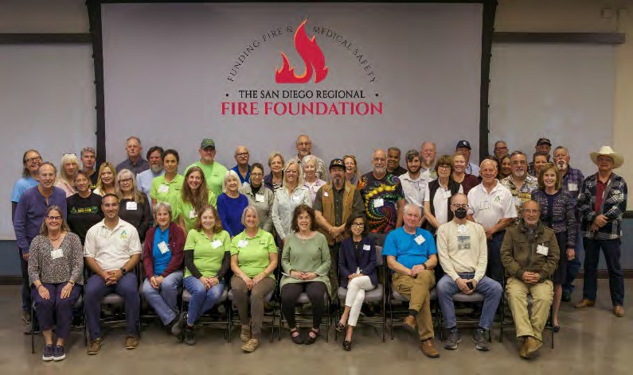

Photo 1. Fire Safe Council Volunteers
SDRFF does not have any recurring sources of funding and must raise the funds for its programs each year.

FSCs are community-based volunteer groups that provide wildfire prevention, preparedness, and evacuation education and conduct fuel reduction projects in their respective communities. The photo to the right was taken at the award event put on by SDRFF and the FSC of Greater San Diego in May 2023 and represents some of the volunteers involved in local FSCs.

There are approximately 40 FSCs in San Diego County, of which thirteen are located in the Conservancy’s service areas, as follows:

- Alpine/ Viejas
- Alvarado Estates
- Campo / Lake Moreno
- Chula Vista
- Cuyamaca Woods
- Jamul
- Julian
- Kensington
- Lakeside
- Mt. Laguna
- Pine Valley
- Potrero & Tecate
- Wynola Estates

PROJECT NEED:
This region has experienced devastating wildfires that have destroyed homes, property, and habitat in addition to contaminating the air with toxic pollutants and impacting the climate by releasing large amounts of carbon dioxide and other greenhouse gases into the atmosphere. California remains in a drought and these dry conditions along with Santa Ana winds put much of San Diego County at further risk. Supporting FSCs is necessary because the FSCs perform critical services that help minimize the number and

severity of wildfires by reducing fuels loads in rural areas. Additionally, the Alpine Fire Protection District (AFPD) is in need of a chipper to reduce overgrown fuel biomass in its community. The chipper will be shared with the Alpine/Viejas Fire Safe Council.

SDRFF is the only foundation that supports the entire San Diego County, which includes over 40 fire agencies/departments, 250 fire stations and about 40 FSCs. Many of the communities, specifically the 13 FSCs located in the Conservancy’s watershed areas, are located in very high wildfire risk zones as identified by CalFire’s Fire Hazard Severity Zone map (Map 1). A large percentage of residents in the wildland urban interface area and rural east county have benefited from the support provided by SDRFF’s programs to educate homeowners and reduce flammable fuel loads in remote areas located near public open space, parks, and the Cleveland National Forest.

Map 1. Fire Safe Councils and Cal FIRE’s Fire Hazard Severity Zone (FHSZ) within the Conservancy’s Service Area
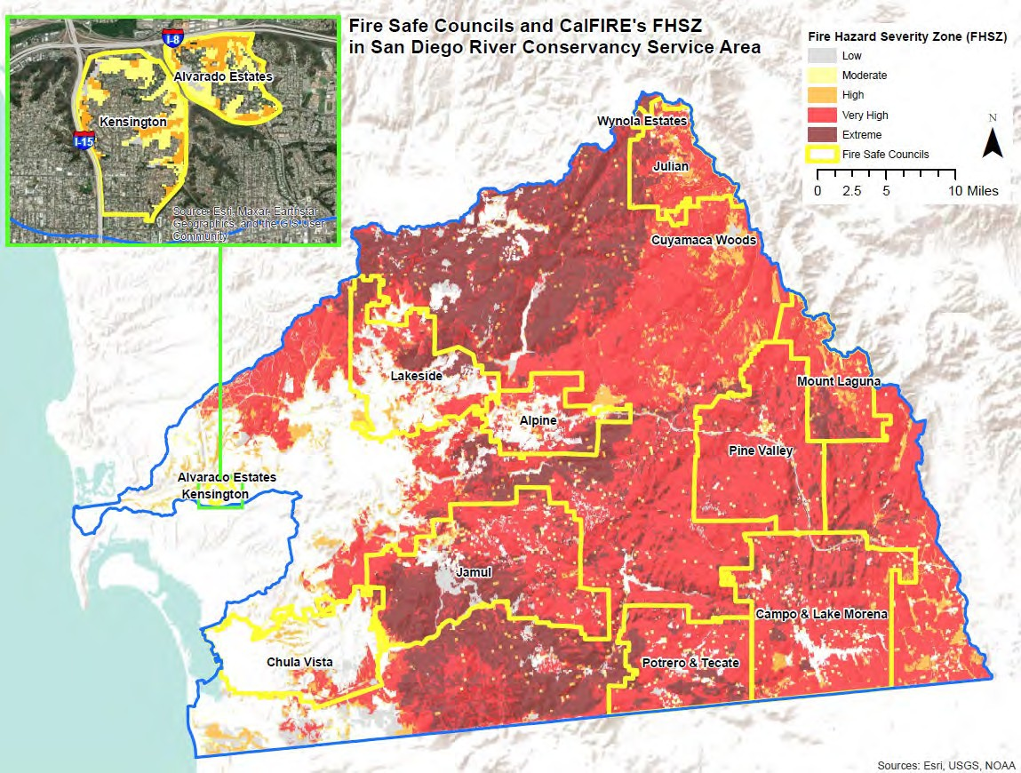

PROJECT SUMMARY:
As noted previously, working to prevent wildfires is an important strategy in keeping San Diego safe from wildfires. SDRFF manages an annual grant program, Project SAFE, in which FSCs are invited to submit requests for funding. All FSCs in San Diego County are invited to apply for funding. Funding from Project SAFE is the only funding that many of the FSCs receive. In the past, Project SAFE has received funding from the SDRFF, SDG&E and the Resource Conservation District of Greater San Diego County through a Conservancy grant.

Unfortunately, funding availability has consistently fallen short of the FSCs’ needs, and the shortfall is expected to increase as FSCs grow and new FSCs are added. For the past two years, FSC requests for Project SAFE funding averaged $215,000 per year and only $150,000 (about 70%) of funding has been available. Historically, requests have averaged $12,000 per FSC. SDRFF is requesting $13,000 per FSC in the grant application to reflect inflation.

The grant request is to support the FSCs in performing community-based projects to reduce wildfire risk and to procure a chipper. The $318,958 requested from the Conservancy will enable the following critical wildfire education and fuel reduction programs as follows:

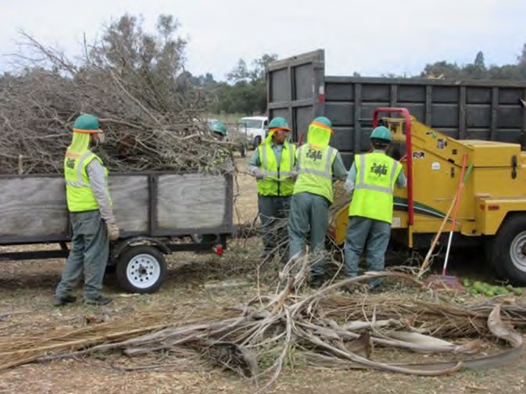
- Fuel reduction, chipping, community wildfire preparedness and preparation education events, and clean up events for 13 FSCs ($169,000).
- A chipper for the Alpine Fire Protection District that will be used and shared with the Alpine/Viejas FSC ($108,355)
- Project administration and management ($41,603)

MEASURABLE RESULTS
Using a consistent measurement methodology, each FSC will report the quantifiable results of their efforts, acres of treatments, the volume of chipped vegetation, the volume brush cleared, the weight of vegetation chipped, the weight of waste removed, the weight of vegetation removed, and length (miles) of escape routes cleared of overgrowth to SDRFF. The Alpine chipper will be acquired and volume of vegetation chipped will be recorded based on the stacked brush and cuttings. Prior to chipping, homeowners will register to a database that has been established to log information on the volume of vegetation chipped and will report to SDRFF. SDRFF will then compile the results for the FSCs and the Alpine chipper and prepare a final report to show the impacts of the Project to the Conservancy.

DELIVERABLES:
Each FSC will hold several community events that provide brush clearing, vegetation chipping and create defensible space around homes and businesses. Emergency kits and information on wildfire and evacuation preparedness, home fire prevention, and home hardening techniques will be disseminated. Each FSC will work with fire agencies to address specific needs in their communities.

Under this Project, it is estimated that the 13 FSCs will have about 40 chipping events; provide over 50 dumpsters (about 170 “dumpster days”); hold 3 large community clean up events in East County; and provide 2 community education events each. Some FSCs will provide reflective address signs which Fire Chiefs say are critical to locate residences in rural areas during emergency situations and one FSC will provide home inspections and ember resistant screening.

Table 1. Estimated Budget and Anticipated Schedule

Task # |  | Description | Amount | Schedule
Grant Request to the Conservancy
1 | Support for 13 Fire Safe Councils | 2024 Fire Safe Council Program | $169,000.00 | Quarterly throughout the grant period
2 | Procure Chipper | Alpine Fire Protection District | $108,355.00
3 | Project Administration and Management | Grant Oversight | $41,603.00
 | Total Amount Requested |  | $318,958.00
Leveraged Funding
4 | Sunrise Power Link Fire Mitigation Grant Fund | Funding for eligible FSCs including the Alpine/Viejas Chipping Program | $202,000.00
5 | In -Kind Services | Dumpsters provided by EDCO | $19,000.00
6 | Volunteer Labor | Estimated value of FSC volunteers - 13,920 hours @  $35/hour | $487,200.00
 |  | Total Project Cost | $1,027,158.00

PROJECT FINANCING: The total Project amount is $1,027,158.00; the Conservancy staff recommends funding in the amount of $318,958.00 for the implementation of the proposed Project. The anticipated source of Conservancy funds for this Project is the Budget Act of 2023.

LEVERAGED FUNDING: Funding for the SAFE Program currently comes from SDG&E, the Resource Conservation District of Greater San Diego County, SDRFF, and other donors. Additionally, the Sunrise Powerlink Fire Mitigation Grant provides $202,000 to eligible FSCs, which includes operation of the Alpine / Viejas FSC’s chipping program.

Each year the 13 FSCs in the Conservancy’s watershed areas contribute an estimated 13,920 hours – valued at $487,200 ($35 per hour) in fuels reduction and wildfire preparedness and prevention programs. Vendors such as EDCO support the FSC’s operations by donating dumpsters at a value of $19,000. San Diego County offers a chipper and crew at no cost to at least one FSC each month.

CONSISTENCY WITH CONSERVANCY’S ENABLING LEGISLATION: This Project
would be undertaken consistent with the Conservancy’s enabling legislation (Public Resources Code, §§ 32630-32659.9).

CONSISTENCY WITH CONSERVANCY’S STRATEGIC PLAN GOAL(S) &
OBJECTIVE(S): The Project is consistent with Program 3 Preserve and Restore Natural Resources, Program 5 Enhance Water Quality and Natural Flood Conveyance, and Program 6 Expand the Organization’s Capacity and Public Outreach of the Conservancy’s Strategic Plan Update 2018-2023.

CONSISTENCY WITH THE PURPOSES OF THE FUNDING SOURCE: Budget Act 2023
is for wildfire and climate resilience, watershed protection, natural and cultural resource protection, and community access projects. The funding is immediately available for shovel-ready projects.

CONSISTENCY WITH THE CONSERVANCY’S DIRECTED GRANT PROGRAM:
This Project achieves one or more of the purposes:
- Located in the San Diego River watershed;
- Resource protection;
- Reducing flood and fire risk;
- Protecting the natural and scenic beauty of the San Diego River watershed.

ALIGNMENT WITH PLANS AND PRIORITIES
  - California Wildfire and Forest Resilience Action Plan
Provides numerous fuel reduction, vegetation management, defensible space, and fuel breaks to reduce fire risk throughout the watershed.

California Community Wildfire Protection Plans (CWPP)
CWPP is a community-based forest planning and fuel reduction prioritization document.

Safeguarding California Plan: 2018 Update California’s Climate Adaptation Strategy
With California’s changing climate, it becomes increasingly important to clear brush and help protect properties.

California’s Fourth Climate Change Assessment
Supports local adaptation strategy and resilience, and protection of the state’s most vulnerable populations and communities.

State Wildlife Action Plan
Goal 3 - Enhance Ecosystem Functions and Processes: Maintain and improve ecosystem functions and processes vital for sustaining ecosystems in California.

San Diego River Conservancy’s Climate Change Policy
Promotes climate-related mitigation or improvements within disadvantaged communities and demonstrates a reduction in baseline greenhouse gas emissions through other innovative techniques or project designs. Leverages partnerships and resources with local communities, including government entities and non- profits.

Strategic Fire Plan for California
Goal 5: Integrate fire and fuels management practices with landowner/land manager priorities across all ownerships and jurisdictions.

California Natural Resources Agency’s Initiatives.
Protects biodiversity and implements nature-based solutions.

  - Conservancy’s Wildfire and Forest Resilience Action Program Fuels Reduction, vegetation management, and creates fuel breaks or defensible space projects.

Conservancy’s Climate Change Policy
Recognizes that wildland fires may be a major contributor to atmospheric carbon dioxide. Leverages partnerships and resources with local communities.
Implements fire safety mitigation projects where appropriate; and engages local communities through outreach, education, and interpretation.

  - Governor’s Executive Orders B-52-18, N-05-19

BENEFITS
The FSC’s Projects reduce the risk of wildfire, benefitting southern California and the San Diego region. By reducing the number of and size of fires flood risk will be reduced because there will be less burned landscape, wildlife habitats will be protected, and the public will be able to continue to enjoy use of public open space, trails, campgrounds, and park facilities. Reducing the frequency and intensity of wildfires will improve the environment as air and water quality will be improved by reducing the amount of harmful chemicals released in the air and debris from runoff impacting waterways.

FSCs prioritize providing services to disadvantaged residents including those with low income, the elderly, veterans, and the disabled who are unable or can’t afford to do the work to keep their homes and properties fire safe.

PROJECT READINESS
SDRFF has a 30+ year strong track record in managing projects and developed a process to manage the grants. The Executive Director, who is a CPA, is well connected with the FSCs, fire departments, fire stations and understands the issues and challenges they face. The Board Chair has over 60 years of experience in the fire service and has chaired the Boards of four nonprofits.

Under the SAFE Grant Program, an annual calendar is established and FSC’s provide grant requests that include projects. While heavy rainfall in the early part of the year may delay chipping events, it is not anticipated that projects will extend beyond two years.

The only equipment requiring long term maintenance is the chipper. A service contract is included in the purchase price for five years through the vendor. Future funding to maintain the equipment would come from AFPD general funds or the Alpine/Viejas FSC or potentially be shared between them.

PERMIT COMPLIANCE
Any permits needed to hold community events will be obtained by the individual Fire Safe Council sponsoring that activity. An Air Quality Control Board permit is needed to operate the chipper. The AFPD intends to purchase a Tier 4 California CARB compliant chipper. The initial annual permit is included in the purchase. AFPD general funds will be used to fund future permit fees and maintain the chipper.

State of California
San Diego River Conservancy

Meeting of November 9, 2023

ITEM: 10

SUBJECT: SAN DIEGO FIRE-RESCUE FOUNDATION PROPOSAL
FOR FUEL REDUCTION IN THE CITY OF SAN DIEGO, LOWER SAN DIEGO RIVER (ACTION)
The San Diego Fire-Rescue Foundation seeks funding to implement brush management and weed abatement activities to reduce fuel loads and maintain and create firebreaks to help safeguard and protect vulnerable, at-risk, and underserved communities in the San Diego River watershed. The Foundation will use funding to procure an F-350 vehicle, a 4-wheel drive ATV, eco-friendly fuel treatments, and battery-powered equipment to replace gas-powered equipment. The San Diego Fire-Rescue Foundation and the San Diego Fire-Rescue Department will partner with other stakeholders to implement activities in targeted locations within the San Diego River watershed. The Conservancy staff recommends funding $366,949.00 for the proposed project.

Presentation:
Wendy Robinson, Executive Director, San Diego Fire-Rescue Foundation
Anthony Tosca, Deputy Chief/Fire Marshall, San Diego Fire- Rescue Department

Recommendation: Approval of Resolution 23-13

Resolution No: 23-13

RESOLUTION OF THE GOVERNING BOARD OF THE SAN DIEGO RIVER CONSERVANCY

AUTHORIZING THE EXECUTIVE OFFICER TO GRANT $366,949.00 FROM THE BUDGET ACT OF 2023 TO SAN DIEGO FIRE-RESCUE FOUNDATION
TO PROCURE ONE F-350 VEHICLE (OR SIMILAR TYPE), ONE ALL-TERRAIN VEHICLE WITH 4-WHEEL DRIVE, AND IMPLEMENT FUEL REDUCTION ACTIVITIES VIA ROAD BRUSHING ON EVACUATION ROUTES, AND MAINTENANCE OF FIRE BREAKS

WHEREAS, the mission of the San Diego River Conservancy is to further the goals of its enabling legislation by conserving and restoring the lands and waters of the San Diego River watershed; and
WHEREAS, the Legislature of the State of California has provided funds under the Budget Act of 2023 to fund climate resilience, natural and cultural resource protection, wildfire resilience, and community access projects; and
WHEREAS, the San Diego River Conservancy has been delegated the responsibility for the administration of this grant program, establishing necessary procedures and guidelines in accordance with statewide priorities and plans; and
WHEREAS, San Diego Fire-Rescue Foundation applied to the San Diego River Conservancy for a grant to reduce the risk and intensity of fire by implementing fuel reduction activities within parts of the City of San Diego and to procure one F-350 Vehicle (or similar type), and one all-terrain vehicle with 4-wheel drive to access difficult terrain (Project); and
WHEREAS, San Diego River Conservancy staff recommends funding in the amount of $366,949.00 to implement the Project; and
WHEREAS, this Project is consistent with the Conservancy’s Strategic Plan, Program 3 Preserve and Restore Natural Resources, Program 5 Enhance Water Quality and Natural Flood Conveyance and Program 6, Expand the Organization’s Capacity and Public Outreach.

WHEREAS, the San Diego River Conservancy staff have reviewed the grant application, met with applicant and recommends the Project for approval.
NOW, THEREFORE, BE IT RESOLVED that the San Diego River Conservancy’s Governing Board, based on the accompanying staff report and attached exhibits:
    - The proposed Project is consistent with the purposes and intent of the Budget Act of 2023.

    - The proposed authorization is consistent with the purposes and objectives of the San Diego River Conservancy Act (Public Resources Code, Sections 32630-32659.9).
    - The San Diego River Conservancy hereby authorizes the disbursement of up to $366,949.00 (Three Hundred Sixty-Six Thousand Nine Hundred Forty-Nine Dollars) to implement the Project.

    - Appoints the Executive Officer, or her designee, as an agent to execute all agreements, grants, sub- contracts, and other documents needed for the completion of the Project.

    - Prior to the disbursement of funds, the grantee shall submit for the review and written approval of the Executive Officer of the Conservancy a scope of work, budget, and schedule.
Approved and adopted on November 9, 2023. I, the undersigned, hereby certify that the foregoing Resolution Number 23-13 was duly adopted by the San Diego River Conservancy’s Governing Board.

Roll Call Vote: Yeas:
Nays: Absent:

Julia L. Richards Executive Officer

San Diego River Conservancy’s Governing Board Members Roll Call Vote

Name | Ayes | Noes | Abstained
CNRA: Katherine Toy
DOF: Stephen Benson
CADFW: Richard Burg
Dr. Jennifer Campbell, SD Mayor Designee
Joel Anderson, County Supervisor
Raul Campillo
Ben Clay, Chair
Ruth Hayward, Vice Chair
J. Cody Petterson
John Elliott
Elsa Saxod
DPR Designee, Ray Lennox
DPR Designee, Nicole Van Doren
Dustin Trotter
Phil Ortiz

Staff Recommendation SDRC Resolution 23-13
November 9, 2023

DIRECTED GRANT PROGRAM

RECOMMENDED ACTION: Authorization to provide up to $366,949.00 to the San Diego Fire-Rescue Foundation (Foundation) to procure one F-350 vehicle, an all-terrain vehicle (ATV) with 4-wheel drive, and implement eco-friendly fuel treatments using battery- powered equipment in the San Diego River watershed.

LOCATION: On public land owned by the City of San Diego within the boundaries of the San Diego River watershed including the communities of Uptown, Old Town San Diego, Mission Valley, Greater North Park, Mid-City Normal Heights, Mid-City Kensington/Talmadge, Serra Mesa, University Heights.

RESOLUTION AND FINDINGS: Staff recommends that the San Diego River Conservancy adopt the following resolution pursuant to the San Diego River Conservancy Act (Public Resources Code, § 32630 et seq.):

The San Diego River Conservancy hereby authorizes the disbursement of funding for projects focused on enhancing river parkways, protecting resources, restoring native habitat and fire protection and suppression, specifically as follows:

To the San Diego Fire-Rescue Foundation, the sum of $366,949.00 (Three Hundred Sixty-Six Thousand Nine Hundred Forty-Nine Dollars and Zero cents) to use as follows:

      - To implement fuel reduction activities (brush management, weed abatement, and maintenance of fire breaks), procure one F-350 vehicle (or similar), a 4-wheel drive ATV and other equipment for eco-friendly fuel treatments in the San Diego River Watershed (Project).

Before the disbursement of funds, the grantee shall submit for the review and written approval of the Executive Officer of the Conservancy a scope of work, budget and schedule, and the names and qualifications of any contractors to be employed in carrying out the project.

Staff further recommends that the Conservancy adopt the following findings:

Based on the staff report and attached exhibits, the San Diego River Conservancy hereby finds that:

- The proposed authorization is consistent with the purposes and objectives of the San Diego River Conservancy Act, including Section 32649.

- The proposed project is consistent with the Guidelines for the Conservancy’s Directed Grant program.

- The proposed Project is consistent with the Budget Act of 2023.

BACKGROUND:

On August 5, 1889, a City Charter Amendment established the San Diego Fire-Rescue Department (SDFD). For over 100 years, the SDFD has provided fire, lifeguard, and emergency medical services to more than 1.4 million residents across 343 square miles. SDFD public services include responding to 9-1-1 calls, fire inspections, and community education. In 2022 alone, the Department responded to 161,399 calls.

There is a need to conduct vegetation management in areas where steep topography and dense vegetation near occupied structures pose an increased threat to life, property, and the environment due to brushfires. Code requirements and standards exist for creating and managing defensible space/brush management zones in the City of San Diego’s canyons and Wildland-Urban Interface (WUI) areas.

The SDFD’s Community Risk Reduction Division and Wildland Management and Enforcement Section conduct inspections at properties to enforce and abate hazardous fuels reduction through thinning, brush removal, and vegetation modification to slow the rate and intensity of a wildfire and create an area for fire suppression activities to occur. This City-wide proactive program helps ensure the protection of the San Diego community by providing fire hazard prevention and safety education.

To support the goals of SDFD, the San Diego Fire-Rescue Foundation (Foundation), a 501(c)(3) nonprofit organization, was founded in 2005. The Foundation’s mission is to provide enhanced equipment, training, technology, and community education resources to SDFD personnel who perform life-saving duties and ensure fire-rescue personnel have the resources they need to keep the community safe.

PROJECT NEED:

SDFD has only a few staff members who conduct routine brush management for 183,000 parcels in the City of San Diego, of which 60,000 properties are on the canyon rim in the Very High Hazard Severity Zone (VHHSZ).

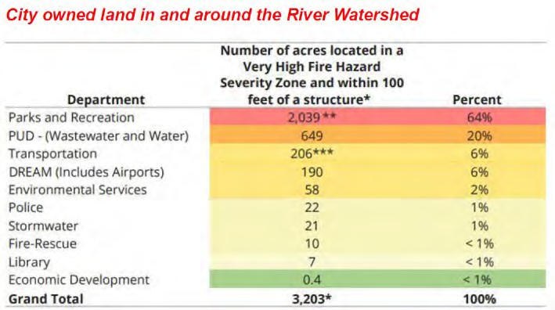
The Parks and Recreation Department and other departments are responsible for brush management on 3,203 acres of city- owned land and within 100 feet of a structure. The brush management equipment is in constant need of repair and maintenance. The Foundation, in partnership with the SDFD, has identified several work locations within the San Diego River watershed. See map below:

Map 1. Proposed Project Areas within the lower San Diego River Watershed
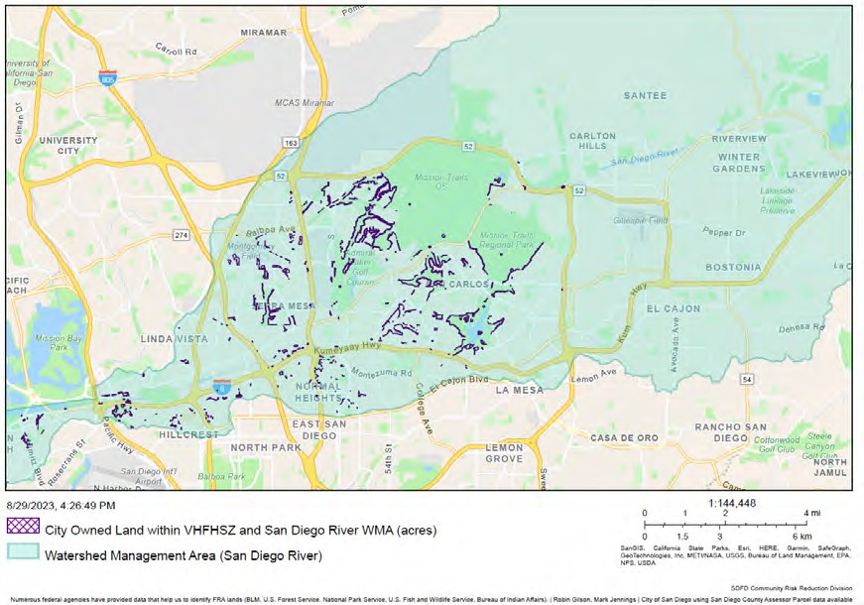

When adjacent to homes, brush management is required to protect homes from wildfire and reduce the risk of fire through site design and vegetation management. Key factors in creating a fire-safe landscape are fuel discontinuity by the separation of the flammable plant cover and reduction in fuel loads by removing dead and excess vegetation.

The Fire Hazard Severity Zones (FHSZ), defined by CAL FIRE and enforced through New Building Codes for California's WUI, are predominantly native chaparral plant communities in southern California. This community contains the most flammable type of vegetation in the United States. This Project will reduce fire hazards around structures by providing an effective fire break between structures and dense vegetation.

PROJECT SUMMARY:

The main goal for the Foundation is to provide administrative and financial management support to SDFD to conduct brush management, weed abatement, and fuel treatment activities in the San Diego River watershed. The project will facilitate fire prevention and safety, understory clearing, establishing fuel breaks, and improve fuel modification zones. To achieve this, SDFD personnel will partner with the San Diego County Fire Protection District, City of San Diego’s Parks and Recreation/Open Space Division, Public Utilities Department, Transportation Department, Real Estate Assets Department, and Alpha Project staff.

The proposed Project includes road brushing on 46 acres, which includes a 10-foot buffer for evacuation routes, as well project locations identified in Map 1. Road brushing is a fuel reduction activity focusing specifically on road ways. Brushing along the road right-of-way is done for safety purposes. The right-of-way is brushed reactively to reduce the height of the vegetation, so sight lines are maintained at intersections and driveways. Trees in close proximity to the edge of pavement represent an increased direct contact hazard to vehicles. Even if contact is avoided, excessive growth along roadways tends to force traffic toward the centerline, reducing mutual clearance with on-coming traffic and increases the potential for accidents. Under this project the targeted roads include: Mission Gorge Road, Montezuma Road, Tierrasanta Boulevard, Fairmont Avenue and others.

Map 2. Target Evacuation Routes for Road Brushing Activities
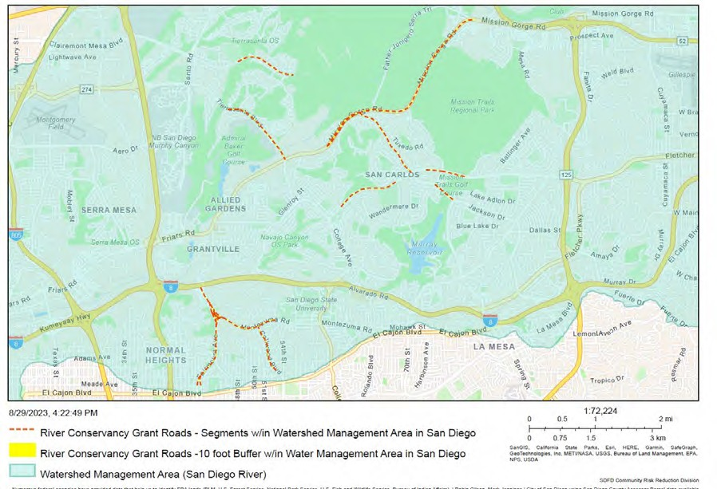

In addition to traditional, proven risk reduction methodologies, the proposed Project proposes the use of MFB-31-CitronTech® technology. This product is the first fire retardant to meet the Environmental Protection Agency’s (EPA’s) Clean Water Act standards and the only fire inhibitor on the EPA’s Safer Choice program to promise environmental safety to vegetation and waterways.

In addition, the proposed Project includes purchase of a new Ford multi-use truck to tow necessary fuel treatment supplies for use in brush management. The SDFD will use the vehicle to carry the personnel, equipment and supplies used for fuel reduction activities, community education and outreach events, including promotion of the creation of new Fire Safe Councils in San Diego County and Community Wildfire Protection Plans (CWPP). In addition, one ATV (4x4) will also be procured to help provide access to challenging areas for brush removal.

The applicant’s request includes replacing gas-powered equipment with battery-powered cordless trimmers for brush management and weed abatement. Fuel breaks will also be created and maintained to help safeguard and protect vulnerable, at-risk, and underserved communities. Fuel treatment backpacks will be provided to personnel for treating areas for firebreaks. Additionally, Global Positioning System (GPS) tracking and mapping will document Project treatments through an ArcGIS mapping tool created on the SDFD website and will be available to the public.

Long-term maintenance and replacement of the vehicles and equipment will be the responsibility of the City of San Diego. The City of San Diego already has Ford vehicles and parts in their fleet.

MEASURABLE RESULTS
  - Noise and emission reduction solutions by using battery-powered hand tools
  - Acres treated; fuel/fire breaks created
  - GPS to track treatments for evacuation routes, firebreaks and fuel reduction activities
  - Education and outreach

DELIVERABLES:
  - Quarterly request for disbursements, progress reports with photo documentation of before and after treatment
  - Use of battery-powered equipment for brush management and weed abatement
  - Eco-friendly fuel treatment
  - GPS tracking
  - Increased education, outreach, and community awareness with the use of signage
  - Final Report

Table 1. Estimated Budget and Anticipated Schedule
Task # | Description | Amount | Schedule
1. Project Administration and Financial Management | Grant management, quarterly requests for disbursements (RFDs), progress reports with photo documentation, Final Report | $39,000.00 | Quarterly throughout 2-year grant period
2. Materials and Equipment | Purchase one F-350 Vehicle, and one ATV (4X4), battery-powered trimmers, chainsaws, handheld blowers, chargers, batteries, 7 Mighty Fire Breaker 275-gallon totes w/ MFB-31-CitronTech® and one treatment refill, 10 backpack sprayers & atomizing nozzles, GPS tracking and mapping, and implementation of fuel reduction activities and firebreaks | $327,949.00
 | TOTAL | $366,949.00

PROJECT FINANCING: The total Project amount is $366,949.00; the Conservancy staff recommends funding in the amount of $366,949.00 for the implementation of the proposed project. The anticipated source of Conservancy funds for this Project is the Budget Act of 2023.

LEVERAGED FUNDING: The city has resources for labor, time, and material maintenance. “In-kind” contributions will be in the form of staff time, field labor, equipment and maintenance over an extended period.

CONSISTENCY WITH CONSERVANCY’S ENABLING LEGISLATION: This Project
would be undertaken consistent with the Conservancy’s enabling legislation (Public Resources Code, §§ 32630-32659.9).

CONSISTENCY WITH CONSERVANCY’S STRATEGIC PLAN GOAL(S) &
OBJECTIVE(S): The Project is consistent with Program 3 Preserve and Restore Natural Resources, Program 5 Enhance Water Quality and Natural Flood Conveyance, and Program 6 Expand the Organization’s Capacity and Public Outreach of the Conservancy’s Strategic Plan Update 2018-2023.

CONSISTENCY WITH THE PURPOSES OF THE FUNDING SOURCE: Budget Act 2023
is for wildfire and climate resilience, watershed protection, natural and cultural resource protection, and community access projects. The funding is immediately available for shovel-ready projects.

CONSISTENCY WITH THE CONSERVANCY’S DIRECTED GRANT PROGRAM:
This Project achieves one or more of the purposes:
- Located in the San Diego River watershed;
- Resource protection;
- Reducing flood and fire risk;
- Removing invasive plant species from the watershed;
- Protecting the natural and scenic beauty of the San Diego River watershed.

ALIGNMENT WITH PLANS AND PRIORITIES
- California Wildfire and Forest Resilience Action Plan
Supports activities such as fuels reduction, forest thinning, vegetation management, prescribed fire, shaded fuel breaks, defensible space, and enhancement of fire-prone habitats to reduce fire risk.

Safeguarding California Plan: 2018 Update California’s Climate Adaptation Strategy
Supports public education on the link between fire risk and the elevated importance of preventative fuels treatment projects and supports California’s most vulnerable populations to increase equity and resilience through investments, planning, research, and education.

California’s Fourth Climate Change Assessment
Supports local adaptation strategy and resilience, and protection of the state’s most vulnerable populations and communities.

State Wildlife Action Plan
Goal 3 - Enhance Ecosystem Functions and Processes: Maintain and improve ecosystem functions and processes vital for sustaining ecosystems in California.

San Diego River Conservancy’s Climate Change Policy
Promotes climate-related mitigation or improvements within disadvantaged communities and demonstrates a reduction in baseline greenhouse gas emissions through other innovative techniques or project designs. Leverages partnerships and resources with local communities, including government entities and non- profits;

Strategic Fire Plan for California
Goal 5: Integrate fire and fuels management practices with landowner/land manager priorities across all ownerships and jurisdictions.

City of San Diego Municipal Code
Division 4: Landscape Regulations Fuel management activities to reduce the volume of flammable vegetation within 100 feet of structures, provided that the activities will not result in the taking of endangered, rare, or threatened plant or animal species, are exempt to fuel management activities if the public agency

having fire protection responsibility for the area has determined that 100 feet of fuel clearance is required due to extra hazardous fire conditions.

City of San Diego Ordinance Fire Prevention Bureau (FPB) Policy B-18-01
Mitigation for reduced brush management zones

California Natural Resources Agency’s Initiatives. This project advances one or more initiatives:
  - Protecting Biodiversity
  - Access for All
  - Nature Based Solutions
• 30x30

- Governors Executive Orders B-52-18, N-05-19

BENEFITS
This proposed Project promotes noise and emission reduction solutions by using battery- powered tools and eco-friendly fuel treatments. This proposed Project would also provide protection for critical city services such as fire stations and other city facilities. The eco- friendly fuel treatment comes with Safety Data Sheets (SDS) and represents no threat to the environment, human or animal species. Additional benefits include protecting native habitats, natural resources, and disadvantaged populations and communities from fire risk in the San Diego River watershed.

PROJECT READINESS
The SDFD is well positioned to complete the project within a 2-year timeframe. The eco- friendly battery powered equipment is a replacement for gas powered equipment currently utilized. The City has staff biologists who operate under local landscape regulations to comply with the City’s permit regulations.

PERMIT COMPLIANCE
The proposed Project is exempt from CEQA.

Meeting of November 9, 2023

ITEM: 11
SUBJECT: THE COUNTY OF SAN DIEGO’S ENHANCED
INFRASTUCTURE FINANCE DISTRICT (INFORMATIONAL)
The County of San Diego undertook a funding feasibility analysis in 2022 to evaluate long-term funding for the San Diego River Park and Trail. The County’s Department of Parks and Recreation is leading efforts with stakeholders to pursue an Enhanced Infrastructure Financing District to develop an alternate funding source for trail, infrastructure and other improvements along the river corridor to help complete the San Diego River Trail and the San Diego River Park vision and will provide a presentation to the Conservancy regarding the above.

Presentation:
Lizzy Bendrick, County of San Diego, Department of Parks and Recreation, Trails Program Manager
James Inglis, County of San Diego, Department of Parks and Recreation, Department Budget Manager

Meeting of November 9, 2023

ITEM: 12
SUBJECT: EXECUTIVE OFFICER’S REPORT (INFORMATIONAL/ACTION)
The following topics may be included in the Executive Officer’s Report. The Board may take action regarding any of them:

  - Wildfire Preparedness Fair hosted by San Diego Fire-Rescue Foundation
  - All State Conservancy meeting
  - California State Leadership Forum
  - California Wildfire & Forest Resilience Task Force meeting
  - All State Director meeting for Resource Agencies
  - San Diego County’s Regional Forest and Fire Capacity Program meeting
  - Tijuana River Calley Steering Committee meeting

Meeting of November 9, 2023

ITEM: SUBJECT:
13

NEXT MEETING

The next regularly scheduled Board meeting is anticipated to be held in person on Thursday, January 4, 2024, from 2:00 to 4:00 p.m.

Meeting of November 9, 2023

ITEM: 14
SUBJECT: ADJOURNMENT

